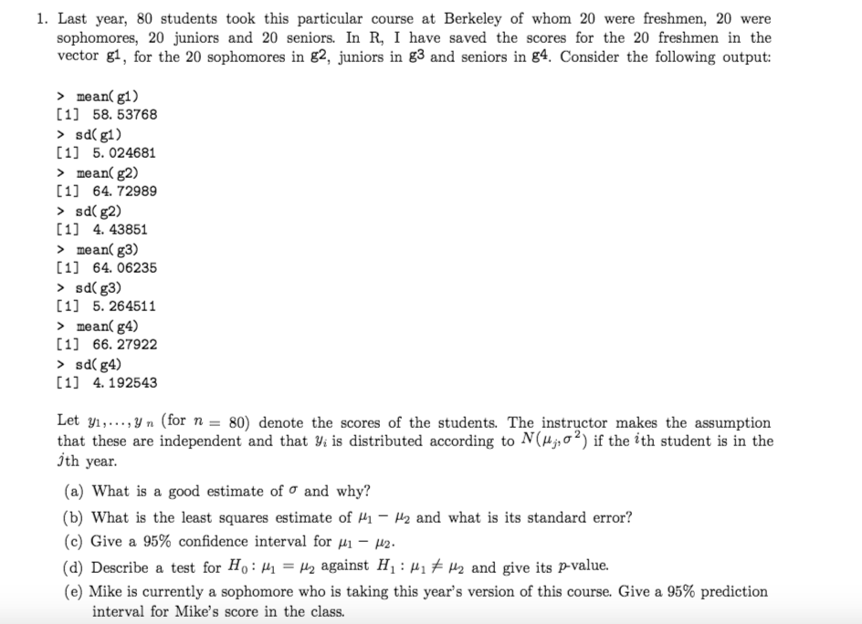

Categorical data

The model is Y= u + e

What’s the design matrix X? (no intercept, so no column of 1s)

What’s the sum of diagonal entries of $X^{T}X$? (the number of samples for each category)

$X^{T}X$ = $\left[\begin{aligned}\begin{matrix}20 & 0 \\ 0 & 20\end{matrix} \begin{matrix}0 & 0 \\ 0 & 0\end{matrix} \\ \begin{matrix} 0 & 0 \\ 0 & 0\end{matrix}\begin{matrix} 20 & 0 \\ 1 & 20\end{matrix}\end{aligned}\right]$

Estimate of SE

$$s.e\left(u_{i}\right)= \frac{s}{\sqrt{n}} (we need this knowledge from stats135)$$

$$s is sample standard deviation$$

$$residual standard error ^2= \frac{RSS}{n-p-1}$$

$$we know sample sd, then we know RSS for each group, so we can calculate this \hat{σ}$$

$$notice that n-p-1 is residual.df, which is the number of columns of X,$$

$$it^{'}s 4 in this case. Not n-4-1, p=4, but no intercept, so we don^{'}t minus one here$$

2.prove.

True model is Y = X $+D+e,$ where ${e=N(0,σ}^{2}),but we fit a model as Y=Xβ+e.$

1. Is the least square estimator unbiased?

Let Y be income, X be age and education, D is gender, we only regress Y on X, so we might miss some information, D definitely contributes to the Y.

$$E(\hat{β})={\left(X^{T}X\right)}^{-1}X^{T}E(Y) \\ ={\left(X^{T}X\right)}^{-1}X^{T}(X+D)$$

$$={\left(X^{T}X\right)}^{-1}X^{T}X+{\left(X^{T}X\right)}^{-1}X^{T}D$$

$$=I+ {\left(X^{T}X\right)}^{-1}X^{T}D$$

3.prove

Simple linear regression. Y = a + bx +e, suppose we regress y on new x’= x +10, what’s the coefficients of least square estimator and their variances?

And suppose we let y’ = y + 10, then we regress y’ on x, what’s the coefficients of least square estimator and their variances?

(replace x’ by x+10 in the formula of $\hat{β_{1}} of simple linear regression)$

4.R output, fill in missing parts

F statistic, what’s the F statistic test on? (Answer: test on beta1=beta2=...=beta_p=0)

$$F =\frac{TSS-RSS(M)/p}{RSS(M)/(n-p-1)}$$

t-test is equivalent to F-test when we test the hypothesis $β_{i}=0$

$$t_{n-p-1}={(\frac{{\hat{β}}_{i}}{s.e\left({\hat{β}}_{i}\right)})}^{2}=F_{1,n-p-1}=\frac{RSS\left(m\right)-RSS(M)/1}{RSS\left(M\right)/(n-p-1)}$$

Cov ($\hat{β})'s diagonal entries are var(\hat{β})$

5 some true and false

Note that how to prove $\sum{\hat{e}=0}, 1 way is to use gradient=0, second way is to use X\hat{e}=0$

What’s the value range for Hat matrix’s entry? Diagonal and non-diagonal?