VIETNAM GENERAL CONFEDERATION OF LABOR

**TON DUC THANG UNIVERSITY**

**FACULTY OF INFORMATION TECHNOLOGY**



**BEHAVIORAL INSIGHTS FROM**

**THE INTERACTION OF THREE TEACHING**

**IN VIETNAMESE FOLKTALES**

*Instructor*: **MA. NGUYỄN QUỐC BÌNH**

*Students*: **CAO ĐỨC MINH – 520H0472**

CLASS**: 20H50303**

**PHẠM THỊ LAN ANH – 520H0003**

CLASS**: 20H50204**

Year**: K24**

**HO CHI MINH CITY, 2024**

VIETNAM GENERAL CONFEDERATION OF LABOR

**TON DUC THANG UNIVERSITY**

**FACULTY OF INFORMATION TECHNOLOGY**



**BEHAVIORAL INSIGHTS FROM**

**THE INTERACTION OF THREE TEACHING**

**IN VIETNAMESE FOLKTALES**

*Instructor*: **MA. NGUYỄN QUỐC BÌNH**

*Students*: **CAO ĐỨC MINH – 520H0472**

CLASS**: 20H50303**

**PHẠM THỊ LAN ANH – 520H0003**

CLASS**: 20H50204**

Year**: K24**

**HO CHI MINH CITY, 2024**

ACKNOWLEDGEMENTS

I would like to express my deepest gratitude to the esteemed professors and faculty members of Ton Duc Thang University, who have imparted invaluable knowledge and experience throughout my studies at the university. I also extend my heartfelt thanks to the faculty members working at the administrative office for their dedicated support whenever I encountered challenges during my academic journey.

My sincere appreciation goes to all the professors in the Department of Information Technology, particularly to Professor Nguyen Quoc Binh, whose guidance, support, and facilitation were instrumental in helping me successfully complete this project report.

I am also grateful to all my friends and colleagues who have been with me, supporting and studying alongside me over the years, and during the course of this IT project report.

Lastly, I would like to thank my family, my loved ones, and the university for providing me with the best conditions to pursue my studies throughout this time.

**THIS REPORT WAS COMPLETED**

**AT TON DUC THANG UNIVERSITY**

I hereby affirm that this report was conducted by me under the guidance of Professor Nguyen Quoc Binh. The contents and results presented in this report are genuine and have not been published in any form. The data included in this report are intended for evaluation, validation, and verification purposes by the authors and have been collected from various sources, with references provided in the "References" section.

Additionally, this study includes assessments, evidence, and some data from various authors, institutions, and organizations, all of which are clearly cited and referenced in the footnotes.

Should any instances of misconduct, such as plagiarism, be detected by the faculty or the university, I will assume full responsibility for this report. Ton Duc Thang University will not be held liable for any violations related to fraud or copyright infringement in this report (if any).

*Ho Chi Minh City, August 18, 2024*

*Author*

*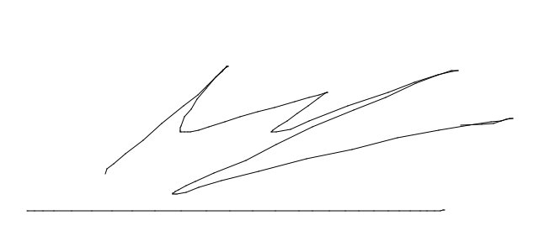 (Signature and full name)*

*Phạm Thị Lan Anh Cao Đức Minh*

LECTURER'S EVALUATION AND FEEDBACK

**Intructor’s comments**

_______________________________________________________________________________________________________________________________________________________________________________________________________________________________________________________________________________________________________________________________________________________________________________________________________

Ho Chi Minh City, …….………………….

(*Signature and full name*)

**Lecturer's comments and grading** ________________________________________________________________________________________________________________________________________________________________________________________________________________________________________________________________________________________________________________________

Ho Chi Minh City, …….………………….

(*Signature and full name*)

FOREWORD

This study focuses on researching and analyzing the influence of Taoism, Buddhism, and Confucianism through Vietnamese folktales to illuminate how these value systems have permeated and shaped culture and social ethics over generations. By delving deeply into traditional stories, we gain a clearer understanding of how these philosophical and religious ideologies have been integrated and conveyed in folk life. This not only enhances our understanding of Vietnam's history and culture but also contributes to the study of how these religious thoughts continue to influence the behavior, lifestyle, and moral concepts of Vietnamese people in the modern context.

Moreover, the research will open a new perspective on the cultural and ideological intersection of these value systems, helping to identify their role in guiding and maintaining traditional cultural values. Through analysis, we can also explore the flexibility and adaptability of these religious ideas in changing social environments, as well as assess their impact on human thinking and behavior in different historical contexts. This study holds not only academic value but also contributes to the preservation and promotion of traditional cultural and ethical values in modern society.

TABLE OF CONTENS

ACKNOWLEDGEMENTS i

LECTURER'S EVALUATION AND FEEDBACK iii

FOREWORD 1

TABLE OF CONTENS 2

CHAPTER 1: OVERVIEW OF THE TOPIC 7

1.1 Background: Context of the Study 7

1.2 Rationale for Addressing This Issue: Objectives 7

1.3 Rationale for Choosing Folktales for Analysis 8

CHAPTER 2: ANALYSIS OF RELEVANT KNOWLEDGE 9

2.1 The Three Religions: Buddhism, Confucianism, Taoism 9

2.1.1 Confucianism 9

2.1.2 Taoism 12

2.1.3 Buddhism 13

2.1.3.1 The Concept of Emptiness (Śūnyatā): 14

2.1.3.2 The Four Noble Truths 14

2.1.3.3 The Ten Good Deeds (Thập Thiện) 16

2.1.3.4 The Five Precepts (Ngũ Giới) 17

2.1.3.5 The Concept of Samsara (Luân Hồi) 17

2.1.3.6 Karma 17

2.1.3.9 The Three Jewels (Tam Bảo): 18

2.1.3.10 The Twelve Links of Dependent Origination (Thập Nhị Nhân Duyên): 18

2.1.3.11 Schools of Buddhism (Các Đạo Phật Phát Triển): 19

2.2 Cultural Additivity 19

2.3 Three Teachings in One (Tam giáo đồng nguyên) 20

CHAPTER 3: INTRODUCTION TO SOME TECHNOLOGIES AND APPLICATIONS 22

3.1 BayesVL 22

3.2 Bayesian 24

3.3 Advantages and Disadvantages of Bayesian Analysis 25

3.3.1 Advantages 25

3.3.2 Disadvantages 26

3.4 Programming Language R & RStudio 26

3.4 Basic syntax in R 27

3.4.1 Data Import and Export 27

3.4.2 Data Exploration Tools 27

3.4.3 Working with Libraries 28

3.4.4 Creating and Managing Models 28

3.4.5 Configuring and Running Models 28

3.4.6 Analyzing and Visualizing Results 28

3.4.7 Model Evaluation 29

3.4.8 Handling Results 29

3.4.9 Note 29

CHAPTER 4: EXECUTING THE PROGRAM 30

4.1 Prepare the Environment 30

4.2 Load Data 30

4.3 Design and Build the Model 30

4.4 Fit the Model 33

4.5 Analyze and Display Results 33

4.6 Evaluate the Model 34

CHAPTER 5: ANALYSIS OF CHARTS 35

5.1 Relational Model 35

5.2 Model Indicators 37

5.3 Code Stan 38

5.4 Detect the number of cores of your CPU 43

5.5 MCMC model 43

5.6 Rhat models 45

5.7 Autocorrelation models 46

5.8 Interval model 48

5.9 Param models 49

5.10 Evaluate the lie factor group coefficients separately 50

5.11 Evaluate the violence factor coefficients separately 53

5.12 Evaluate the remaining factors 55

CHAPTER 6: CONCLUSION 67

6.1 Similarities to the Original Article 67

6.2 New Insights from the Research 67

6.3 Future Directions for the Study 67

REFERENCES 69

LIST OF TABLES, FIGURES, GRAPHS

Figure 1 Object relationship model 34

Figure 2 Object relationship model in Rstudio 35

Figure 3 MCMC model 43

Figure 4 Rhat models 44

Figure 5 Autocorrelation models 46

Figure 6 Interval plot 47

Figure 7 Param models 48

Figure 8 Lie Factor Rating Model 50

Figure 9 Density Model of the Three Religions and Lie 51

Figure 10 Viol Factor Rating Model 52

Figure 11 Density Model of the Three Religions and Viol

Run by command 53

Figure 12 Correlation between violence and lying 55

Figure 13 Correlation between violence of Buddhism and Confucianism Run by command 56

Figure 14 Correlation between violence of Buddhism and Taoism Run by command 57

Figure 15 Correlation between violence of Confucianism and Taoism 58

Figure 16 Correlation between lying of Confucianism and Taoism 59

Figure 17 Correlation between lying of Buddhism and Taoism 60

Figure 18 Correlation between lying of Confucianism and Taoism Run by command 61

Figure 19: Impact and no impact model of int 1 62

Figure 20: Impact and no impact model of int 2 63

Figure 21: Param model of Correlation of supernatural element (int1) and human element (int2) 64

Figure 22: Correlation of supernatural element (int1) and human element (int2) 65

CHAPTER 1: OVERVIEW OF THE TOPIC

1.1 Background: Context of the Study

The study of folk culture is pivotal in unraveling the complexities of past societies and their evolution. The article "Cultural Additivity: Behavioral Insights from the Interaction of Confucianism, Buddhism, and Taoism in Folktales" introduces the innovative concept of "cultural additivity." This concept illuminates how Confucian, Buddhist, and Taoist values interweave and merge within Vietnamese folktales. Such interactions not only highlight the rich tapestry and intricate nature of Vietnamese culture but also offer valuable insights that can be applied to the analysis of other cultural traditions.

1.2 Rationale for Addressing This Issue: Objectives

Based on the values of Confucianism, Buddhism, and Taoism, this study analyzes 201 Vietnamese folktales using Bayesian statistical methods and Markov Chain Monte Carlo techniques to gain a deeper understanding of how the values and beliefs of these three religions interact and influence Vietnamese culture.

The analysis reveals that while religions are often seen as sources of moral values and positive behavior, they can sometimes inadvertently encourage behaviors contrary to the values of the religions themselves (anti-values), such as lying and violence. Our team uses folktales as a medium to study and illustrate these phenomena.

There are four desired outcomes from addressing this issue:

* **Clarify the Influence of Philosophical Values**: To elucidate how the values of Taoism, Buddhism, and Confucianism interact and affect each other in Vietnamese folktales.
* **Enhance Cultural Understanding**: To deepen understanding of how these values contribute to the richness and ethical framework of Vietnamese society.
* **Provide Comparative Insights**: To offer perspectives that can be applied to the study of interactions and value systems in other cultures.
* **Preserve Cultural Heritage**: To emphasize the importance of preserving and appreciating the cultural and philosophical heritage reflected in traditional stories.

1.3 Rationale for Choosing Folktales for Analysis

Folktales are an ancient medium for transmitting culture within society. As oral traditions passed down through generations, folktales deeply reflect the cultural, moral, and religious values of a community over different historical periods. They encapsulate lessons, social norms, and often depict the relationship between individuals and supernatural forces. Therefore, folktales provide a rich repository for analyzing how religion influences human behavior and thought. However, in many folktales, characters or narratives related to religion sometimes exhibit behavior contrary to the values of the three religions, such as lying or using violence to achieve their goals.

For example, characters who lie and/or engage in violent acts tend to face negative outcomes, yet when these actions are linked to any teachings from the three religions, the final outcomes can vary.

Overall, this study highlights the complexity of human decision-making, especially beyond the scope of folktales.

Nhờ sự hỗ trợ của công nghệ, người dùng đã có ngay 1 ứng dụng tích hợp nhu cầu thiết yếu trong cuộc sống hiện đại ngày nay “ăn uống” trong một môi trường lành mạnh.

CHAPTER 2: ANALYSIS OF RELEVANT KNOWLEDGE

2.1 The Three Religions: Buddhism, Confucianism, Taoism

Confucianism, Buddhism, and Taoism are the three most profoundly influential philosophical systems in East Asian culture. Each of these systems has its own distinct characteristics and values, but they all converge on a shared objective: guiding individuals towards inner peace and personal fulfillment.

2.1.1 Confucianism

Renowned for its practicality, emphasis on ethics, and the role of individuals in society, Confucianism highlights the importance of personal moral cultivation. It focuses on values such as propriety (礼, Lǐ), righteousness (义, Yì), loyalty (忠, Zhōng), and filial piety (孝, Xiào), guiding individuals on how to behave appropriately in social relationships and build a harmonious, orderly society. The fundamental principles of Confucianism are expressed through concepts such as the "Three Bonds" (三纲, Sāngāng), "Five Constants" (五常, Wǔcháng), "Three Obediences and Four Virtues" (三从四德, Sāncóng sìdé), and "Four Virtues" (四德, Sìdé).

Confucianism: Key Elements and Principles

* **Five Constant Virtues - 五常 – Wǔcháng (Ngũ thường):**

**+ Nhân (仁 - Rén)** Often translated as "benevolence" or "humaneness," Ren is the core virtue in Confucianism. It emphasizes compassion, kindness, and empathy towards others. A person with Ren exhibits a genuine concern for the well-being of others and acts with kindness.

**+ Lễ (礼 - Rei):** Translated as "ritual" or "propriety," Li refers to the proper conduct and manners expected in social interactions. It encompasses etiquette, respect for traditions, and the fulfillment of social roles and rituals. Li helps maintain social harmony and order.

**+ Nghĩa (义 - Yì):** This virtue is often translated as "righteousness" or "justice." It denotes the moral disposition to do what is right, even at personal cost. Yi involves acting with integrity and making ethical decisions based on moral principles.

**+ Trí (智 - Zhì):** Translated as "wisdom" or "knowledge," Zhi represents the ability to make sound judgments and decisions. It involves understanding and applying moral principles to real-life situations, guided by insight and discernment.

+ **Tín (信 - Xìn):** Often translated as "trustworthiness" or "faithfulness," Xin emphasizes the importance of keeping promises, being honest, and maintaining reliability in one's relationships and commitments.

**Three Principles - 三纲 - (Tam Cương)** are the three fundamental principles in Confucianism that define important relationships in society and family:

* **Ruler - Subject:** The relationship between the ruler and the subjects. The ruler is the supreme leader, and the subjects must be loyal and follow the ruler’s commands. The ruler must act with fairness and integrity, while the subjects are responsible for obeying and supporting the ruler.
* **Father - Son:** The relationship between father and child. Children must be filial, respectful, and obedient to their parents. The father has the responsibility to nurture and guide the children, while the children must appreciate and adhere to their parents' teachings.
* **Husband - Wife:** The relationship between husband and wife. The husband is the head of the family, and the wife is responsible for supporting and respecting him. This relationship requires mutual cooperation, love, and support between the spouses.
* **Three Obediences 三从- sāncóng** (Tam tòng):

**+ Tòng Quân** (Monarch-Subject Relationship): This relationship emphasizes the obligation of subjects to be loyal and obedient to their leaders. In turn, leaders should rule justly and compassionately.

**+ Tòng Phụ** (Father-Son Relationship): This relationship emphasizes the importance of filial piety and respect for parents. The Confucian ideal is that children should respect their parents and fulfill their family obligations.

**+ Tòng Phu** (Husband-Wife Relationship): This relationship emphasizes the roles and responsibilities of marriage, with the husband leading with virtue and the wife supporting and respecting her husband.

**Four Virtues - 四德** **– sìdé** (Tứ đức) consist of **Phụ Công (婦功), Phụ Dung (婦容), Phụ Ngôn (婦言), and Phụ Hạnh (婦行):**

* **Công (婦功):**

+ Definition: Skill in domestic duties and household management.

+ Explanation: Women were expected to be proficient in domestic skills such as sewing, mending, embroidery, weaving, cooking, and selling goods. Talented women might also engage in the arts, including music, poetry, and painting.

* **Dung (婦容):**

+ Definition: Physical appearance and demeanor.

+ Explanation: A woman should present herself in a pleasant and tidy manner, showing respect for her appearance. She should be modest, graceful, and dignified.

* **Ngôn (婦言):**

+ Definition: Speech and communication.

+ Explanation: A woman's speech should be calm, gentle, soft, and tactful. She should choose her words carefully and speak in a considerate and skillful manner.

* **Hạnh (婦行):**

+ Definition: Character and conduct.

+ Explanation: A woman should exhibit virtuous behavior, be respectful, and act modestly. At home, she should be courteous, respectful to elders, considerate towards her husband and children, and maintain good relations with her in-laws. Publicly, she should be gentle, mature, and avoid arrogance and harshness.

2.1.2 Taoism

The core principles in Taoism concern the origin of the universe and the structure of the world from the philosophical and spiritual perspective of Taoism.

The Origin is One: The passage begins by stating that all beginnings stem from a single point, referred to as the Dao, the One (*yi), Original Pneuma (*yuanqi), or Chaos (*hundun). This represents the initial state from which all things and phenomena in the universe emerge.

Threefold and Fivefold Patterns: Taoism uses two main models to describe the formation of the universe: the threefold model and the fivefold model. The threefold model is related to the vertical axes, while the fivefold model corresponds to the horizontal axes of the world. From these two models, all structures and phenomena in heaven and earth are formed.

The Threefold Pattern: The threefold pattern is first mentioned in the "Shang Shen Jing" (Scripture of the Life-Giving Spirits), which speaks of the Three Treasures, the Three Caverns, and the Three Pneumas. The Three Pneumas include the Mysterious, the Original, and the Inaugural. Initially, these elements are united in the Void, then they generate the highest Heavens, and finally, they divide into Heaven and Earth.

Interpretation in Taoism philosophy about the process of creation of the universe and all things.

In Taoism philosophy, *Hundun* (混沌, Hùndùn) refers to the primal state of the universe, where everything is undifferentiated and fused together. From this state of chaos, Yin (阴, Yīn) and Yang (阳, Yáng) are born. Yin and Yang are two opposing yet complementary principles, representing forces such as darkness and light, female and male, stillness and movement.

From the interaction between Yin and Yang, the Five Elements (*Wuxing* 五行, Wǔxíng) are generated. The Five Elements consist of five basic substances: Metal (金, Jīn), Wood (木, Mù), Water (水, Shuǐ), Fire (火, Huǒ), and Earth (土, Tǔ). These elements are considered the foundation of all things and phenomena in nature and society.

The Five Elements give rise to all things in the universe. These elements interact with each other according to the laws of generation (creating) and overcoming (controlling), maintaining the balance and dynamics of the universe.

*Bagua* (八卦, Bāguà) is a system of symbols consisting of eight trigrams, each representing a state or principle in nature. *Bagua* is a crucial part of the *I Ching* (易經, Yìjīng), one of the classical texts of Chinese philosophy. The trigrams are created based on the combination of Yin and Yang (in the form of solid and broken lines), leading to eight fundamental trigrams representing natural elements such as Heaven (天, Tiān), Earth (地, Dì), Water (水, Shuǐ), Fire (火, Huǒ), Wind (風, Fēng), Thunder (雷, Léi), Mountain (山, Shān), and Lake (澤, Zé).

In general, Taoism is famous for its theory of yin and yang, the five elements, the soul and the world of nothingness, and the eight trigrams, which talk about, magic, and the practice of seeking immortality. In addition, Taoism also focuses on values ​​such as worshiping gods.

2.1.3 Buddhism

The Process of Formation and Existence

Primordial State and the Emergence of Existence:

In Buddhism, the concept of the universe does not begin with a singular primordial state like the Hundun in Taoism. Instead, Buddhism often describes the universe and all phenomena as being in a state of continuous flux and impermanence. According to Buddhist cosmology, there isn't a singular creation event; rather, the universe operates in a cycle of birth, existence, decay, and dissolution.

2.1.3.1 The Concept of Emptiness (Śūnyatā):

Another key concept is Śūnyatā (空, Kōng), or emptiness, which asserts that all phenomena are void of inherent, independent existence. This principle suggests that everything is interdependent and lacks a permanent, unchanging essence.

2.1.3.2 The Four Noble Truths

The Four Noble Truths (Tứ Diệu Đế) are the fundamental principles of Buddhism that outline the nature of suffering and the path to overcoming it. Here is a detailed explanation of each truth:

1. The Truth of Suffering (Dukkha)

Explanation: The Truth of Suffering identifies and acknowledges the nature of suffering in life. It asserts that all existence is inherently linked to suffering, whether it be physical pain, loss, or dissatisfaction. Suffering includes not only evident pain but also feelings of discontent and dissatisfaction in life.

Objective: To recognize the presence of suffering in life and understand that it is an inescapable aspect of existence.

1. The Truth of the Cause of Suffering (Samudaya)

Explanation: The Truth of the Cause of Suffering explains the origins of suffering, which arise from craving, desire, and attachment. It teaches that suffering stems from our incessant desires and wants, which drive our actions and thoughts, thereby exacerbating suffering.

Objective: To understand the deep-rooted causes of suffering and recognize that craving and desire are primary contributors to suffering.

1. The Truth of the Cessation of Suffering (Nirodha)

Explanation: The Truth of the Cessation of Suffering asserts that suffering can be ended. It is the truth that suffering can cease when the causes of suffering (craving and desire) are eradicated. This truth signifies that it is possible to achieve a state of peace and freedom from suffering.

Objective: To instill belief and hope that suffering can be ended and to attain liberation and inner peace.

1. The Truth of the Path to the Cessation of Suffering (Magga)

Explanation: The Truth of the Path to the Cessation of Suffering outlines the specific path to end suffering, known as the Noble Eightfold Path. This path involves:

Right View: Understanding the reality of the Four Noble Truths.

Right Intention: Cultivating intentions that abandon harmful desires and nurture beneficial ones.

Right Speech: Speaking truthfully, kindly, and avoiding harmful words.

Right Action: Engaging in ethical actions and avoiding harmful deeds.

Right Livelihood: Choosing a profession that does not cause harm and adheres to ethical standards.

Right Effort: Striving to cultivate good qualities and avoid bad ones.

Right Mindfulness: Maintaining awareness and mindfulness of oneself and the surrounding environment.

Right Concentration: Developing focused concentration and meditation to attain profound wisdom.

Objective: To provide practical guidance on overcoming suffering and achieving liberation.

Significance of the Four Noble Truths

Foundation of Liberation: The Four Noble Truths form the foundation of Buddhist teachings, helping to understand the origins and path to the cessation of suffering.

Guidance for Practice: These truths offer clear and practical guidance on how to practice and achieve enlightenment and freedom from suffering.

Tool for Awareness: The Four Noble Truths help practitioners gain insight into the nature of suffering, fostering compassion and wisdom.

The Four Noble Truths are not just theoretical concepts but practical instructions for overcoming suffering and achieving inner peace.

2.1.3.3 The Ten Good Deeds (Thập Thiện)

The Ten Good Deeds are ten ethical actions in Buddhism that a person should practice to achieve good conduct and avoid negative karma. They help develop virtue and accumulate merit.

1. Right Speech: Avoid lying, gossiping, causing division, and using harsh words.
2. Right Action: Avoid actions that harm others, such as killing, stealing, and inappropriate sexual behavior.
3. Right Livelihood: Choose a profession that does not harm life and does not involve actions that hurt others.
4. Right Effort: Make an effort to develop good qualities and avoid bad habits.
5. Right Mindfulness: Maintain awareness and mindfulness in every action, speech, and thought.
6. Right Concentration: Develop the ability to focus through meditation to achieve deep understanding and enlightenment.
7. Right Effort: Create conditions to avoid harmful factors and cultivate good virtues.
8. Right Joy: Find joy in righteous actions and avoid temptation and craving.
9. Right Conduct: Practice good deeds, compassion, and actions that benefit the community.
10. Right Generosity: Share and help others with compassion and generosity.

2.1.3.4 The Five Precepts (Ngũ Giới)

The Five Precepts are fundamental rules that Buddhists should follow to live an ethical life and reduce suffering for oneself and others. They are basic principles that everyone should adhere to for good practice and virtue development.

1. Abstain from Killing: Do not kill any living beings, including animals and humans.
2. Abstain from Stealing: Do not take what is not yours, and do not rob others of their property.
3. Abstain from Sexual Misconduct: Avoid inappropriate sexual behavior, such as adultery and sexual abuse.
4. Abstain from False Speech: Avoid lying, slandering, and causing division among others.
5. Abstain from Intoxicants: Avoid using intoxicants like alcohol and drugs, as they impair mindfulness and lead to negative behavior.

2.1.3.5 The Concept of Samsara (Luân Hồi)

Samsara: Samsara is the continuous cycle of birth, life, death, and rebirth that sentient beings go through. It is a part of the never-ending cycle of life and is seen as the source of suffering and dissatisfaction.

Causes of Samsara: Samsara occurs due to desires, cravings, and actions of sentient beings, along with ignorance about the true nature of life and reality. These actions generate karma, which affects rebirth and the conditions of future lives.

2.1.3.6 Karma

Karma: Refers to actions, including physical actions, speech, and thoughts. According to Buddhist teachings, karma produces results in the current life and influences future lives. Positive actions can lead to better rebirths, while negative actions can lead to worse rebirths.

2.1.3.7 Rebirth

Rebirth: Samsara leads to rebirth in a new form after death. Rebirth can occur in various realms, including human, heavenly, hellish, and ghostly realms, depending on an individual's karma.

Rebirth Realms: In Buddhism, there are six primary realms of rebirth: the human realm, heavenly realm, hell realm, hungry ghost realm, animal realm, and the Asura realm (non-human beings).

2.1.3.8 Liberation from Samsara

Nirvana: The ultimate goal in Buddhism is to achieve liberation from samsara, which means completely escaping the cycle of birth, death, and suffering. Liberation is attained through understanding the true nature of reality and removing the causes of samsara, including ignorance, craving, and aversion.

Path to Liberation: To escape samsara, Buddhists practice the Eightfold Path, which includes right understanding, right intention, right speech, right action, right livelihood, right effort, right mindfulness, and right concentration.

2.1.3.9 The Three Jewels (Tam Bảo):

Buddha: The enlightened one who shows the path to enlightenment.

Dharma: The teachings and practices conveyed by the Buddha to help people understand and practice.

Sangha: The community of practitioners, especially monks and nuns, who follow the Buddha’s teachings.

2.1.3.10 The Twelve Links of Dependent Origination (Thập Nhị Nhân Duyên):

1. Ignorance (Avidya): Ignorance or misunderstanding of reality.
2. Mental Formations (Sankhara): Actions and thoughts formed from ignorance.
3. Consciousness (Vijnana): Awareness and cognition.
4. Name and Form (Nama-Rupa): Name and form, the distinction between phenomena.
5. Six Sense Bases (Salayatana): The six senses (sight, hearing, smell, taste, touch, and mind).
6. Contact (Phassa): The interaction between the senses and their objects.
7. Feeling (Vedana): Sensations resulting from contact.
8. Craving (Tanha): Desire and longing.
9. Clinging (Upadana): Attachment and grasping.
10. Becoming (Bhava): The process of becoming and personal development.
11. Birth (Jati): Rebirth into a form of existence.
12. Old Age and Death (Jara-Marana): Aging and death.

2.1.3.11 Schools of Buddhism (Các Đạo Phật Phát Triển):

Theravada: A classical tradition of Buddhism focusing on the practice of the Buddha’s original teachings.

Mahayana: A major branch of Buddhism emphasizing the salvation of all beings and the development of compassion and wisdom.

Vajrayana: A form of Buddhism particularly popular in Tibet, combining meditation, rituals, and mysticism.

2.2 Cultural Additivity

Cultural Additivity refers to the phenomenon where elements from different cultures interact, combine, and influence each other, resulting in the creation of new cultural values and practices. This concept highlights how diverse cultural inputs can blend together, leading to enriched and innovative outcomes in various aspects of life.

In cultural studies, Cultural Additivity is used to analyze how different cultural values and practices interact and influence each other. This concept helps in understanding the complexity of cultural exchanges and the formation of new cultural identities. Researchers explore how blending cultural elements can lead to new traditions, beliefs, and social practices.

Cultural Additivity involves a two-way influence where not only does one culture impact another, but the receiving culture also modifies and reshapes the elements it absorbs. This dynamic process contributes to cultural evolution and diversity, enriching both the originating and receiving cultures.

Examples of Cultural Additivity can be seen in various domains. For instance, in music, genres like jazz and reggae have incorporated elements from African, European, and Caribbean cultures, leading to innovative and diverse musical forms. Similarly, in literature and storytelling, cross-cultural influences often result in unique narratives and themes that reflect a blend of cultural perspectives.

2.3 Three Teachings in One (Tam giáo đồng nguyên)

Three Teachings Harmonized as One is a unique philosophical and religious concept in Vietnam and some East Asian countries, where the three major religions—Confucianism, Taoism, and Buddhism—coexist and interweave within the culture and thought of the people. This concept goes beyond mere coexistence, embodying the harmony, interaction, and mutual supplementation of the three ideologies to create a unified foundation of ethics and culture.

**Confucianism**:

Morality and Ritual: Confucianism emphasizes personal and social ethics, the responsibility of each individual in the family and society, particularly respect for hierarchy and rituals. Confucian thought strongly influences social organization and relationships in East Asian countries.[3]

Moderation and Benevolence: The concepts of "moderation" and "benevolence" are core values in Confucianism, promoting harmony and balance in relationships and behavior.

**Taoism:**

Nature and Non-Action: Taoism focuses on harmony with nature, pursuing a simple life, and practicing "non-action" (Wu Wei)—acting in accordance with the natural flow of things without force or intervention.

Spirituality and Immortality: Taoism also emphasizes spiritual aspects and the quest for immortality through internal cultivation, meditation, and health practices.

**Buddhism:**

Compassion and Enlightenment: Buddhism guides people towards enlightenment through the path of compassion and wisdom, emphasizing the law of cause and effect and the cycle of birth and rebirth.

Letting Go of Greed, Hatred, and Delusion: Buddhism teaches how to let go of greed, hatred, and delusion to achieve a state of peace and liberation.

**The Harmonization of the Three Teachings:**

Three Teachings Harmonized as One does not mean merging the three religions into one, but rather the resonance between the best elements of each. In daily life, Vietnamese people may follow the ethics and rituals of Confucianism, practice the meditation and compassion of Buddhism, and live in harmony with nature in the spirit of Taoism.

This harmony is evident in the customs, festivals, and cultural traditions of the Vietnamese. For example, ancestor worship ceremonies often bear the imprint of Confucianism, while rituals for peace and afterlife are influenced by both Buddhism and Taoism.

**Social and Cultural Significance:**

The harmony of the three religions has contributed to creating a diverse, rich, and highly integrated Vietnamese culture. It provides us with a comprehensive view of the Vietnamese people, while establishing a solid foundation of moral and spiritual values. This harmony helps maintain stability and peace in Vietnamese society, creating an environment where religions can coexist and develop without conflict.

CHAPTER 3: INTRODUCTION TO SOME TECHNOLOGIES AND APPLICATIONS

3.1 BayesVL

BayesVL is an open-source tool developed to perform Bayesian model analysis with the goal of making data modeling and analysis easier, particularly in social and behavioral research. It provides an intuitive interface for building complex statistical models based on Bayesian theory, allowing users to visualize, analyze, and test hypotheses without requiring deep knowledge of programming or complex mathematics. Especially in the fields of social and behavioral sciences, it allows for the easy application of Bayesian methods without requiring deep knowledge of programming or complex statistics.

BayesVL supports researchers in:

* + Intuitive Interface: BayesVL offers a user-friendly graphical interface, allowing users to easily build complex statistical models through drag-and-drop operations without the need to write code.
  + Integration with R: BayesVL utilizes R as the foundation for statistical analyses, enabling users to leverage the power of R packages for data processing and analysis.
  + Automation of Bayesian Analysis: This tool automates many steps in the Bayesian analysis process, including hypothesis testing and evaluation, model validation, and parameter optimization.
  + Visualization of Results: BayesVL provides powerful visualization tools, making it easier for users to understand and interpret analysis results, leading to more accurate conclusions.
  + Broad Application: Although specifically designed for social and behavioral sciences, BayesVL can be used in many other fields such as medicine, economics, and machine learning, thanks to the flexibility and strength of Bayesian methods.
* Community Support: BayesVL has an active community of users and developers who provide documentation, tutorials, and technical support to help new users get acquainted with the tool.

BayesVL enables the prediction of a model's outcome after performing regression. To incorporate this capability, it's necessary to include the test parameter when defining nodes within the model. For instance, when constructing the node Int1_or_Int2, the corresponding BayesVL code would look like this:

model <- bvl_addNode(model, "Int1_or_Int2", "trans", fun = "({0} > 0 ? 1 : 0)", out_type = "int", lower = 0, test = c(0, 1))

The parameter test = c(0, 1) in BayesVL adds extra code to forecast the outcome when Int1_or_Int2 is set to 0 and 1. This directive prompts the software to recompute the outcome sets yrep_Int1_or_Int2_1 and yrep_Int1_or_Int2_2 after every regression iteration during the model's simulation. Consequently, this process yields n sets of new outcome values.

3.2 Bayesian

**Bayesian** refers to a statistical method developed based on Bayes' theorem, a mathematical formula in probability theory. The Bayesian method is widely used in various fields, including machine learning, economics, computer science, medicine, and many others.

The Bayesian approach focuses on updating the probability of a hypothesis as more data or evidence becomes available. It is based on the formula:

P(H|D) =

Where:

* P(H|D) is the posterior probability, which is the probability of the hypothesis H after considering the data D.
* P(D|H) is the likelihood , or the probability of the data under the hypothesis H.
* P(H) is the prior probability of the hypothesis H before observing the data.
* P(D) is the probability of the data D, also known as the normalizing constant.

The Bayesian method is used for:

* Analyzing data with complex statistical models.
* Making predictions and inferences in machine learning.
* Optimizing models and testing hypotheses in scientific research.

Mathematical foundation:

Oi ~ alpha[xvarint] + betaj * xji

Where Oi is the outcome variable, xvarint is the varying intercept variable, and xj​ is the j independent variable.

The variable O is a binomial variable, so in statistical form, the distribution of O is:

O ~ binomial(ilogit(theta))

Where:

thetai = alpha[xvarint] + betaj * xji

3.3 Advantages and Disadvantages of Bayesian Analysis

3.3.1 Advantages

To address the issue of research results being non-replicable due to changes in p-values when using traditional Frequentist statistical methods, where the p-value plays a central role in determining statistical significance, variations in p-values across different studies can lead to inconsistent conclusions and difficulties in replicating results.

**Bayesian Solution**: The Bayesian approach does not rely on p-values to make decisions about statistical significance. Instead, it provides the ability to update results based on new evidence. When a new study or a new dataset is added, the Bayesian method uses the previous results as a foundation and updates the information to produce new results. This makes Bayesian a powerful tool in constantly changing environments, helping to address issues in social science research, a field full of uncertainties. It allows scientific results to be updated based on changes in reality.

**Example**: If a researcher has an estimate of disease prevalence from a previous study, they can update this estimate as soon as new data from another study becomes available, without having to redo the entire analysis from scratch.

**Flexibility with Complex Models—“The Power of Mathematics and Computing”**: Markov Chain Monte Carlo (MCMC) helps Bayesian statistics handle complex models by simulating from the posterior distribution. Creating simulated samples from this allows for more accurate statistics on small samples, enabling researchers to flexibly infer complex models (e.g., multilevel models, nonlinear models).

**Increased Accuracy of Estimates for Small Datasets**: Bayesian methods allow the integration of prior knowledge or information about the parameters being estimated into the analysis. When new data becomes available, the Bayesian method updates this knowledge based on the new data (likelihood), thereby producing a posterior probability distribution. This helps provide reasonable estimates even when data is very limited.

3.3.2 Disadvantages

Complex Computations: The Markov Chain Monte Carlo (MCMC) algorithms are commonly used to compute posterior distributions in Bayesian analysis. However, these algorithms can be computationally intensive, especially for complex models and large datasets.

Requires Specialized Knowledge: While Bayesian methods offer many advantages, effectively using these methods requires expertise and experience. Selecting an appropriate prior distribution (which often relies on experience, domain knowledge, and initial assumptions) is crucial, as an unsuitable prior can lead to biased analysis results. Evaluating the convergence of MCMC chains and interpreting results are also challenging aspects of Bayesian analysis.

3.4 Programming Language R & RStudio

Introduction to R Programming Language

R: R is a powerful programming language and software environment for statistical analysis and graphics. It is widely used in statistical research, data analysis, and data science.

RStudio: RStudio is an integrated development environment (IDE) for R that provides a user-friendly interface and a variety of tools to support coding, testing, and data visualization. RStudio enhances the data analysis process with R, allowing researchers to efficiently manage and analyze large datasets and build models.

Key Features of R:

Robust Statistical Analysis: R is optimized for a wide range of statistical problems, from basic to advanced.

Exceptional Graphics: The ggplot2 library allows for the creation of high-quality plots and visualizations.

Strong Community Support: A large and active user community provides extensive resources and support.

Diverse Packages: A rich repository of packages supports various analytical methods.

Flexibility: R allows customization and expansion of analyses according to specific needs.

Effective Data Management: Supports importing and processing data from multiple sources.

Abundant Learning Resources: Numerous materials and guides are available for both beginners and experts.

Interactive Environment: Integrates well with IDEs like RStudio and supports command-line interfaces.

Support for Modern Techniques: Provides tools for machine learning and data mining.

3.4 Basic syntax in R

3.4.1 Data Import and Export

Read data from a CSV file:

data <- read.csv("path/to/file.csv", header = TRUE, stringsAsFactors = TRUE)

Write data to a CSV file

write.csv(data, "path/to/output.csv", row.names = FALSE)

3.4.2 Data Exploration Tools

View data structure:

str(data)

Summarize data:

summary(data)

3.4.3 Working with Libraries

Install a library

install.packages("packageName")

Load a library

library(packageName)

3.4.4 Creating and Managing Models

Create a Bayesian model

model <- bayesvl()

Add nodes and links to the model

model <- bvl_addNode(model, "nodeName", "nodeType")

model <- bvl_addArc(model, "sourceNode", "targetNode", "operator")

3.4.5 Configuring and Running Models

Run the model with technical parameters

model <- bvl_modelFit(model, data, warmup = 4000, iter = 10000, chains = 4)

View the generated Stan code:

model_string <- bvl_model2Stan(model)

cat(model_string)

3.4.6 Analyzing and Visualizing Results

Plot MCMC chains

bvl_plotTrace(model)

Plot uncertainty intervals from posterior samples

bvl_plotIntervals(model)

Plot distributions of coefficients

bvl_plotDensity(model, c("parameter1", "parameter2"))

3.4.7 Model Evaluation

Calculate and display fit statistics

library(loo)

log_lik <- extract_log_lik(model@stanfit, parameter_name = "log_lik_O", merge_chains = FALSE)

r_eff <- relative_eff(exp(log_lik))

loo_result <- loo(log_lik, r_eff = r_eff, cores = 2)

print(loo_result)

3.4.8 Handling Results

Display distributions of specific coefficients

bvl_plotDensity2d(model, "parameter1", "parameter2", color_scheme = "scheme")

3.4.9 Note

Replace "path/to/file.csv" and "packageName" with your specific file path and package name.

Replace "nodeName", "nodeType", "sourceNode", "targetNode", and "operator" with the specific values for your model.

CHAPTER 4: EXECUTING THE PROGRAM

4.1 Prepare the Environment

Install Required Packages: Ensure that rstan, ggplot2, and bayesvl packages are installed.

install.packages("rstan", dependencies=TRUE)

install.packages("ggplot2", dependencies=TRUE)

Load the bayesvl Package: Load the necessary library.

library(bayesvl)

4.2 Load Data

Read the Dataset: Load your dataset from the specified path and select relevant columns.

data1 <- read.csv("D:/project/bayesvl-master/data/Legends201.csv", header = TRUE, stringsAsFactors = TRUE)

keeps <- c("O", "Lie", "Viol", "VB", "VC", "VT", "Int1", "Int2")

data1 <- data1[keeps]

data1 <- na.omit(data1)

Inspect the Data: Check the structure of your data to ensure it's correctly loaded.

str(data1)

4.3 Design and Build the Model

Create the Model Object: Initialize a new Bayesian model using bayesvl().

model <- bayesvl()

Add Nodes to the Model: Define the observed data nodes and their types.

model <- bvl_addNode(model, "O", "binom")

model <- bvl_addNode(model, "Lie", "binom")

model <- bvl_addNode(model, "Viol", "binom")

model <- bvl_addNode(model, "VB", "binom")

model <- bvl_addNode(model, "VC", "binom")

model <- bvl_addNode(model, "VT", "binom")

model <- bvl_addNode(model, "Int1", "binom")

model <- bvl_addNode(model, "Int2", "binom")

Add Transform Data Nodes and Arcs: Define transformations and connections between nodes.

model <- bvl_addNode(model, "B_and_Viol", "trans")

model <- bvl_addNode(model, "C_and_Viol", "trans")

model <- bvl_addNode(model, "T_and_Viol", "trans")

model <- bvl_addArc(model, "VB", "B_and_Viol", "*")

model <- bvl_addArc(model, "Viol", "B_and_Viol", "*")

model <- bvl_addArc(model, "VC", "C_and_Viol", "*")

model <- bvl_addArc(model, "Viol", "C_and_Viol", "*")

model <- bvl_addArc(model, "VT", "T_and_Viol", "*")

model <- bvl_addArc(model, "Viol", "T_and_Viol", "*")

model <- bvl_addArc(model, "B_and_Viol", "O", "slope")

model <- bvl_addArc(model, "C_and_Viol", "O", "slope")

model <- bvl_addArc(model, "T_and_Viol", "O", "slope")

model <- bvl_addArc(model, "Viol", "O", "slope")

Add Additional Nodes and Arcs: Continue defining transformations and connections.

model <- bvl_addNode(model, "B_and_Lie", "trans")

model <- bvl_addNode(model, "C_and_Lie", "trans")

model <- bvl_addNode(model, "T_and_Lie", "trans")

model <- bvl_addArc(model, "VB", "B_and_Lie", "*")

model <- bvl_addArc(model, "Lie", "B_and_Lie", "*")

model <- bvl_addArc(model, "VC", "C_and_Lie", "*")

model <- bvl_addArc(model, "Lie", "C_and_Lie", "*")

model <- bvl_addArc(model, "VT", "T_and_Lie", "*")

model <- bvl_addArc(model, "Lie", "T_and_Lie", "*")

model <- bvl_addArc(model, "B_and_Lie", "O", "slope")

model <- bvl_addArc(model, "C_and_Lie", "O", "slope")

model <- bvl_addArc(model, "T_and_Lie", "O", "slope")

model <- bvl_addArc(model, "Lie", "O", "slope")

Add Conditional Nodes: Define nodes for conditional transformations and specify priors.

model <- bvl_addNode(model, "Int1_or_Int2", "trans", fun = "({0} > 0 ? 1 : 0)", out_type = "int", lower = 0, test = c(0, 1))

model <- bvl_addArc(model, "Int1", "Int1_or_Int2", "+")

model <- bvl_addArc(model, "Int2", "Int1_or_Int2", "+")

model <- bvl_addArc(model, "Int1_or_Int2", "O", "varint", priors = c("a0_ ~ normal(0,5)", "sigma_ ~ normal(0,5)"))

Review the Model Diagram: Visualize the model's structure.

bvl_bnPlot(model)

4.4 Fit the Model

Generate the Stan Model Code: Check the generated Stan code.

model_string <- bvl_model2Stan(model)

cat(model_string)

Set CPU Cores: Configure the number of CPU cores for parallel processing.

options(mc.cores = parallel::detectCores())

Fit the Model: Run the model with specified parameters.

model <- bvl_modelFit(model, data1, warmup = 4000, iter = 10000, chains = 4)

4.5 Analyze and Display Results

Plot MCMC Chains: Visualize the MCMC chains to check for convergence.

bvl_plotTrace(model)

Plot Uncertainty Intervals: Display uncertainty intervals from posterior draws.

bvl_plotIntervals(model)

Plot Coefficient Distributions: Show distributions of coefficients.

bvl_plotDensity(model, c("b_B_and_Lie_O", "b_C_and_Lie_O", "b_T_and_Lie_O", "b_Lie_O"))

Plot Specific Coefficient Pairs: Visualize relationships between pairs of coefficients.

bvl_plotDensity2d(model, "b_B_and_Viol_O", "b_C_and_Viol_O", color_scheme = "orange")

bvl_plotDensity2d(model, "b_C_and_Viol_O", "b_T_and_Viol_O", color_scheme = "blue")

Plot Additional Coefficient Distributions: Show distributions for additional coefficients.

bvl_plotDensity(model, c("a_Int1_or_Int2[1]", "a_Int1_or_Int2[2]"), labels = c("a_Int1_or_Int2[0]", "a_Int1_or_Int2[1]"))

bvl_plotDensity2d(model, "a_Int1_or_Int2[1]", "a_Int1_or_Int2[2]", color_scheme = "orange", labels = c("a_Int1_or_Int2[1]", "a_Int1_or_Int2[2]"))

4.6 Evaluate the Model

Compute Log-Likelihood and LOO: Calculate log-likelihood and perform leave-one-out cross-validation.

library("loo")

log_lik <- extract_log_lik(model@stanfit, parameter_name = "log_lik_O", merge_chains = FALSE)

r_eff <- relative_eff(exp(log_lik))

loo_O <- loo(log_lik, r_eff = r_eff, cores = 2)

print(loo_O)

CHAPTER 5: ANALYSIS OF CHARTS

5.1 Relational Model

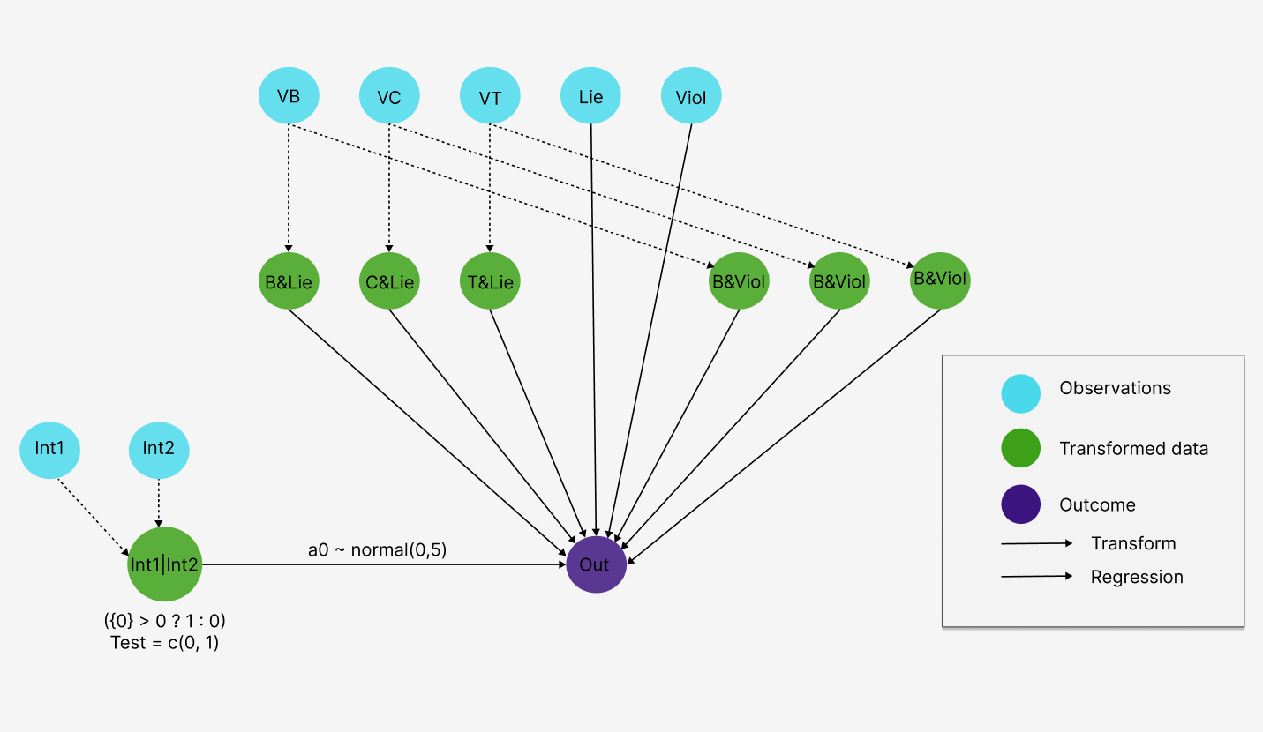

Figure 1: Object relationship model

Objects used:

Lie: does the main character lie

Viol: does the main character commit violent acts

VB: does the main character follow Buddhist values

VC: does the main character follow Confucian values

VT: does the main character follow Taoist values

Int1: is there an impact of supernatural elements

Int2: is there an impact of human elements

Out: the story ends happily for the main character

The assessment item assesses the influence of Confucianism, Taoism, and Buddhism on lying and violence. The relationships established are the influence of the three religions on the main character's lying and violent behavior as well as whether the main character follows the values of the three religions and the influence of supernatural elements and human elements.

Figure 2: Object relationship model in Rstudio

5.2 Model Indicators

Run by command

Summary(model)

|  |  |  |  |  |  |  |  |  |  |  |
| --- | --- | --- | --- | --- | --- | --- | --- | --- | --- | --- |
|  | nean | se_mean | sd | 2.5% | 25% | 50% | 75% | 97.5% | n_eff | Rhat |
| b_B_and_Viol_O | 0.34 | 0.01 | 0.75 | -1.11 | -0.17 | 0.32 | 0.83 | 1.85 | 12795 | 1 |
| b_C_and_Viol_O | 0.54 | 0.01 | 0.71 | -0.82 | 0.06 | 0.52 | 1.00 | 1.94 | 7823 | 1 |
| b_T_and_Viol_O | 0.72 | 0.01 | 0.58 | -0.42 | 0.33 | 0.72 | 1.11 | 1.88 | 7774 | 1 |
| b_Viol_O | -1.68 | 0.01 | 0.72 | -3.15 | -2.16 | -1.66 | -1.20 | -0.33 | 10741 | 1 |
| b_B_and_Lie_O | 1.18 | 0.01 | 1.13 | -0.87 | 0.40 | 1.13 | 1.88 | 3.57 | 16491 | 1 |
| b_C_and_Lie_O | 2.04 | 0.01 | 0.71 | 0.68 | 1.55 | 2.02 | 2.51 | 3.48 | 12282 | 1 |
| b_T_and_Lie_O | -0.13 | 0.01 | 0.76 | -1.63 | -0.64 | -0.12 | 0.39 | 1.36 | 5879 | 1 |
| b_Lie_O | -1.03 | 0.01 | 0.63 | -2.29 | -1.45 | -1.02 | -0.60 | 0.19 | 12056 | 1 |
| a_Int1_or_Int2[1] | 0.84 | 0.00 | 0.43 | 0.02 | 0.57 | 0.83 | 1.11 | 1.73 | 27760 | 1 |
| a_Int1_or_Int2[2] | 0.80 | 0.00 | 0.22 | 0.37 | 0.65 | 0.80 | 0.95 | 1.25 | 21598 | 1 |
| a0_Int1_or_Int2 | 0.80 | 0.02 | 1.39 | -2.35 | 0.38 | 0.81 | 1.24 | 3.84 | 4856 | 1 |
| sigma_Int1_or_Int2 | 1.61 | 0.02 | 1.86 | 0.06 | 0.35 | 0.92 | 2.19 | 6.89 | 5598 | 1 |

The results indicate that the model has converged effectively, with Rhat values close to 1 (values above 1.1 would be concerning) and n_eff consistently exceeding 2000 (values above 1000 are considered a strong indicator of convergence).

5.3 Code Stan

Để tạo code stan tự động cho mô hình như trên, ta chỉ cần gọi lệnh:

|  |
| --- |
| model_string <- bvl_model2Stan(model)  cat(model_string) |

Toàn bộ code stan được tao ra như sau:

functions{

  int numLevels(int[] m) {

     int sorted[num_elements(m)];

     int count = 1;

     sorted = sort_asc(m);

     for (i in 2:num_elements(sorted)) {

       if (sorted[i] != sorted[i-1])

          count = count + 1;

     }

     return(count);

  }

}

data{

  // Define variables in data

  int<lower=1> Nobs;   // Number of observations (an integer)

  int<lower=0,upper=1> O[Nobs];   // outcome variable

  int<lower=0,upper=1> Lie[Nobs];

  int<lower=0,upper=1> Viol[Nobs];

  int<lower=0,upper=1> VB[Nobs];

  int<lower=0,upper=1> VC[Nobs];

  int<lower=0,upper=1> VT[Nobs];

  int<lower=0,upper=1> Int1[Nobs];

  int<lower=0,upper=1> Int2[Nobs];

}

transformed data{

  // Define transformed data

  vector[Nobs] B_and_Viol;

  vector[Nobs] C_and_Viol;

  vector[Nobs] T_and_Viol;

  vector[Nobs] B_and_Lie;

  vector[Nobs] C_and_Lie;

  vector[Nobs] T_and_Lie;

  int Int1_or_Int2[Nobs];

  int NInt1_or_Int2;

  for (i in 1:Nobs) {

     Int1_or_Int2[i] = (Int1[i]+Int2[i] > 0 ? 1 : 0);

  }

  NInt1_or_Int2 = numLevels(Int1_or_Int2);

  for (i in 1:Nobs) {

     T_and_Lie[i] = VT[i]*Lie[i];

  }

  for (i in 1:Nobs) {

     C_and_Lie[i] = VC[i]*Lie[i];

  }

  for (i in 1:Nobs) {

     B_and_Lie[i] = VB[i]*Lie[i];

  }

  for (i in 1:Nobs) {

     T_and_Viol[i] = VT[i]*Viol[i];

  }

  for (i in 1:Nobs) {

     C_and_Viol[i] = VC[i]*Viol[i];

  }

  for (i in 1:Nobs) {

     B_and_Viol[i] = VB[i]*Viol[i];

  }

}

parameters{

  // Define parameters to estimate

  real b_B_and_Viol_O;

  real b_C_and_Viol_O;

  real b_T_and_Viol_O;

  real b_Viol_O;

  real b_B_and_Lie_O;

  real b_C_and_Lie_O;

  real b_T_and_Lie_O;

  real b_Lie_O;

  real a0_Int1_or_Int2;

  real<lower=0> sigma_Int1_or_Int2;

  vector[NInt1_or_Int2] u_Int1_or_Int2;

}

transformed parameters{

  // Transform parameters

  real theta_O[Nobs];

  vector[NInt1_or_Int2] a_Int1_or_Int2;

  // Varying intercepts definition

  for(k in 1:NInt1_or_Int2) {

     a_Int1_or_Int2[k] = a0_Int1_or_Int2 + u_Int1_or_Int2[k];

  }

  for (i in 1:Nobs) {

     theta_O[i] = b_B_and_Viol_O * B_and_Viol[i] + b_C_and_Viol_O * C_and_Viol[i] + b_T_and_Viol_O * T_and_Viol[i] + b_Viol_O * Viol[i] + b_B_and_Lie_O * B_and_Lie[i] + b_C_and_Lie_O * C_and_Lie[i] + b_T_and_Lie_O * T_and_Lie[i] + b_Lie_O * Lie[i] + a_Int1_or_Int2[Int1_or_Int2[i]+1];

  }

}

model{

  // Priors

  b_B_and_Viol_O ~ normal( 0, 10 );

  b_C_and_Viol_O ~ normal( 0, 10 );

  b_T_and_Viol_O ~ normal( 0, 10 );

  b_Viol_O ~ normal( 0, 10 );

  b_B_and_Lie_O ~ normal( 0, 10 );

  b_C_and_Lie_O ~ normal( 0, 10 );

  b_T_and_Lie_O ~ normal( 0, 10 );

  b_Lie_O ~ normal( 0, 10 );

  a0_Int1_or_Int2 ~  normal(0,5);

  sigma_Int1_or_Int2 ~  normal(0,5);

  u_Int1_or_Int2 ~ normal(0, sigma_Int1_or_Int2);

  // Likelihoods

  O ~ binomial_logit(1, theta_O);

}

generated quantities {

  // simulate data from the posterior

  int<lower=0,upper=1> yrep_O[Nobs];

  // log-likelihood posterior

  vector[Nobs] log_lik_O;

  int<lower=0,upper=1> yrep_Int1_or_Int2_1[Nobs];

  int<lower=0,upper=1> yrep_Int1_or_Int2_2[Nobs];

  for (i in 1:num_elements(yrep_O)) {

    yrep_O[i] = binomial_rng(O[i], inv_logit(theta_O[i]));

  }

  for (i in 1:Nobs) {

    log_lik_O[i] = binomial_logit_lpmf(O[i] | 1, theta_O[i]);

  }

  for (i in 1:Nobs) {

     yrep_Int1_or_Int2_1[i] = binomial_rng(O[i], inv_logit(b_B_and_Viol_O * B_and_Viol[i] + b_C_and_Viol_O * C_and_Viol[i] + b_T_and_Viol_O * T_and_Viol[i] + b_Viol_O * Viol[i] + b_B_and_Lie_O * B_and_Lie[i] + b_C_and_Lie_O * C_and_Lie[i] + b_T_and_Lie_O * T_and_Lie[i] + b_Lie_O * Lie[i] + a_Int1_or_Int2[1]));

  }

  for (i in 1:Nobs) {

     yrep_Int1_or_Int2_2[i] = binomial_rng(O[i], inv_logit(b_B_and_Viol_O * B_and_Viol[i] + b_C_and_Viol_O * C_and_Viol[i] + b_T_and_Viol_O * T_and_Viol[i] + b_Viol_O * Viol[i] + b_B_and_Lie_O * B_and_Lie[i] + b_C_and_Lie_O * C_and_Lie[i] + b_T_and_Lie_O * T_and_Lie[i] + b_Lie_O * Lie[i] + a_Int1_or_Int2[2]));

  }

}

5.4 Detect the number of cores of your CPU

Run by command

options(mc.cores = parallel::detectCores())

5.5 MCMC model

Run by command

bvl_trace(model)

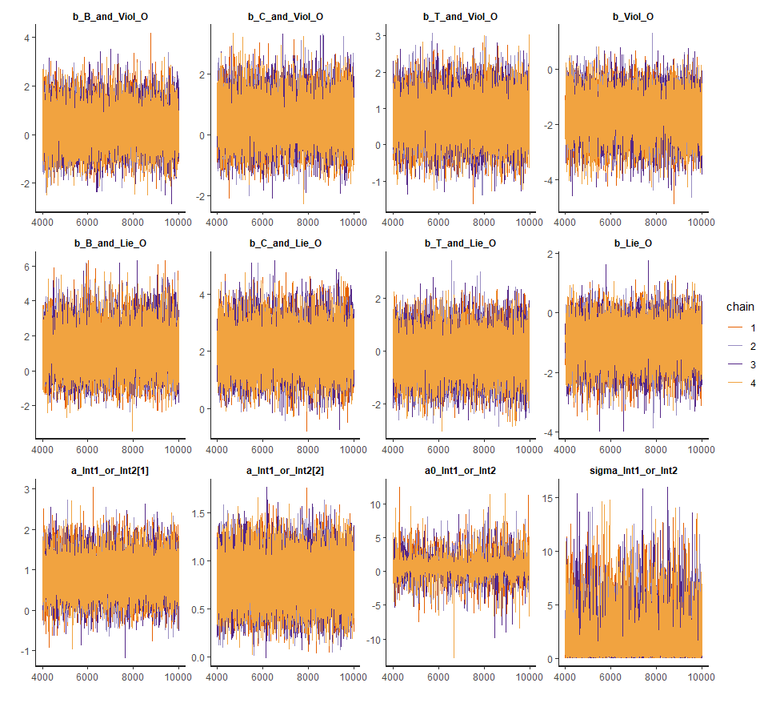

Figure 3: MCMC model

The lines of each series fluctuate around an average, with no discernible trend appearing (i.e., the series do not show a consistent upward or downward trend over time). The values of each series fluctuate randomly around an average without any definite patterns, which indicates that the sampling steps are good.

The convergence plot is important in assessing the stability and reliability of the results from the Bayesian model.

5.6 Rhat models

Run by command

bvl_plotGelmans(model, NULL, 4, 3)

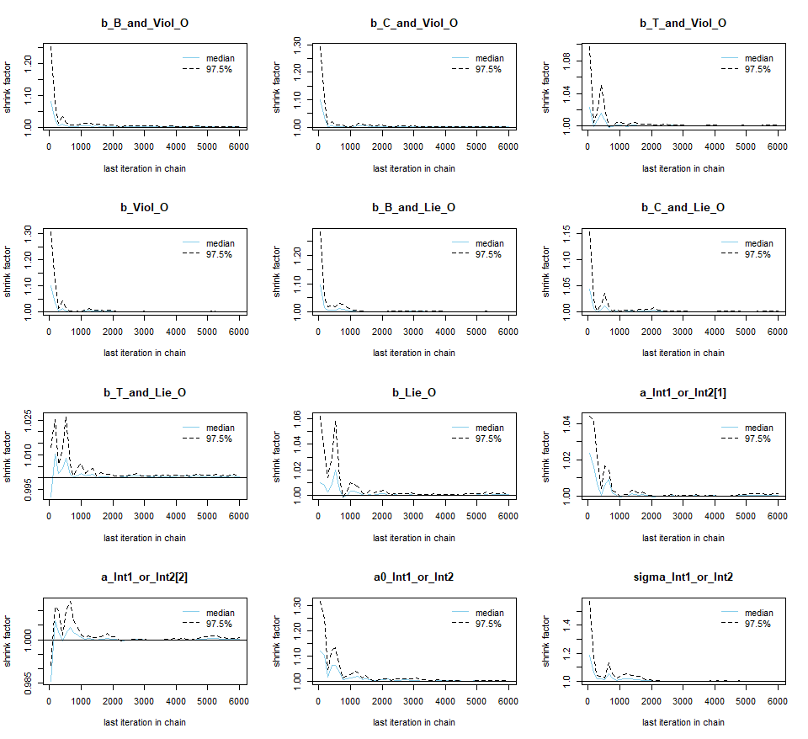

Figure 4: Rhat models

The image you provided shows plots tracking Rhat (sometimes called the shrink factor) against the number of iterations in the MCMC (Markov Chain Monte Carlo) chains. Rhat is a metric used to assess the convergence of a model, with an ideal value close to 1.

Good convergence: Most of the plots indicate that Rhat is very close to 1 after a few thousand iterations. This suggests that the MCMC chains have converged well.

Safe values: An Rhat value below 1.1 is a safe sign, indicating that the model parameters have stabilized and the independent chains have agreed on the estimated values.

Initial fluctuations: Some plots show slightly higher Rhat values in the early iterations, but these quickly drop below 1.1, which is normal during the convergence process.

Conclusion: Based on these plots, the model appears to have converged well, indicating that the model estimates are reliable.

5.7 Autocorrelation models

Run by command

bvl_plotAcfs(model, NULL, 4, 3)

Figure 5: Autocorrelation models

Autocorrelation plots for parameters in Markov Chain Monte Carlo (MCMC) sampling.

Low autocorrelation (lag): The plot shows that the autocorrelation drops rapidly to zero after a small lag. This shows that the samples taken in the MCMC chain are almost independent.

The higher the ESS, the more efficient the sampling process, meaning you get more independent samples from the MCMC chain.

Conclusion: This plot shows low lag correlation and efficient sampling through the ESS index.

5.8 Interval model

This chart gives an overview of the regression coefficients.

Run by command

bvl_plotIntervals (model)

Figure 6: Interval plot

The graph shows confidence intervals for parameters or predictions from the model, which are posterior intervals, representing the confidence level for estimated parameters sampled from the posterior distribution. If the data is negative, then one independent variable and one dependent variable will increase and one will decrease. If the value is positive, then both the independent variable and the dependent variable will increase.

For example, if marketing expenditure increases, then sales will increase, then the value is positive, and vice versa.

5.9 Param models

Figure 7: Param models

Run by command

bvl_plotParams(model, 4, 3)

The chart provided highlights several important points:

Good Convergence: The posterior probability distribution plots for the parameters show that most modes are close to the mean values, with relatively narrow HPDI intervals. This suggests that the parameters have converged well.

Safe Values: The 89% HPDI intervals are not too wide, and some parameters have HPDI intervals that do not include the value 0, indicating that they may be statistically significant and reliable values.

Initial Variability: Some parameters have HPDI intervals that include the value 0, suggesting that there may be variability or significant uncertainty regarding the effects of these parameters. This should be carefully considered when interpreting the results.

Conclusion: Based on the chart, some parameters indicate clear and statistically significant relationships (e.g., b_Viol_O), while others may require additional data or model adjustments to improve reliability.

5.10 Evaluate the lie factor group coefficients separately

Run by command

bvl_plotIntervals(model, c("b_B_and_Lie_O", "b_C_and_Lie_O", "b_T_and_Lie_O", "b_Lie_O"))

Figure 8: Lie Factor Rating Model

This chart shows that people whose actions or tendencies are related to Buddhism and Confucianism will tend to lie.

Taoism has a negligible or unclear correlation value in this case and the result is bad because the value is between -1 and 1. If the main character in the story is not influenced by the three religions, he or she will not tend to lie.

Figure 9: Density Model of the Three Religions and Lie

Run by command

bvl_plotDensity(model, c("b_B_and_Lie_O", "b_C_and_Lie_O", "b_T_and_Lie_O", "b_Lie_O"))

Preliminary results show that in general, lying does not lead to a good outcome for the protagonist. The negative b_Lie_O coefficient indicates that lying is contrary to the protagonist's happy outcome. This distribution is narrow, with a good confidence interval.

However, the combined coefficients when the protagonist lies but belongs to Buddhism and Confucianism are positive. When there is influence from Confucianism and Buddhism, the protagonist seems to have a happier ending, even if he lies. Of the three religions, Buddhism has the least influence on encouraging lying, the coefficient b_B_and_Lie_O is much smaller than the other two religions.

5.11 Evaluate the violence factor coefficients separately

Run by command

bvl_plotIntervals(model, c("b_B_and_Viol_O", "b_C_and_Viol_O", "b_T_and_Viol_O", "b_Viol_O"))

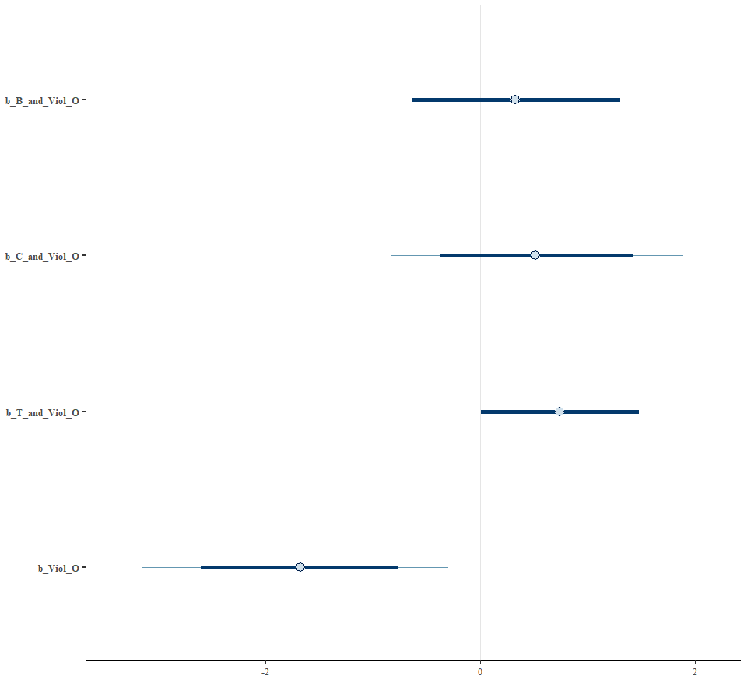

Figure 10: Viol Factor Rating Model

The chart shows that Buddhism and Confucianism do not tend to be strongly associated with violence, but Taoism does show values ​​that are associated with violence.

If the main character in the story is not influenced by the 3 religions, he or she will not tend to be violent.

Figure 11: Density Model of the Three Religions and Viol

Run by command

bvl_plotDensity(model, c("b_B_and_Viol_O", "b_C_and_Viol_O", "b_T_and_Viol_O", "b_Viol_O"))

The preliminary results show that in general, violence does not lead to a good ending for the protagonist. The negative b_Viol_O coefficient indicates that violence is contrary to the protagonist's happy ending. This distribution is narrow, with a good confidence interval.

However, the coefficients are combined when the protagonist is violent but belongs to 3 religions. When there is influence from Confucianism, Taoism and Buddhism, the protagonist seems to have a happier ending, even though he is violent.

Of the 3 religions, Buddhism has the least influence on encouraging violence, the coefficient b_B_and_Lie_O is smaller but not too much compared to the other 2 religions.

5.12 Evaluate the remaining factors

Correlation between violence and lying

bvl_plotDensity2d(model, "b_Lie_O","b_Viol_O")

Figure 12: Correlation between violence and lying

We see that both coefficients are negative, which tends to be opposite to the happy ending of the main character. Or we can say that when there is lying or violence, the main character tends to have a bad ending.

If we compare the correlation of these two coefficients, at the most concentrated range, the coefficient of violence is much weaker than lying, the influence of violence on the ending of the story is not much, while the factor of lying is much stronger.

The diagonal y = x shows the ideal case where b_Lie_O and b_Viol_O have equal values.

Most of the points are concentrated below this diagonal, which may imply that b_Viol_O tends to be smaller than b_Lie_O.

Figure 13: Correlation between violence of Buddhism and Confucianism

Run by command

bvl_plotDensity2d(model, "b_B_and_Viol_O", "b_C_and_Viol_O", color_scheme = "orange")

Both coefficients are negative, which tends to be opposite to the happy ending of the main character. Or when there is violence, the main character tends to have a bad ending. If we compare the correlation of these two coefficients, the coefficients of Confucianism and Buddhism have almost the same influence.

Figure 14: Correlation between violence of Buddhism and Taoism

Run by command

bvl_plotDensity2d(model, "b_B_and_Viol_O", "b_T_and_Viol_O", color_scheme = "orange")

The correlation coefficient between Buddhism and Taoism is that Taoism has a higher proportion of violence, but the similarity is that when the main character has a tendency to be violent, the ending is not happy.

Figure 15: Correlation between violence of Confucianism and Taoism

Run by command

bvl_plotDensity2d(model, "b_C_and_Viol_O", "b_T_and_Viol_O", color_scheme = "skyblue")

The correlation coefficient between Confucianism and Taoism shows that Taoism has a higher proportion of violence, but the similarity is that when the main character has a tendency to be violent, the ending is not happy.

Figure 16: Correlation between lying of Confucianism and Taoism

Run by command

bvl_plotDensity2d(model, "b_B_and_Lie_O", "b_C_and_Lie_O", color_scheme = "skyblue")

The Buddhist and Confucian factors have the same sign in the mean concentration interval, however the coefficient of Buddhism is very small, the distribution interval is almost between negative and positive. It can be seen that Buddhism does not support the lying factor clearly. On the contrary, the Confucian factor combined with lying has a strong positive coefficient, the entire 95% confidence interval is in the positive coefficient.

Figure 17: Correlation between lying of Buddhism and Taoism

Run by command

bvl_plotDensity2d(model, "b_B_and_Lie_O", "b_T_and_Lie_O", color_scheme = "orange")

In this chart, the value of Buddhism tends to lie more than that of Taoism. Although Buddhism tends to encourage not lying.

Elements of the three religions together when combined with the element of violence.

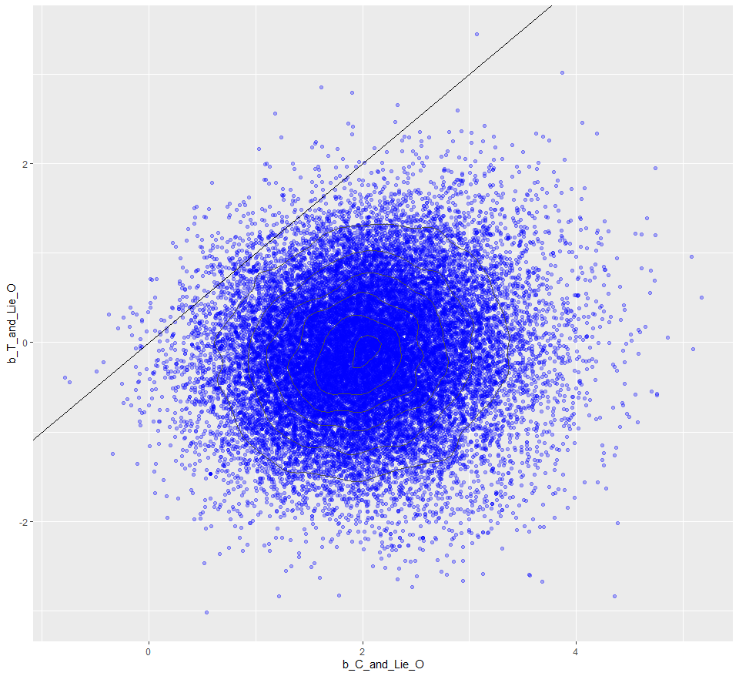

Figure 18: Correlation between lying of Confucianism and Taoism

Run by command

bvl_plotDensity2d(model, "b_C_and_Lie_O", "b_T_and_Lie_O", color_scheme = "blue")

This chart shows that Confucian values are absolutely superior to Taoism in terms of lying behavior.

Figure 19: Impact and no impact model of int 1

Run by command

bvl_plotTest(model, "O", "Int1_or_Int2_1")

Figure 20: Impact and no impact model of int 2

Run by command

bvl_plotTest(model, "O", "Int1_or_Int2_2")

Comparison with and without impact:

Code test outcome with and without external factors affecting (see predict section) gives us 2 y_rep distribution graphs above.

It can be seen that these 2 graphs are quite similar, the story outcome is not much different with or without external factors.

Correlation of supernatural element (int1) and human element (int2)

Figure 21: Param model of Correlation of supernatural element (int1) and human element (int2)

Run by command

bvl_plotDensity(model, c("a_Int1_or_Int2[1]", "a_Int1_or_Int2[2]"), labels = c("a_Int1_or_Int2[0]", "a_Int1_or_Int2[1]"))

We can see the influence of Int2 (human factor) has a higher influence rate than Int1 (supernatural factor).

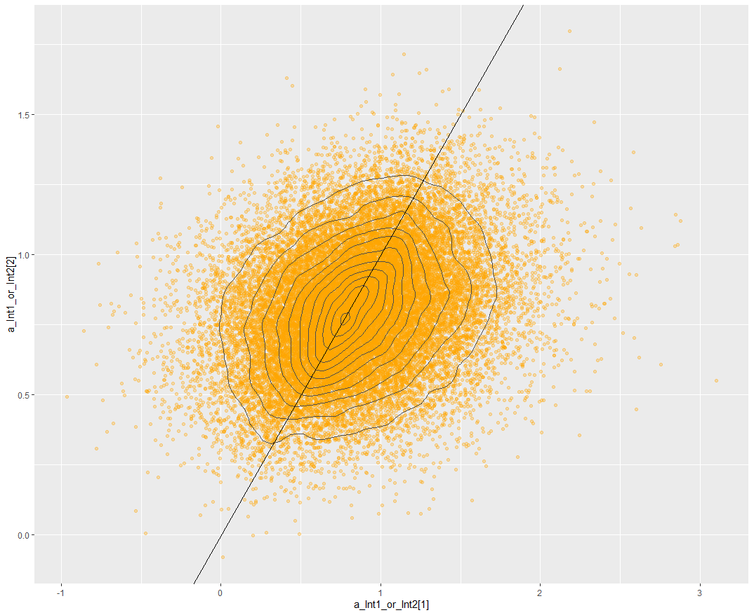

Figure 22: Correlation of supernatural element (int1) and human element (int2)

Run by command

bvl_plotDensity2d(model, "a_Int1_or_Int2[1]", "a_Int1_or_Int2[2]", color_scheme = "orange", labels = c("a_Int1_or_Int2[1]", "a_Int1_or_Int2[2]"))

The correlation of the graph is divided into 2 halves, but Int2 (human factor) has a higher average value because the value increases from 0 and above with a higher proportion than Int1 (supernatural factor).

In general, we can conclude that the ending of the story is often affected by human factors. From this, we can understand that the influence of Confucianism is obvious on the ending of the story.

CHAPTER 6: CONCLUSION

6.1 Similarities to the Original Article

This study further contributes to the growing body of interdisciplinary research by integrating knowledge across various fields. By reaffirming the existence of cultural additivity, our findings align closely with the conclusions of the original article. The dataset used in this study also served as a basis for two previous studies on cultural additivity and violence-lie, demonstrating the robustness and versatility of the data. Additionally, this research combines insights from social sciences, psychology, and mathematics, offering a more comprehensive understanding of Vietnam's historical context. Furthermore, the study strengthens the connection between culture and the arts, emphasizing the importance of cultural narratives in shaping societal values.

6.2 New Insights from the Research

This research introduces several novel findings. First, the collection and utilization of data derived from Vietnamese folktales provide a unique lens through which to examine cultural and religious influences. The study reveals the impact of various religions mentioned in these folktales, highlighting their role in shaping cultural narratives. Additionally, it identifies other factors that influence cultural development, offering new perspectives on the intricate relationship between religion and culture in Vietnamese society.

6.3 Future Directions for the Study

Moving forward, the study can be expanded by incorporating Propp's Morphology Theory, providing a structural analysis of the folktales and deepening the understanding of their narrative patterns. Additionally, integrating psychoanalytic theories could offer further insights into the subconscious cultural messages embedded within these stories. The research can also be applied to other countries, exploring the cultural values beyond the three main religions (Buddhism, Taoism, and Confucianism) to include indigenous Vietnamese values, socialism, and cultural influences from Korea, Japan, Thailand, and Western liberal values.

Moreover, future studies could delve deeper into the dataset by exploring unused variables, allowing for more in-depth and valuable research. This expansion would not only enhance the current findings but also contribute to a more nuanced understanding of cultural and religious influences in a broader context.

REFERENCES

1. [**Quan-Hoang Vuong**](https://www.researchgate.net/scientific-contributions/Quan-Hoang-Vuong-80926032?_tp=eyJjb250ZXh0Ijp7ImZpcnN0UGFnZSI6InB1YmxpY2F0aW9uIiwicGFnZSI6InB1YmxpY2F0aW9uIn19), [**Viet-Phuong La**](https://www.researchgate.net/profile/Viet-Phuong-La?_tp=eyJjb250ZXh0Ijp7ImZpcnN0UGFnZSI6InB1YmxpY2F0aW9uIiwicGFnZSI6InB1YmxpY2F0aW9uIn19), [**Trung Tran**](https://www.researchgate.net/profile/Trung-Tran-62?_tp=eyJjb250ZXh0Ijp7ImZpcnN0UGFnZSI6InB1YmxpY2F0aW9uIiwicGFnZSI6InB1YmxpY2F0aW9uIn19), [**Minh-Hoang Nguyen**](https://www.researchgate.net/profile/Minh-Hoang-Nguyen-4?_tp=eyJjb250ZXh0Ijp7ImZpcnN0UGFnZSI6InB1YmxpY2F0aW9uIiwicGFnZSI6InB1YmxpY2F0aW9uIn19) “Bản hòa tấu dữ liệu xã hội” July 2021. [Online].

Available: [**https://osf.io/preprints/osf/9jreq**](https://osf.io/preprints/osf/9jreq)

[2] Quan-Hoang Vuong, Quang-Khiem Bui, Viet-Phuong La, Thu-Trang Vuong, Viet-Ha T. Nguyen, Manh-Toan Ho, Hong-Kong T. Nguyen & Manh-Tung Ho, “Cultural additivity: behavioural insights from the interaction of Confucianism, Buddhism and Taoism in folktales” 04 December 2018 [Online] Available:

<https://www.nature.com/articles/s41599-018-0189-2>

[3] ThS. Nguyễn Thị Hiền - GV Khoa Xây dựng Đảng, “Tam giáo đồng nguyên”[Online]

Available:

<https://www.truongchinhtrikontum.org.vn/tim-hieu-hien-tuong-tam-giao-dong-nguyen-o-viet-nam-thoi-ly-tran>

[4] “Acculturation”

Available:

<https://vi.wikipedia.org/wiki/Ti%E1%BA%BFp_bi%E1%BA%BFn_v%C4%83n_h%C3%B3a>

[5] Quan-Hoang Vuong, Manh-Tung Ho, Hong-Kong T. Nguyen, Thu-Trang Vuong, Trung Tran, Khanh-Linh Hoang, Thi-Hanh Vu, Phuong-Hanh Hoang, Minh-Hoang Nguyen, Manh-Toan Ho & Viet-Phuong La “On how religions could accidentally incite lies and violence: folktales as a cultural transmitter” 04 May 2020 [Online]

Available: <https://www.nature.com/articles/s41599-020-0442-3>

[6] Wikipedia “Tiếp biến văn hóa” [Online]

Available: <https://vi.wikipedia.org/wiki/Ti%E1%BA%BFp_bi%E1%BA%BFn_v%C4%83n_h%C3%B3a>

[7] Wikipedia “Cộng tính văn hóa” [Online]

Available: <https://vi.wikipedia.org/wiki/C%E1%BB%99ng_t%C3%ADnh_v%C4%83n_h%C3%B3a>

[8] Wikipedia “Định lý Bayes” [Online]

Available: <https://vi.wikipedia.org/wiki/%C4%90%E1%BB%8Bnh_l%C3%BD_Bayes>.

[9] Library BaiyesVL [Online]

Available:

<https://github.com/sshpa/bayesvl/tree/master>

<https://osf.io/8f7rm/>

<https://osf.io/zcsfq>

<https://dataverse.harvard.edu/file.xhtml?persistentId=doi:10.7910/DVN/QKGBSE/MVHXUF&version=1.0&toolType=PREVIEW>

<https://www.nature.com/articles/s41599-020-0442-3>

[10] Richard McElreath “Statistical Rethinking” December 21, 2015 [Online]

Available: <https://xcelab.net/rm/>

[11] Robert E. Buswell, Jr., Donald S. Lopez, Jr. “The Princeton Dictionary of Buddhism” November 24, 2013 [Online]

Available:

<https://press.princeton.edu/books/hardcover/9780691157863/the-princeton-dictionary-of-buddhism?srsltid=AfmBOopArBJPEygRKSk3qzczkPQpEF03MCQ5WqwEznrniUZpXhCovaWj>

[12] Fabrizio Pregadio “The Encyclopedia of Taoism” 2007 [Online]

Available: <https://www.taylorfrancis.com/books/mono/10.4324/9780203695487/encyclopedia-taoism-fabrizio-pregadio>

[13] Nguyễn Đổng Chi “Kho tàng truyện cổ tích Việt Nam - Quyển I (Tập I - Tập II - Tập III)” 1975 [Online]

Available :

<https://archive.org/details/khotangtruyencotichvietnam_quyen1/mode/2up>

[14] Nguyễn Đổng Chi “Kho tàng truyện cổ tích Việt Nam - Quyển II (Tập IV - Tập V)” 1975 [Online]

Available: : <https://archive.org/details/khotangtruyencotichvietnam_quyen2/page/1557/mode/2up>

[15] Fr.Joseph Tân Nguyễn, OFM “Tôn giáo qua nhãn quan tâm lý học(I) Freud & Jung” 2023 [Online]

Available : <https://www.hvanphongso.edu.vn/2023/03/ton-giao-qua-nhan-quan-tam-ly-hoc-i-freud--jung.html>

[16] Ngô Thanh Quý "Dấu ấn tự sự trong hình thái học truyện cổ tích của V. I.A Propp" [Online]

Available: <https://s2.monhoc.vn/web/viewer.html?file=https://s2.monhoc.vn/q7RSWKxtJFmt12KY/demo/2021/11/10/dau_an_tu_su_trong_hinh_thai_hoc_truyen_co_tich_cua_via_prop_spmwdwb2MB.png>