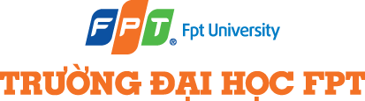

CAPSTONE PROJECT REGISTER

Class: Duration time: from 5/9/2025. To 5/11/2025
(*) Profession: <Software Engineer> Specialty: <ES> <IS> <JS>

x

(*) Kinds of person make registers: Lecturer Students
x

1. Register information for supervisor (if have)
 | Full name | Phone | E-Mail | Title
Supervisor | THÂN THỊ NGỌC VÂN |  | VanTTN2@fe.edu.vn | Mrs.
2. Register information for students (if have)
 | Full name | Student code | Phone | E-mail | Role in Group
3. Register content of Capstone Project
(*) 3.1. Capstone Project name:
- English: Developing a Personal Website for a Beauty Blogger to mange Brand Collaborations (B-ShowSell)
- Vietnamese: Xây dựng một website theo dõi sự hợp tác của một beauty blogger với các nhãn hàng trên nền tảng mạng xã hội.
Context:
Currently, in Vietnam, there are many people working as beauty bloggers. They are individuals with a large following and high engagement on social media platforms. The main job of these bloggers is to write blog posts or upload videos to review products from various brands, thereby increasing product visibility and helping the brands sell more products. Ms. Trinh is a Vietnamese beauty blogger with a large following on Facebook and TikTok. She works in the beauty industry, writing blog posts about beauty-related topics. In addition, her work and her team’s work involve collaborating with brands to promote beauty products to her large audience on ocial media platform.
Currently, she and her team need a web-based system with two main features:
1)Tracking collaboration work with brands
2) Selling brand products directly on the system.
Details of a beauty blogger’s work are as follows:
1) Collaboration with brands:There are several forms of collaboration
- Advertising: Brands pay the beauty blogger to review or introduce products in videos or post.
- Affiliate marketing: The blogger shares product purchase links on the website/Facebook. For each product sold via the link, she earns a commission.
- Brand ambassador: Becoming the face of a beauty or skincare brand.
- Co-producing limited editions: Collaborating with cosmetic brands to release a limited-edition product bearing her name.
2) Selling brand products: an website is required to sell the beauty products directly.
Below is the revenue flow chart for collaboration and sales:
[Content Idea] [post Video / post blog]

[Post on social media / Website]

┌────────────────┼────────────────┐
▼ ▼ ▼
Advertising Affiliate Link Product Sales

Advertising Revenue Commission Sales Profit

[Total Income]
.
Proposal solution
Build a website for a beauty blogger to support in managing brand collaborations and selling products in the beauty industry within the Vietnamese market. This website will support two main features:
- Collaborating with brands to advertise products, write blog posts/videos with embedded affiliate links to products. When customers click these links, they will be redirected to a product page on e-commerce platforms like Shopee, Lazada, etc.
- Selling beauty products online directly on the website.
User roles and their functions in the system:
Admin:
- Manage configuration settings for system operation.
- Manage users.
- Generate reports and statistics for all data in the system: income reports from advertising, affiliate links, sales; order-related statistics.
- Manage brand information, commission rates from brands, and campaigns with brands. The system should connect with a calendar to remind of collaboration milestones.
- Post Advertising articles to the website, and then the system will automatic posting to social media: Integrate Facebook/Tiktok APIs to automatically post content promoting new products.
- Provide a collaboration KPI analysis dashboard:
- Total number of collaboration campaigns (by month/quarter/year).
- Number of posts / promotional videos per campaign.
- Total reach/impressions across the channel
- Most effective channel (top social media platform).
- Number of likes, comments, shares per campaign.
- Click-through rate (CTR) for promotional links.
Below is a suggested chart for the statistics table in the dashboard
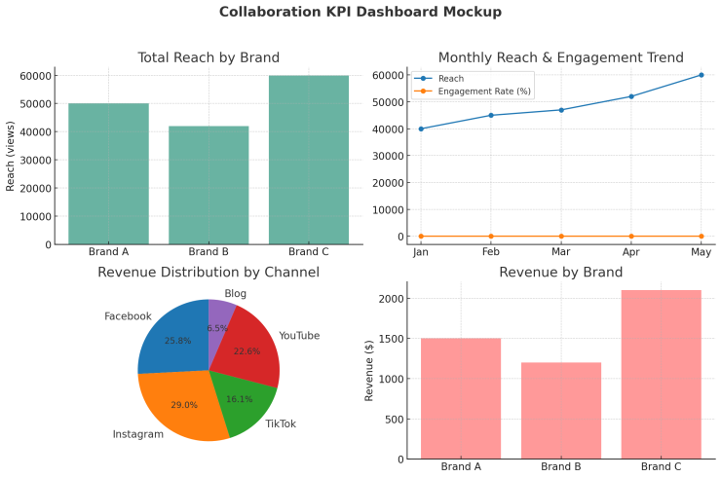
Staff:
- Manage products listed for sale on the website.
- Manage customer orders.
- View order-related reports and statistics.
Customer:
- View products on the website.
- Purchase products on the website.
- Review products.

(*) 3.2. Main proposal content (including result and product)
Theory and practice (document):
Students should apply the software development process and UML 2.0 in the modeling system.
The documents include User Requirements, Software Requirement Specification, Architecture Design, Detail Design, System Implementation and Testing Document, Installation Guide, sources code, and deployable software packages
Server-side technologies:
  - Server: ASP.NET Core API, Firebase or other suitable technologies
  - Database System: SQL Server/ Mongo DB or other suitable technologies
- Client-side technologies: suitable technologies
Products:
Web-app for roles: staff, admin
Mobile-app for customers
Proposed Tasks for Students:
- Task package 1: Develop the API for the system.
- Task package 2:Develop the API for Admin
- Task package 3:Develop the API for Customer
- Task package 4:Develop the API for Staff
- Task package 5: Build – Deploy and Test the system.
- Task package 6: Prepare all the required documents: System analysis and design, test plan, installation manual, and user manual.
- Notice: all students are required to understand the reference documents thoroughly and may need to explain to the viva committee.
- All above features are only basic information. The team needs to analyze more requirements so the product can be used easier.
4. Other comments (propose all relative things if have)

Supervisor (If have)  (Sign and full name) | HCM, date 13/8/2025  On behalf of Registers  (Sign and full name)
Thân Thị Ngọc Vân

