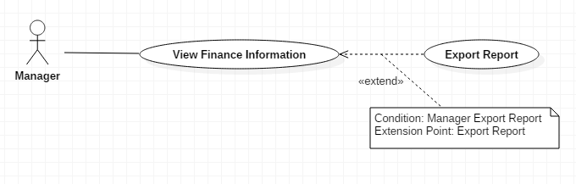

|  |  |  |  |
| --- | --- | --- | --- |
| USE CASE – M01 | | | |
| Use Case No. | M01 | **Use Case Version** | 1.0 |
| Use Case Name | View Finance Information | | |
| Author | AnhLT | | |
| Date | 27/09/2015 | **Priority** | Medium |
| Actor:   * Manager.   Summary:   * This use case shows finance information of student.   Goal:   * User view list all finance information of student.   Triggers:   * User send command View finance Information.   Preconditions:   * User must login into the system with role manager.   Post Conditions:   * Success: Show the list finance information of student to the user. * Fail: Show error message.   Main Success Scenario:   |  |  |  | | --- | --- | --- | | Step | Actor Action | System Response | | 1 | User go to view list of tuitions fees | List finance information of student will be shown with following information :   * Number * Name of student * Type of student * Type of tuition * The money student must pay * The money student has paid * Pay status * A link to “Finance Information Detail” | | 2 | User select student to view detail finance information | The student finance detail will be shown with following information :   * Student name * Student code * Type of student * List of terms student payed tuition fees for. Display will show some information:   + Required amount   + Amount paid   + Time paid | | 3 | User send command “export report” to system | System send response to user report. |   Alternative Scenario 1:   |  |  |  | | --- | --- | --- | | Step | Actor Action | System Response | | 1 | User go to view list credit loans student | List credit loans student will be shown with following information :   * Number * Student code * Name of student * Type of student * Study status of student (studying or graduated) * Student loan amount * Interest arising * Total * Detail : link to finance information of student | | 2 | User select student to view detail finance information | The student finance detail will be shown with following information :   * Student code * Name of student * Status * Amount paid * Time paid: date time * Debit * Interest | | 3 | User send command “export report” to system | System send response to user report. |   Alternative Scenario 2:   |  |  |  | | --- | --- | --- | | Step | Actor Action | System Response | | 1 | User go to view list “invest with you” | List “invest with you” student will be shown with following information :   * Number * Student code * Name of student * Type of student * Study status of student (studying or graduated) * A link to finance information of student | | 2 | User select student to view detail finance information | The student finance detail will be shown with following information :   * Student code * Name of student * Type of student * Amount paid * Time paid: date time * Status * Bank name | | 3 | User send command “export report” to system | System send response to user report. |   Alternative Scenario 2:   |  |  |  | | --- | --- | --- | | No | Actor Action | System Response | | 1 | There are no data | Show message to notify that there are no data. |   Exceptions: N/A  Relationships: N/A  Business Rules:   * The information is loaded from the system. * Tuition list is sorted per term. * Search bar on the top help user finding information of student faster. * Pagination must be displayed if number of student larger than 10. | | | |

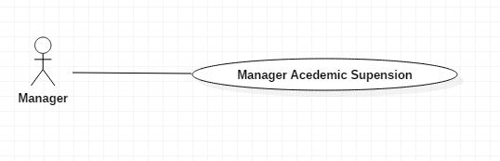

|  |  |  |  |
| --- | --- | --- | --- |
| USE CASE – M01 | | | |
| Use Case No. | M01 | **Use Case Version** | 2.5 |
| Use Case Name | Manage Management | | |
| Author | AnhLT | | |
| Date | 27/09/2015 | **Priority** | Medium |
| Actor:   * Manager.   Summary:   * This use case shows information of student academic suspension.   Goal:   * User view list all information of student.   Triggers:   * User send command Manager Student.   Preconditions:   * User must login into the system with role manager.   Post Conditions:   * Success: Show the list information of student to the user. * Fail: Show error message.   Main Success Scenario:   |  |  |  | | --- | --- | --- | | Step | Actor Action | System Response | | 1 | User go to list academic suspension | List academic suspension student will be shown with following information :   * Student code * Student name * Term * Status (paid yes or no) * A link to finance information of student   [Alternative 1] | | 2 | User select student to view detail finance information | The student finance detail will be shown with following information :   * Student name * Student code * Status * Term * Suspension time: date time | | 3 | User send command “export report” to system | System send response to user report. |   Alternative Scenario 1:   |  |  |  | | --- | --- | --- | | No | Actor Action | System Response | | 1 | There are no data | Show message to notify that there are no data. |   Exceptions: N/A  Relationships: N/A  Business Rules:   * The information is loaded from the system. * Academic suspension student is sorted by MSSV. * Search bar on the top help user finding information of student faster. * Pagination must be displayed if number of student larger than 10. | | | |

