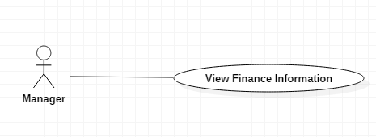

|  |  |  |  |
| --- | --- | --- | --- |
| USE CASE – M01 | | | |
| Use Case No. | M01 | **Use Case Version** | 2.5 |
| Use Case Name | Manage Management | | |
| Author | AnhLT | | |
| Date | 27/09/2015 | **Priority** | Medium |
| Actor:   * Manager.   Summary:   * This use case shows information of student.   Goal:   * User view list all information of student.   Triggers:   * User send command Manager Student.   Preconditions:   * User must login into the system with role manager. * There is at least 01 people in list of the system.   Post Conditions:   * Success: Show the list information of student to the user. * Fail: Show error message.   Main Success Scenario:   |  |  |  | | --- | --- | --- | | Step | Actor Action | System Response | | 1 | User send command to “xem danh sách đóng học phí” | System show information to manager:   * “MSSV”: text * “Họ và tên”: text * “Ngày đóng tiền”: text * “Số tiền phải đóng”: text * “Số tiền đã đóng”: text * “Nội dung”: text * “Hỗ trợ”: text * “Trạng thái”: text   [Alternative 1,2] | | 2 | User send command “chi tiết” student | Show message information of student have tuition per term. |   Alternative Scenario 1:   |  |  |  | | --- | --- | --- | | Step | Actor Action | System Response | | 1 | User send command to “Xem danh sách vay tín dụng” | System show information to manager:   * “MSSV”: text * “Họ và tên”: text * “Đã vay”: text * “Lãi xuất”: text * “Tổng cộng”: text * “Trạng thái”: text (trả tín dụng hay chưa) | | 2 | User send command “chi tiết” student | Show message information of student have credit loan. |   Alternative Scenario 2:   |  |  |  | | --- | --- | --- | | No | Actor Action | System Response | | 1 | There are no data | Show message to notify that there are no data. |   Exceptions: N/A  Relationships: N/A  Business Rules:   * The information is loaded from the system. * Tuition list is sorted per term. * Credit loan is sorted by MSSV. * Search bar on the top help user finding information of student faster. * Pagination must be displayed if number of student larger than 10. | | | |

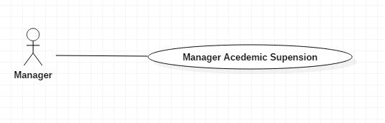

|  |  |  |  |
| --- | --- | --- | --- |
| USE CASE – M01 | | | |
| Use Case No. | M01 | **Use Case Version** | 2.5 |
| Use Case Name | Manage Management | | |
| Author | AnhLT | | |
| Date | 27/09/2015 | **Priority** | Medium |
| Actor:   * Manager.   Summary:   * This use case shows information of student academic suspension.   Goal:   * User view list all information of student.   Triggers:   * User send command Manager Student.   Preconditions:   * User must login into the system with role manager. * There is at least 01 people in list of the system.   Post Conditions:   * Success: Show the list information of student to the user. * Fail: Show error message.   Main Success Scenario:   |  |  |  | | --- | --- | --- | | Step | Actor Action | System Response | | 1 | User send command to “Xem danh sách sinh viên tạm ngưng học” | System show information to manager:   * “MSSV”: text * “Họ và tên”: text * “Học kỳ”: text * “Trạng thái”: text (trả tín dụng hay chưa).   [Alternative 1] | | 2 | User send command “chi tiết” student | Show message information of “sinh viên tạm ngưng học”. |   Alternative Scenario 1:   |  |  |  | | --- | --- | --- | | No | Actor Action | System Response | | 1 | There are no data | Show message to notify that there are no data. |   Exceptions: N/A  Relationships: N/A  Business Rules:   * The information is loaded from the system. * “sinh viên tạm ngưng học” is sorted by MSSV. * Search bar on the top help user finding information of student faster. * Pagination must be displayed if number of student larger than 10. | | | |