1. **Danh sach thu hoc phi**

|  |  |  |  |  |  |  |  |  |
| --- | --- | --- | --- | --- | --- | --- | --- | --- |
| STT | MSSV | HO VA TEN | TRANG THAI | NOI DUNG NOP TIEN | PHAI DONG | DA DONG | TINH TRANG | CHI TIET |
| 1 | SE60882 | Ho Doan Trung | TD50 | Chuyen nganh 9 | 24.000.000 | 23.000.000 | Thieu | Chi tiet |
| 2 | SE60883 | Tran Khac Vy | HB NVD | Chuyen nganh 9 | 0 | 0 | Du | Chi tiet |
| 3 | SE60884 | Le Tuan Anh | BT | Chuyen nganh 9 | 24.000.000 | 24.000.000 | Du | Chi tiet |
| 4 | SE60885 | Nguyen Anh Khoa | BT | Chuyen nganh 9 | 24.000.000 | 23.000.000 | Thieu | Chi tiet |

**Tong Ket:**

|  |  |
| --- | --- |
| Du Toan Thu | 500.000.000 (VND) |
| Tong So Tien Da Thu | 498.000.000 (VND) |
| Thieu | 2.000.000 (VND) |
| Tong So Tien Cho Vay | 202.000.000 (VND) |

CHI TIET

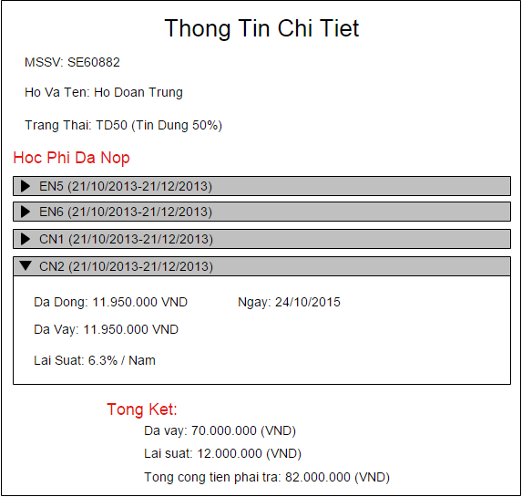

1. **Danh sach sv vay tin dung**

|  |  |  |  |  |  |  |  |  |
| --- | --- | --- | --- | --- | --- | --- | --- | --- |
| STT | MSSV | HO VA TEN | TRANG THAI | TINH TRANH | DA VAY | LAI SUAT | TONG CONG | CHI TIET |
| **1** | SE60882 | Ho Doan Trung | TD50 | Dang Hoc | 67.000.000 | 5.000.000 | 72.000.000 | Chi tiet |
| **2** | SE60883 | Tran Khac Vy | TD70 | Da Tot Nghiep | 67.000.000 | 5.000.000 | 72.000.000 | Chi tiet |
| **3** | …. | …. | … |  |  |  |  |  |

**Tong Ket:**

|  |  |
| --- | --- |
| **Tong Tien Da Cho Vay** | 180.000.000 (VND) |
| **Lai Suat** | 25.000.000 (VND) |
| **Tong Cong** | 205.000.000 (VND) |

1. **Danh sach sv tam ngung hoc**

|  |  |  |  |  |  |
| --- | --- | --- | --- | --- | --- |
| **STT** | **MSSV** | **HO VA TEN** | **TRANG THAI** | **LY DO** | **CHI TIET** |
| 1 | SE60882 | Ho Doan Trung | DANG NGUNG HOC | Bi Dinh Chi | Chi tiet |
| 2 | SE60883 | Tran Khac Vy | DANG NGUNG HOC | Khong Hoan Thanh Hoc Phi | Chi tiet |
| 3 | …. | …. |  |  |  |