1. ???
2. **System Requirement Specification**
   1. **External Interface Requirement**
      1. **User Interface**

* General requirement for graphics user interface is the GUI should be simple, clear, intuitive, and reminiscent.
* The interface design is an iterate process includes: design, sketching, prototyping, user assessment.
* Some design principles will be taken into consideration:
* UI for businesss web applications - Janko Jovanovic [Ref:http://www.smashingmagazine.com/2010/02/25/designing-user-interfaces-forbusiness-web-applications/]
* Ten principles of effective web design – Vitaly Friedman [Ref:http://www.smashingmagazine.com/2008/01/31/10-principles-of-effective-webdesign/]
  + 1. **Hardware Interface**
* N/A
  + 1. **Software Interface**
* Web application: work with Firefox (v30 or above), Chromes (v14 or above), Internet Explorer (v10 or above) browse.
  + 1. **Communication Protocol**
* Use HTTP protocol 1.1 for communication between the web browser and the web server.
  1. **System Overview Use Case**
  2. **List of Use Case**
     1. 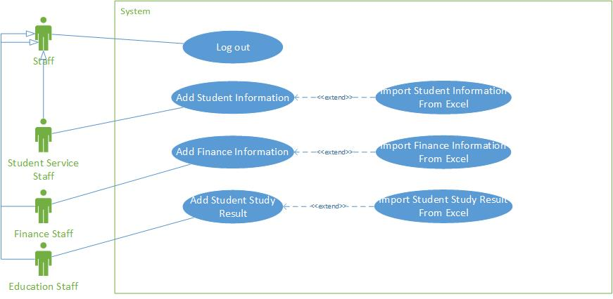**<Staff> Overview Use Case**

**Figure: <Staff> Overview Use Case**

* + - 1. 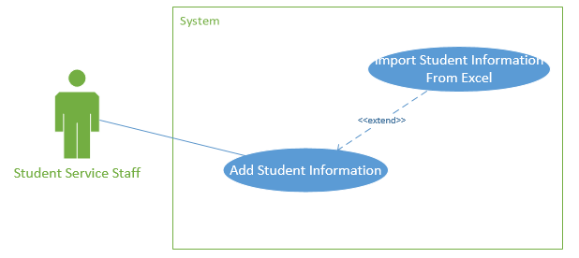**<Student Service Staff>Add Student Information Use Case Diagram**

**Figure: <Student Service Staff> Add Student Information Use Case**

|  |  |  |  |
| --- | --- | --- | --- |
| **USE CASE -** STAFF01 | | | |
| **Use Case No.** | STAFF01 | **Use Case Version** | 1.0 |
| **Use Case Name** | Add Student’s Information | | |
| **Author** | Ho Doan Trung | | |
| **Date** | 25/09/2015 | **Priority** | High |
| **Actor:**   * Student Service Staff   **Summary:**   * This use case allows staff enter list of student into the system   **Goal:**   * Allow staff enters student list. List of new students will be added to the system.   **Triggers:**   * The staff will select function to enter student information.   **Preconditions:**   * Staff login to the system with the rights of the Student Service Staff   **Post Conditions:**   * Success: The system will add list of student and notify it was added successfully * Fail: There is no list were added and the system will display error messages to the staff.   **Main Success Scenario:**   |  |  |  | | --- | --- | --- | | **Step** | **Actor Action** | **System Response** | | 1 | Staff will log in to site and enter student’s information | The system will return:   * Page displayed data in order to add or edit information. * Page allows staff to enter excel file. | | 2 | If staff sends command "add information" in page displays the data to the system. | The system will display the table include::   * Full name: Free text input * Sex: Radio button * Student ID: Free text input * Date of birth: Date * Address: Free text input * Email: email text input * Date admission: Date * Semester begin: Date * Compulsory English class: Drop down list * Supported: Number input * Parent’s phone number: Number input * Parent’s email: email text input | | 3 | Staff will enter new information and send command "Add" to the system. | The system will add new information and notify it was added successfully | | 4 | In addition, in the page displays data, staff can choose one line in the table and then send command "Update" to the system to update information. | The system will display a table allows staff to edit information from the selected line include:   * Full name: Free text input * Sex: Radio button * Student ID: Free text input * Date of birth: Date * Address: Free text input * Email: email text input * Date admission: Date * Semester begin: Date * Compulsory English class: Drop down list * Supported: Number input * Parent’s phone number: Number input * Parent’s mail: email text input | | 5 | Staff can choose the information they need to be updated to edit and then send the command "Update" to the system. | The system will update new information and notify it was added successfully. | | 6 | If staff send command ”download excel template” on website to enter excel page | The system will allow employees to download the Excel template available. | | 7 | If staff send command “Import file excel” to system. | The system will display interface allows staff to upload excel files directly from your computer to the system. | | 8 | Staff select files to upload and then send the command "Upload" to the system. | The system will add data about learning results then notify it was “added successfully”. |   **Alternative Scenario:**   |  |  |  | | --- | --- | --- | | **Step** | **Actor Action** | **System Response** | | 1 | Staff enter information in the wrong format. | The system informs error |   **Exceptions:**   |  |  |  | | --- | --- | --- | | **Step** | **Actor Action** | **System Response** | | 1 | Length of “Full name” is not in range. | Show error message: “Full name” length must be from 6 to 30 characters!” | | 2 | “Sex” is not specified. | Show error message: “Sex” must be selected!” | | 3 | “Email” is wrong format. | Show error message: “”Email” must be formatted abc@example.fpt.edu.vn!” | | 4 | “Parent’s number” is wrong format. | Show error message: “Parent’s number is the number and length from 8-11 characters!” | | 5 | “Parent’s email” is wrong format. | Show error message: “Parent’s email must be formatted abc@example.com” |   **Relationships:** N/A  **Business Rules:** | | | |

* + - 1. **<Finance Staff> Add Finance Information Use Case Diagram**

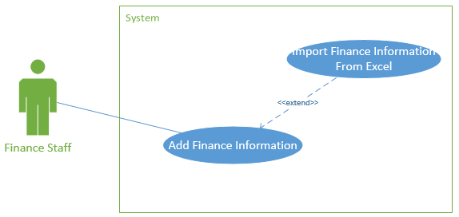

**Figure: <Finance Staff> Add Finance Information Use Case**

* + - 1. **<Education Staff> Add Student Study Result Use Case Diagram**

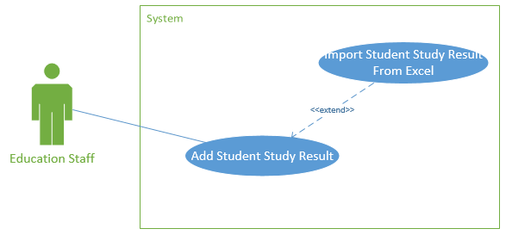

**Figure: <Education Staff> Add Student Study Result Use Case**

* + 1. 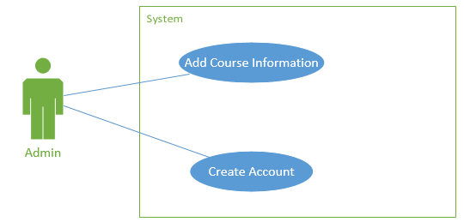**<Admin> Overview Use Case**

**Figure : <Admin> Overview Use Case**

* + - 1. **<Admin> Create Account Use Case Diagram**

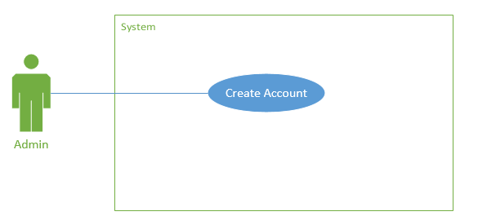

**Figure: <Admin> Create Account Use Case Diagram**

|  |  |  |  |
| --- | --- | --- | --- |
| USE CASE - Admin01 | | | |
| Use Case No. | Admin01 | **Use Case Version** | 1.0 |
| Use Case Name | Create Account | | |
| Author | Ho Doan Trung | | |
| Date | 25/09/2015 | **Priority** | High |
| Actor:   * Admin   Summary:   * This use case allows admin to create new user account for the system.   Goal:   * Allows admin to create new user account. New user account will be added to the system.   Triggers:   * Admin send command “Create new account” to the system.   Preconditions:   * User must log in the system with admin role.   Post Conditions:   * Success: New user account will be added and redirect to “Manage User” page. Display success message. * Fail: No account will be created. Display error message.   Main Success Scenario:   |  |  |  | | --- | --- | --- | | **Step** | **Actor Action** | **System Response** | | 1 | Admin send command “Thêm nhân viên” to the system. | Navigate to “Thêm nhân viên” pop-up which contains:   * Username: Free text input. * Email: Email input. * Role: Drop down list. | | 2 | Admin fills data to the form. |  | | 3 | Admin send command “Thêm” to the system. | Insert new user account to the system and redirect to “Quản lý nhân viên” page. |   Alternative Scenario:   |  |  |  | | --- | --- | --- | | **Step** | **Actor Action** | **System Response** | | 1 | Admin clicks outside pop-up. | Pop-up dismiss and still keep data for next time open. |   Exceptions:   |  |  |  | | --- | --- | --- | | **Step** | **Actor Action** | **System Response** | | 1 | Length of username is not in range. | Show error message: “Username length must be from 6 to 30 characters!” | | 2 | Length of password is not in range. | Show error message: “Password length must be from 8 to 30 characters!” | | 3 | “Email” does not right format. | Show error message: “Email must be right format abc@fpt.edu.vn!“ | | 4 | Role is not specified. | Show error message: “The role must be selected!” |   Relationships: N/A  Business Rules: N/A   * Each created account must be in active state when it’s inserted to system. * Password is generated random by system that contains 8 character, mixes both number and letter. * Password is sent to user email automatically. * User must change password when they login system for the first time. | | | |

* + - 1. **<Admin> Add Course Information Use Case Diagram**
    1. **<Scheduler> Overview Use Case**