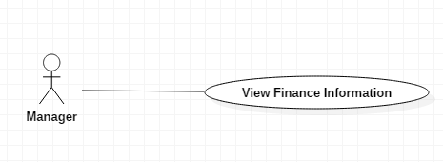

|  |  |  |  |
| --- | --- | --- | --- |
| USE CASE – M01 | | | |
| Use Case No. | M01 | **Use Case Version** | 1.0 |
| Use Case Name | View Finance Information | | |
| Author | AnhLT | | |
| Date | 27/09/2015 | **Priority** | Medium |
| Actor:   * Manager.   Summary:   * This use case shows finance information of student.   Goal:   * User view list all finance information of student.   Triggers:   * User send command View finance Information.   Preconditions:   * User must login into the system with role manager. * ~~There are at least 01 people in list of the system.~~   Post Conditions:   * Success: Show the list finance information of student to the user. * Fail: Show error message.   Main Success Scenario:   |  |  |  | | --- | --- | --- | | Step | Actor Action | System Response | | 1 | User send command to “Danh sách thu học phí” | List finance information of student will be shown with following information :   * Number : number * Name of student : text * Type of student : text * Type of tuition : text * The money student must pay : number * The money student has paid : number * Pay status : text * Detail : link to “Finance Information Detail” | | 2 | User select student to view detail finance information | The student finance detail will be shown with following information :   * Student name : text * Student code : text * Type of student : text * Danh sách những học kỳ mà sv đó đã đóng học phí, mỗi học kỳ sẽ có những thông tin sau : * Số tiền cần đóng * Số tiền đã đóng * Thời gian đóng |   Alternative Scenario 1:   |  |  |  | | --- | --- | --- | | Step | Actor Action | System Response | | 1 | User send command to “Sinh Viên Vay Tín Dụng” | List credit loans student will be shown with following information :   * Number : number * Student code : text * Name of student : text * Type of student : text * Study status of student (studying or graduated) : text * Số tiền sv đã vay : number * Lãi phát sinh : number * Tổng số : number * Detail : link to chi tiết sinh viên vay tín dụng | | 2 | User lựa chọn sinh viên để xem chi tiết thông tin | Updating …. |   Alternative Scenario 2:   |  |  |  | | --- | --- | --- | | No | Actor Action | System Response | | 1 | There are no data | Show message to notify that there are no data. |   Exceptions: N/A  Relationships: N/A  Business Rules:   * The information is loaded from the system. * Tuition list is sorted per term. * Credit loan is sorted by MSSV. * Search bar on the top help user finding information of student faster. * Pagination must be displayed if number of student larger than 10. | | | |

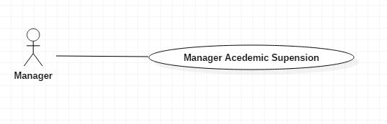

|  |  |  |  |
| --- | --- | --- | --- |
| USE CASE – M01 | | | |
| Use Case No. | M01 | **Use Case Version** | 2.5 |
| Use Case Name | Manage Management | | |
| Author | AnhLT | | |
| Date | 27/09/2015 | **Priority** | Medium |
| Actor:   * Manager.   Summary:   * This use case shows information of student academic suspension.   Goal:   * User view list all information of student.   Triggers:   * User send command Manager Student.   Preconditions:   * User must login into the system with role manager. * There is at least 01 people in list of the system.   Post Conditions:   * Success: Show the list information of student to the user. * Fail: Show error message.   Main Success Scenario:   |  |  |  | | --- | --- | --- | | Step | Actor Action | System Response | | 1 | User send command to “Xem danh sách sinh viên tạm ngưng học” | System show information to manager:   * “MSSV”: text * “Họ và tên”: text * “Học kỳ”: text * “Trạng thái”: text (trả tín dụng hay chưa).   [Alternative 1] | | 2 | User send command “chi tiết” student | Show message information of “sinh viên tạm ngưng học”. |   Alternative Scenario 1:   |  |  |  | | --- | --- | --- | | No | Actor Action | System Response | | 1 | There are no data | Show message to notify that there are no data. |   Exceptions: N/A  Relationships: N/A  Business Rules:   * The information is loaded from the system. * “sinh viên tạm ngưng học” is sorted by MSSV. * Search bar on the top help user finding information of student faster. * Pagination must be displayed if number of student larger than 10. | | | |