**GOAL-BASED VISUAL SERVOING**

by

**SHAWN HUNT**

**DISSERTATION**

Submitted to the Graduate School

of Wayne State University,

Detroit, Michigan

in partial fulfillment of the requirements

for the degree of

**DOCTOR OF PHILOSOPHY**

2010

MAJOR: COMPUTER ENGINEERING

Approved by:

______________________________

Advisor Date

______________________________

______________________________

______________________________

______________________________

**DEDICATION**

This is dedicated to

**ACKNOWLEDGMENTS**

Committee members, fellow colleagues, US Army for funding

**TABLE OF CONTENTS**

Contents

CHAPTER 1 INTRODUCTION AND MOTIVATION 4

1.1 Motivation and Problem Statement 4

1.2 Research Objective and Specific Aims 4

1.3 Outline of the Thesis 5

CHAPTER 2 BACKGROUND 6

2.1 Introduction 6

CHAPTER 3 TRACKING ALGORITHMS 7

3.1 Literature Review 7

3.2 Correlation Tracking 8

3.3 Optical Flow 8

3.4 Blob Tracking 9

3.5 Discussion 9

CHAPTER 4 ROBOT CONTROL 10

4.1 Literature Review 10

4.1 Implementation of the System 10

4.2 Discussion 10

CHAPTER 5 SUBJECT TESTING 11

5.1 Introduction and Motivation 11

5.2 Method 11

5.3 Results 12

5.4 Conclusions 12

CHAPTER 6 SUMMARY, CONTRIBUTIONS, AND FUTURE WORK 13

6.1 Summary 13

6.2 Contributions 13

6.3 Future Work 13

## CHAPTER 1 INTRODUCTION AND MOTIVATION

### 1.1 Motivation and Problem Statement

Mobile robots, or Unmanned Ground Vehicles (UGVs), play an increasing role in both the defense and security of our nation and in the ability to respond to emergency situations. Robots have been used in Iraq and Afghanistan for bomb disposal. They also played a key role in searching for victims of the World Trade Center attack.

The current method of UGV control – rate control teleoperation – is burdensome. There is a high workload that requires constant attention and limits personal situational awareness. A dedicated operator is not able to interleave multiple tasks and control of the UGV can be difficult when the terrain is rough or communications are degraded.

### 1.2 Research Objective and Specific Aims

The research objective in this thesis was to determine if goal-based visual servoing improves operator performance. To support that research question, three aims were formulated. The first aim was the development and analysis of a tracking algorithm that reliably tracks features in real-time. The second aim was the development and application of an algorithm to autonomously navigate to a goal location. The third, and final, aim was the development and execution of a robust subject test. Each aim and how it relates to the research objective are described later in this thesis.

### 1.3 Outline of the Thesis

The second chapter of this thesis provides background information on the algorithms that were used in creating this system. The third chapter details the algorithms used for tracking points in a series of images. The fourth chapter describes the implementation, including the control algorithms, of what runs on the robot. The fifth chapter details the human factors testing that was performed to determine at what point the semi-autonomous algorithms perform better than teleoperation. The sixth chapter concludes with the contributions of this thesis and the future applications that can be used to build on this work.

## CHAPTER 2 BACKGROUND

### 2.1 Introduction

This chapter will define basic terms and explain the background on the technologies being used.

Explain the various sensors used in robots, especially IMU and how odometry works.

Explain conceptually what visual servoing, dead reckoning, kinematics are.

## CHAPTER 3 TRACKING ALGORITHMS

### 3.1 Literature Review

The literature on tracking a point, or multiple points, through a series of images is vast because there are as nearly as many different approaches to tracking as there are applications. The basic component of any tracking algorithm is feature detection and matching. There is, however, no universal definition of what constitutes a feature. A feature that works well in one algorithm might not work well in another. A feature may be loosely defined as an “interesting” part of an image and something is able to be located from frame to frame. The most common types of features found in the literature are edges, corners, and blobs.

Edge detection is a method used in image processing to detect discontinuities. The Sobel operator [1] and the Canny edge detector [2] are two commonly used algorithms to find edges. The Sobel operator works by performing a 2D spatial gradient measurement on an image. This emphasizes the regions that contain high spatial gradient corresponding to the edges. In the Canny edge detector, the first derivatives are computed in x and y and then computed into four directional derivatives. The points whose directional derivatives are local maxima are the candidates for assembling into edges.

The focus on

TACTICAL

Explain in detail all algorithms

Don’t forget the annulus 1D vector thing

MY THEORETICAL CONTRIBUTION

Machine learning for which points are trackable

### 3.2 Correlation Tracking

Spatial filtering, Nyquist

Filtering

Different foveal kernels

Multiple points

### 3.3 Optical Flow

The extension of KLT by adding an annulus turned into a 1D vector. How do you identify specific corner features? The 1D annulus at a radius (or three if use HSV). Or the HSV histogram within a radius. Compare their performance and examine the statistical independence. What distance metric? Suppose frame A has one corner and frame B has two corners. Is either of the two corners in frame B the same as in Frame A? If so, which one? Or two corners in frame A and two in frame B. Which maps to which? If A1 looks like B2 and A2 looks like B1, we infer different motion than the other way around.

Dense optical flow . Most of the dense optical flow algorithms do block matching and most of the time, the blocks overlap. The algorithms just divide the current and previous images up into blocks and compute the motion of the blocks using a spiral search that works out from the location of the original block in the previous frame and compares candidate new blocks with the original. The comparison is usually a sum of the absolute difference of the pixel values. If the match is good enough, then the search is terminated and the next block is processed until all of the blocks have been processed.

Add blurb on RANSAC, and the recent real-time counterparts

### 3.4 Blob Tracking

SIFT vs. SURF

Kd-tree - BFF

Don’t forget the new FLANN algorithm

### 3.5 TACTICAL

### 3.6 Discussion

What about Bag of Words? Where should that fit in?

## CHAPTER 4 ROBOT CONTROL

### 4.1 Literature Review

This

### 4.1 Implementation of the System

Adaptive selection of the parms for each algorithm based on IMU data??

Bundle Adjustment –

On-board vs. off-board (ie at the OCU level)

Control modes:

teleoperation

Visual dead reckoning

Displacement control

Correlation

KLT

Automatic selection of settings based on IMU data

### 4.2 Discussion

## CHAPTER 5 SUBJECT TESTING

### 5.1 Introduction and Motivation

The goal of subject testing was to find out at what dropout rate level the supervisory control algorithms performed better than teleoperation.

### 5.2 Method

#### 5.2.1 Course Design

Three courses were constructed that looked similar to what is shown in Figure 1. The first course was made out of masking tape applied to the floor. The second course was designed to simulate small bumps and was made out of 1x2s as the bumps, with 2x4 as the rails. The third course simulated large bumps and was made out of 2x4s as the bumps and 2x4s as the rails. The total length of the course was forty-five feet.

There were five inspection points that were taped to the ground and are labeled sequentially in Figure 1. The inspection points

How were the max speeds chosen?

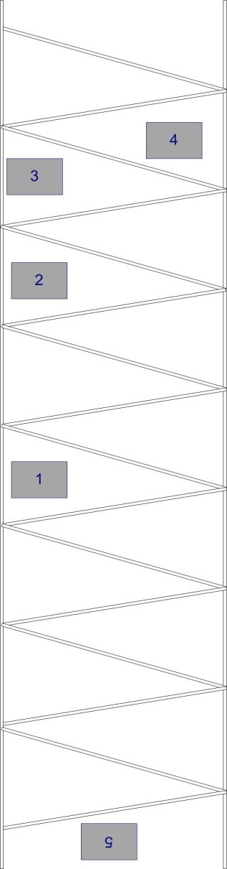

Figure : Course Layout Used in Subject Testing

There were five

Figure 2 shows an image taken from the PackBot’s drive camera as it goes over the course made out of 2x4 lumber.

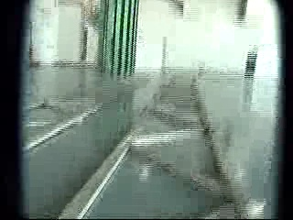

Figure : View from the PackBot as it Goes Over the 2x4 Course

### 5.3 Results

### 5.4 Conclusions

## CHAPTER 6 SUMMARY, CONTRIBUTIONS, AND FUTURE WORK

### 6.1 Summary

This

Discuss application to surveillance (flow field, inter-frame motion for stabilization), latency protection, Sam’s thesis, surgical, IGVC

### 6.2 Contributions

Discuss the theoretical contribution of my work. The different trackers, the subject test,

Analysis of all tracking algs

TACTICAL – env for the user to learn which features work and wont dont

Preprocess the scene for good features

Improved corner tracker

Ensemble approach to reliable tracking

Auto-recover from error

### 6.3 Future Work

Future work: includes the voice command, pre-processing the scene, latency protection

**REFERENCES**

**ABSTRACT**

GOAL-BASED VISUAL SERVOING

by

SHAWN HUNT

May 2010

Advisor: Dr. Abhilash Pandya

Major: Computer Engineering

Degree: Doctor of Philosophy

This research has focused on

**AUTOBIOGRAPHICAL STATEMENT**

SHAWN HUNT

I

1. Sobel, I. and G. Feldman, *A 3x3 isotropic gradient operator for image processing.* Presentation for Stanford Artificial Project, 1968.

2. Canny, J., *A computational approach to edge detection.* IEEE Transactions on pattern analysis and machine intelligence, 1986: p. 679-698.