# User installation (linux)

## SDK installation

http://www.ti.com/tool/download/SIMPLELINK-CC3220-SDK

Linux Installer for SimpleLink CC3220 SDK (includes Service Pack) 1.30.01.03

Modify simplelink_cc32xx_sdk_1_30_01_03/imports.mak

Update relevant paths:

|  |
| --- |
| XDC_INSTALL_DIR ?= /home/phung/ti/xdctools_3_50_01_12_core  CCS_ARMCOMPILER ?= /home/phung/ti/ccsv7/tools/compiler/ti-cgt-arm_16.9.1.LTS  GCC_ARMCOMPILER ?= /home/phung/ti/ccsv7/tools/compiler/gcc-arm-none-eabi-4_9-2015q3 |

Ignore FreeRTOS:

|  |
| --- |
| FREERTOS_INSTALL_DIR ?= /home/phung/FreeRTOSv9.0.0 |

## CCS7 installation

http://processors.wiki.ti.com/index.php/Download_CCS

Linux Version 7.1.0.00016

# Binary build (linux)

Clone cc3220.git\

#Make kernel

>cd cc3220\simplelink_cc32xx_sdk_1_30_01_03\kernel

>make

#Make example  
>cd cc3220\simplelink_cc32xx_sdk_1_30_01_03\examples\rtos\CC3220S_LAUNCHXL\demos\portable\tirtos\ccs

>make

An *.out will be generated

#Convert from .out to .in

/home/phung/ti/ccs7/utils/tiobj2bin/tiobj2bin portable.out portable.in

# Flashing (window)

Download and install uniflash 4.x @http://www.ti.com/tool/UNIFLASH

Select CC3220SF-LAUNCHXL as below:

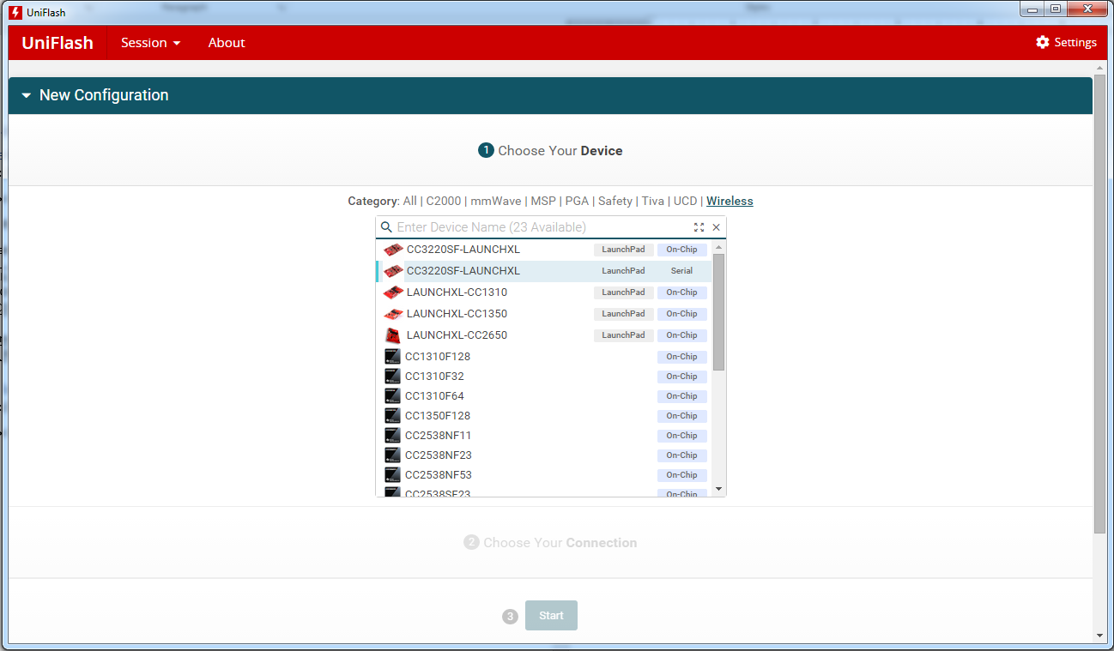

Select “Start Image Create”

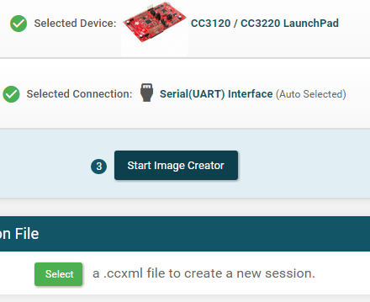

Create new project:

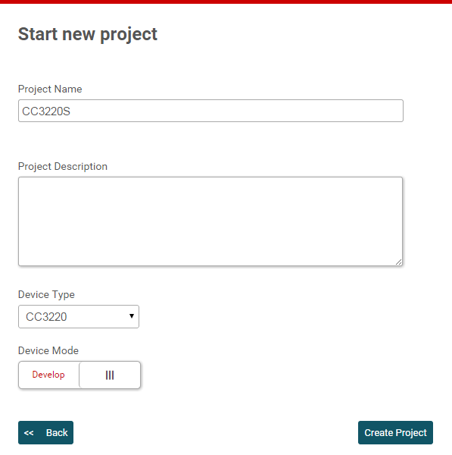

Select playground key (for development only, not for production)

TI\simplelink_cc32xx_sdk_1_30_01_03\tools\cc32xx_tools\certificate-playground

certcatalogPlayGround20160911.lst then certcatalogPlayGround20160911.lst.signed.bin

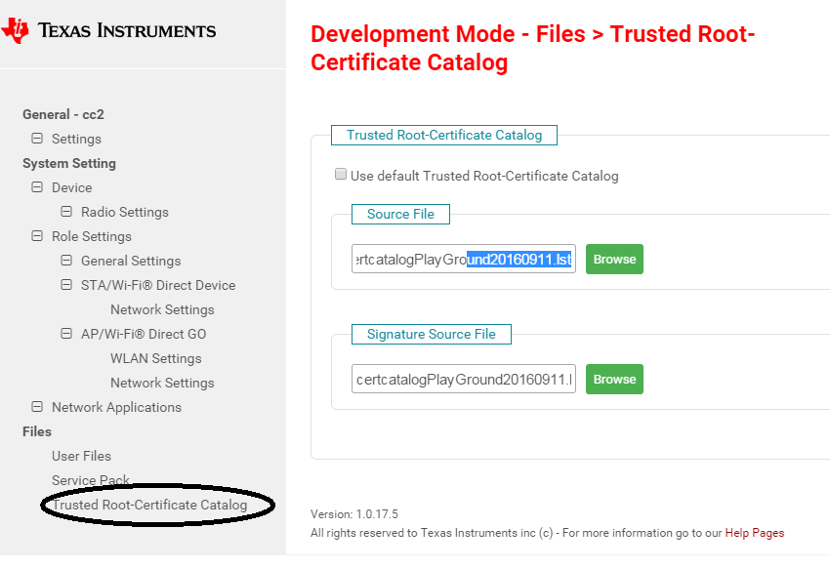

Upload dummy-root-ca-cert

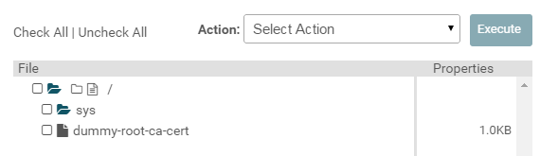

Add application image

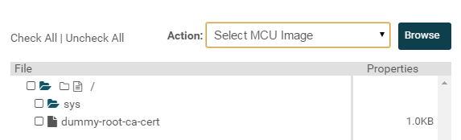

Select binary as MCU Image

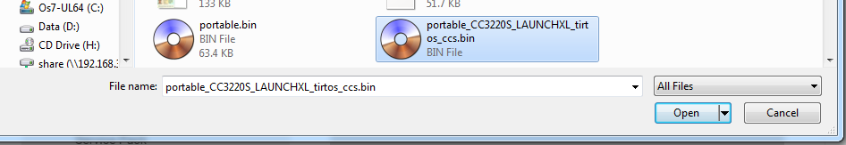

Browse dummy-root-ca-cert-key

In box “Certification File Name”, select the pre-uploaded file

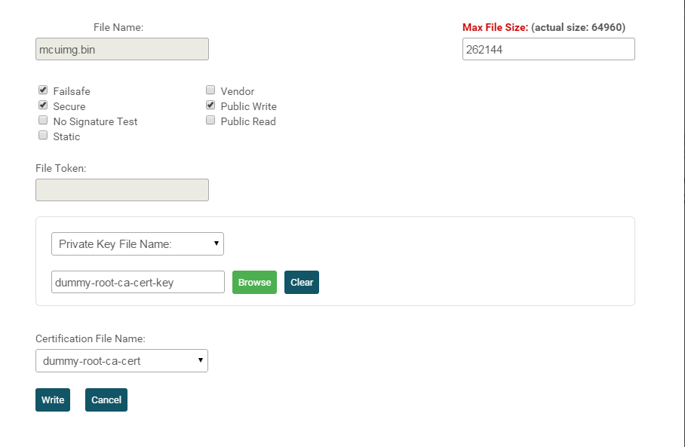

Write file:

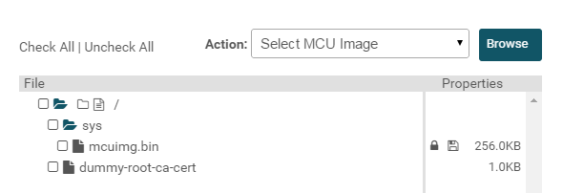

Connect to device

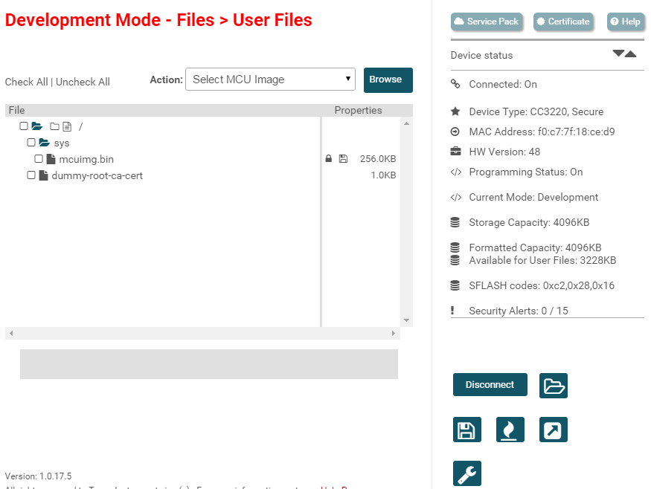

Generate image:

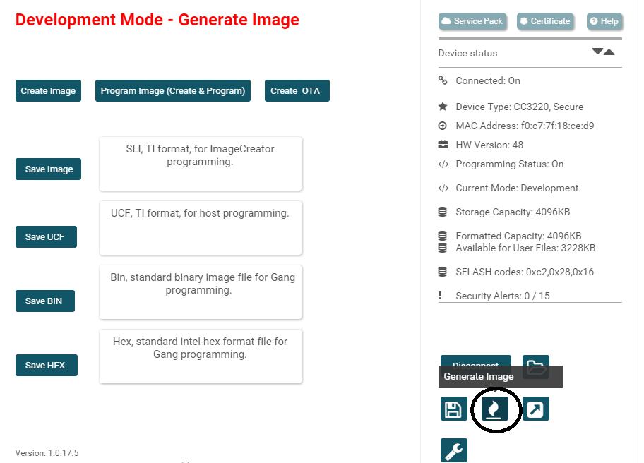

Program image (SOP pin setting 010)



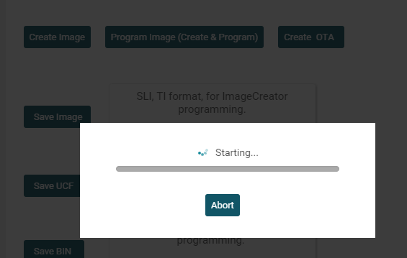

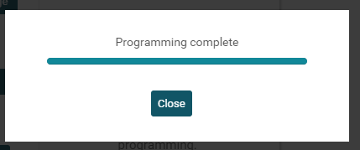

View log in Uart

