停留时间应为：
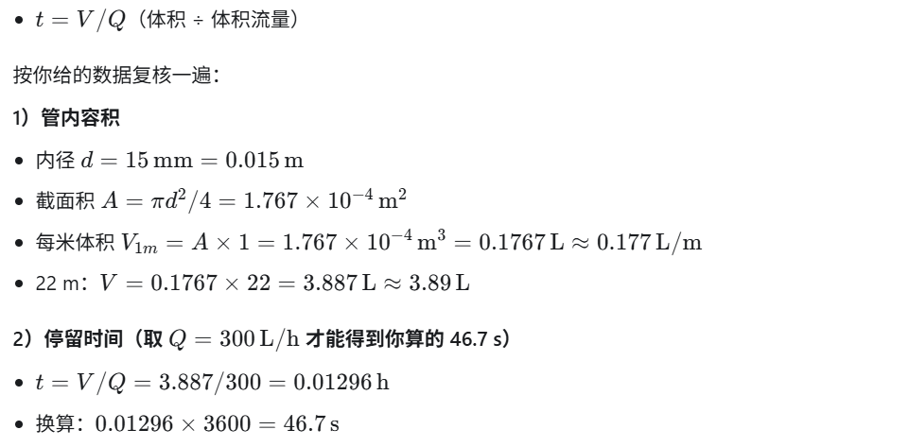

$$t(s) = \{ [ π × ( (15×10^-3 m) / 2 )^2 × (22 m) ] × (1000 L/m^3) / (300 L/h) \} × (3600 s/h)$$

$$t(s) = \{ [ π × ( (d×10^-3 m) / 2 )^2 × (L m) ] × (1000 L/m^3) / (Q L/h) \} × (3600 s/h)$$

