|  |  |  |
| --- | --- | --- |
| **LAB101 Assignment** | **Type:** | **Short Assignment** |
| **Code:** | **C.S.P0042** |
| **LOC:** | **38** |
| **Slot(s):** | **1** |

**Title**

Array Manipulations.

**Background**

N/A

**Program Specifications**

Develop a C-program that allows:

* Input (up to an array size 100)
  + Users input array’s elements unless the input is 0.
* Output the max element.
* Output all array elements
* Output all even elements.

***Function details:***

1. User input the array’s size and elements.
2. Users keep inputting elements unless users input 0.
3. The program displays all the array’s elements.
4. The program displays the max element in the array.
5. The program displays all the even numbers in the array.

***Expectation of User interface:***

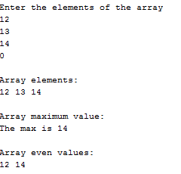

Each number is separated by a white space character.

**Guidelines**

An even number is the number being divisible by 2.