  SU26

Q1:

Software Requirements Specification

for

Online Car Renting Management System - OCRMS
Version 1.0 approved
Prepared by
Hoàng Ngọc Trinh – SE838668
FPT University - HCMC
2026, Aug-01

Q2:

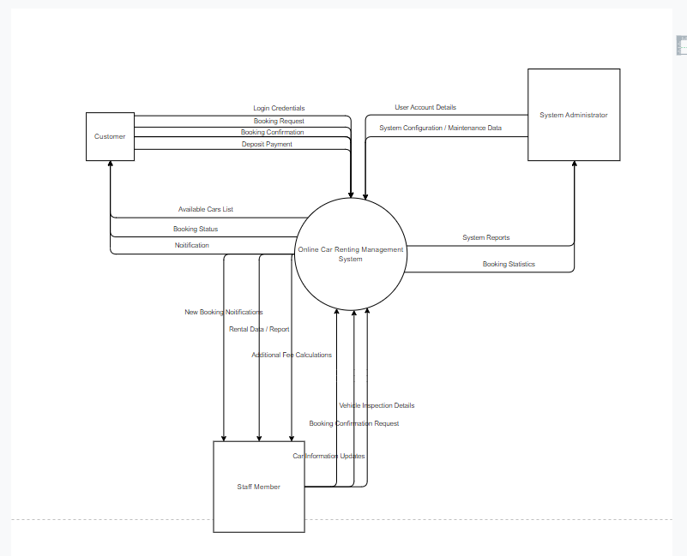

Q3:

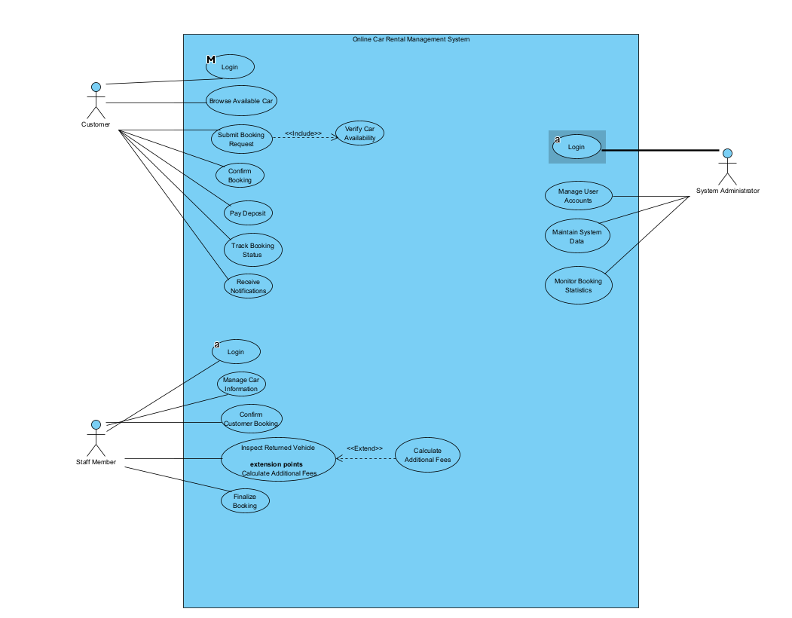
# | Actor | Description
01 | Customer | End-users who browse available cars, submit booking requests, pay deposit payments, and track their rental status.
02 | Staff Member | Operational personnel responsible for managing car details, confirming bookings, inspecting returned vehicles, and finalizing rentals.
03 | System Administrator | Administrative users responsible for managing user accounts, maintaining system data, and monitoring booking statistics.
# | Use Case | Actors | Description
UC-01 | Log In | Customer, Staff Member, System Administrator | Authenticates users to access system functions according to their assigned roles.
UC-02 | Browse Available Cars | Customer | Allows customers to search and view available vehicles based on chosen rental periods.
UC-03 | Verify Car Availability | System | Automatically checks whether selected vehicles are available for specified dates.
UC-04 | Submit Booking Request | Customer | Enables customers to submit a rental booking by selecting a car and rental duration.
UC-05 | Confirm Booking | Customer, Staff Member | Allows customers to confirm their bookings and staff members to review/approve requests.
UC-06 | Pay Deposit | Customer | Enables customers to pay required deposit fees online to lock in their bookings.
UC-07 | Track Booking Status | Customer | Allows customers to monitor real-time updates and receive status notifications.
UC-08 | Manage Car Information | Staff Member | Enables staff to create, update, or remove vehicle records and update availability.
UC-09 | Inspect Returned Vehicle | Staff Member | Allows staff to inspect cars upon return and record vehicle conditions.
UC-10 | Calculate Additional Fees | Staff Member | Computes extra fees for late returns, damages, or extra mileage after inspection.
UC-11 | Finalize Booking | Staff Member | Completes the rental process and archives transaction data for record-keeping.
UC-12 | Manage User Accounts | System Administrator | Allows the administrator to create, update, or deactivate accounts for all system users.
UC-13 | Maintain System Data | System Administrator | Enables the administrator to update system settings and maintain operational data.
UC-14 | Monitor Booking Statistics | System Administrator | Allows the administrator to review rental reports and analyze system usage metrics.

Q4:
# | Entity | Description
01 | Customer | Stores customer profile details including Customer ID, Driver License Number, Address, Phone Number, and reference to UserAccount for login access.
02 | Car | Stores vehicle details including Car ID, License Plate, Brand, Model, Rental Rate per day, Required Deposit Amount, and real-time Availability Status.
03 | Booking | Stores rental booking requests including Booking ID, Customer ID, Car ID, Start Date, End Date, Total Rental Amount, Deposit Paid, Booking Status, and Staff ID.
04 | DepositPayment | Stores payment transaction records for rental deposits, including Payment ID, Booking ID, Payment Amount, Payment Method, Payment Date, and Transaction Status.
05 | VehicleInspection | Stores post-rental vehicle condition inspections conducted by staff upon car return, including Inspection ID, Booking ID, Inspection Date, Return Mileage, Fuel Level, Condition Notes, and Extra Fees.
06 | UserAccount | Stores user authentication credentials, Username, Encrypted Password, Role (Customer, Staff Member, System Administrator), and Account Status.
07 | StaffMember | Stores operational staff details including Staff ID, Account ID, Full Name, Department, Position, and Contact Phone.
08 | Notification | Stores system and status update notifications sent to users during the rental lifecycle, including Notification ID, User Account ID, Title, Message, Sent Date, and Read Status.

