耳机

插入耳机后，关闭功放输出，打开耳机输出

蓝牙

蓝牙连接后，使能接收蓝牙输入的控制信息，然后通过I2C传输相应控制命令给音控芯片NTP8230

按键

检测到有按键（短）信号，控制输出通道切换，有按键（长）信号，控制输出通道轮流切换（一个脉冲切换一次）

编码器

检测到编码器相应信号，然后通过I2C传输相应控制命令给音控芯片NTP8230

遥控器

接收到遥控信息，然后做相关操作

音控芯片NTP8230接口命令

Addr 0x01: General Serial Audio Format

Addr 0x02: Master Clock Frequency Control

Addr 0x03~0x08: Mixer Gain

Reserved Addr 0x09~0x0B

Addr 0x0C : Front Bi-quad Filter Chain (FBQ) Configurations for Ch 1&2&3

Addr 0x0D: 3D Delay Amount

Addr 0x0E: 3D Effect Control Configuration

Addr 0x0F : Equalizer (EQ) Configuration

Addr 0x10~0x14: GEQ Gain for Band 1 ~ 5

Addr 0x15: CH1&CH2 Prescaler Value Configuration

Addr 0x16: CH3 Prescaler Value Configuration

Addr 0x17~0x18: Post Biquad Filter (PBQ) Configuration0 for Ch 1 and Ch2, respectively

Addr 0x19~0x1A : Post Biquad Filter (PBQ) Configuration1 for Ch 1 and Ch 2, respectively

Addr 0x1B : Post Biquad Filter (PBQ) Configuration for Ch 3

Addr 0x1C: DRC Control 0

Addr 0x1D : DRC Control 1

Addr 0x1E : DRC Control 2

Addr 0x1F : DRC Control3

Addr 0x20 : DRC Control 4

Addr 0x21: DRC Control 5

Addr 0x22 : DRC Control 6

Addr 0x23: DRC Control 7

Addr 0x24 : DRC Control 8

Addr 0x25 : DRC Control 9

Addr 0x26 : Soft Mute Control 0

Addr 0x27 : PWM Switching On/Off Control

Addr 0x28 : PWM_MASK Control 0

Addr 0x29: PWM_MASK Control 1

Addr 0x2A : PWM_MASK Control 2

Addr 0x2B : PWM_MASK Control 3

Addr 0x2C: PWM_MASK Control 4

Addr 0x2D: Master Volume Fine Control

Addr 0x2E~0x31: Master Volume, and Ch1/2/3 volume, respectively

Addr 0x32: Soft Volume Control

Addr 0x33: Auto-Mute Control for CH1 & CH2

Addr 0x34: Auto-Mute Control for CH3

Addr 0x35 : PWM Output Port Control for PWM Port 1A & 1B

Addr 0x36 : PWM Output Port Control for PWM Port 2A & 2B

Addr 0x37 : PWM Output Port Control for PWM port 3A & 3B

Addr 0x38: Miscellaneous PWM Control

Addr 0x39: I 2 C Glitch filter

Addr 0x3A : Headphone Mute Control

Reserved Addr 0x3B~0x49

Addr 0x4A : SE Soft Start Control 0

Addr 0x4B : SE Soft Start Control 1

Addr 0x4C : SE Soft Start Control 2

Addr 0x4D : SE Soft Start Control 3

Addr 0x4E : PWM D-BTL MODE Control 0

Reserved Addr 0x4F

Addr 0x50 : PWM D-BTL Mode Control 1

Reserved Addr 0x51

Addr 0x52 : PWM Soft Start

Addr 0x53: Power Meter Control

Addr 0x54: Power Meter (read-only)

Addr 0x55: Modulation Index & NS-Type Control

Reserved Addr 0x56~0x5D

Addr 0x5E: System Error Status (read-only)

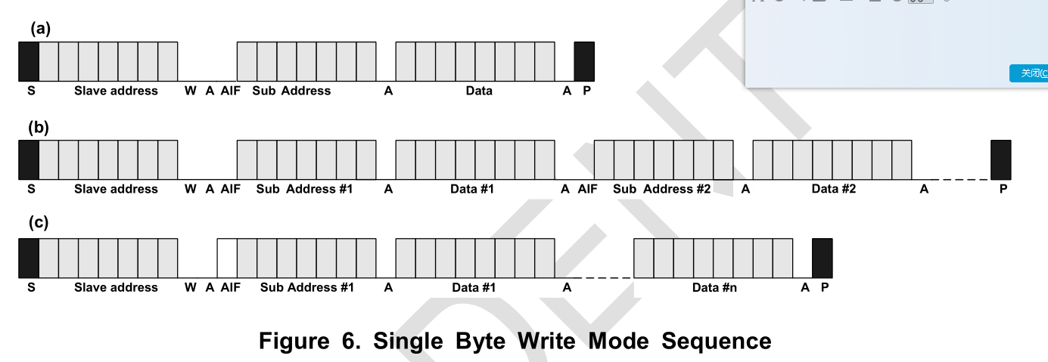

In write operation, the register 0x7E value needs to be set first for performing the configuration of the

registers belong to all channels. The 0x7E register also support to configuring byte writes operation

and word i.e. 4 byte writes operation.

If 0x7E register is configure to 0x00, it support byte write operation and for word i.e. 4 byte write

operation for each channel it needs to configure as 0x01 for channel 1, 0x02 for channel 2, 0x04 for

channel 3 and 0x08 for PEQ coefficient. Also to configure channel1 and channel2 with the same

values, the 0x7E register needs to configure as 0x03. So the same values get sets for both the

channel with only one write operation.

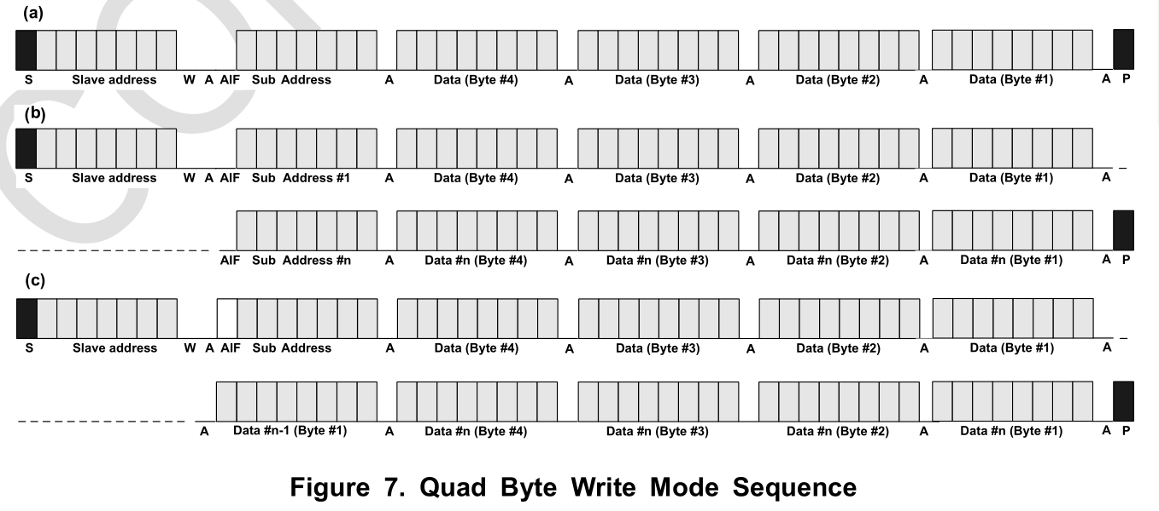

The ROM BQ addresses from 0x00 to 0x3B and from 0x41 to 0x63 are used for the Bi-Quad filter

coefficients in the coefficient mode. Each Bi-Quad filter uses 5 coefficients. Any unexpected coefficient

value changes on any part of 5 coefficients can generate unstable Bi-Quad filter response. For

example, if only one of 5 coefficients for a Bi-quad filter is changed and downloaded, its combined 5-

coefficient set can have unstable operation while old and new coefficients are mixed together.

Therefore to prevent this kind of problem, the NTP-8230 writes coefficients to coefficient registers only

when the last 5th coefficients of each Bi-Quad filter are downloaded, which means all of 5 coefficients

are fully ready.