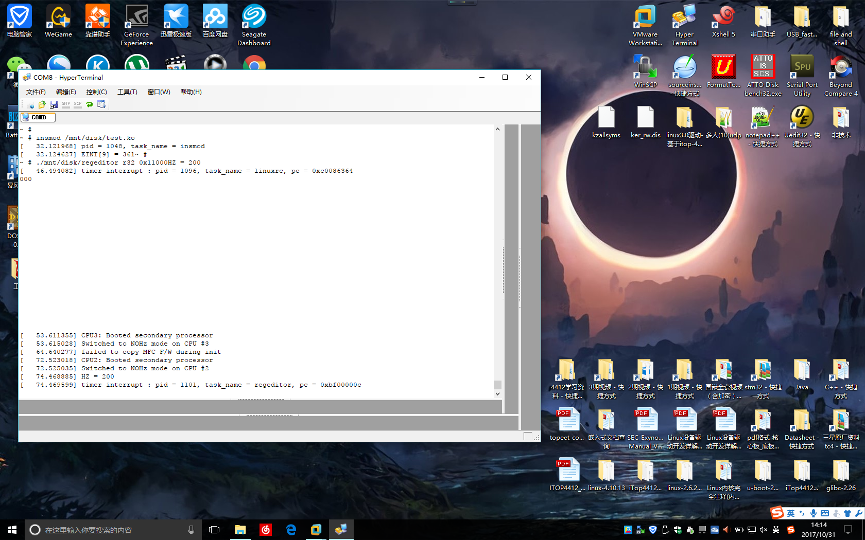

修改内核arch/arm/kernel/irq.c

在asm_do_IRQ函数中添加每隔一定中断数就打印一次

**static int cnt = 0;**

**if((current->pid != 0) && ((cnt % 250) == 0))**

**{**

**printk("irq = %d, pid = %d, task_name = %s, pc = 0x%x\n", irq, current->pid, current->comm, regs->ARM_pc);**

**}**

**cnt++;**