

APp summary

[Document subtitle]



[Date]

[Company name]

[Company address]

# Homepage

In the main interface, each task name, task date and task content will be displayed. At the bottom of the page, you can switch between complete task or uncomplete task.

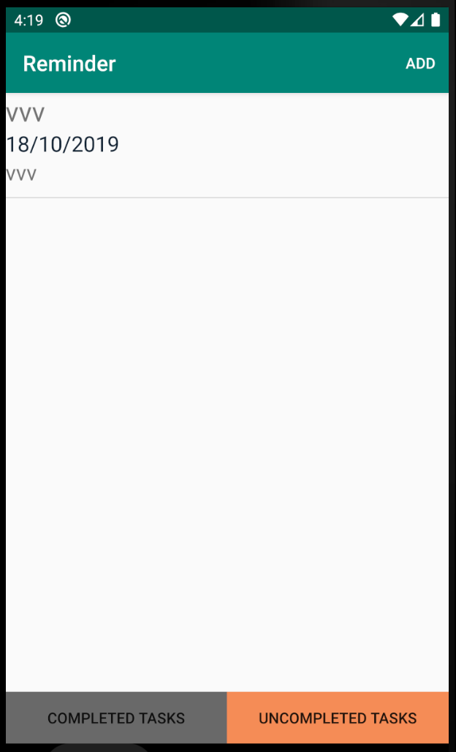

When the user presses and holds the taskbar for a long time, the taskbar will pop up the interface and you can change status, cancel or delete the task.

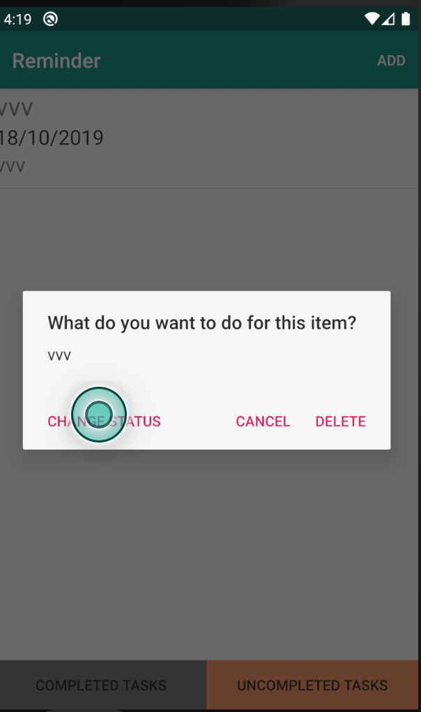

When you click change status, the taskbar will switch states.

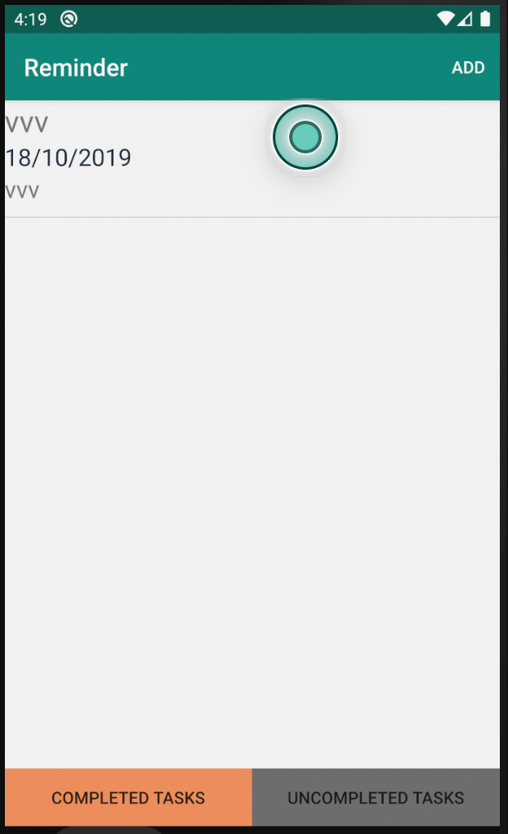

If you click delete, the system will remove the task from the list.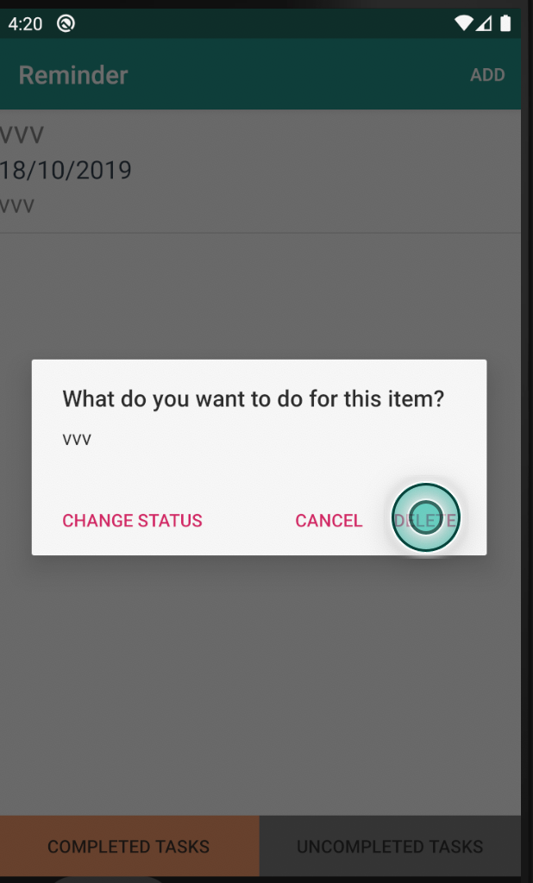

# Edit page

When the user clicks add button, the button is at the top right of the page. After clicking the Add button, the page will jump to the calendar interface, and the user can choose which day to set the reminder. On the calendar interface, you can also use the back button to return to the main interface.

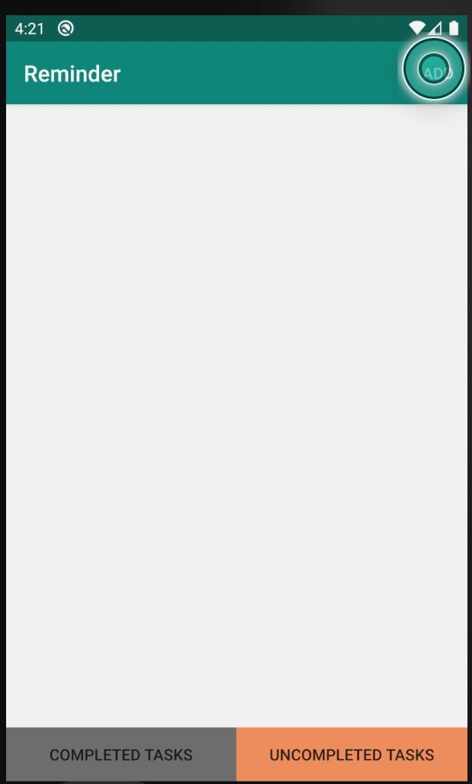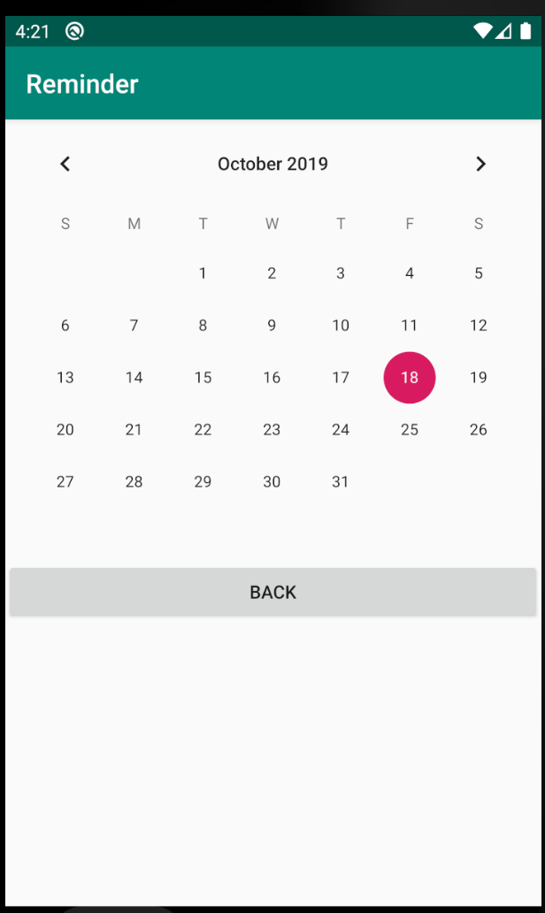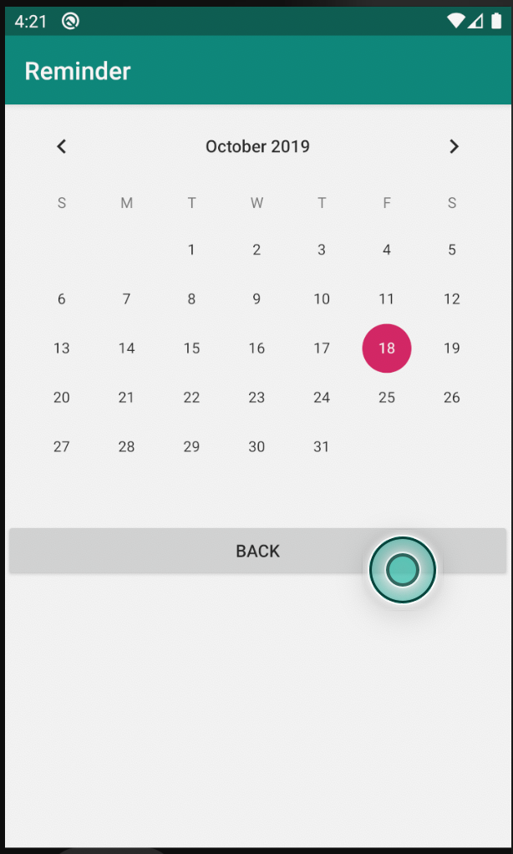

When the user selects the time, the interface will come to the main editing interface. In the editing interface, users need to add task name, content and set alarm time. The system forces the user to add task name. If the user does not add, the system cannot save this information.

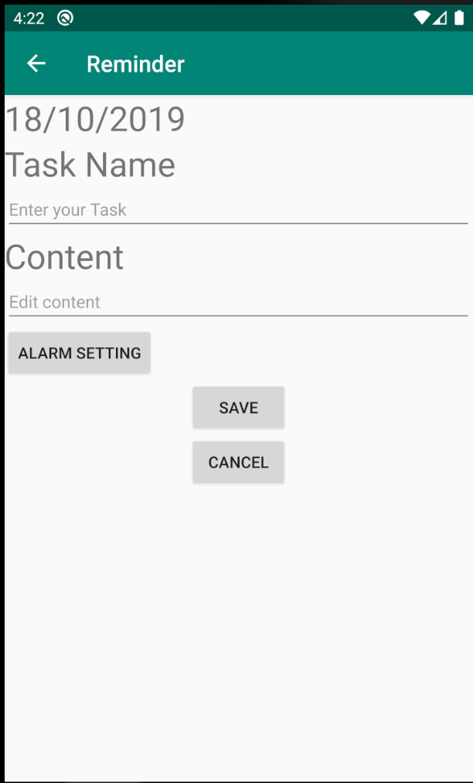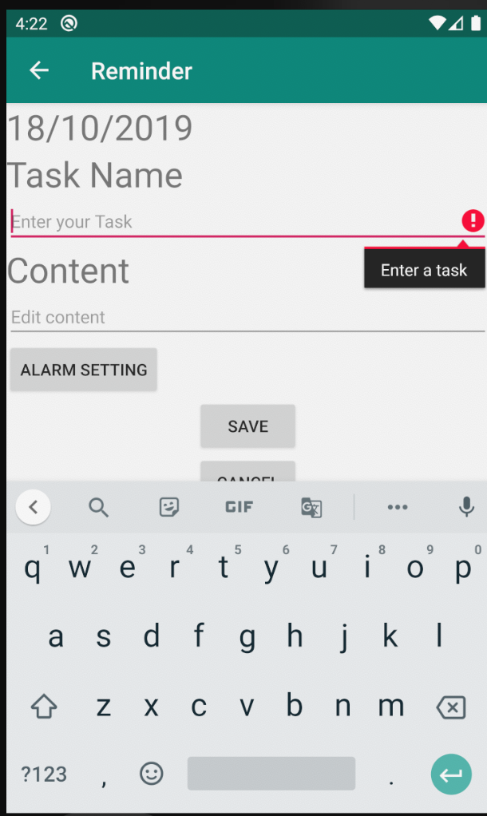

Click the alarm setting button to set the alarm time. When the user setting is completed, the setting time will be displayed at the top of the page.

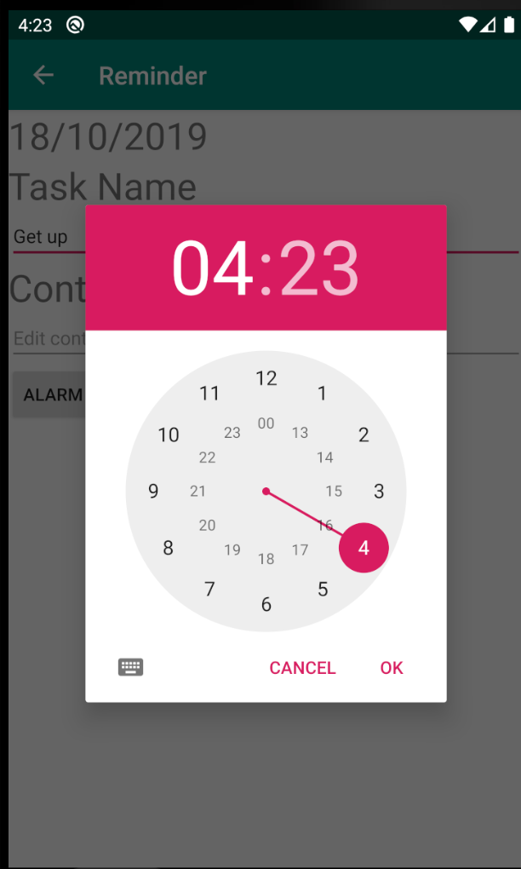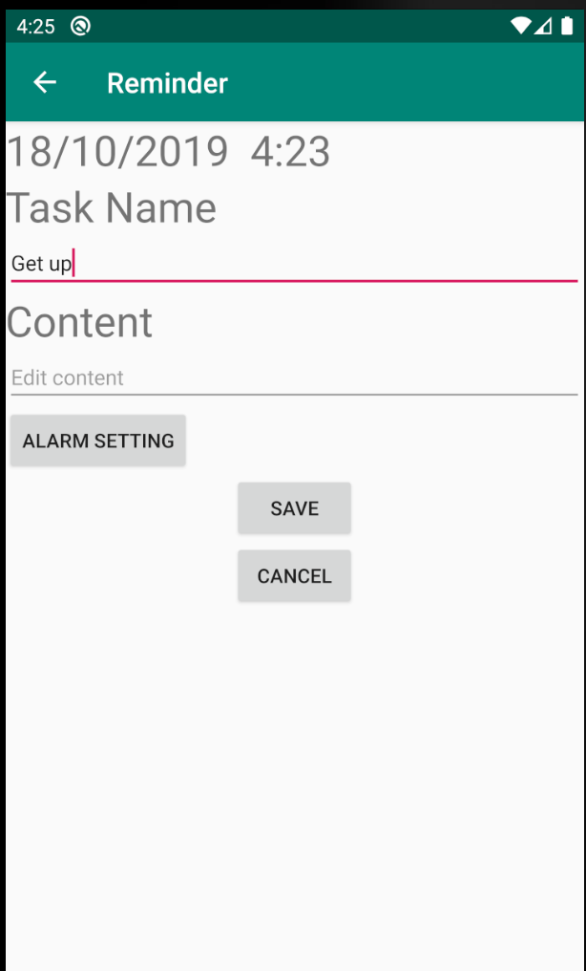

When the user has entered the information, user can select Cancel to cancel all settings and return to the main interface. User can also click Save button to save all the information.

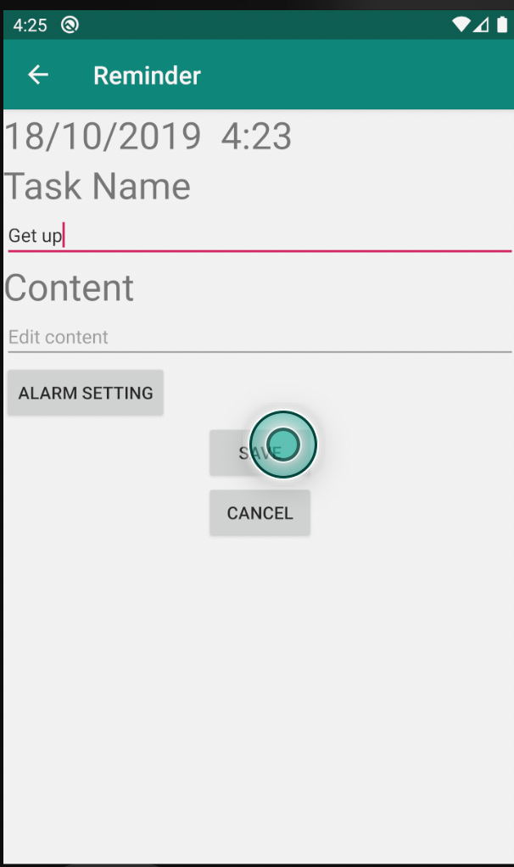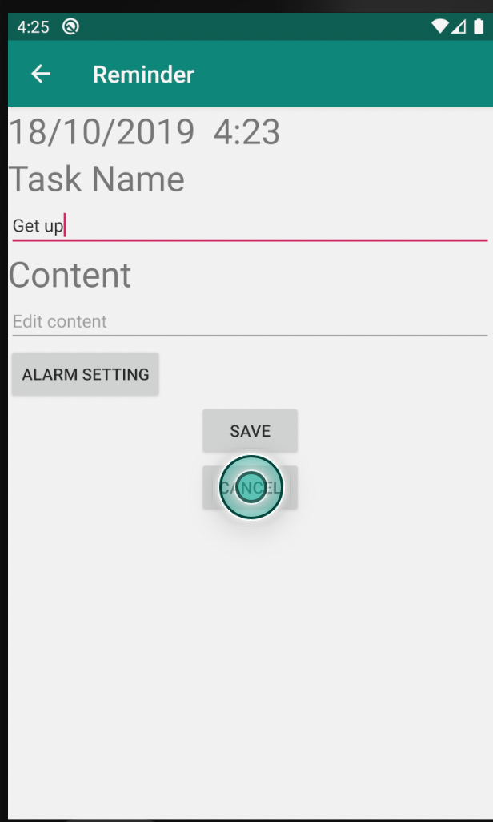

All the information will be displayed in the main interface, and the user can also click this information for secondary editing and modification.

