**武汉大学计算机学院**

**本科生课程设计报告**

**Use the enterprise annual report to build an industry dictionary and analyze the upstream and downstream of the enterprise**

专 业 名 称 ：软件工程

课 程 名 称 ：商务智能

指 导 教 师 一：朱卫平 副教授

学 生 学 号 ：2016302580203

学 生 姓 名 ：曹子轩

二○一八年11月

1. **Background**

Listed companies will publish their quarterly and annual company reports on time to disclose the company's production and operation status. But these reports are very lengthy, and it is very difficult for humans to extract effective information from them. Therefore, in the near future, using data mining methods to grasp the company's production and operation status is a very popular direction.

Most companies have their own upstream and downstream industries. The state of these industries has an important impact on the company's situation. Therefore, extracting this information from the company's annual report is of great significance for better understanding and forecasting the production and operation of listed companies. The extracted information can provide an important reference for our more in-depth analysis.

Through the search, I found that there are already some websites on the market that analyze the upstream and downstream of the industry([产业价值链咨询平台](http://ic.tpex.org.tw/)). However, most of these sites are analyzed for the entire industry, and there is a lack of analysis of the company's granularity. Moreover, most of their extraction uses manual extraction and keyword analysis, which lacks efficiency and accuracy. Therefore, I consider using some of the knowledge I have learned in the BI course, text mining the company's annual report, using support vector machines and neural networks to analyze key statements in the company's annual report, establish an industry dictionary containing all industries and achieve The upstream and downstream extraction of the industry in the company's annual report.

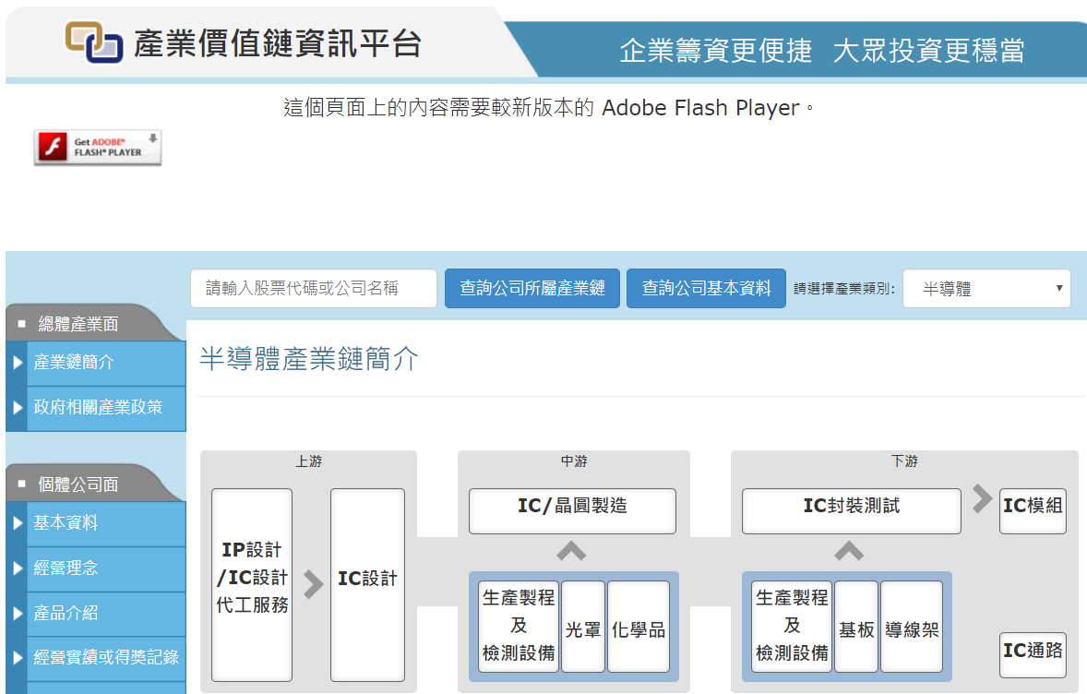

图 1 产业价值链咨询平台

1. **Requirement Analysis**

The entire system contains two functions. For the input vocabulary, the system must be able to determine whether the vocabulary can be considered to represent an industry. For the input document, the system outputs the upstream, downstream and midstream industries involved in the company's annual report.

First, we need to collect relevant data. The corpus includes a news corpus (which helps us collect industry vocabulary) and a corporate annual corpus.

After that, we need to manually label the data, whether the data is an industry vocabulary, and whether it represents the upstream downstream or midstream vocabulary in the company annual report.

Then, we train through machine learning algorithms and neural networks to automatically label all the data.

Finally, visualize the results.

1. **Solution**
2. With a corpus, use word embedding to train and map words into vector space as the basis for subsequent calculations.
3. Use the support vector machine to train the annotated corpus.
4. Use LSTM to determine if each vocabulary in a sentence in the document represents an upstream downstream or midstream.
5. **Running Environment And Dependencies**

**Python 3.6**: Python is a popular computer language in machine learning and NLP for its easy grammar and rich packages. All the code are written via python.

**Django**: Django is a free and open-source web framework, written in Python, which follows the model-view-template (MVT) architectural pattern. It is maintained by the Django Software Foundation (DSF), an independent organization established as a non-profit. Actually, this project does not necessarily use Django. But considering Django provides us very convenient api to operate database and build a web site, we use it to improve our efficiency.

**Numpy**: Numpy is the fundamental package for scientific computing with Python.

jieba:

**Tensorflow**: TensorFlow is an open-source software library for dataflow programming across a range of tasks. It is a symbolic math library, and is also used for machine learning applications such as neural networks.

**Jieba**: It is a professional Chinese word segmentation tool.

1. **Technology Used**

**Word2vec**: Word2vec is a group of related models that are used to produce word embeddings. These models are shallow, two-layer neural networks that are trained to reconstruct linguistic contexts of words. Word2vec takes as its input a large corpus of text and produces a vector space, typically of several hundred dimensions, with each unique word in the corpus being assigned a corresponding vector in the space. Word vectors are positioned in the vector space such that words that share common contexts in the corpus are located in close proximity to one another in the space.

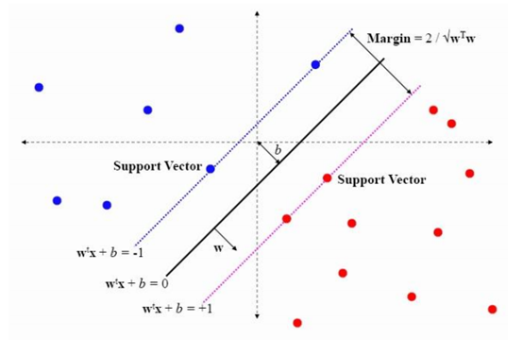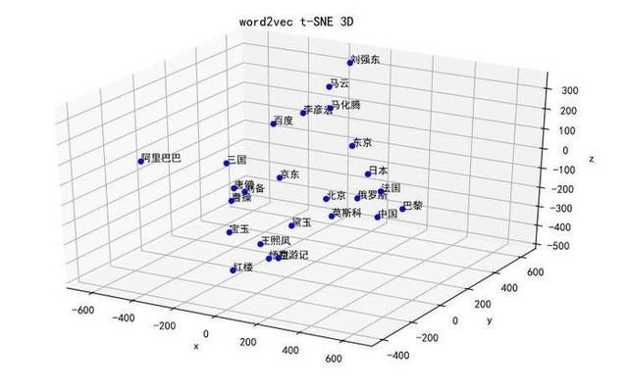

图 2 SVM 图 3 word2vec

**SVM**: In machine learning, support vector machines (SVMs, also support vector networks) are supervised learning models with associated learning algorithms that analyze data used for classification and regression analysis. Given a set of training examples, each marked as belonging to one or the other of two categories, an SVM training algorithm builds a model that assigns new examples to one category or the other, making it a non-probabilistic binary linear classifier (although methods such as Platt scaling exist to use SVM in a probabilistic classification setting). An SVM model is a representation of the examples as points in space, mapped so that the examples of the separate categories are divided by a clear gap that is as wide as possible. New examples are then mapped into that same space and predicted to belong to a category based on which side of the gap they fall.

**LSTM**: Long short-term memory (LSTM) units are units of a recurrent neural network (RNN). An RNN composed of LSTM units is often called an LSTM network. A common LSTM unit is composed of a cell, an input gate, an output gate and a forget gate. The cell remembers values over arbitrary time intervals and the three gates regulate the flow of information into and out of the cell.LSTM networks are well-suited to classifying, processing and making predictions based on time series data, since there can be lags of unknown duration between important events in a time series.

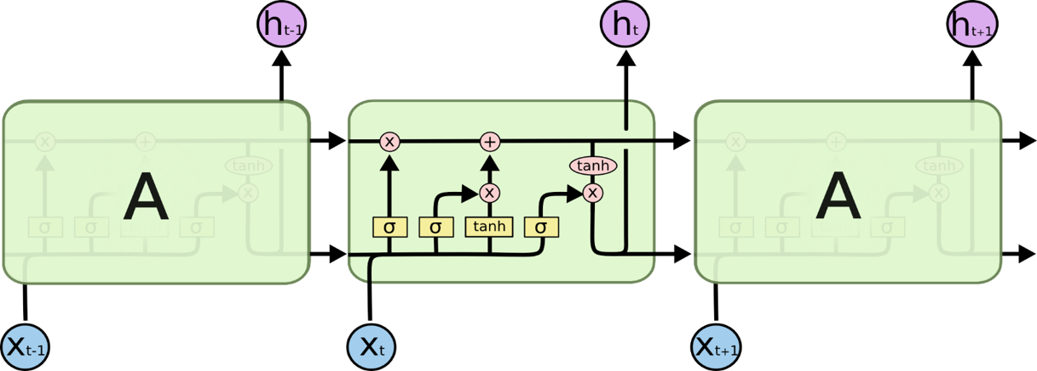

图 4 LSTM cell

1. **Data Set**

**Sohu news data**: The data can be downloaded in this website

**Listed company annual reports**: All the reports are collected in [EastMoney](http://www.eastmoney.com/). This work was done by the seniors of my laboratory and belongs to a branch of Professor Han Bo's research.

1. **Experiment**
2. First, we need to train word to vector. The code can be seen in function train_data_build() and train_data(). Here are some examples of our vector. 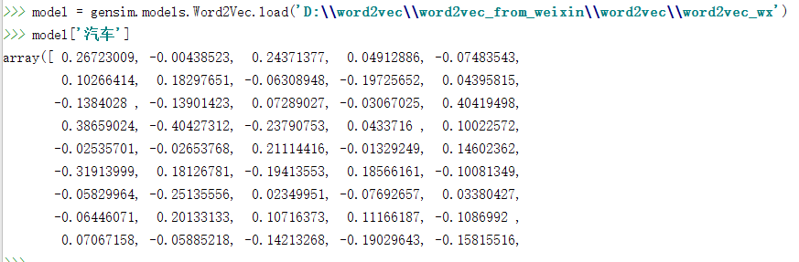
3. Select “行业” as the key word and extract the words in the sentence before "行业". Because we want to build an industry dictionary, we ignore the words that are not used for nouns. After that, we manually label all the industry vocabulary, and the size of the labeled data set is 1000. The code can be seen in function buildData()
4. Using the word vectors and annotations of different words as input, use the support vector machine for training and save the training results. All data is annotated using the results of the training. The following figure is a graphical representation of the accuracy and loss of the support vector machine. It can be seen that as the training progresses, the accuracy rate continues to increase and the loss continues to decrease. The code can be seen in SVM().

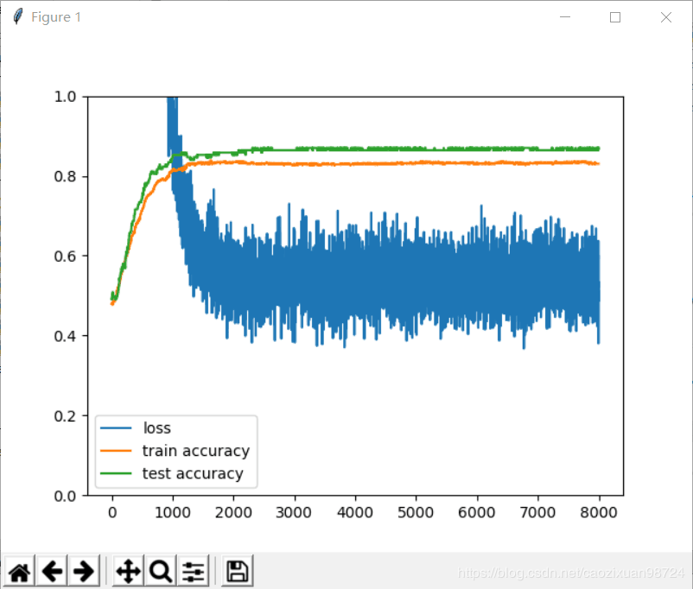

图 5 SVM accuracy and loss

1. **Key Codes**

**def** train_data_build():  
 file = **r'F:\train_data.txt'** names = file_name(**'F:\\data'**)  
 **for** name **in** names:  
 f = open(name, errors=**'ignore'**)  
 st = f.read()  
 **with** open(file, **'a+'**) **as** f:  
 seg_list = jieba.cut(st, cut_all=**False**)  
 f.write(**" "**.join(seg_list))  
 f.write(**'\n'**)  
 f.close()  
  
  
**def** train_data():  
 **from** gensim.models **import** word2vec  
 sentences = word2vec.Text8Corpus(**'F:\\train_data.txt'**)  
 model = word2vec.Word2Vec(sentences, size=50)  
 model.save(**'word2vec_model'**)

**def** buildData():  
 rule = **r'(.*)行业'** compile_name = re.compile(rule, re.M)  
 names = file_name(**'E:\\temp_data\\tmp'**)  
 **for** name **in** names:  
 f = open(name, errors=**'ignore'**)  
 st = f.read()  
 res_name = compile_name.findall(st)  
 **for** sentence **in** res_name:  
 seg_list = jieba.lcut(sentence, cut_all=**False**)  
 word = seg_list[len(seg_list) - 2]  
 **if** len(word) <= 1:  
 **continue** values = pseg.cut(word)  
 flag_word = **True  
 for** value, flag **in** values:  
 **if** flag == **'n'**:  
 **continue  
 else**:  
 flag_word = **False  
 if** flag_word:  
 Dictionary.objects.get_or_create(name=word)

**def** SVM():  
 sess = tf.Session()  
 words = Divided.objects.all()  
 model = gensim.models.Word2Vec.load(**'D:\\word2vec\\word2vec_from_weixin\\word2vec\\word2vec_wx'**)  
 x_vals = np.array([model[word.name].tolist() **for** word **in** words])  
 y_vals = np.array([1 **if** word.is_industry **else** -1 **for** word **in** words])  
 train_indices = np.random.choice(len(x_vals), round(len(x_vals) * 0.8), replace=**False**)  
 test_indices = np.array(list(set(range(len(x_vals))) - set(train_indices)))  
 x_vals_train = x_vals[train_indices]  
 x_vals_test = x_vals[test_indices]  
 y_vals_train = y_vals[train_indices]  
 y_vals_test = y_vals[test_indices]  
 *# 批训练中批的大小* batch_size = 100  
 x_data = tf.placeholder(shape=[**None**, 256], dtype=tf.float32)  
 y_target = tf.placeholder(shape=[**None**, 1], dtype=tf.float32)  
 W = tf.Variable(tf.random_normal(shape=[256, 1]))  
 b = tf.Variable(tf.random_normal(shape=[1, 1]))  
 *# 定义损失函数* model_output = tf.matmul(x_data, W) + b  
 l2_norm = tf.reduce_sum(tf.square(W))  
 *# 软正则化参数* alpha = tf.constant([0.1])  
 *# 定义损失函数* classification_term = tf.reduce_mean(tf.maximum(0., 1. - model_output * y_target))  
 loss = classification_term + alpha * l2_norm  
 *# 输出* prediction = tf.sign(model_output)  
 accuracy = tf.reduce_mean(tf.cast(tf.equal(prediction, y_target), tf.float32))  
 train_step = tf.train.GradientDescentOptimizer(0.01).minimize(loss)  
 *# saver = tf.train.Saver()  
 # 开始训练* sess.run(tf.global_variables_initializer())  
 loss_vec = []  
 train_accuracy = []  
 test_accuracy = []  
 **for** i **in** range(8000):  
 rand_index = np.random.choice(len(x_vals_train), size=batch_size)  
 rand_x = x_vals_train[rand_index]  
 rand_y = np.transpose([y_vals_train[rand_index]])  
 sess.run(train_step, feed_dict={x_data: rand_x, y_target: rand_y})  
 temp_loss = sess.run(loss, feed_dict={x_data: rand_x, y_target: rand_y})  
 loss_vec.append(temp_loss)  
 train_acc_temp = sess.run(accuracy, feed_dict={x_data: x_vals_train, y_target: np.transpose([y_vals_train])})  
 train_accuracy.append(train_acc_temp)  
 test_acc_temp = sess.run(accuracy, feed_dict={x_data: x_vals_test, y_target: np.transpose([y_vals_test])})  
 test_accuracy.append(test_acc_temp)  
 **if** (i + 1) % 100 == 0:  
 print(**'Step #'** + str(i + 1) + **' W = '** + str(sess.run(W)) + **'b = '** + str(sess.run(b)))  
 print(**'Loss = '** + str(test_acc_temp))  
 *# saver.save(sess, "./model/model.ckpt")* print(train_accuracy)  
 print(test_accuracy)  
 plt.plot(loss_vec)  
 plt.plot(train_accuracy)  
 plt.plot(test_accuracy)  
 plt.legend([**'loss'**, **'train accuracy'**, **'test accuracy'**])  
 plt.ylim(0., 1.)  
 plt.show()