**Anagram App Game Design**

**Team ACEE:** Alexander Sears, Cherie Parsons, Erik Dixon, Erik Ward

**Number of Screens:** 5

**Prototype:**

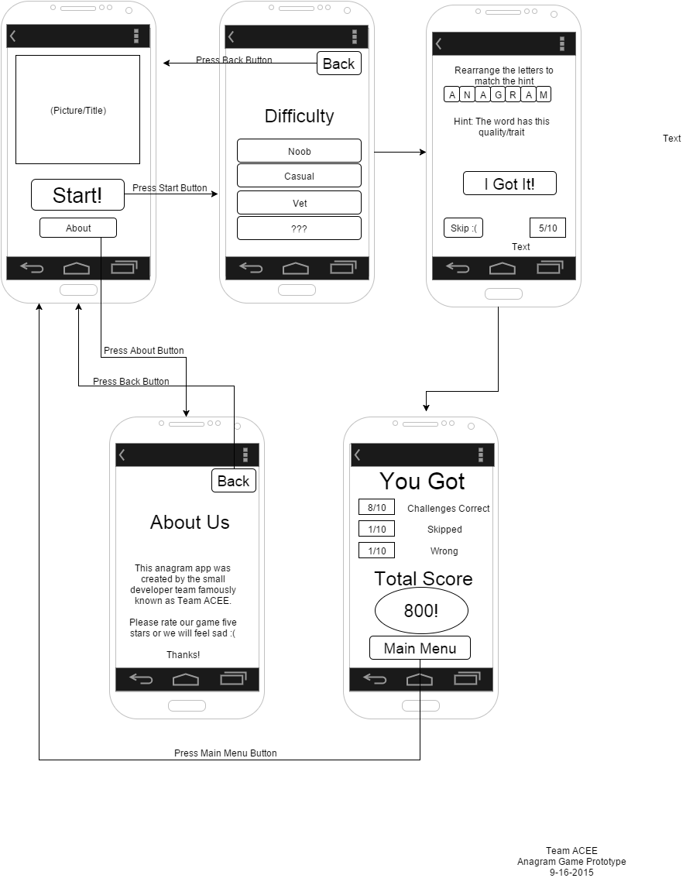

**Screen Descriptions:**

**Top left:** The title screen is where you are first taken upon entering the app. This is where you can choose whether to “Start” the game or go the “About” screen.

**Middle**: When the “Start!” button is pressed from the title screen, you are redirected to a difficulty selection screen. You can also choose to go back to the title screen with the “Back” button.

**Top right**: After choosing a difficulty, you enter the actual game screen where an anagram is displayed and the user can try to solve for the correct answer or skip the question.

**Bottom left**: The “About” screen is accessed through the Title screen. This screen will describe how the game works and give a brief description about the development team.

**Bottom right:** After the game is completed, there is a finished game page that displays your score, along with a button that will take you back to the main menu.

**Resources:**

Flow Chart Maker - Draw.io : [*https://www.draw.io/*](https://www.draw.io/)

Cloud Storage and Collaboration - Google Drive: *https://www.google.com/drive/*