EECS 3214

Assignment 1

Instructor: [Natalija Vlajic](http://www.cse.yorku.ca/~vlajic)

Student Name: Tingting Yang

Student ID: 215120579

**1. Queueing Disciplines Analyzed.**

**1.1**

Maximum Queues size is 500 in (pkts)

**1.2**

1. 4 priority ‘classes’: Low, Normal, Medium, High
2. Low priority queue: Maximum Queue size is 80 in (pkts)

Normal priority queue: Maximum Queue size is 60 in (pkts)

Medium priority queue: Maximum Queue size is 40 in (pkts)

High priority queue: Maximum Queue size is 20 in (pkts)

1. Low: Best Effort (0)

Normal: Standard (2)

Medium: Streaming Multimedia (4)

High: Interactive Voice (6)

**1.3**

1. 8 ‘weighted’ queues: Weight 1.0, Weight 10, Weight 20, Weight 30, Weight 40, Weight 50, Weight 60, Weight 70
2. All of the weight queue have the same Maximum Queue size: 500 in (pkts)
3. Weight 1.0: Best Effort (0)

Weight 10: Background (1)

Weight 20: Standard (2)

Weight 30: Excellent Effort (3)

Weight 40: Streaming Multimedia (4)

Weight 50: Interactive Multimedia (5)

Weight 60: Interactive Voice (6)

Weight 70: Reserved (7)

**2. IP Traffic Dropped.**

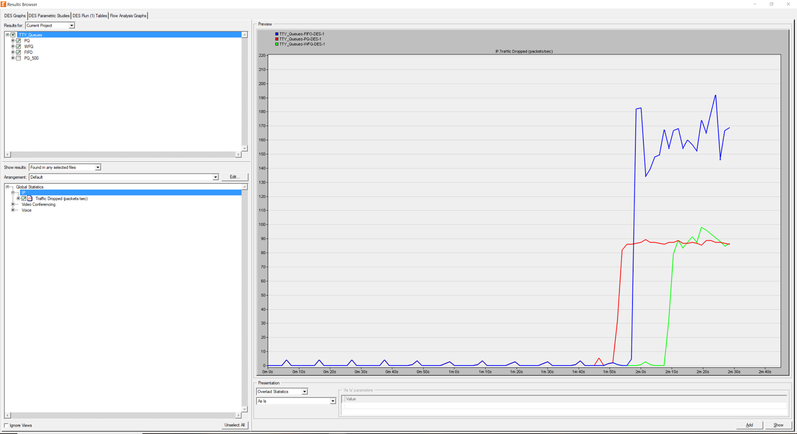

FIFO, PQ and WFQ are different in IP Traffic Drop Plot.

PQ curve: It is the first curve that start to drop, because the high priority size in PQ is the smallest one, 20 in (pkts).

FIFO curve: It is the second curve that start to drop, because the high priority size in FIFO is the second large one.

WFQ curve: It is the last curve that start to drop, because the high priority size in WFQ is the largest one, 100 in (pkts).

By comparing the priority, VoIP (voice) is the highest one, Video is the secondary, and FTP is the last one.

**3. Video Conferencing Traffic Received.**

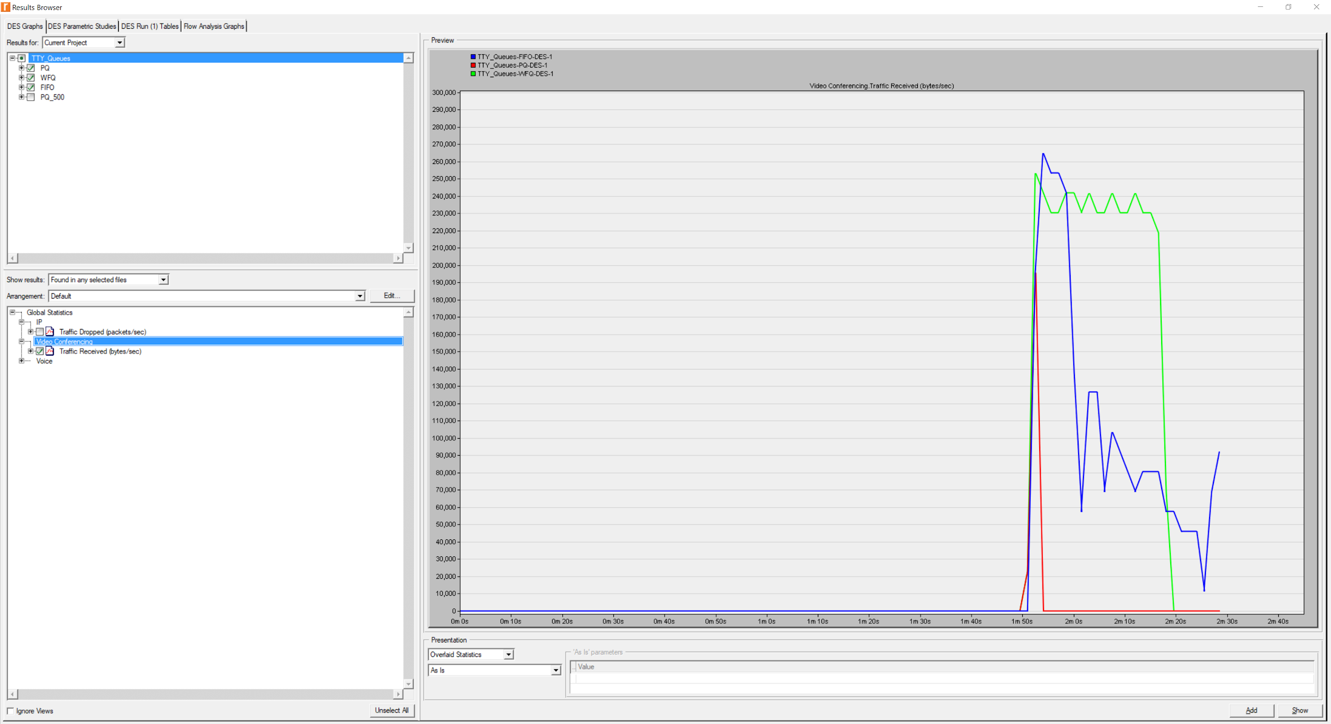

FIFO, PQ and WFQ are different in Video Conferencing Traffic Received Plot.

By comparing the priority, VoIP (voice) is the highest one, Video is the secondary, and FTP is the last one.

Because the Maximum Queue size of FIFO and WFQ is 500 (pkts), so both of them reach around 260,000 at the curve peak. Besides, PQ only reaches at 200,000 and falls after that, because video conference has second priority in PQ and the size is only 40(pkts).

**4. Voice Traffic Received.**

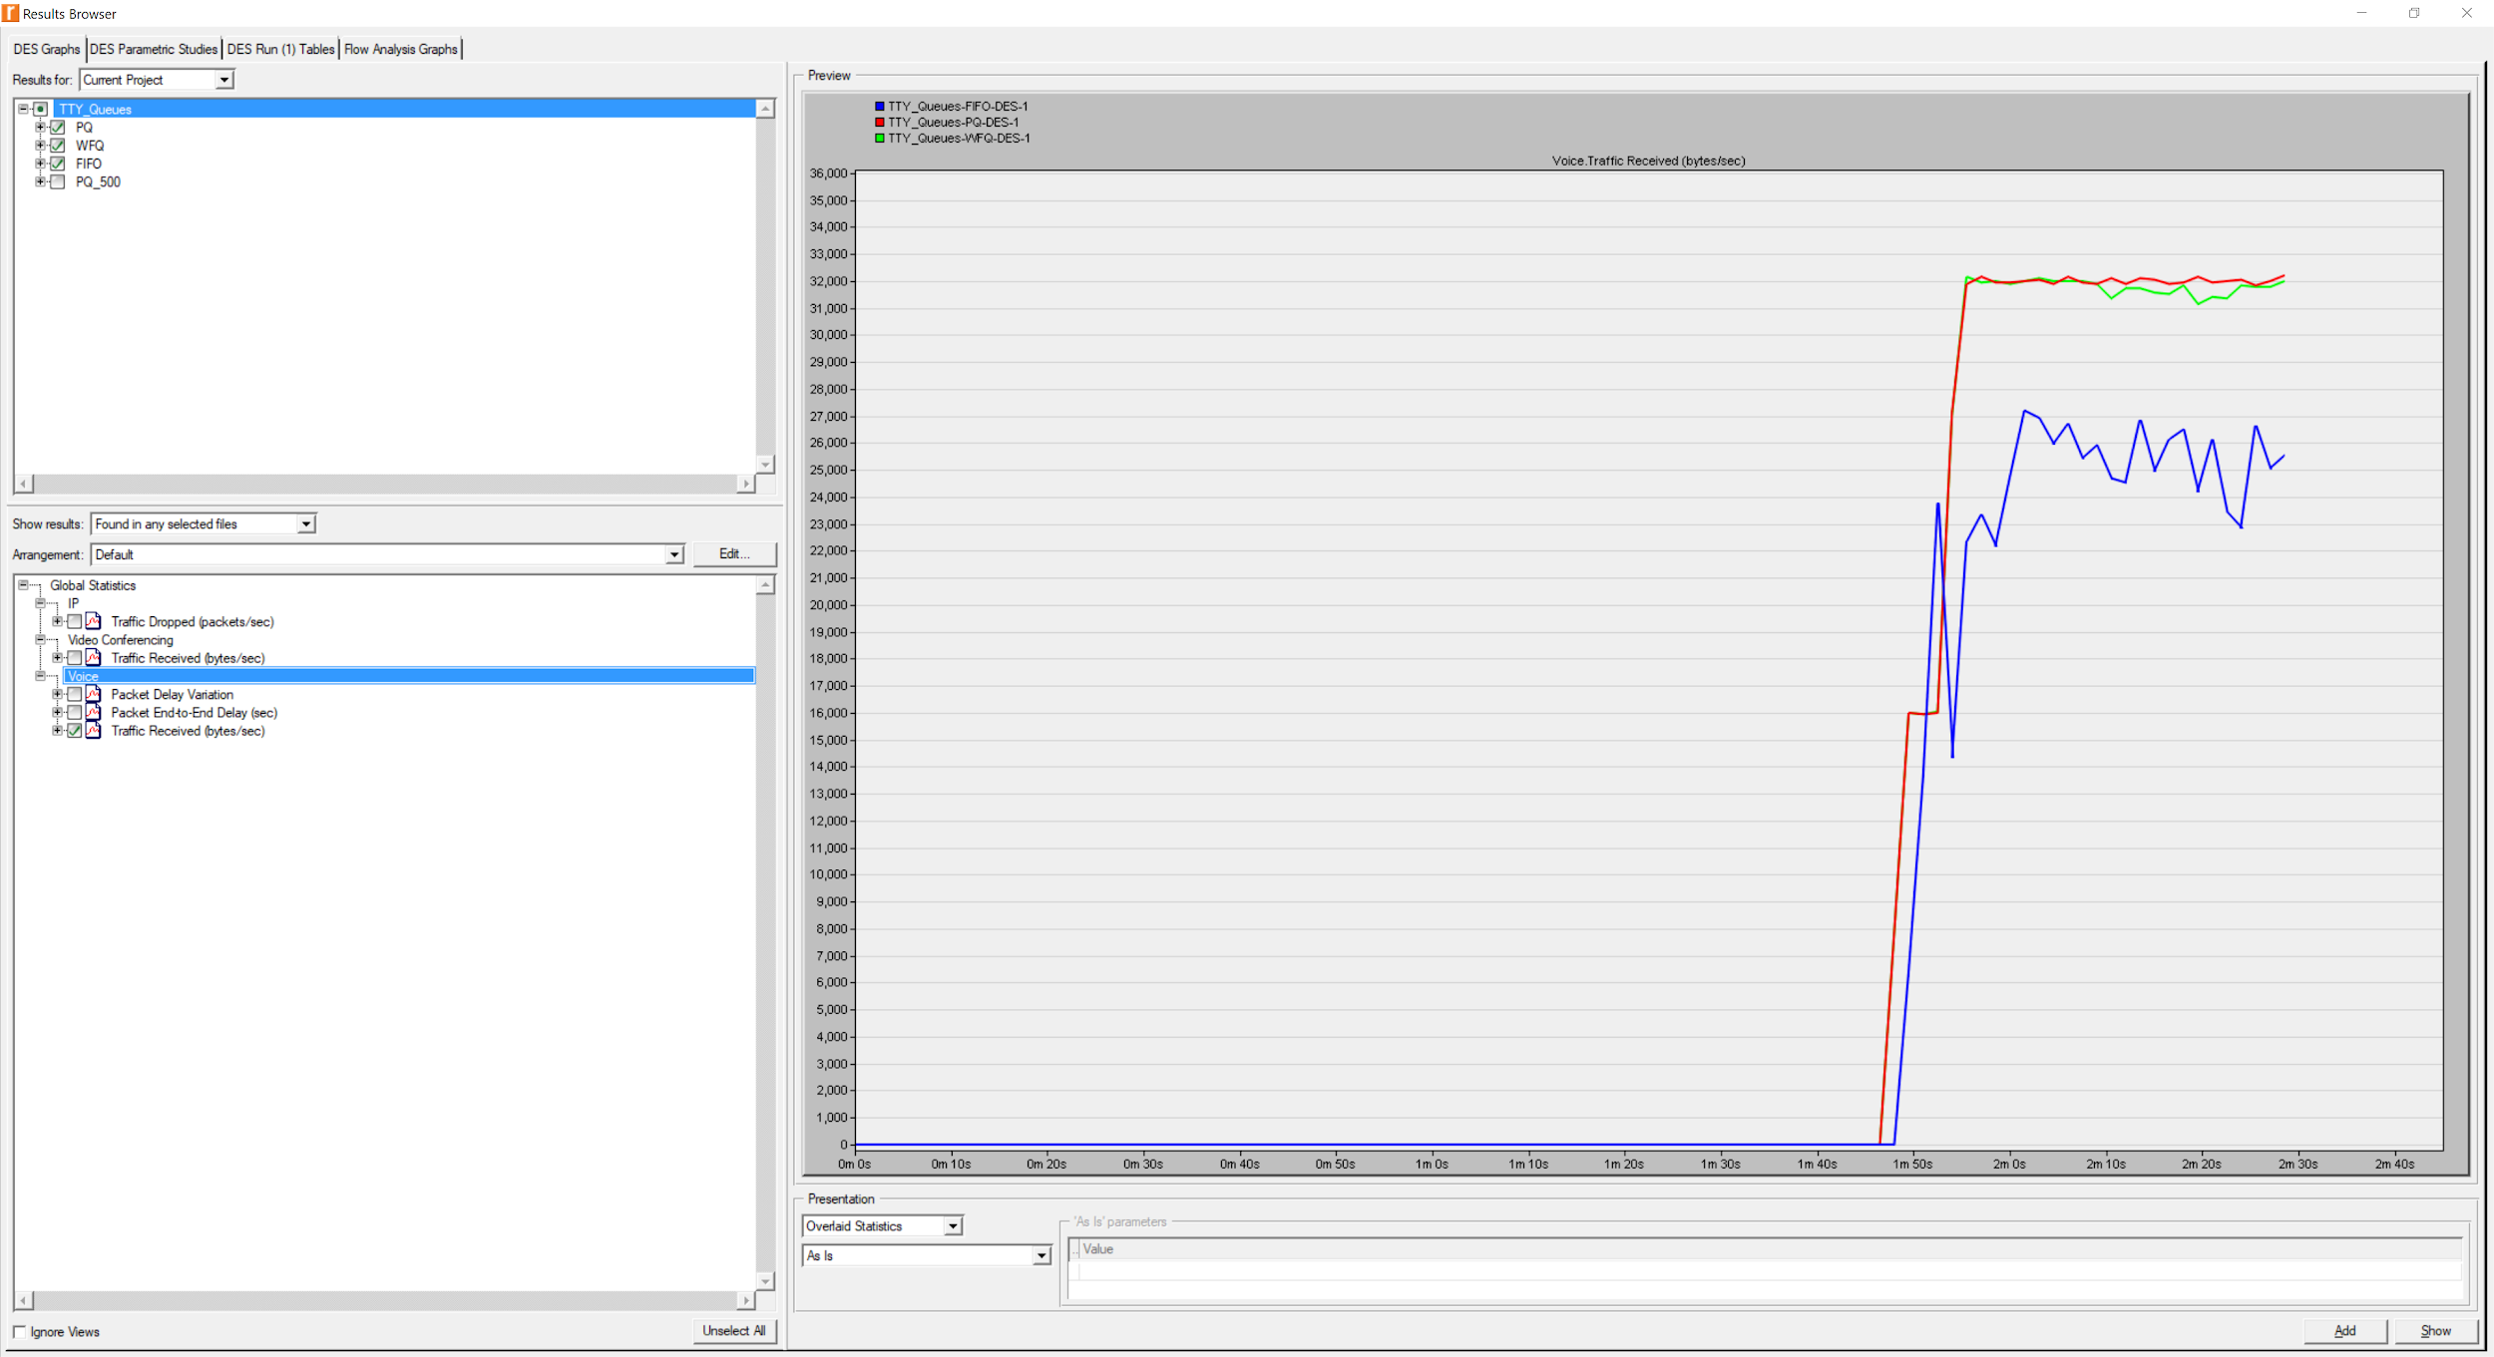

FIFO, PQ and WFQ are different in Voice Traffic Received plot.

In this plot, it is clear that FIFO curve is lower than both PQ curve and WFQ curve, because we can get a higher volume of traffic under either PQ or WFQ than FIFO.

This is the second priority voice, and any packet drop will affect the overall quality of the voice signal.

**5. Voice Traffic End-to-End Delay.**

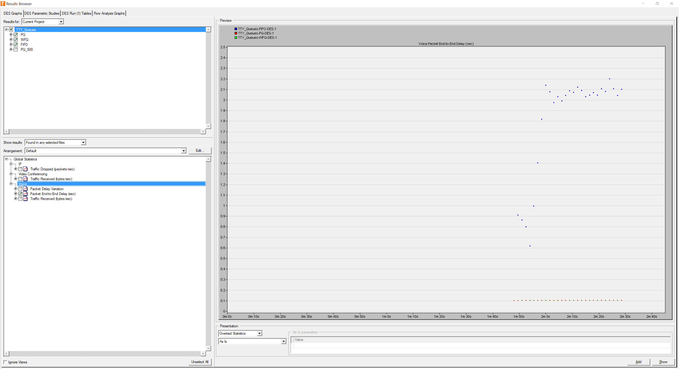

WFQ and PQ plot maintain voice and as the second priority in the Voice Traffic End-to-End Delay plot.

Then, a low bandwidth is guaranteed. Therefore, the WFQ and PQ are in the lowest curve and almost remain original status.

But FIFO is different, because FIFO has no priority, so it will keep going up and there’s no too much fluctuate.

**6. New PQ-500 Scenario.**

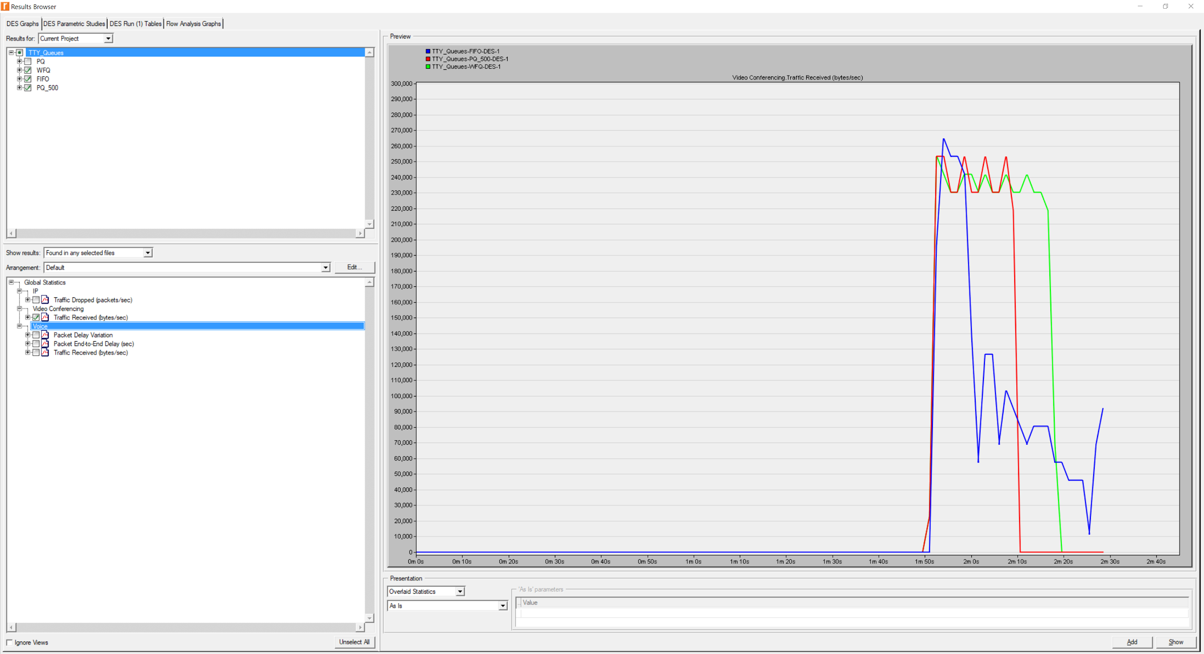

WFQ, FIFO, and PQ_500 request almost the same time for the packet drop in the new PQ-500 Scenario plot because we have increased the size of the queue to class 2 (medium) traffic from 40 to video traffic 500.

After we changed the class2 size to 500, it won’t be dropped so early because it’s too large. Therefore, it goes as high as FIFO and WFQ, and the video traffic will stop after all the video traffic are transmitted.