EECS 3214

Assignment 2

Instructor: [Natalija Vlajic](http://www.cse.yorku.ca/~vlajic)

Student Name: Tingting Yang

Student ID: 215120579

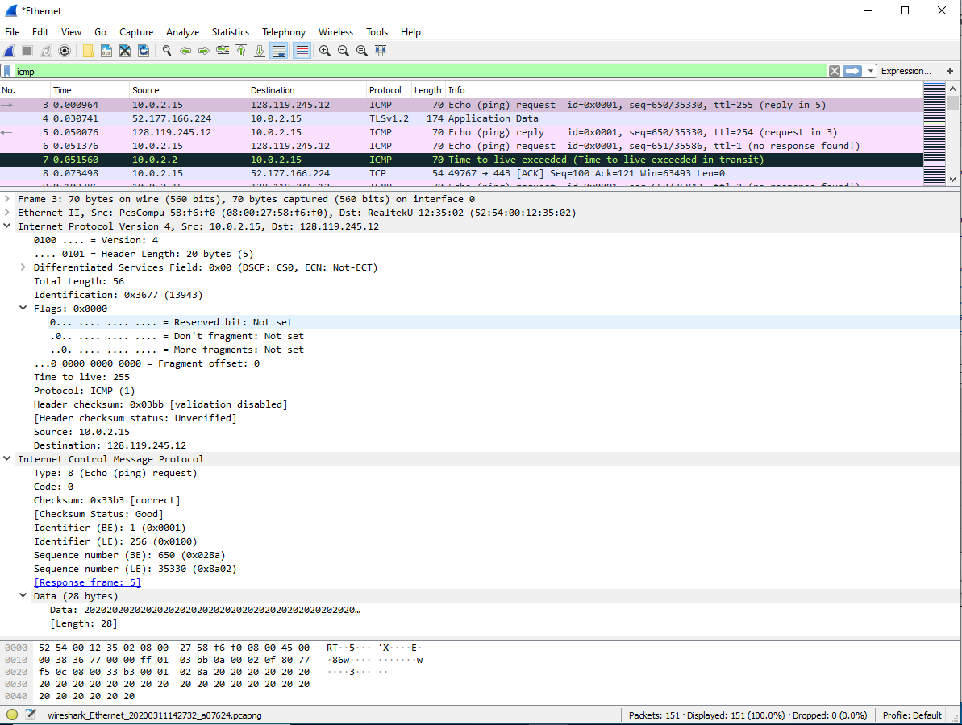

Figure 1.

1. What is the IP address of your computer?

10.0.2.15

2. Within the IP packet header, what is the value in the upper layer protocol field?

ICMP(1)

3. How many bytes are in the IP header? How many bytes are in the payload of the IP datagram? Explain how you determined the number of payload bytes.

IP Header: 20 Bytes

Total Length: 56 Bytes

IP Datagram: (56 - 20 =) 36 Bytes

4. Has this IP datagram been fragmented? Explain how you determined whether or not the datagram has been fragmented.

In Flag option, the ‘More fragments = Not set’, which means there’s no

more remain fragments, so the IP datagram is not fragmented.

5. Which fields in the IP datagram always change from one datagram to the next within this series of ICMP messages sent by your computer?

Identification

Time to live (TTL)

Header checksum

6. Which fields stay constant? Which of the fields must stay constant? Which fields must change? Why?

**Stay constant:**

1. Version
2. Header length
3. Source IP
4. Destination IP
5. Differentiated Services
6. Upper Layer Protocol

**Must stay constant:**

1. Version: because it’s version IPv4 for all packets
2. Header length: because these are all ICMP packets
3. Source IP: because the source is same for all packets
4. Destination IP: because destination is same for all packets
5. Differentiated Services: because the Type of Service class are all same
6. Upper Layer Protocol: because these are all ICMP packets

**Must change:**

1. Identification: because each IP packets must have different identification
2. Time to live (TTL): traceroute increments each subsequent packet
3. Header checksum: because header changes, so the header checksum also changes

7. Describe the pattern you see in the values in the Identification field of the IP datagram

Each ICMP Echo (ping) request increments the IP header Identification

fields.

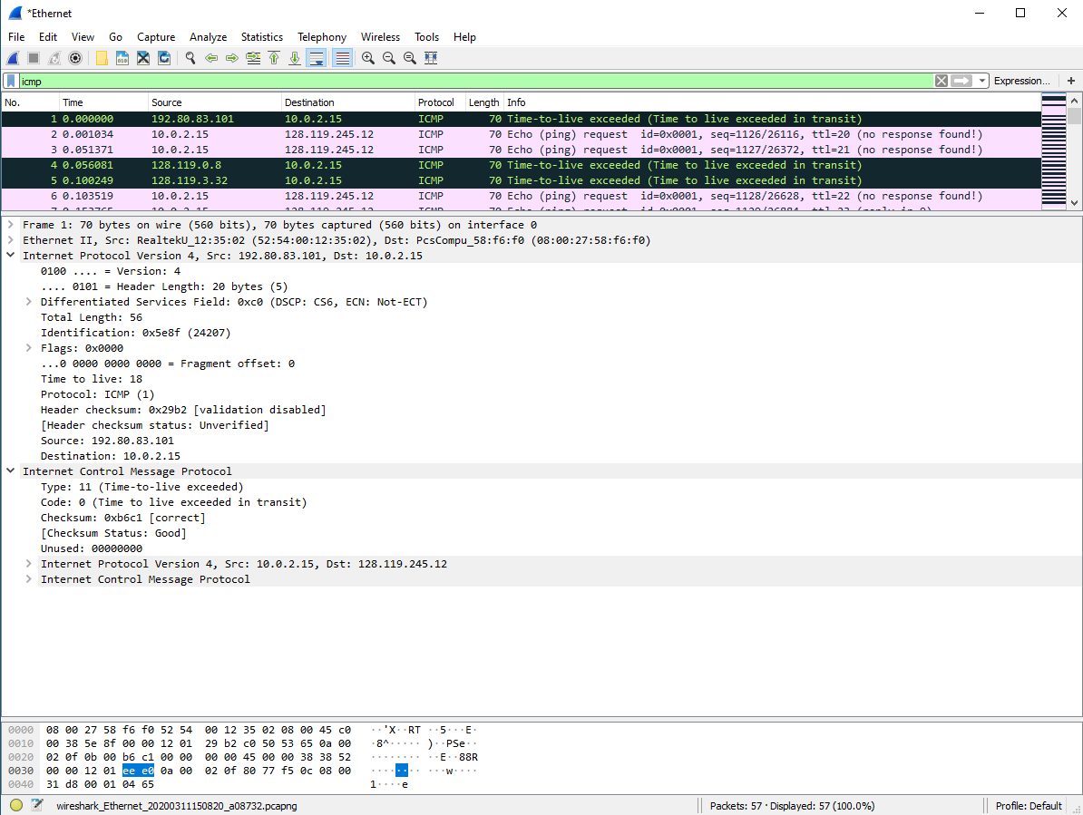

Figure 2.

8. What is the value in the Identification field and the TTL field?

Identification: 24207

TTL: 18

9. Do these values remain unchanged for all of the ICMP TTL-exceeded replies sent to your computer by the nearest (first hop) router? Why?

The identification field changes for all the ICMP TTL-exceeded replies because the identification is unique for each packet.

The TTL field remains unchanged because the TTL for the nearest router is always the same.

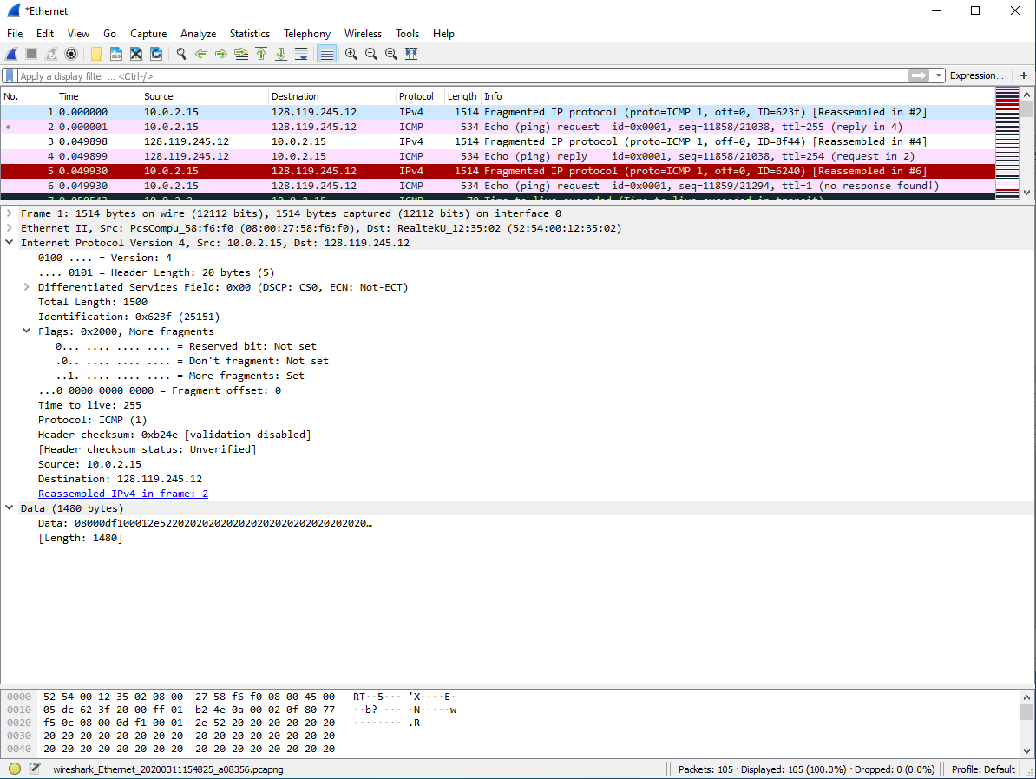

Figure 3.

10. Find the first ICMP Echo Request message that was sent by your computer after you changed the Packet Size in pingplotter to be 2000. Has that message been fragmented across more than one IP datagram?

Yes, this packet has been fragmented across more than one IP datagram, because in first fragment, the attribute ‘More fragment: Set’ means there’s more fragments after this fragment.

11. Print out the first fragment of the fragmented IP datagram. What information in the IP header indicates that the datagram been fragmented? What information in the IP header indicates whether this is the first fragment versus a latter fragment? How long is this IP datagram?

The attribute ‘More fragment: Set’ means the datagram has been fragmented;

The attribute ‘Fragment offset: 0’ means the datagram is the first fragment;

This first datagram has a total length of 1500, including the header.

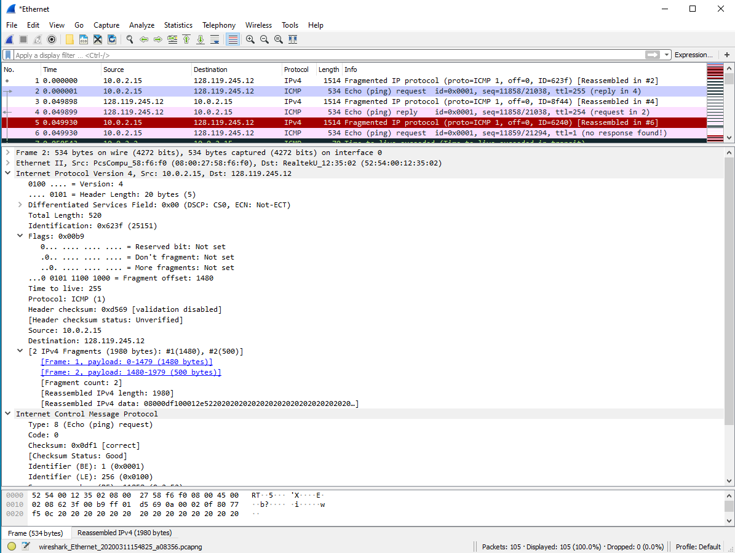

Figure 4.

12. Print out the second fragment of the fragmented IP datagram. What information in the IP header indicates that this is not the first datagram fragment? Are the more fragments? How can you tell?

The attribute ‘Fragment offset: 1480’ means it is not the first fragment.

The attribute ‘More fragment: Not set’ means it is the last fragment.

13. What fields change in the IP header between the first and second fragment?

Total length

Flags

Fragment offset

Checksum

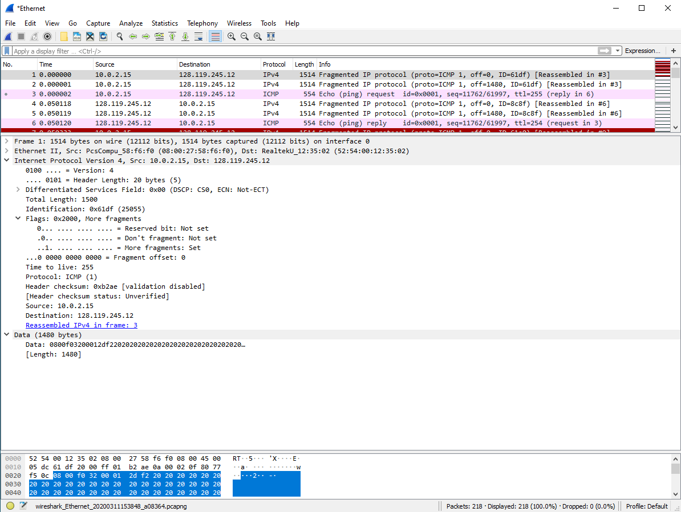Figure 5.

14. How many fragments were created from the original datagram?

3 fragments

15. What fields change in the IP header among the fragments?

1. Fragment offset

2. Checksum

3. Between the first two packets and the last packet: total length & flags