EECS 3214

Assignment 4

Instructor: [Natalija Vlajic](http://www.cse.yorku.ca/~vlajic)

Student Name: Tingting Yang

Student ID: 215120579

1. Run nslookup to obtain the IP address of York University's Web-server (i.e., the machine that hosts www.yorku.ca site). What is the IP address of this server?

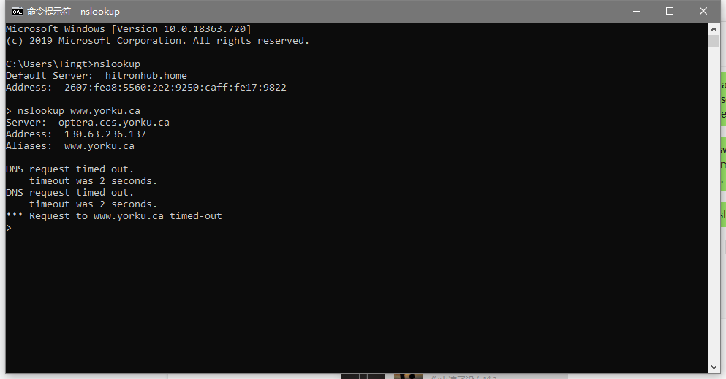

IP Address: 130.63.236.137

2. Run nslookup to determine the names and IP addresses of the Authoritative DNS servers for York University.

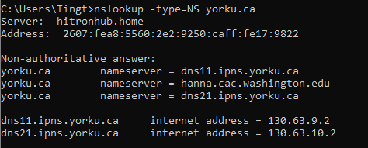

3. Run nslookup to obtained the names and IP addresses of he Authoritative DNS servers for University of Ottawa (i.e., uottawa.ca domain) - BUT not from your Local DNS server, instead obtain this information from the Google's DNS server that runs on/with IP address 8.8.8.8.

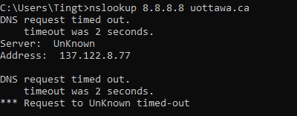

Name: Unknown

IP Address: 137.122.8.77

4. Locate the DNS Query and Response messages. Are they sent over UDP or TCP?

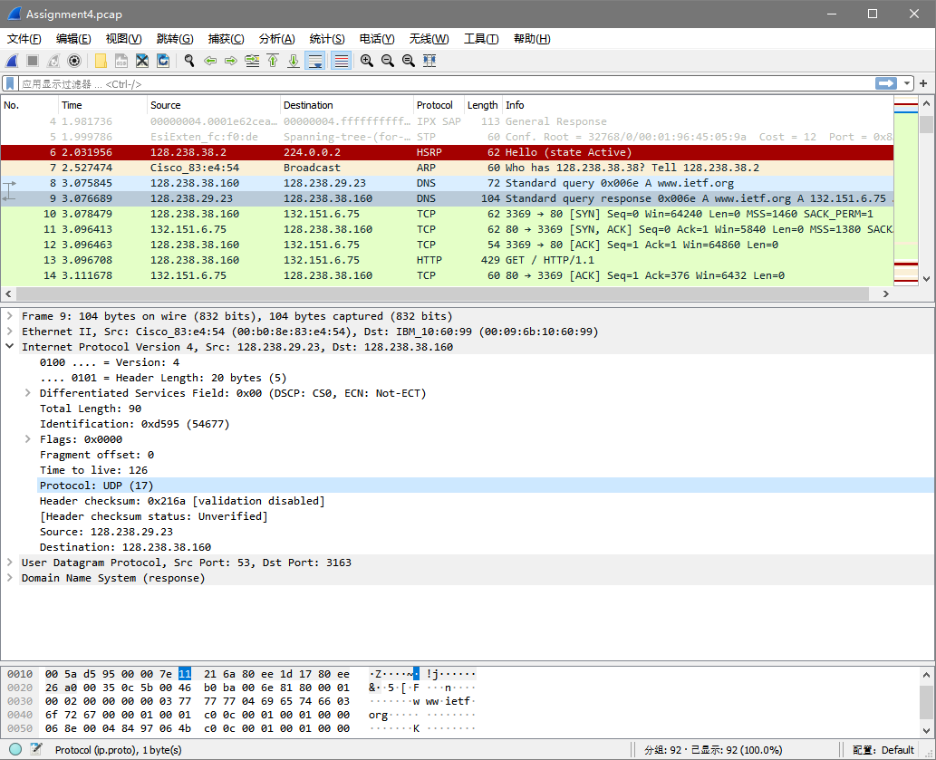

UDP

5. What is the destination port for the DNS Query message? What is the source port of DNS Response message?

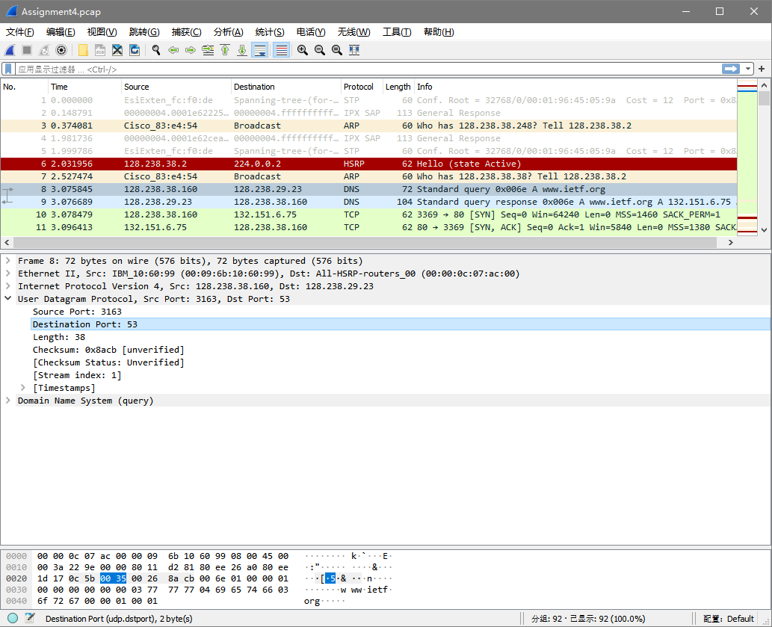

Destination port: 53

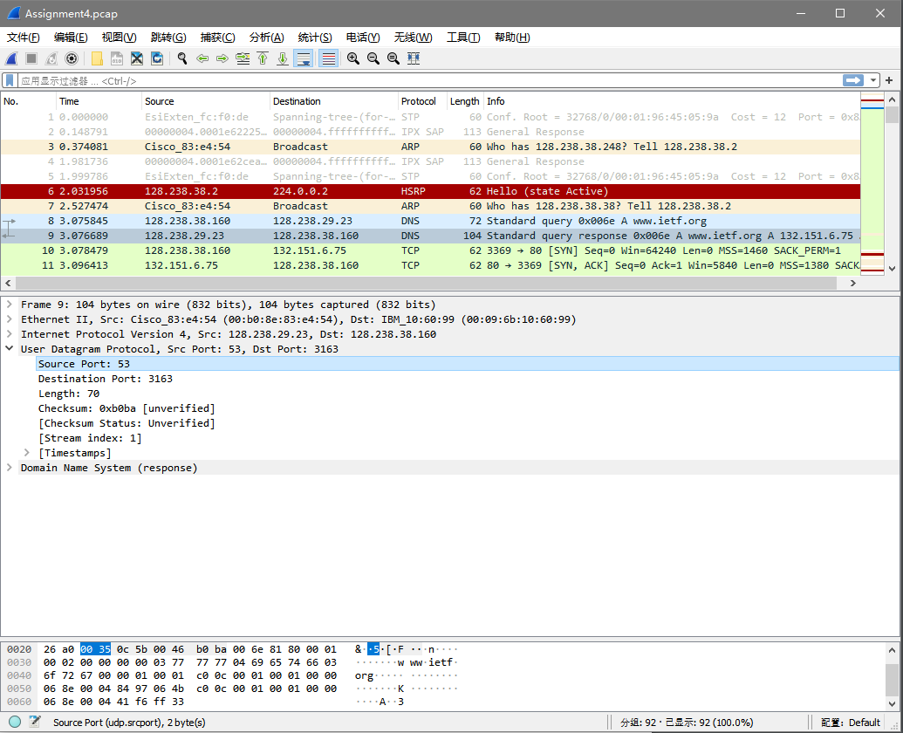

Source Port: 53

6. Examine the DNS Query message. What “Type” of DNS query is it? (Check the message's OpCode field.) Does this query message contain any “answers”?

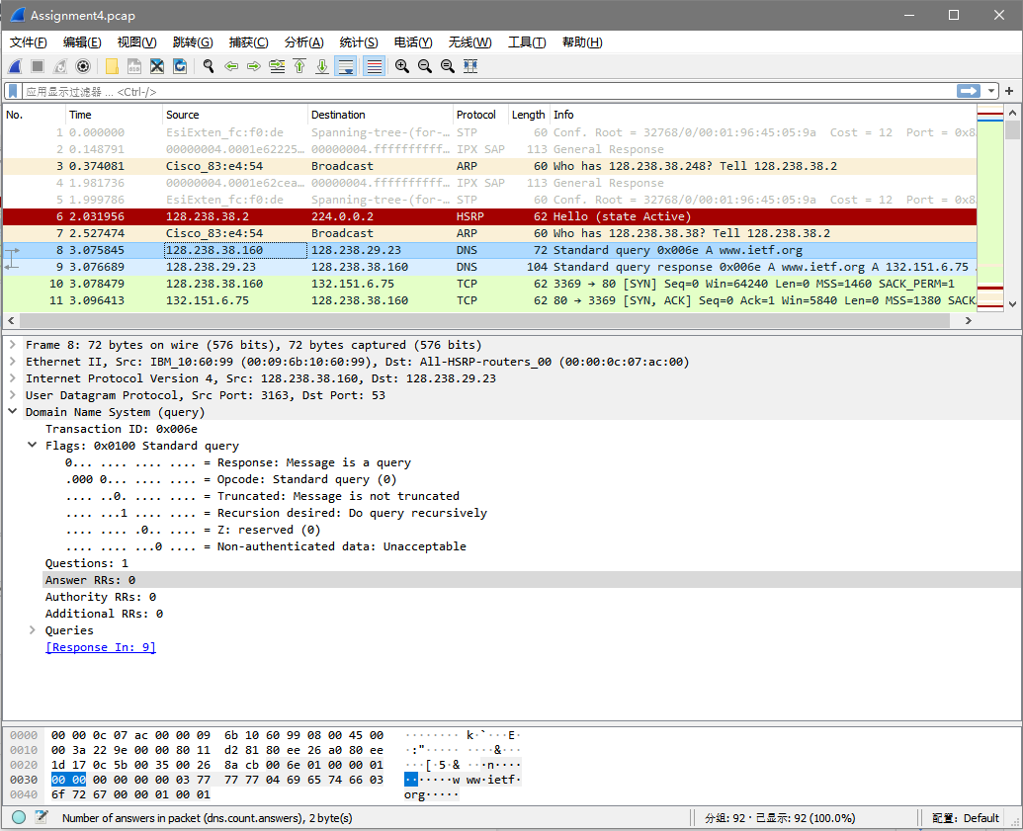

Type: type A Standard Query

It doesn’t contain any answers

7. Examine the DNS Response message. How many “answers” are provided? What do each of these answers contain?

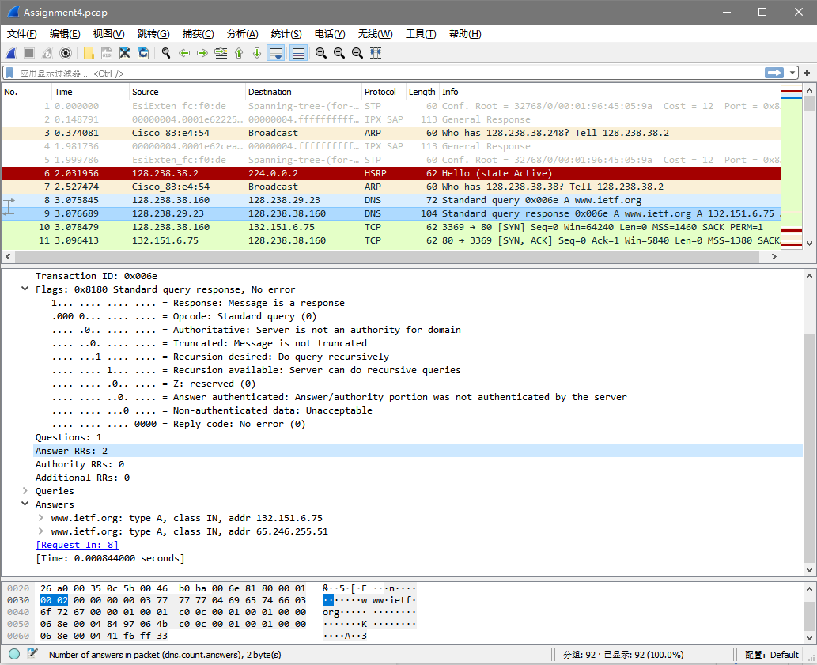

2 answers

type A, class IN, addr 132.151.6.75

type A, class IN, addr 65.246.255.51

8. Consider the subsequent TCP SYN packet sent by the host. Does the destination IP address of the SYN packet correspond to any of the IP addresses provided in the DNS Response message?

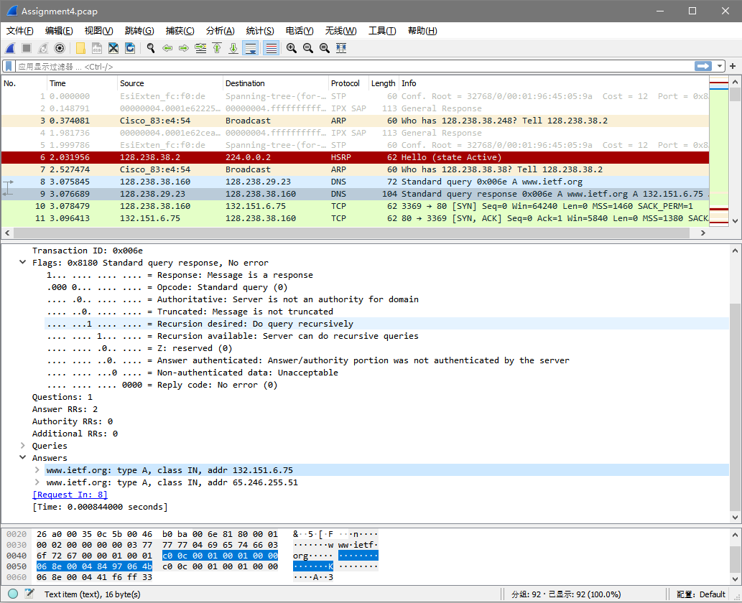

132.151.6.75

9. Which type of DNS server, do you think, has sent the DNS Response message (Local, Root, Authoritative)? Justify your answer!

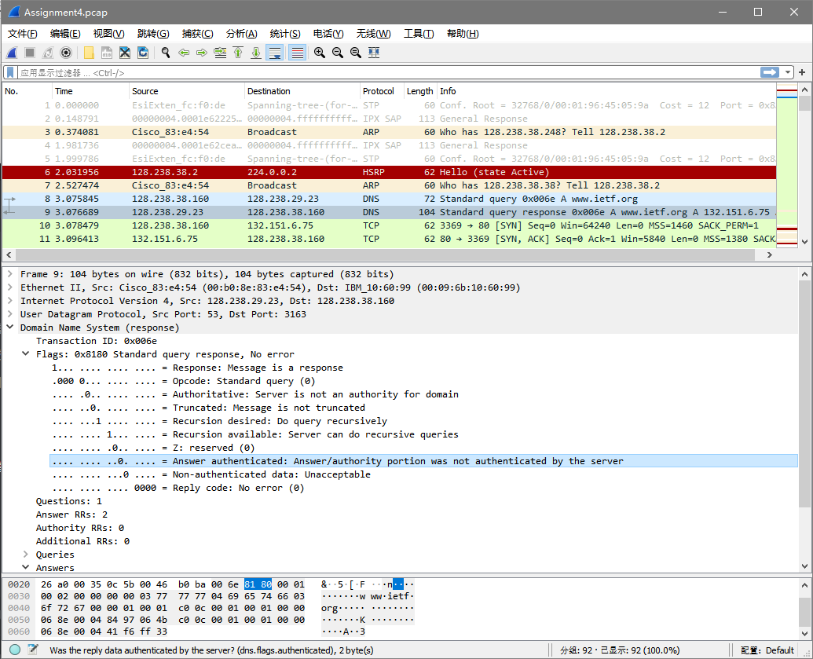

Authoritative

10. Does the DNS server from Question 9 support recursion?

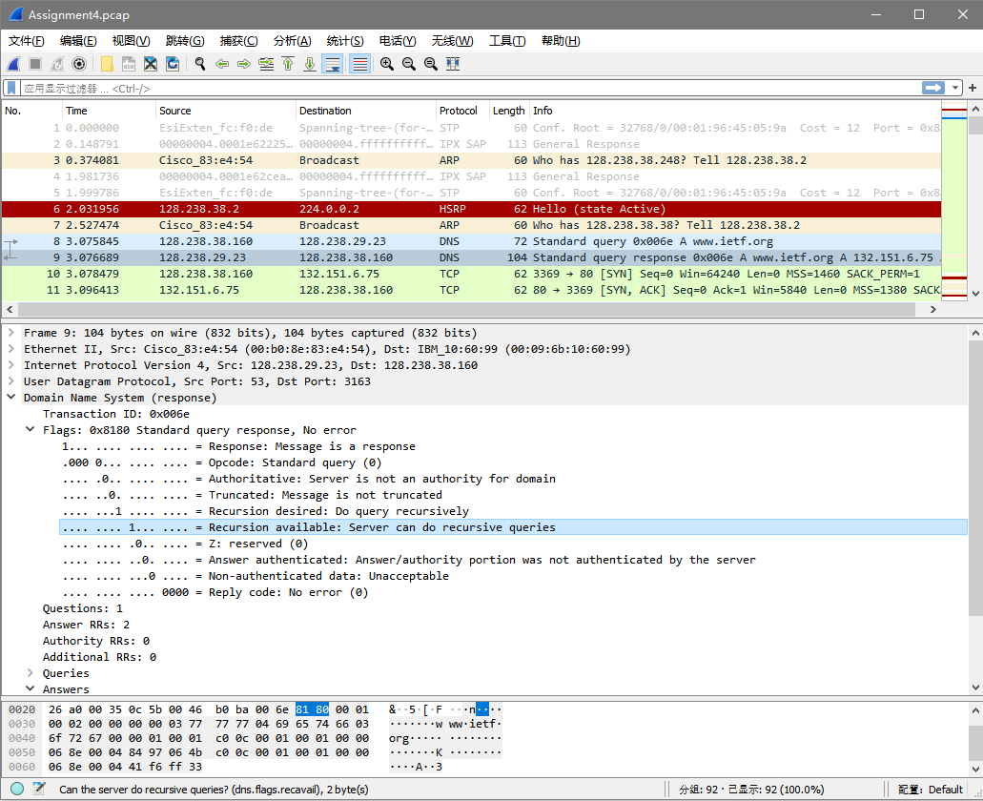

Support recursion because the flag = 1