**Coding challenge**

A Rust program is needed which calculates the **surface area** and **volume** of a **dodecahedron**.

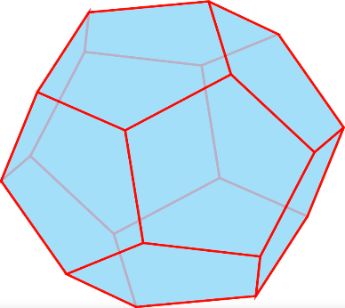

[This Photo](https://tikz.net/dodecahedron/) by Unknown Author is licensed under [CC BY-SA](https://creativecommons.org/licenses/by-sa/3.0/)

**Design notes:**

* Here are the two formulae you’ll need:

$$Volume=\frac{15+7 √5}{4} a^{3}$$

$$Area=3\sqrt{25+10\sqrt{5} } a^{2}$$

**Note**. In both cases, *a* is the length of one of the sides of the dodecahedron

* Manually convert these to Rust-compliant arithmetic expressions.
* Test your program using suitable test data (*see below*).
* Verify your calculated results here:

<https://en.neurochispas.com/geometry/volume-of-a-dodecahedron-formulas-and-examples/>