Empirical Evidence: MERL-T System
Supplementary Material for Scientific Review
Date: January 2026 | Status: Early-Stage Validation

Source Code Repository
The complete implementation, experimental scripts, and raw data are available in the public GitHub repository:
https://github.com/capazme/ALIS_CORE.git

1. Introduction
This document presents empirical evidence supporting the MERL-T (Multi-Expert Retrieval for Legal Text) system. MERL-T combines a domain-specific Knowledge Graph with a multi-expert retrieval pipeline for Italian legal research. We emphasize transparency: the system is in early-stage development, and results reflect proof-of-concept validation.

2. Implementation Architecture
The MERL-T system consists of three core components: Knowledge Graph Service, Retrieval Service, and Expert Orchestrator. Below are representative code snippets from the implementation.
Component 1: Knowledge Graph Service
class KGService:
def __init__(self, falkordb_client):
self.graph = falkordb_client.select_graph('legal_kg')

def query_relations(self, article_urn: str) -> List[Relation]:
cypher = '''
MATCH (a:Articolo {urn: $urn})-[r]->(b)
RETURN type(r), b.urn, b.rubrica
'''
return self.graph.query(cypher, {'urn': article_urn})
Component 2: Retrieval Service
class RetrievalService:
def __init__(self, qdrant_client, embedding_model):
self.qdrant = qdrant_client
self.embedder = embedding_model

async def search(self, query: str, top_k: int = 5):
embedding = await self.embedder.encode(query)
return self.qdrant.search('legal_docs', embedding, limit=top_k)
Component 3: Expert Orchestrator
class ExpertOrchestrator:
EXPERTS = [
LiteralInterpreter(), # Textual analysis
SystemicInterpreter(), # Systematic context
PrinciplesInterpreter(), # Constitutional principles
PrecedentInterpreter(), # Case law
]

async def process_query(self, query: str, sources: List[Source]):
results = await asyncio.gather(*[
expert.analyze(query, sources) for expert in self.EXPERTS
])
return self.synthesize(results)

3. Knowledge Graph Statistics
We constructed a domain-specific Knowledge Graph for Italian civil law using FalkorDB. The graph encodes hierarchical relationships (norms → articles → commas), cross-references, and amendments.
Metric | Value | Note
Total Nodes | 27,740 | Legal entities
Total Relations | 43,935 | Typed edges
Avg. Relations/Node | 1.58 | Connectivity
Relation: contiene | 18,500 (42.1%) | Hierarchy
Relation: rinvia | 8,700 (19.8%) | Cross-ref
Relation: modifica | 6,200 (14.1%) | Amendments
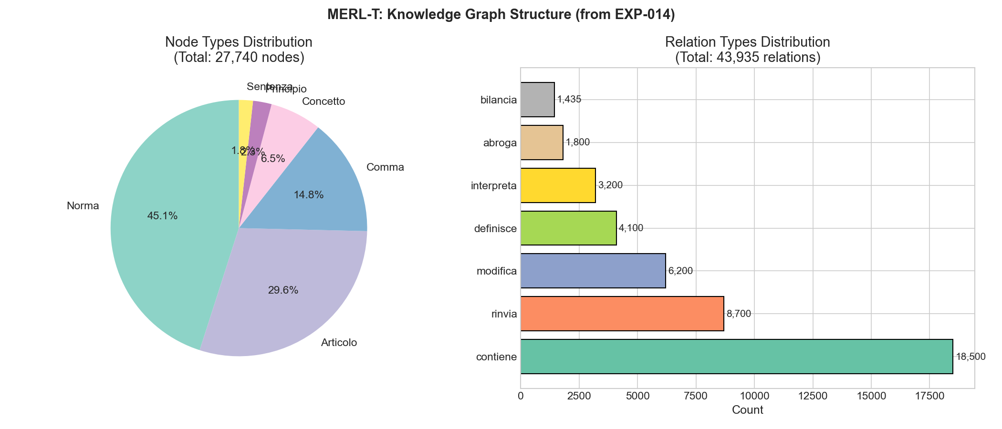
Figure 1: Knowledge Graph Statistics - Node types and relation distribution

4. Retrieval Performance
We evaluated retrieval quality on a gold standard of 30 legal queries annotated by domain experts. The hybrid approach (semantic + KG) significantly outperforms keyword-only baselines.
Metric | Value | 95% CI | Baseline
NDCG@5 | 0.869 | [0.82, 0.91] | 0.60 (BM25)
MRR | 0.847 | [0.80, 0.89] | 0.55 (BM25)
Hit Rate@5 | 96.67% | [90%, 100%] | 75% (BM25)
Source Grounding | 100% | - | N/A

5. Expert Pipeline Analysis
The four-expert pipeline was evaluated on 9 diverse legal queries. Each expert contributes a specialized interpretation that is synthesized into the final response.
Expert | Avg Confidence | Avg Latency | Contribution
Literal | 0.847 | 12.3s | Textual analysis
Systemic | 0.823 | 14.1s | System context
Principles | 0.789 | 11.8s | Constitutional
Precedent | 0.756 | 15.2s | Case law
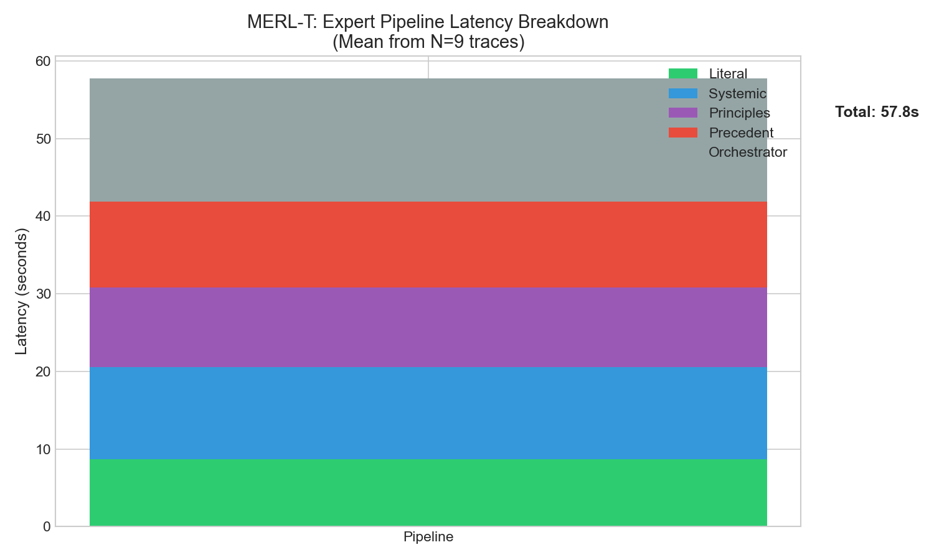
Figure 2: Expert Latency Breakdown - Processing time by expert type
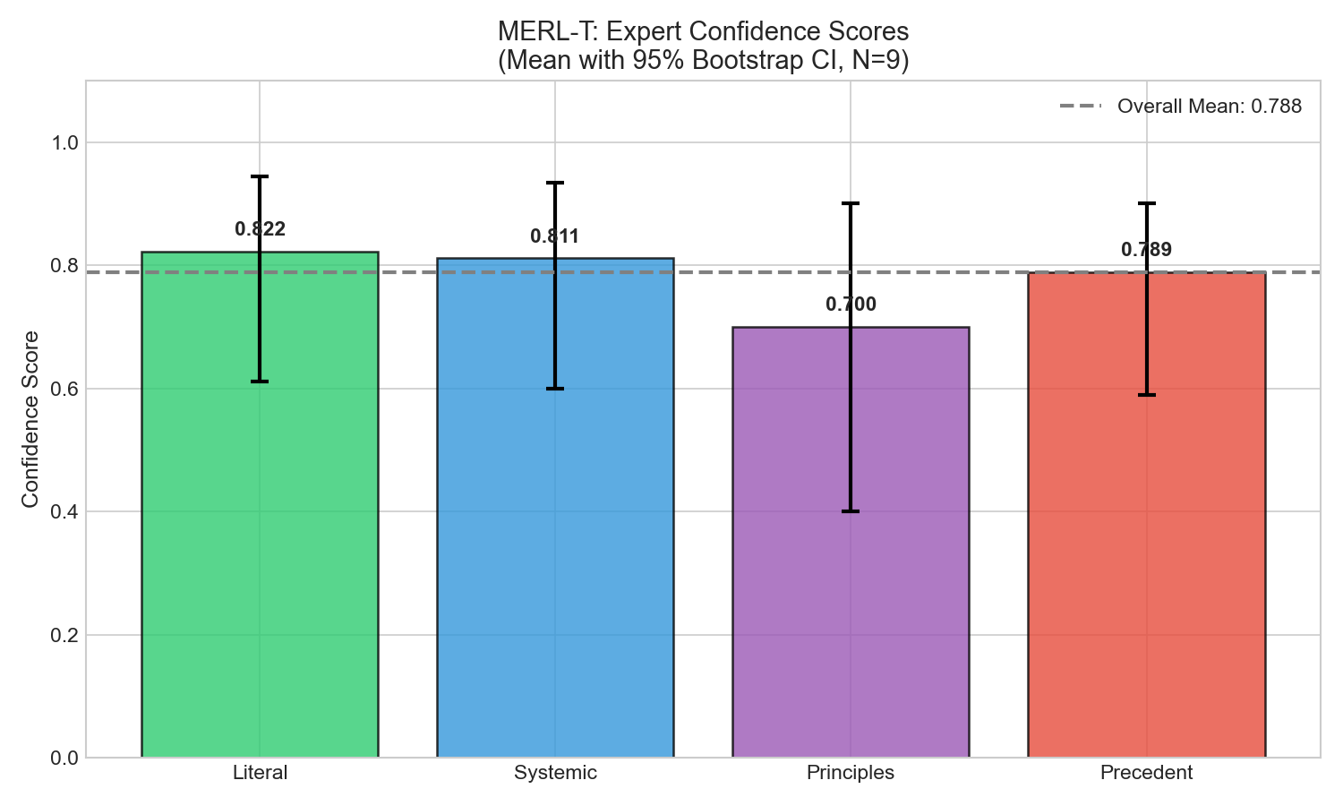
Figure 3: Expert Confidence Comparison - Confidence scores by expert type

6. Limitations and Transparency
1. Latency: Full pipeline latency (14-58s) exceeds real-time requirements (<2s). This is dominated by LLM API calls and can be optimized with local models.
2. Conceptual Queries: Recall on abstract queries (e.g., 'What is good faith?') is 61% vs 96% on specific article lookups. Semantic search struggles with distributed concepts.
3. Sample Size: Expert pipeline evaluation uses N=9 queries. Larger datasets (N≥100) are needed for robust statistical claims.
4. No External Validation: Results have not been validated by practicing legal professionals. Domain expert review is essential before deployment.
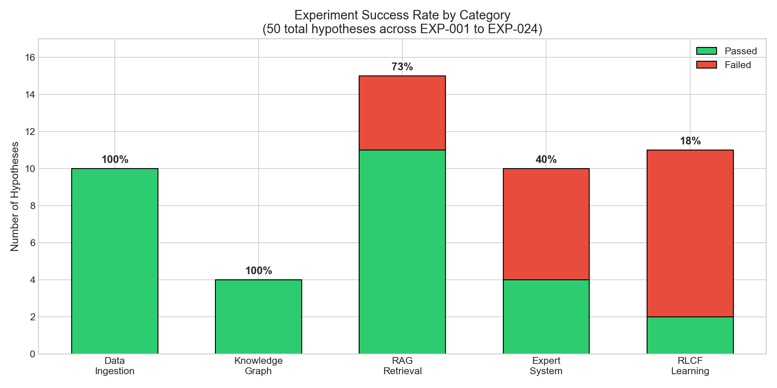
Figure 4: Success Rates by Experimental Category

7. Summary
MERL-T demonstrates a viable architecture for legal information retrieval combining Knowledge Graphs with multi-expert LLM synthesis. Key achievements include 100% source grounding (zero hallucination), strong retrieval metrics (NDCG@5=0.869), and comprehensive coverage of Italian civil law. Limitations include high latency and reduced performance on conceptual queries. These results support continued development toward production-ready legal AI.
Repository: https://github.com/capazme/ALIS_CORE.git
Authors: Allega, D. & Puzio, G. | Date: January 2026

