Certification White Paper

INTENDED AUDIENCE

This document is written for various types of audiences internal to Capgemini only. Here is the intended benefit to each reader:

Practitioner – To better understand the opportunities available and value to you related to pursuing internal certification, and to serve as a reference tool to understand and initiate the process of certification for programs most appropriate for your skills and career objectives.

Capgemini Management – To provide a high-level overview of the Capgemini certification programs to use as a reference when counseling and mentoring your team members.

Sales Team – To provide an explanation of the value received by the client related to a robust Capgemini certification program.

# Capgemini Certification

## Why Have Capgemini Certification Programs?

There are already several independent external certification programs available…why should Capgemini have their own suite of certification programs? Capgemini’s certification programs allow us to build a real market differentiator. They are a unique combination of external and internal qualifications, proven methodologies, continuous innovation and value creation through collaboration. The initial goal for Capgemini certification programs was to provide a skills appraisal of our professionals, and to assist with consistency in staffing international assignments. But now, the goal of Capgemini certification programs is more robust. It is to imprint a “Capgemini way” into our DNA and make it a real market differentiator for the Group. Capgemini is investing in our own certification programs to provide maximum benefit to:

* our practitioners by providing development opportunities, recognition, rewards and the ability to belong to lively professional communities,
* our clients by demonstrating how we can guarantee the qualifications of our people, and
* the shareholders overall by reducing risks, providing homogeneity across a heterogeneous organization and enabling us to deliver higher client satisfaction (OTACE).

Capgemini certification programs assess and recognize practical skills and knowledge, methods mastery based on proven delivery experience, leadership, community contribution and capability to capture and re-use the Group heritage.

***Benefits to Practitioners*** - Capgemini certification programs show our commitment to our people by defining and investing in the development of foundation skills and methods. They provide a map for growing professionally and within a community. They are a peer-to-peer recognition, not a performance appraisal. The certification programs are up-to-date and aligned with the Group strategy. Obtaining Capgemini certification allows our practitioners to align their careers to foundation roles that are in long-term demand by the marketplace. By meeting the certification criteria defined by a certification program, he/she proves the knowledge and experiences gained related to the “Capgemini way”. In most cases, this certification allows for higher priority on leading edge engagements; greater success by understanding and meeting Capgemini delivery measures; increased value in the market as a proven, certified consultant and participation in a global community of people in the same program and irregardless of level.

***Benefits to Clients*** – Clients benefit from our Capgemini certification programs by having engagements delivered by qualified people who have been assessed against a rigorous set of criteria, thereby helping to improve the quality of projects; reduce project risks and execution problems; and receive a consistent, successful approach to delivering results. By designing the certification programs to encompass external certification at most levels, along with criteria related to prior, successful experience, the client is assured of working with qualified, experienced consultants who understand the content (proven through external certification for the technology programs) and have applied it (through prior engagement experiences using group methods and additional Capgemini certification criteria).

***Benefits to the Shareholders*** – Capgemini benefits as a company by strengthening its brand and reputation as a consistent, reliable provider of quality services. It also improves the financial standing through increased profitability from less project overruns and reduces overall risk. Capgemini is also more effective as a global provider of services by having consistent foundation skills and roles that serve as a differentiator in the marketplace.

## The Capgemini Approach to Certification

The Capgemini certification process is designed to work at various levels and across various domains. It is linked to our Global Competency Model. Certification programs focus on the third layer of the model – Shared Capabilities and Discipline/ Profession Specific Competencies.

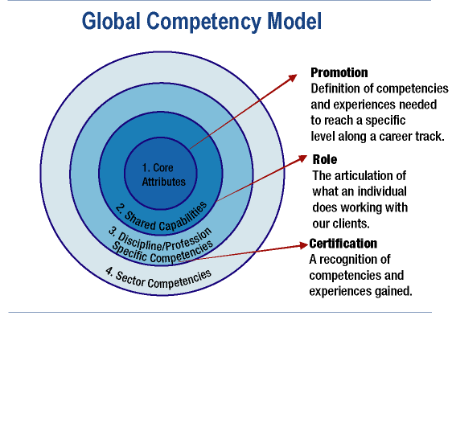

Each certification program is based upon the following fundamentals:

* Application of Capgemini methods to emphasize understanding of the Capgemini way
* Experience in the field to prove understanding of approach
* Proven soft skills to demonstrate ability to work effectively with clients, partners and colleagues
* External certification, when applicable (technology programs), to ensure achievement of external market recognition and capability.

Go to the [Global Competency Model](http://talent.capgemini.com/$talent/document?IDsection=258) for more information.

Each Capgemini certification program includes four levels of certification. The first two levels are managed and administered at a local level, but controlled globally. The third and fourth levels are conducted at a global level to ensure consistency and recognition across the Group. Each level has certification criteria that build upon the previous level, with additional areas of mastery and experience expectations. Here is a general description of each level:

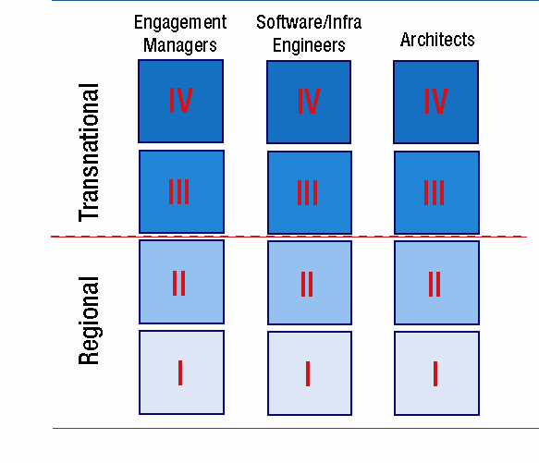

Level 1, Practitioner – has met all of the foundation criteria, including base knowledge, successful delivery experience and community participation

Level 2, Senior – builds upon Level 1 to include additional experience, expertise in 1-2 areas, sales experience, external certification (in most cases, if not during Level 1), leadership and mentoring.

Level 3, Enterprise – continues to build upon the previous two levels, and includes leadership and performance in an international environment and a transnational team, thought leadership, external recognition of expertise.

Level 4, Global - includes all of the criteria for the first three levels, and is a market influencer via thought leadership, internal and external speeches, publications and other proofs of market recognition.

The Group Certification Framework defines four foundation roles for client-serving professionals: Consultants, Architects, Engineers and Engagement Managers. Related to each Discipline, foundation roles have associated core methods, further linked to the business model of each Discipline. Our target is to certify professionals who fit these related roles.

## Group Certification Framework Rationale

## FrameworkRational

## A Capgemini Way of Delivering Engagements

Capgemini certification is content-rich and relates to methods that are the result of years of field experience, combined with external market standards. This is a unique way to differentiate our services and our brand. The best expression of the output of certification is the client value it brings: it is all about the “Capgemini way”, where certification ensures we have people who not only have been trained, but are also experienced in our methods, procedures, standards, and who meet the key criteria of experience in the field. For example, when somebody new starts with the Group, with over 10 years of related experience, Capgemini wants to be in a position, via certification, to say that on top of a person’s own experience, skills and personality, he or she has the Group’s heritage when it comes to delivering value to our customers. In doing so, we develop our professionals, ensuring they have received and shared the number one asset of our firm…its people richness. The explanation of our foundation roles we recognize to deliver engagements follows:

**Consultants** provide strong management consulting skills to help clients analyze and strengthen their performance by redefining key processes and transforming major components of their businesses.

* Business Processes Consultants (a program will be developed in 2005)
* Transformation Consultants (TC) are the advisors to client executives, designing and delivering complex programs to solve their business and technology issues. They work with CXOs to articulate the issues, develop and implement a transformation program, to generate high impact results. These programs address both the Business Transformation and Technology Transformation issues. There are three tracks:
  + 1. CEO-Selling track for the team of experienced transformation consultants who focus on establishing peer to peer relationships with client executives and converting this quickly into solid transformation business;
    2. Transformation Design and Delivery track aimed at the transformation practitioners delivering high client value on Phase 1 and Phase 2 transformation engagements, and
    3. ASE (Accelerated Solutions Environment) track for the consultants designing and facilitating ASE DesignEvents, to help business leaders and their teams make better, faster decisions. This track begins with the **Collaboration Engineer** certification for consultants who demonstrate mastery in 1) designing all of the Group’s acceleration and collaboration tools into engagements; 2) facilitating ASE-style acceleration workshops for groups; and 3) managing “Collaboration Stations”, ASE environments at the client site. Certification Levels 2 through 4 are for consultants working within the ASE itself.

**Architects** are IT professionals who combine business understanding with deep technical knowledge and experience to develop IS&T solutions to business problems. By creating solution designs and enterprise standards at the conceptual, logical and physical levels, Architects help organizations achieve their vision through integrated development and deployment of IS&T. Architects, utilizing the Capgemini Integrated Architecture Framework (IAF), assist in implementing the IT Strategy of our client’s enterprise through the design of both the IT landscape and specific information systems and technical infrastructure. They plan the migration to this design vision within the context of each client; integrating consequences, priorities, costs and technology choices to allow alignment with the enterprise business strategy and goals. Architects play a central role in managing delivery risk for Capgemini ensuring that solutions are technically and commercially feasible. Capgemini Architects have as a central design principle the goal of developing solutions for customers that are adaptive.

**Engineers**are solution builders. There are three types of engineers:

* Software Engineers (SE) are solution builders enabled to automate and customized business functions meeting specific requirements. From our system design and analysis roles, through development, testing and implementation, the SE program encompasses all aspects of typical systems development and delivery. It recognizes specialty areas in terms of roles and technologies, coupled with, at higher levels, breadth of experience across the complete project lifecycle. External certification, through recognized certification bodies and vendors, is a major constituent of the program and is complimentary to what we aim to achieve.
* Infrastructure Engineers (IE) are infrastructure solution builders enabling companies to use automated functions. Our solutions are secured and reliable due to the infrastructure services provided and its design and usage of standards to allow all data to be accessible in the way needed. While Software Engineers focus on the development of customized application solutions meeting specific requirements, Infrastructure Engineers focus on the development of the generic infrastructure components that support many applications; even if these are being developed when triggered for a specific solution. Areas of focus include: Networks, Server Platforms, Storage Technologies, Middleware, Security and System Management. Engineers support their respective domain from the initial Assessment through the Design and Build phase on to the Run stage.
* Enterprise Application Consultants (EAC) are solution builders focusing on enterprise applications/packages. They provide an understanding of functional requirements of a business area, which they are able to discuss in detail with clients. They also possess deep product knowledge, which enables them to configure and implement enterprise applications for our clients to create competitive advantage.

**Engagement Managers** (EM) are those who have been given day-to-day responsibility for the management of a project, program or service that will produce the required products or services, to the required standard of quality, within specified constraints of time and cost, and to the client’s satisfaction. They control the engagement, by monitoring progress, resources, budget, scope, risk etc. and determining the necessary actions to keep the engagement on track.

## A Sound and Reliable Program

Capgemini has defined a complete, formal certification program suite. Each program has the following components:

* Active Community of Practice, including tools (CHS, Discussion Forums, events, etc)
* Related method(s)
* Knowledge repositories
* Mechanisms for learning
* Certification Criteria
* Structured certification process
* Global and Regional Certification Boards

These components provide a framework for ensuring the Capgemini certification programs are respected internally, as well as externally as a complete and objective certification program that consistently acknowledges capable, experienced professionals.

## Interested in Getting Certified?

It is very important to understand the difference between Capgemini grades and certification – they are complementary to each other, but not necessarily synchronized. The two do not measure the same attributes of a Capgemini practitioner. Grading is an evolution path for a practitioner to follow through their career that measures many aspects of a person’s job. Certification measures how they have demonstrated their skill base, experiences and specific capabilities associated with a particular role. Achieving certification may help you move from one grade to the next, but it is not an absolute requirement. For example, a person could be promoted from grade to grade every few years, but remain at level 2 of a particular certification program for several years or the rest of their career, due to characteristics of their role within that area, such as remaining a regional practitioner.

The links below will take you to the global home pages for each of the certification communities. Review the certification criteria to determine which type of certification best fits your career path.

|  |
| --- |
| [Transformation Consultant](http://knew.capgemini.com/gl-tc-chs) |
| [Architect](http://architecture.capgemini.com/) |
| [Engineer - Software Engineer](http://knew.capgemini.com/KNEW/Databases/CHS/CHSGlTechProf.NSF/0/E97568ADB775550CC1256DAA00325ED9/$file/software_eng.htm) |
| [Engineer - Infrastructure Engineer](http://iec.capgemini.com/) |
| [Engineer – Enterprise Application Cons](http://eac.capgemini.com/) |
| [Engagement Manager](http://eminfocenter.capgemini.com) |

Each certification community site describes the detailed process to follow to obtain certification, however, the following describes, at a high level, what to expect.

* Obtain sponsorship – speak with your counselor, mentor or line manager to discuss the types of certification programs available; actions you may need to take in order to meet the certification criteria and sponsorship to proceed
* Plan for and take specific actions to fill in the gaps related to specific certification criteria (e.g., take a course on a Capgemini methodology, obtain external vendor certification, or assist with a sales pursuit). The TS and CS Schools provide excellent courses, which are tightly linked to the certification programs.
* Fill out and submit your candidate nomination form to the appropriate regional representative. Answer questions in preparation of the Global or Regional Certification Board review
* Upon certification, serve as a mentor to others related to all aspects of certification and the criteria associated with it (e.g., coaching, knowledge sharing, participation in communities, thought leadership)

To ensure our foundation skills remain up-to-date with the marketplace and current certification criteria, practitioners must renew their certification every 24-36 months, depending upon the program.

## Into the Future with Confidence

By institutionalizing and implementing our own internal certification, Capgemini is *building a key differentiator where we work collaboratively with our clients and colleagues to deliver high client satisfaction and leave a legacy.* Market recognition of our certifications is the main way to get more value from our programs. The push and drive internally needs to be echoed and boosted externally.