# How does your crow fly?

**Speaker**: Robert Fowler (*@RobertFowler007*)

**Presentation link**: <https://github.com/cape-town-testing/meetup/blob/master/2018-Q2/Presentations/How_Does_Your_Crow_Fly.pptx>

1. Robert is an engineer, but it doesn’t matter what your role is.
2. Three “kicks in the head” that influenced career
   1. **Problem space vs. solution space** – challenge the way we think about the problem and change how much time we spend understanding the problem
   2. Get back to **first principles / fundamentals**
   3. **Get to the value quickly**
3. These will all help you:
   1. Understand the problem
   2. Rethink the problem
   3. Construct and *out-of-the-box-thinking* solution

## Problem space vs. solution space

1. We jump too quickly to the solution, forgetting to explore the problem space
2. The concept may seem foreign, but it can be learnt
   1. Allows us to be more creative if we have a better understanding

## First principles / fundamentals

1. First principle thinking allows us to deal in truth without bias
2. Ensures that we are building on something solid
3. Always testing your thinking against such principles

## Deliver value quickly

1. Lean thinking - Add value in the shortest time possible (Robert C. Martin)
2. Test Driven Development example from Robert C. Martin’s book Clean Code:

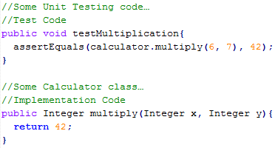

Money Shot

1. Quickest piece of code to meet the requirements of the test
2. It doesn’t make sense initially –eventually will be fixed in future iterations
   1. Initially do the illogical to get the desired result
   2. Read up on this example

## Closing

1. Quote from W. Edwards Deming:

“*It is not enough to do your best; you must know what to do, and then do your best.*”

1. Simplicity is the art of maximising the amount of work done – Agile principle