Answers:

1. Question focus: one-sided binomial test

To calculate the likelihood that this sample represents a decline in the reported percentage, we calculate the probability of finding 1,953 blue eyed people or fewer within a sample of 5,982 people given a 33.8% probability. This is found by evaluating the cumulative binomial distribution with n=5,982 : k = 1,953 : p = 0.338

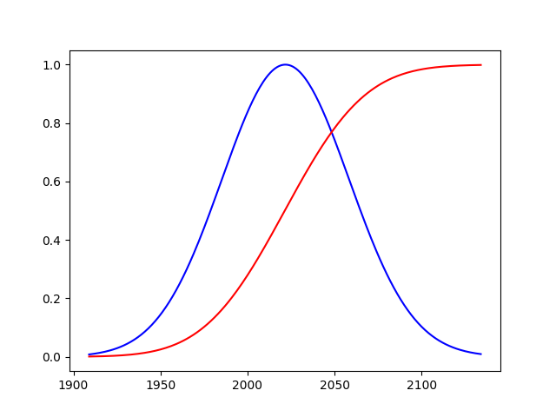

We find that the probability of finding 1,953 blue eyed people or fewer is just 3.04%. If we are looking for a 95% confidence level this would then indicate a decline in the percentage of people being born with blue eyes.

To identify the 95% confidence level, we seek the first cumulative distribution value that exceeds 5%. In this case, when k = 1962. This represents the level above which there is a 95% chance of having identified that many blue eyed people within a sample of 5,982 people given a 33.8% chance of having blue eyes.

1. a. True- statistical hypothesis tests establish the likelihood of obtaining the observed data assuming the null hypothesis. The results are deemed statistically significant if the null hypothesis meets predefined criteria for unlikeliness.

b. False- if the null hypothesis fails to meet the criteria and is rejected, it does not follow that the proposed alternative hypothesis is therefore true.

c. True- When a parameter is only theoretically possible in one direction (Acres of forest, for example, can’t be negative), a one-sided alternative hypothesis is appropriate.

d. False- The alternative hypothesis should be stated such that it is distinguishable from the null hypothesis in a way that can be determined by the statistical hypothesis testing process.

e. True- As the sample size grows to be a larger percentage of the total population, the need for simple random sampling decreases

f. True- the p-value represents the probability of observing the sampled data given the null hypothesis. Larger values indicates a higher likelihood of the observation, thus stronger evidence that the null hypothesis is true

g. False- the p-value is the probability of observing a more extreme test statistic in the direction of the alternative hypothesis than the one observed

h. False- the p-value indicates the likelihood of the observed result given the null hypothesis but is not a direct measure of the probable validity of the hypothesis itself.

1. Similar to question 1, we calculate the CDF for n = 5312 : p = 22.8% : k = n\*p. In this case we are interested in finding the one-sided p-value for values >= k. This can be found by summing the binomial distribution from k to n, or by pval = 1-CDF[k-1]. This gives a pval = 0.013. Thus the answer is (e) and there is strong evidence for an increased percentage of unaffiliated adults in San Francisco. (The actual San Francisco statistic is 33.4%)
2. The hypothesis assumed is the null hypothesis, not the alternative. “Assuming the null hypothesis, there is a 2.3% chance of obtaining a result equal to or more extreme than what was actually observed.”