Sarah A. Cushing

Monday, September 29, 2014

Web Programming Fundamentals

**Problem Solving**

**A Cat, a Parrot, and a Bag of Seed**

**Define the problem:**

The problem is that the man needs to get all three of his belongings to the other side in an order that will prevent him from losing any of passengers due to predation. The goal is to figure out which pairing between the parrot, cat and seed on both sides of the riverbank will keep the parrot and seed safe. Some insight into the problem: cats don’t usually eat bags of seed, nor do bags of seed eat cats. Also, birds can fly.

**Break the problem apart:**

The constraints of this problem are that the man can only bring over one belonging at a time, due to the small size of his boat, and that nothing can be left in a pairing on either side of the riverbank where one might eat the other.

The sub goals are to figure out what pairing will work without anything being eaten, and which order they need to be ferried over to the other side in.

**Identify potential solutions:**

A solution for the predatory problem is that the cat and the bag of seed can be left together without risk.

A solution to the problem of what order to bring them over in is to have the bird fly back and forth alongside the boat while the man brings the bag of seed over, and then the cat.

Another possible solution to the order problem would be to bring the bird over first and put him away somewhere safe. Then bring over the bag of seed and then the cat.

**Evaluate each potential solution:**

Each of these solutions would meet the goal, and would work in all cases so long as the bird is safely tucked away or with the man.

**Choose a solution and develop a plan to implement it:**

I would have the man tie the bird to the boat with enough rope to allow him to fly above it. Then I would have him bring the cat over to the other side of the river, and then go back and bring the bag of seed over. He will only need to make two trips and none of the passengers will be left alone in a combination that would allow on to eat the other.

**Socks in the Dark**

**Define the problem:**

The problem is to figure out how to guarantee that you will pick out the correct number of socks.

**Break the problem apart:**

The constraints are that each solution has to be the smallest number of socks to meet each part of the criteria.

The sub goals are to figure out the smallest number of socks you would need to pull out of the drawer to get one matching pair, and then the smallest number to get a matching pair of each of the three colors.

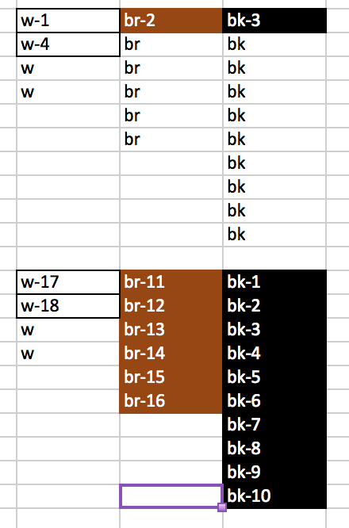**Identify potential solutions:**

The solution for each sub goal is to figure out the probability for each, and then translate that into a number.

**Evaluate each potential solution:**

The solution should meet the goal, and should work in both cases.

**Choose a solution and develop a plan to implement it:**

My solution is to map out the number of socks in the drawer, by color, and then count out what the smallest possible number is for both sub goals.

**Answers:**

The smallest number of socks I would need to select to guarantee getting one matching pair is 4.

The smallest number of socks I would need to select to guarantee getting one matching pair of each color is 18.

**Predicting Fingers**

**Define the problem:**

The problem is that I need to figure out what finger the little girl will be on when she counts to 10, 100 and 1000 without actually having to count that high on our own fingers. I should be able to find a pattern, and then use that pattern to determine which finger she will be on for each question.

**Break the problem apart:**

I have to use the left hand only, otherwise the sequence will be out of order. The sub goal of this problem is to find the pattern that will allow us to determine which finger the little girl will be on when she counts to 10, 100 and 1000.

**Identify potential solutions:**

The potential solution I have come up with is the count the fingers on my left hand in the same manner that the little girl was for a number of sets of ten, and then record which finger I am on. After I see a pattern emerge, I will use that pattern to solve all three cases.

**Evaluate each potential solution:**

I believe that the solution above will meet the goals, and it will work for all cases.

**Choose a solution and develop a plan to implement it:**

I will use the fingers on my left hand to count to 10 in the same manner as the little girl. I will record which finger I am on. Then I will continue to count on my fingers to 20, and then record the finger. I will do the same for 30, 40, 50, and so on until I find a pattern. Once I have found the pattern, I will determine which finger will be chosen if I were to count to 100. I will then take that result’s pattern and figure out the pattern for every 100 to find out which finger she will be on by the time she counts to 1000.

I tested the solution by counting on my fingers a few times to find the patterns.

10 is pointer

20 is ring

30 is ring

40 is pointer

50 is pointer

60 is ring

70 is ring

80 is pointer

90 is pointer

100 is ring

110 is ring

130 point

150 ring

170 pointer

190 ring

200 pointer

210 pointer

230 ring

250 pointer

270 ring

290 pointer

300 ring

310 ring

**Answers:**

On 10 the little girl would be on her pointer finger.

On 100 the little girl would be on her ring finger.

On 1000 the little girl would be on her ring finger.