

**DR. D. Y. PATIL VIDYAPEETH**

**PIMPRI, PUNE – 411 018**

**DR. D. Y. PATIL BIOTECHNOLOGY & BIOINFORMATICS INSTITUTE**

**TATHAWADE, PUNE**

**A Mini- Project Report on**

**……………Face Recognition System ……………**

**Submitted By**

**NAME OF MEMBERS SEAT NUMBER**

**1. SACHIN RATHOD 343**

**2. SHREEYA SHARMA 345**

**3. KEDAR 359**

**ARTIFICIAL INTELLIGENCE & DATASCIENCE**

**ACADEMIC YEAR 2022-2023**



**DR. D. Y. PATIL VIDYAPEETH**

**PIMPRI, PUNE – 411 018**

**DR. D. Y. PATIL BIOTECHNOLOGY & BIOINFORMATICS INSTITUTE**

**TATHAWADE, PUNEs**

**CERTIFICATE**

**This is to certify that the Mini- Project Report entitled**

**Face Recognition System**

Is a bonafede work carried out by the students under the supervision of **Mrs. Akanksha Goel** and it is submitted towards the partial fulfillment of the requirement Project Based Learning

Mrs. Akanksha Goel Prof J.K Pal

Subject TeacherDirector

**ARTIFICIAL INTELLIGENCE & DATASCIENCE**

**ACADEMIC YEAR 2022-2023**

Problem Statement

.

To develop and implement live facial recognition system.

ABSTRACT

We are living in a world where everything is automated and linked online. The internet of

things, image processing, and machine learning are evolving day by day. Many systems

have been completely changed due to this evolve to achieve more accurate results. The

face recognition system is a typical example of this transition, starting from the traditional

signature on a paper sheet to face recognition. This Project proposes a method of

developing a comprehensive embedded face recognition system showing whether the face of the person is the individual for that specified purpose. The system is based on the machine learning algorithm which is to be implemented on python language and using computer/laptop camera for the input image of the students or a normal outer camera can also be used which has to be connected to the system which is programmed to handle the face recognition by implementing the Local Binary Patterns algorithm LBPs.

Introduction

Everyday actions are increasingly being handled electronically, instead of pencil and paper or

This growth in electronic transactions results in great demand for fast and accurate user identification and authentication.

Access codes for buildings, bank accounts and computer systems often use PIN's for identification and security clearances.

Using the proper PIN gains access, but the user of the PIN is not verified. When credit and ATM cards are lost or stolen, and unauthorized user can often come up with the correct personal codes.

Face recognition technology may solve this problem since a face is undeniably connected to its owner expect in the case of identical twins

**Where else is facial recognition used for?**

Depending on the situation, the facial recognition algorithm can play two distinct functions.

The first time a facial recognition system addresses a face in order to register and correlate it with an identity so that it is recorded in the system. This is known as digital onboarding with facial recognition.

The option in which the topic is authenticated before being registered. Throughout this step, the incoming data from the camera is cross-checked against the existing data in the database. If the subject's face matches a previously registered identification, he is allowed to use his credentials to access the system.

Lifecycle of System

PLANNING

Distributing different tasks to group members, resource, time analysis.

ANALYSIS

Fetching information of different users

DESIGN

Designing databases, designing the complete business logic

IMPLEMENTATION

Implementing front end and back-end codes,

MAINTENANCE

Cost estimation of system.

TESTING

Testing codes and entire system.

Business Logic

Business logic in this project is dealing with image processing for real time face recognition. For naïve users a front end i:e GUI is provided with help of tkinter module.It is integrated with database using pandas module to store records of user’s.

Step 1: Start

Step 2: Install dependencies-namely opencv-python, tinkter,pandas using pip install in terminal.

Step 3: Create folder in project directory called dataset with training images with label’s

Step 4: Data of user is added to the dataframe as record in relational database excel (.csv).

Step 4: Use opencv to access webcam, take images and pass these images to make a training set.

Step 5: Output video footage in real time

Step 6: Use haarcascade file to detect landmark’s and compare the footage frames with trained images.

Step 7: Calculate the measurements using the landmarks to create a template which is in numerical form.

Step 8: On taking input through camera iterate through these templates and match for measurements on face.

Step 7: If face is a match draw rectangle on face and print label.

Step 8: Stop

Details of hardware and software Requirements

**Requirement analysis:** In the first phase of the incremental model), the product analysis expertise identifies the requirements and the system functional requirements are understood by the requirement analysis team. To develop the software under the Incremental model this phase performs a crucial rule. In our software face recognition system.

**Requirements:**

* **Hardware requirements** 
  + Laptop with 8 GB RAM or above
  + Camera 720p or above
* **Software requirements** 
  + Visual Studio Code
  + Tkinter
* **Python Module’s required:**
* Opencv
* face_recognition
* pandas
* tkinter
* **Implementation:**

In this phase of the Incremental model of the app, using tkinter and fisher algorithm being in the backend images are collected through webcam and outputted on app window.

Implementation

The implementation of face recognition technology includes the following four stages:

* Image acquisition
* Image processing
* Distinctive characteristic location
* Template creation
* Template matching

## Image Acquisition

Facial-scan technology can acquire faces formal most any static camera or video system that generates images of sufficient quality and resolution.  High-quality enrollment is essential to eventual verification and identification enrollment images define the facial characteristics to be used in all future authentication events.

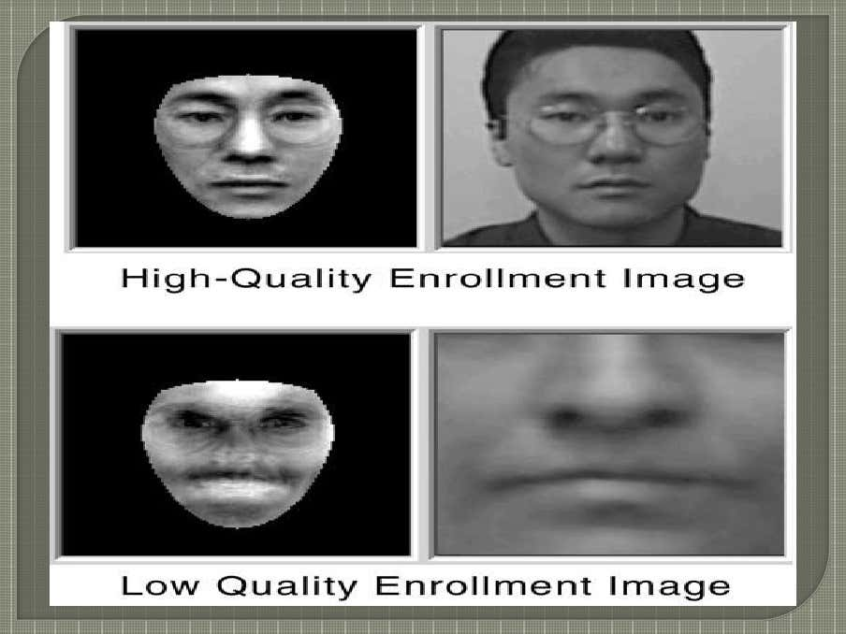

## Image processing

Images are cropped such that the ovoid facial image remains, and colour images are normally converted to black and white in order to facilitate initial comparisons based on grayscale characteristics.

First the presence of faces or face in a scene must be detected. Once the face is detected, it must be localized and Normalization process may be required to bring the dimensions of the live facial sample in alignment with the one on the template.

## Distinctive characteristic location

All facial-scan systems attempt to match visible facial features in a fashion similar to the way people recognize one another.

The features most often utilized in facial-scan systems are those least likely to change significantly over time: upper ridges of the eye sockets, areas around the cheekbones, sides of the mouth, nose shape, and the position of major features relative to each other.

## Template creation

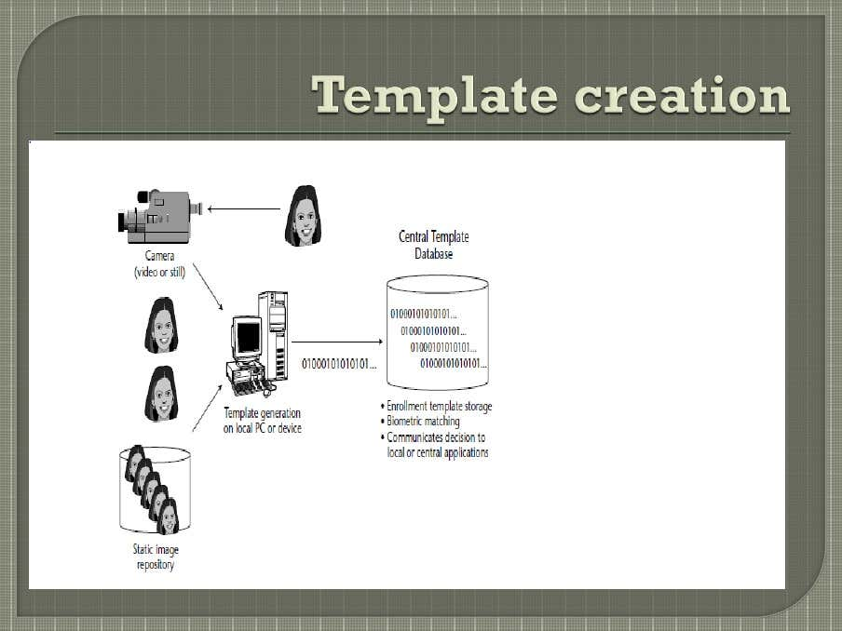Behavioural changes such as alteration of hairstyle, changes in makeup, growing or shaving facial hair, adding or removing eye glasses are behaviours that impact the ability of facial-scan systems to locate distinctive features, facial-scan systems are not yet developed to the point where they can overcome such variables.

Enrolment templates are normally created from a multiplicity of processed facial images. These templates can vary in size from less than 100 bytes, generated through certain vendors and to over 3K for templates. The 3K template is by far the largest among technologies considered physiological biometrics. Larger templates are normally associated with behavioural biometrics,

## Template matching

It compares match templates against enrolment templates. A series of images is acquired and scored against the enrolment, so that a user attempting 1:1 verification within a facial-scan system may have 10 to 20 match attempts take place within 1 to 2 seconds.  facial-scan is not as effective as finger-scan or iris-scan in identifying a single individual from a large database, a number of potential matches are generally returned after large-scale facial-scan identification searches.

Working of Facial Recognition System



**Output**

**Label**

Facial recognition software is based on the ability to first recognize faces, which is a technological feat in itself. If you look at the mirror, you can see that your face has certain distinguishable landmarks. These are the peaks and valleys that make up the different facial features- defines these landmarks as nodal points. There are about 80 nodal points on a human face.

Here are few nodal points that are measured by the software.

1. distance between the eyes 5. jaw line

2. width of the nose 6. chin

3. depth of the eye socket

4. cheekbones

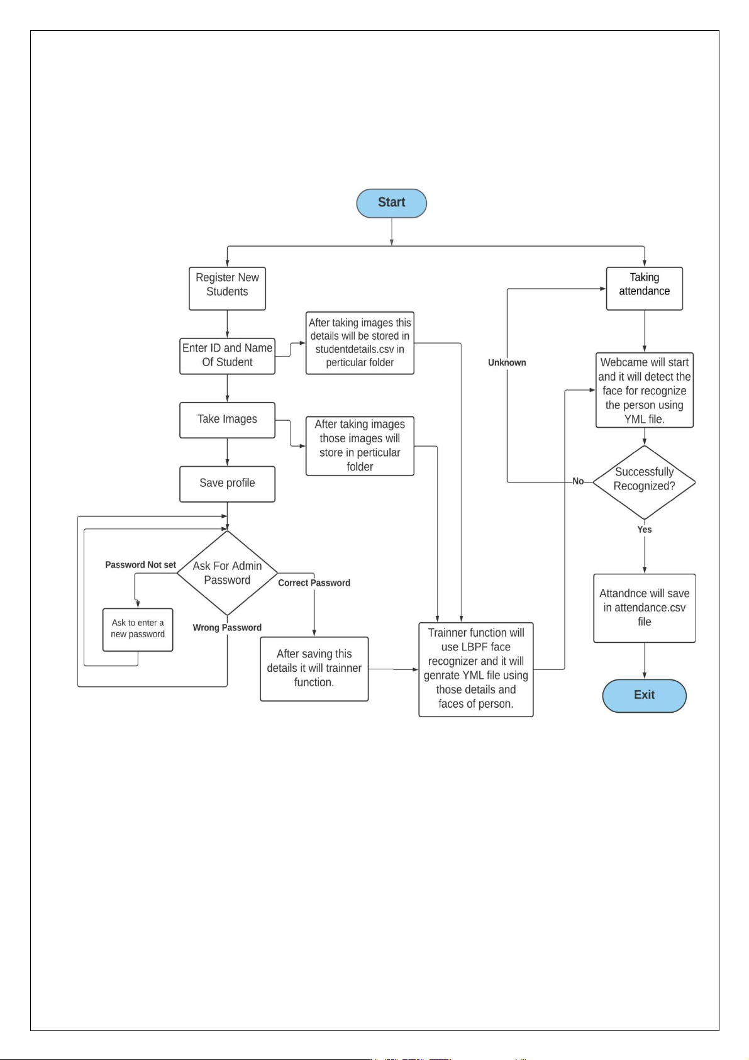

**Return label and give output**

**Return False**

**After taking images this details will be stored in data.csv in local folder**

**Enter New user ID and Name**

**Register new User**

Conclusion

* It has the ability to leverage existing image acquisition equipment.
* It can search against static images such as driver’s license photographs.
* It is the only biometric able to operate without user cooperation.
* Changes in acquisition environment reduce matching accuracy.
* Changes in physiological characteristics reduce matching accuracy.
* It has the potential for privacy abuse due to noncooperative enrollment and identification capabilities.
* Problem with false rejection when people change their hair style, grow or shave a beard or wear glasses. Identical twins

Factors such as environmental changes and mild changes in appearance impact the technology to a greater degree than many expect. For implementations where the biometric system must verify and identify users reliably over time, facial scan can be a very difficult, but not impossible, technology to implement successfully.

Code

For more details: <https://github.com/caped-baldys/face-recognition>



