**AU1940313 Pranav Gandhi**

**OS End Sem Practical exam Description doc:-**

**Ans1):-**

**B)Multithreads:-**

Output ss:-

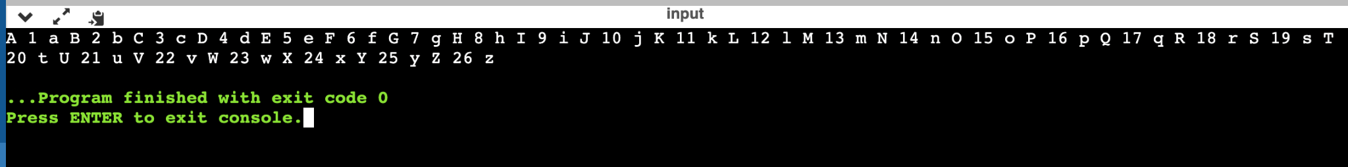

Description:-

>For this question, we have used binary semaphores with variable flags and threads. Here we use the flag variable as a counter. Here we create 3 threads now:- t1,t2,t3. Now we are using thread(), thread_2(), and thread_3() for t1,t2,t3 respectively. Here thread() , thread_2 and thread_3(). In thread_2() we are iterating over a for loop from 0 to 26. In each iteration, we are waiting for the semaphore to get access to use the shared variable and then if the value of (flag variable % 3) is 0 then we print the loop index 'a + A' or else we decrement the loop. Similarly thread and thread_3() functions work. Then in main(), we use the inbuilt function 'pthread_create()' and then we use pthread_join for each thread which works and we get our required output.

**Ans2) Output:-**

**Description:-**

>When we allocate memory with buddy’s, we also create a map. In this map, we keep size as value and starting address as key. And then we will add the block to the free list and we will also the merge the consecutive free memory with it.

**Allocate:-**

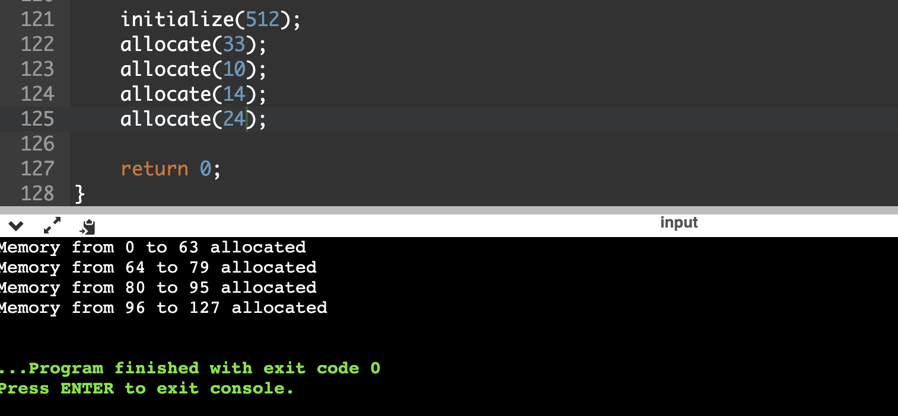

**Roll no:- AU1940313**

**Pranav Gandhi**