Topology
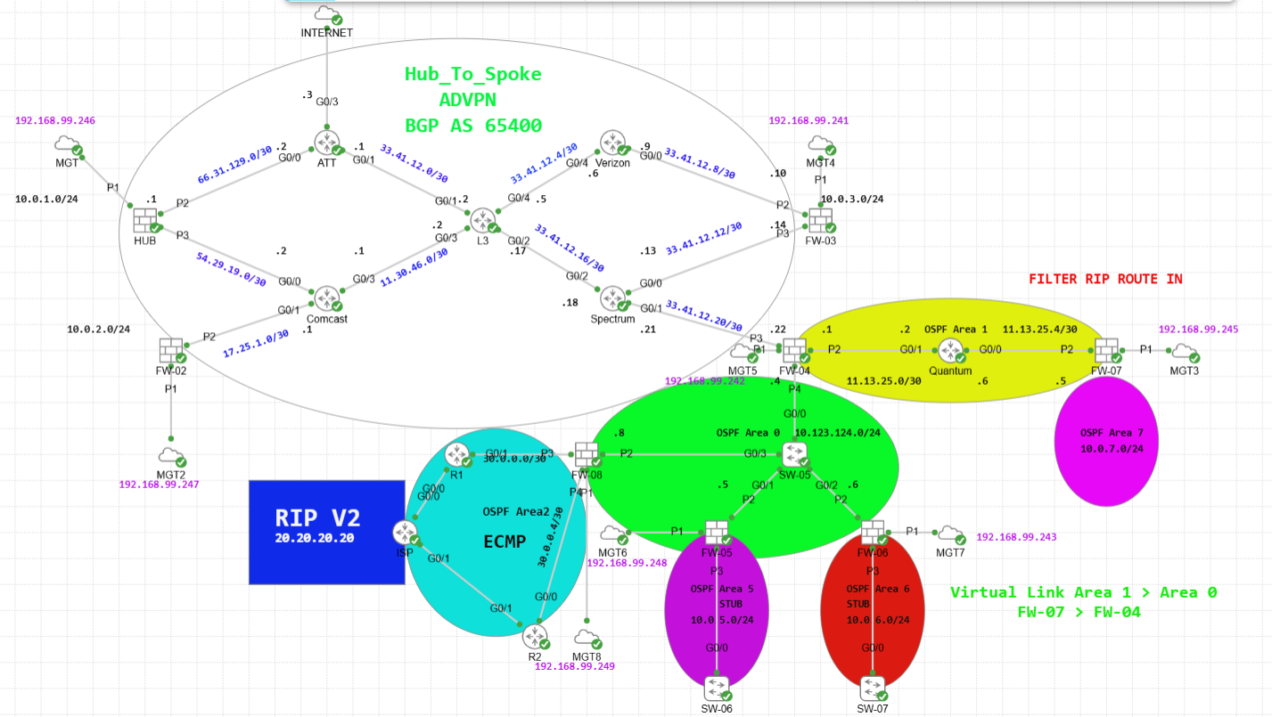

Before we start:
- All Routers are configured to route all routes back and forward, the configuration of such are outside the scope of this lesson.
- The purpose of this lab is to configure ADVPN with hub and spoke and spoke to spoke connection between firewalls.
- Internet connection is primarily coming out of ATT.
- Hub and Spoke Design with ADVPN configured, we are using iBGP for the Overlay routing protocol.
- The Overlay subnets are 172.16.254.0 for WAN1 and 172.16.253.0 for WAN2.
- The LAN IP Addresses are 10.0.1.0, 10.0.2.0, 10.0.3.0, 10.0.5.0, 10.0.6.0, 10.0.7.0
- We are to configure a Virtual Link on FW-07 for communication with FW-04.
- We are to configure ECMP for RIP route on FW-08
- We are to configure SD-WAN according to client needs at HUB and FW-03
- We are to configure BFD for fast convergence of BGP.

- We are to filter Routes from RIP at FW-07 to reach the Routing table using prefix list.
- Test connectivity between LANs
- Test Failover to WAN2 during live PING from one of the Spokes.
- All LAN’s have Internet Access as well.
HUB Configuration
Interfaces:
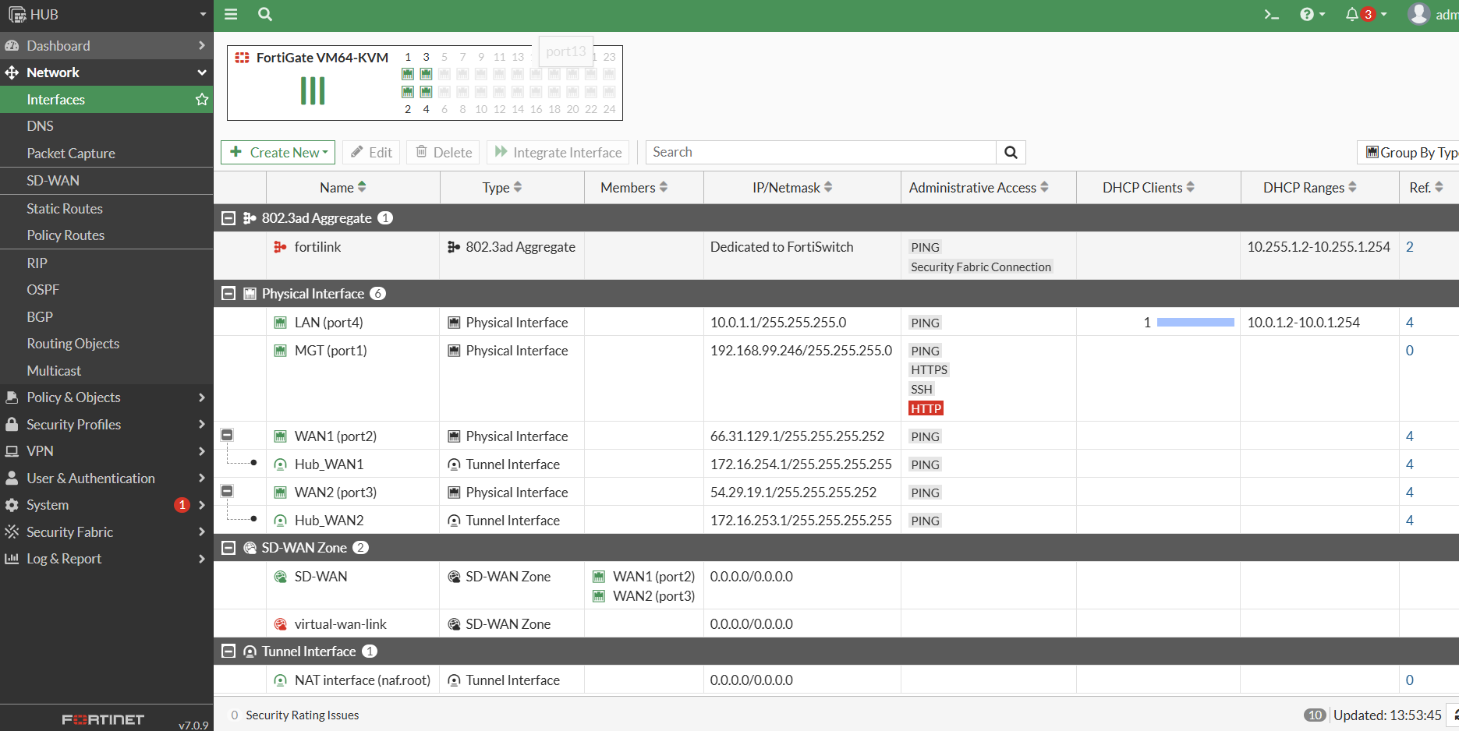

DNS:
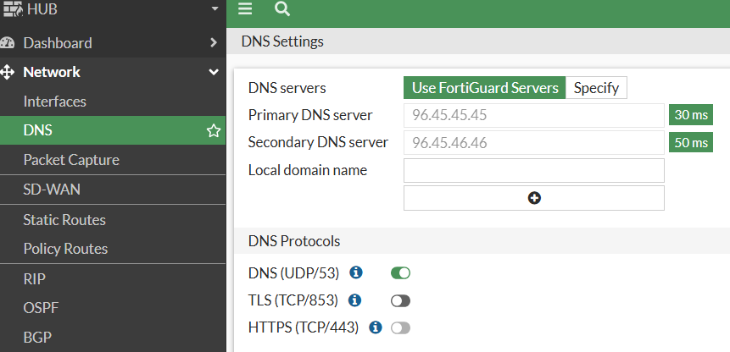
Static Routes:
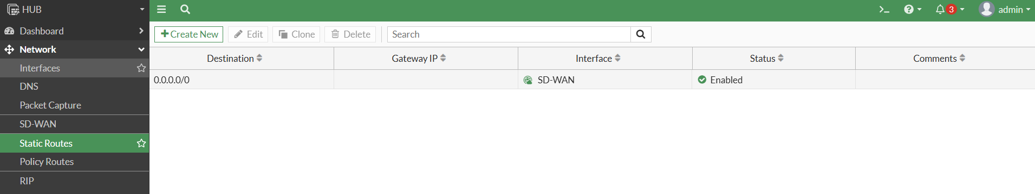
Firewall Policy:
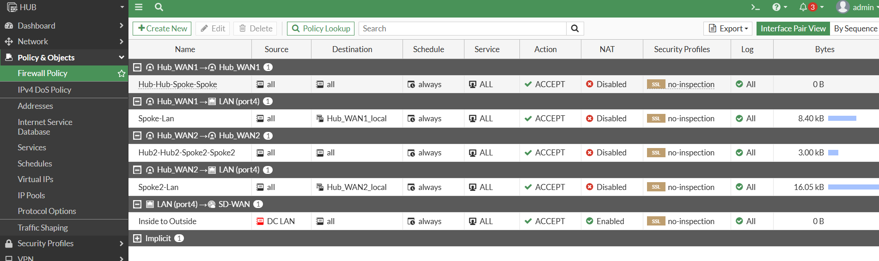

ADVPN
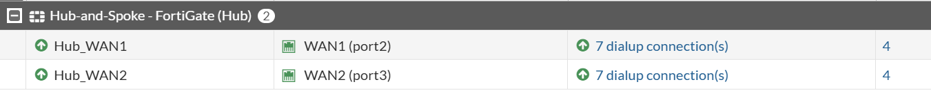

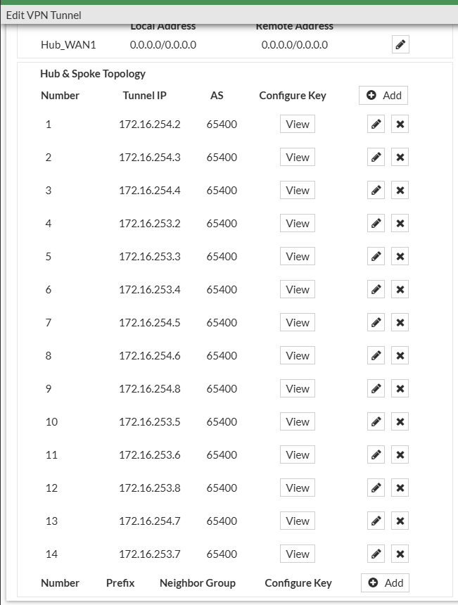
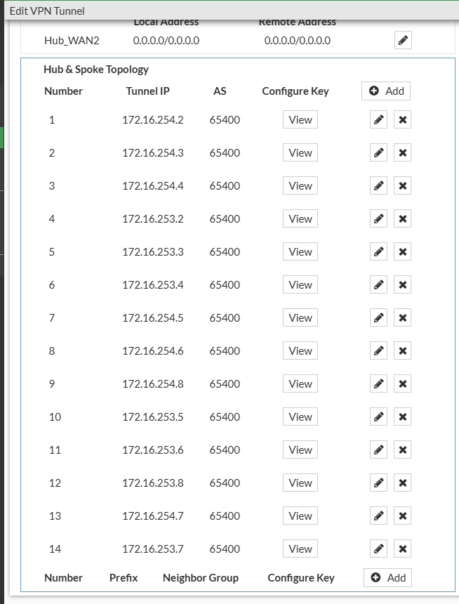

SD-WAN
- Our WAN1is the fastest circuit, most of the rules will choose WAN1.
- Client requested all O365 traffic to be load balanced across both connections.
- Client requested AWS to be sent out primarily out of WAN1 but if it does not meet SLA send it out of WAN2.
- Client requested all Google Cloud services to be sent out of WAN2 but if it does not meed SLA send it out of WAN1.
- For all other traffic that is not specified send it out of WAN1 the fastest circuit.
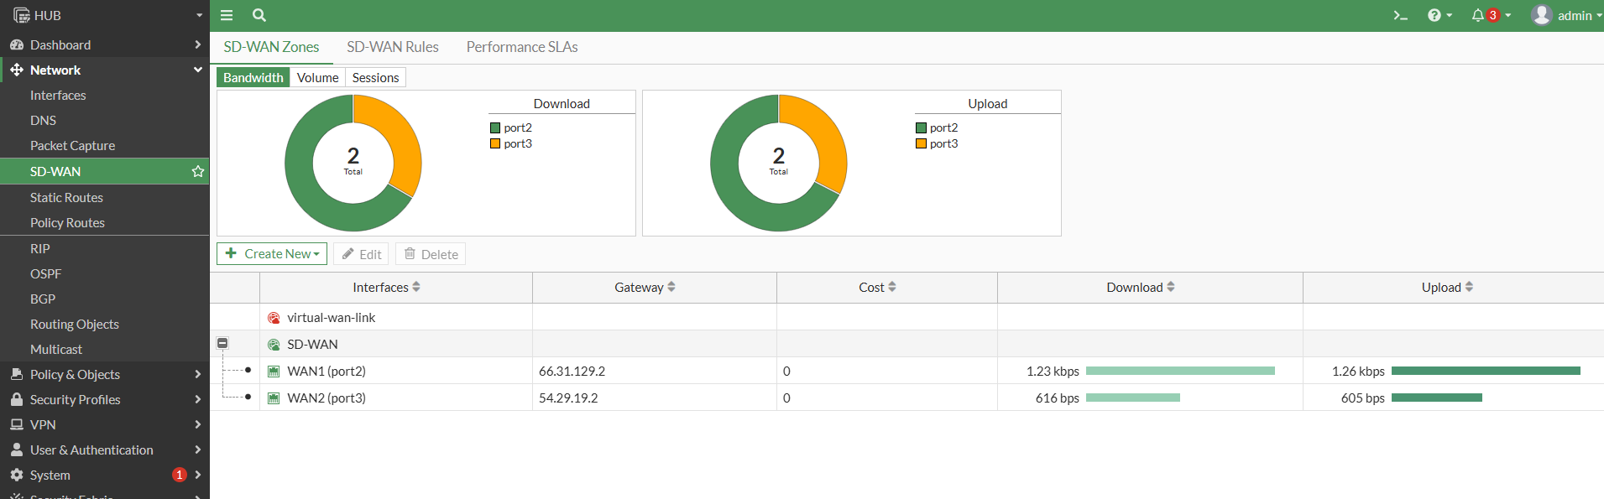
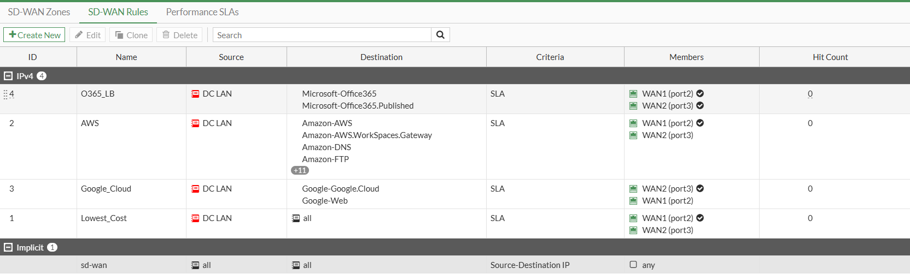
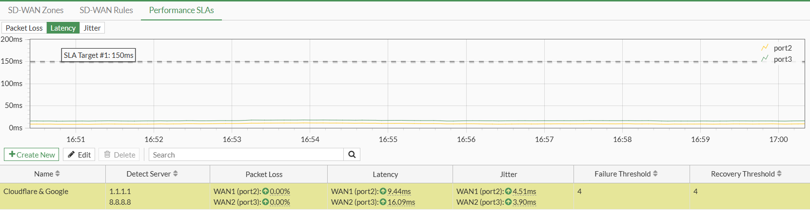

BGP
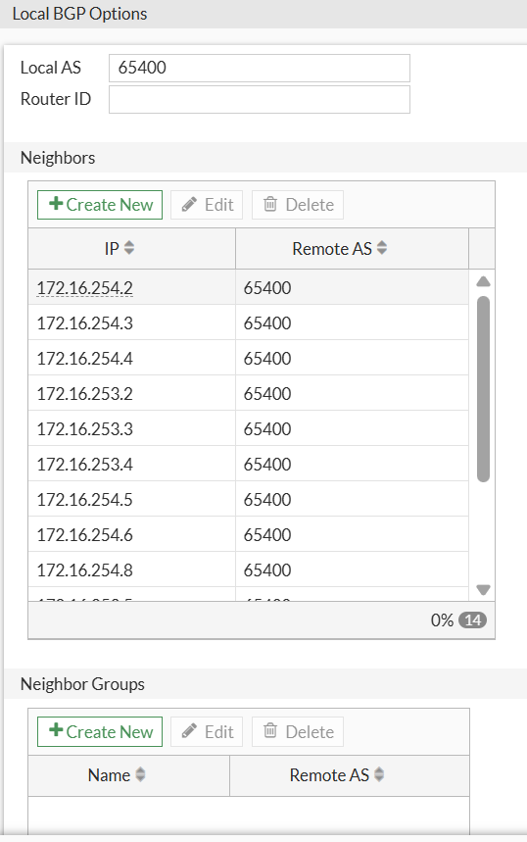
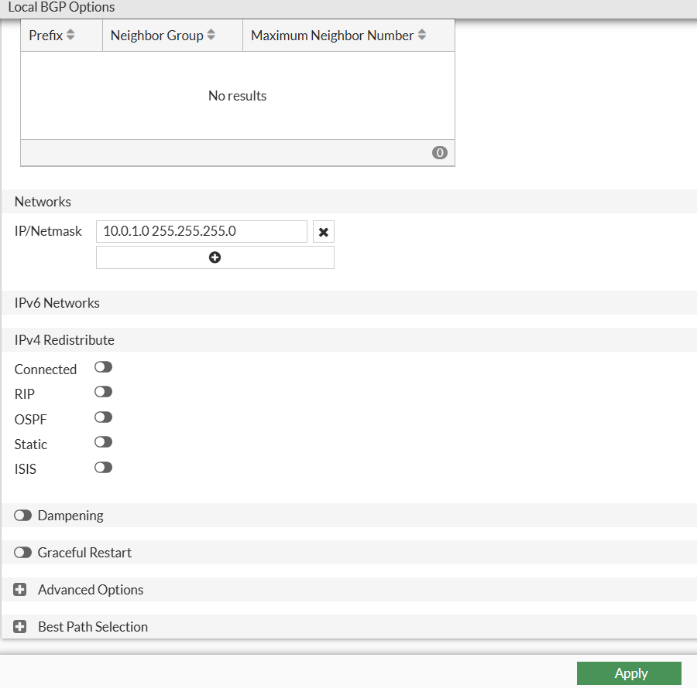

Addresses:
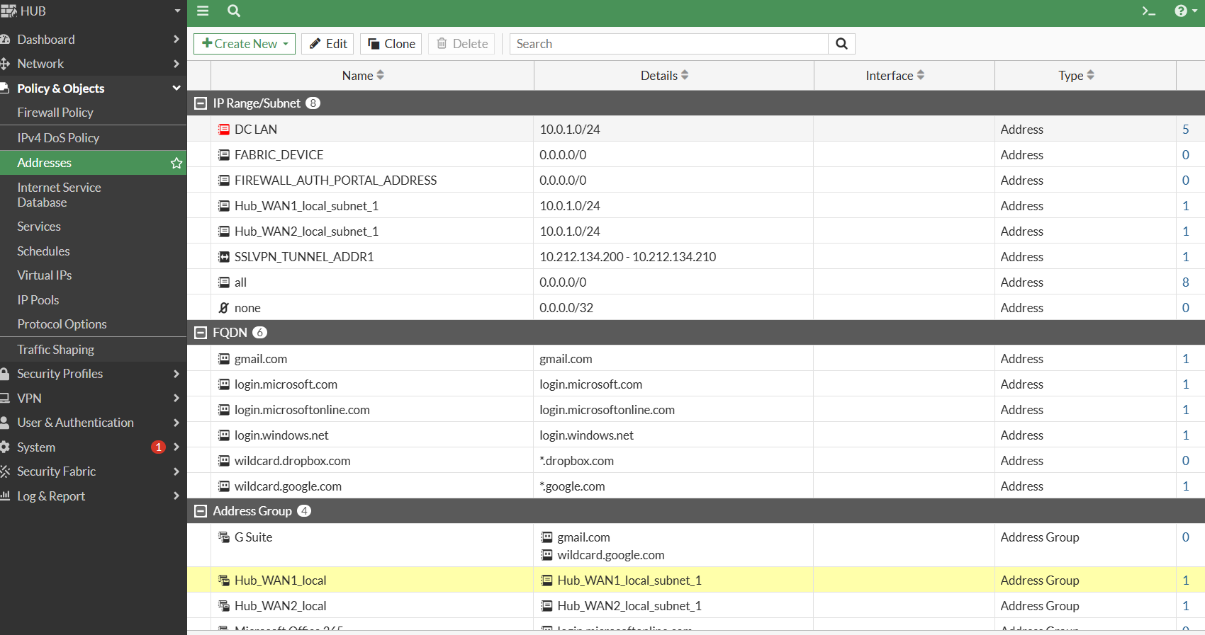

FW-02 Configuration
Interfaces:
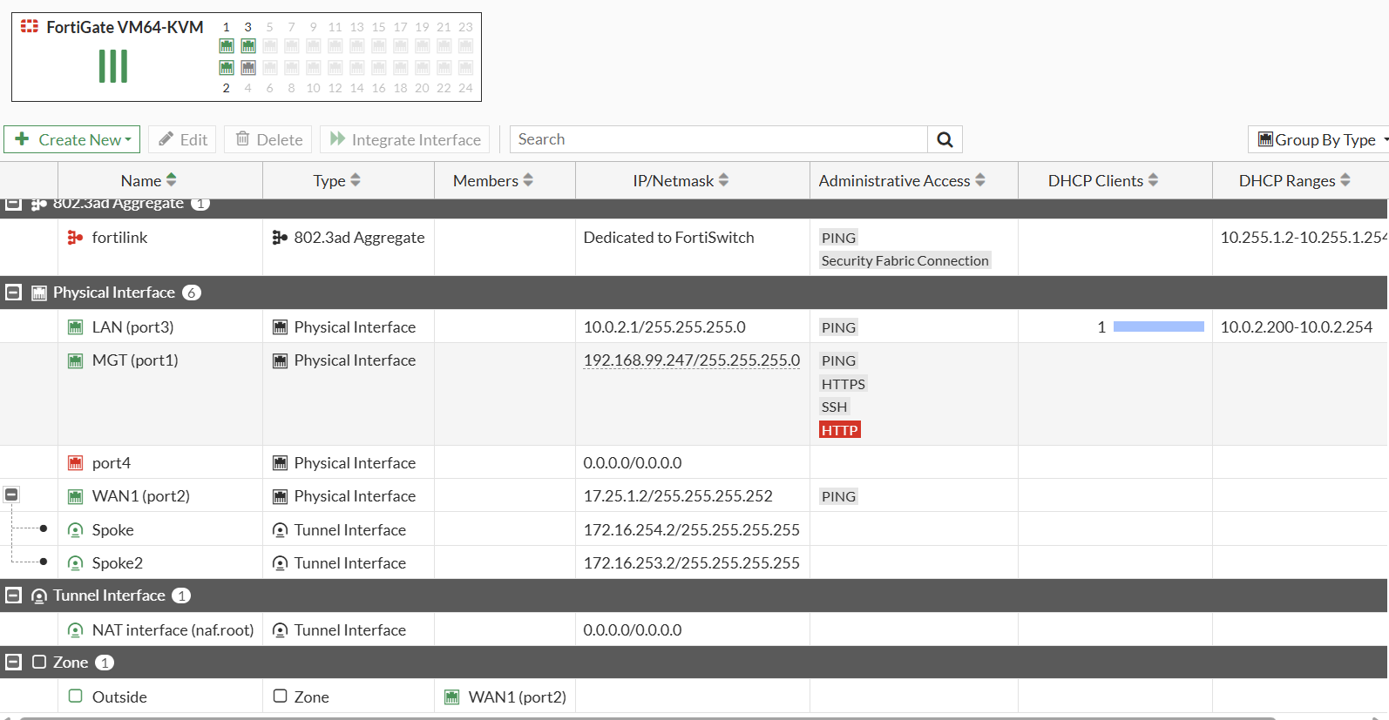
DNS
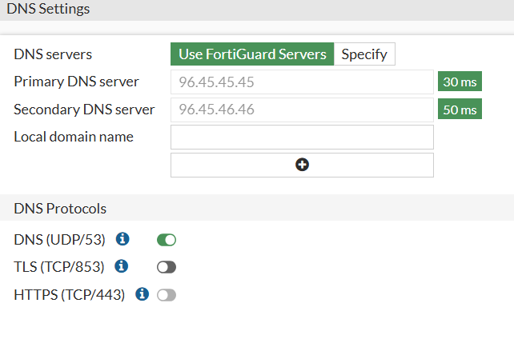
Static Route

BGP
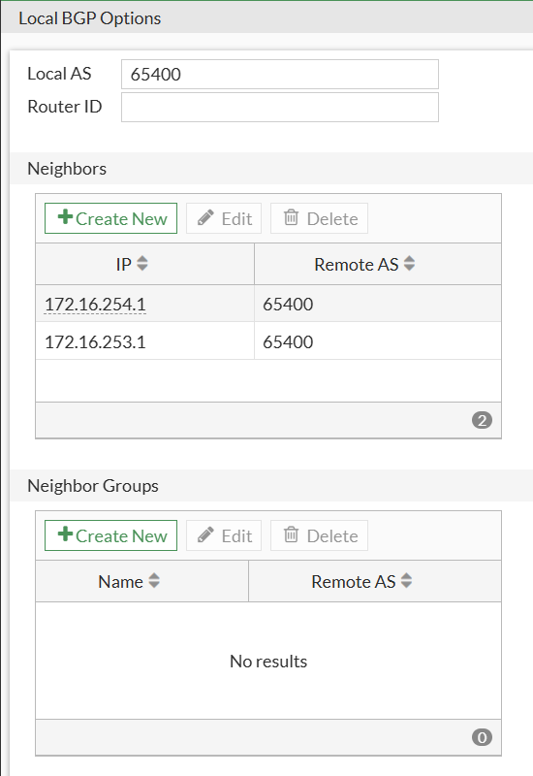
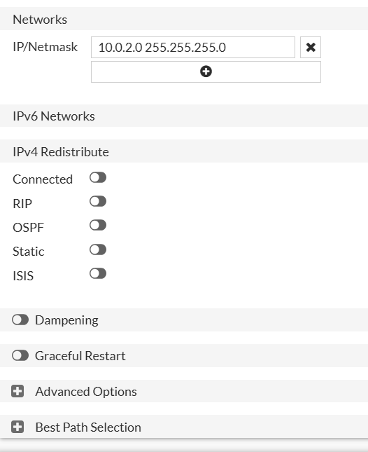

Firewall Policies
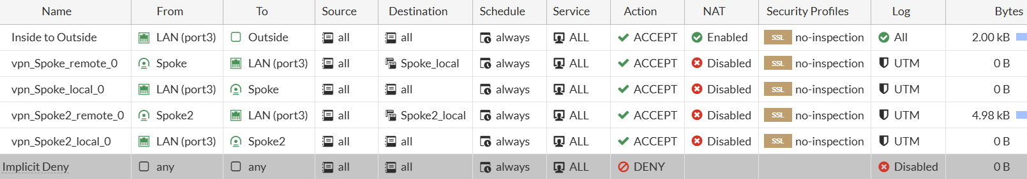
Addresses:
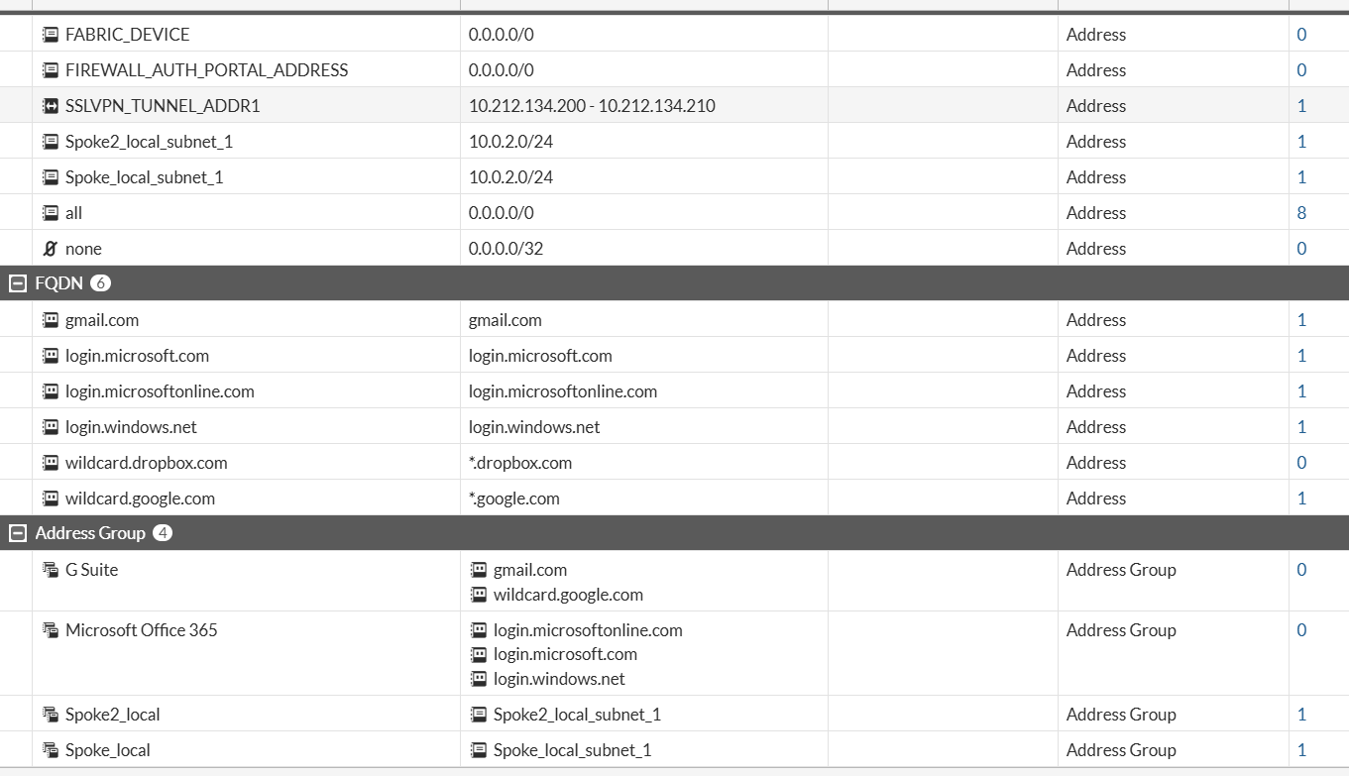
VPN
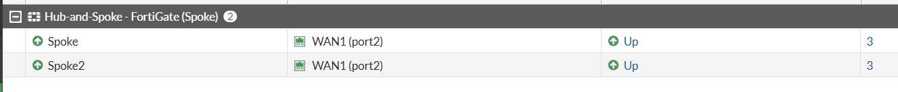
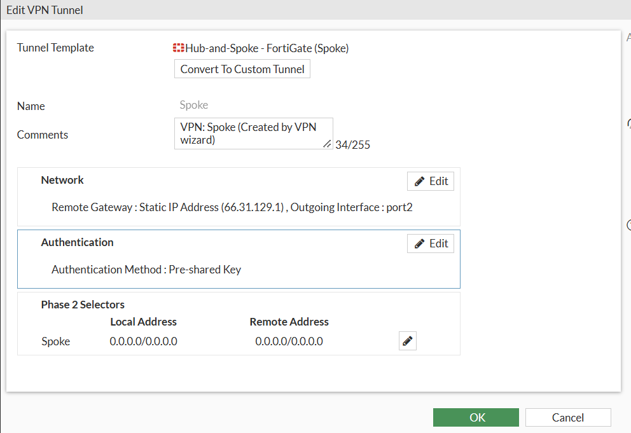
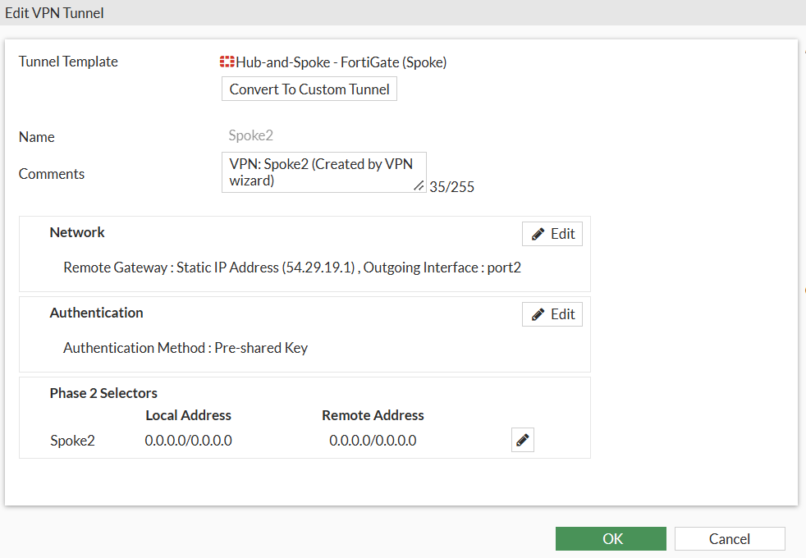

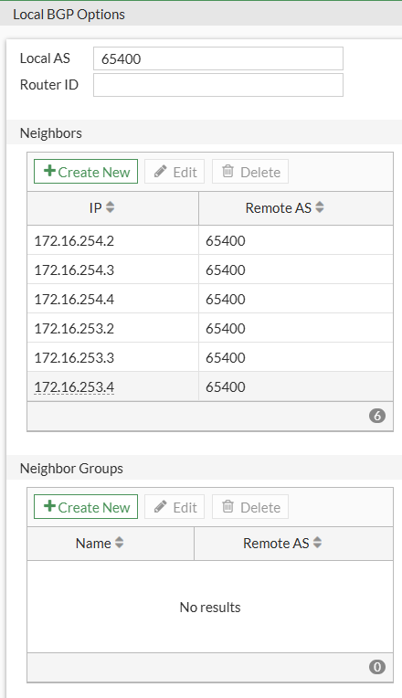
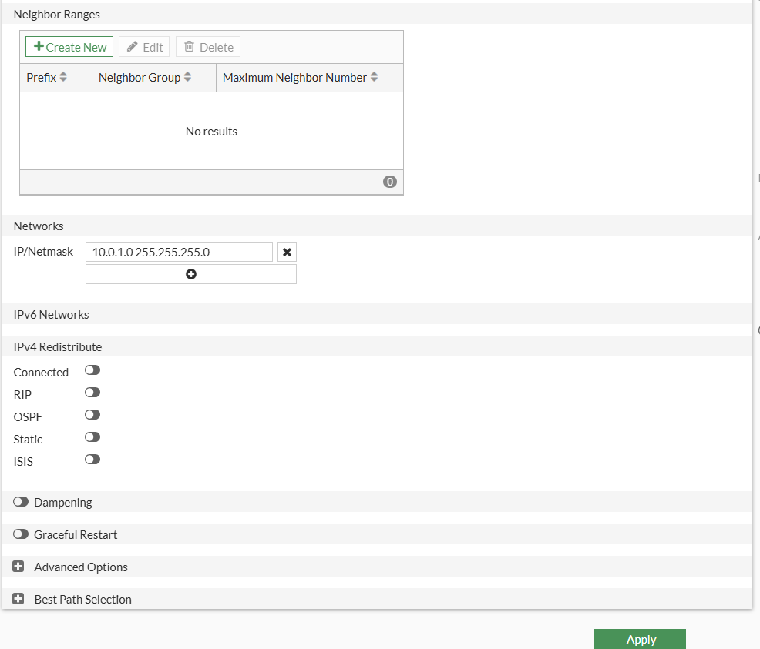

FW-03 Configuration
Interfaces:
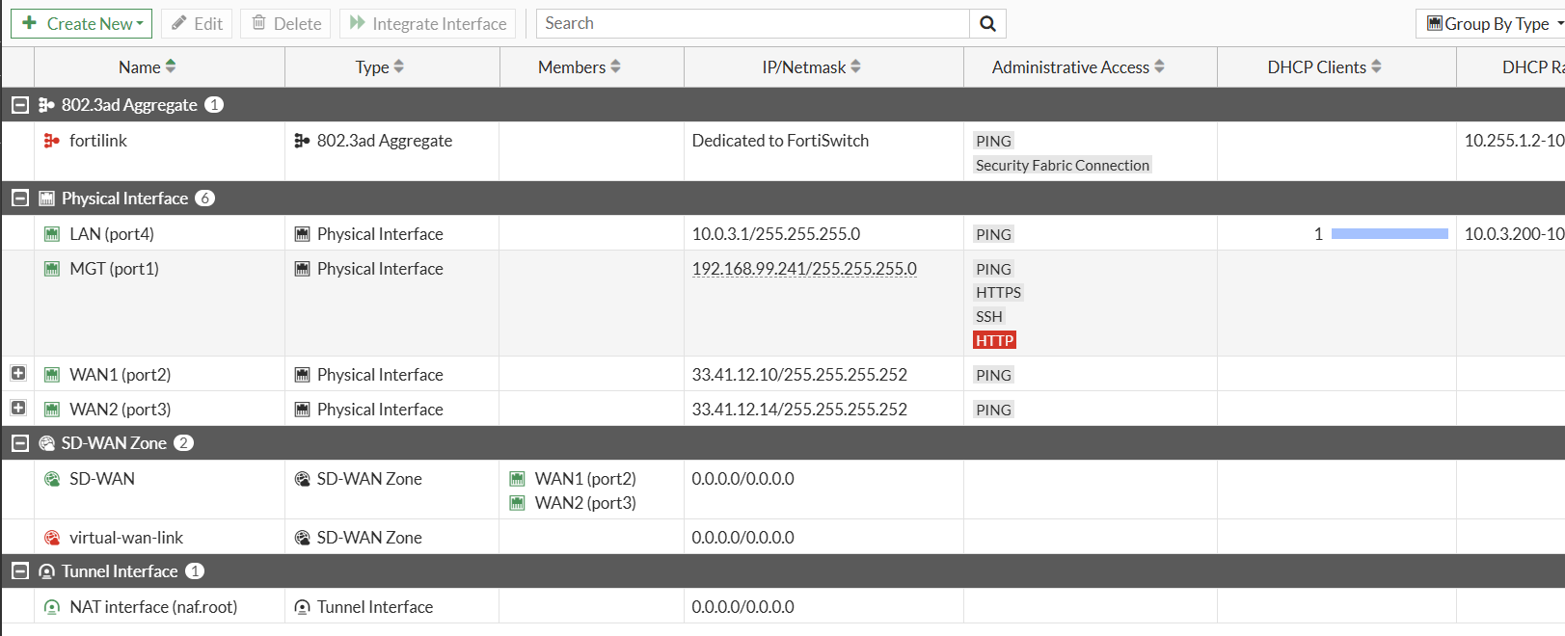
DNS
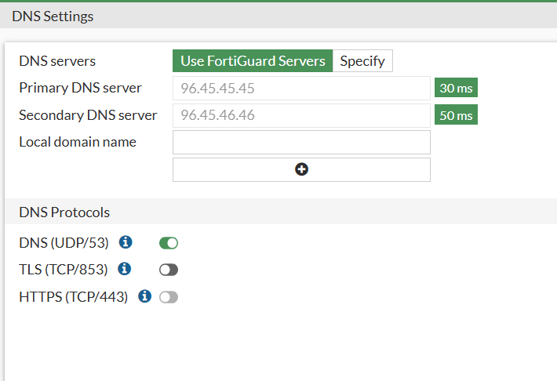

SD-WAN
- Because Verizon WAN2 only has 50 Mbps it is used as a backup in case WAN1 performance degrades.
- We are to configure WAN1 as the primary but monitor actively for Performance of Latency, Jitter and Packet loss, if it doesn’t meet the SLA it will failover to WAN2 Verizon.
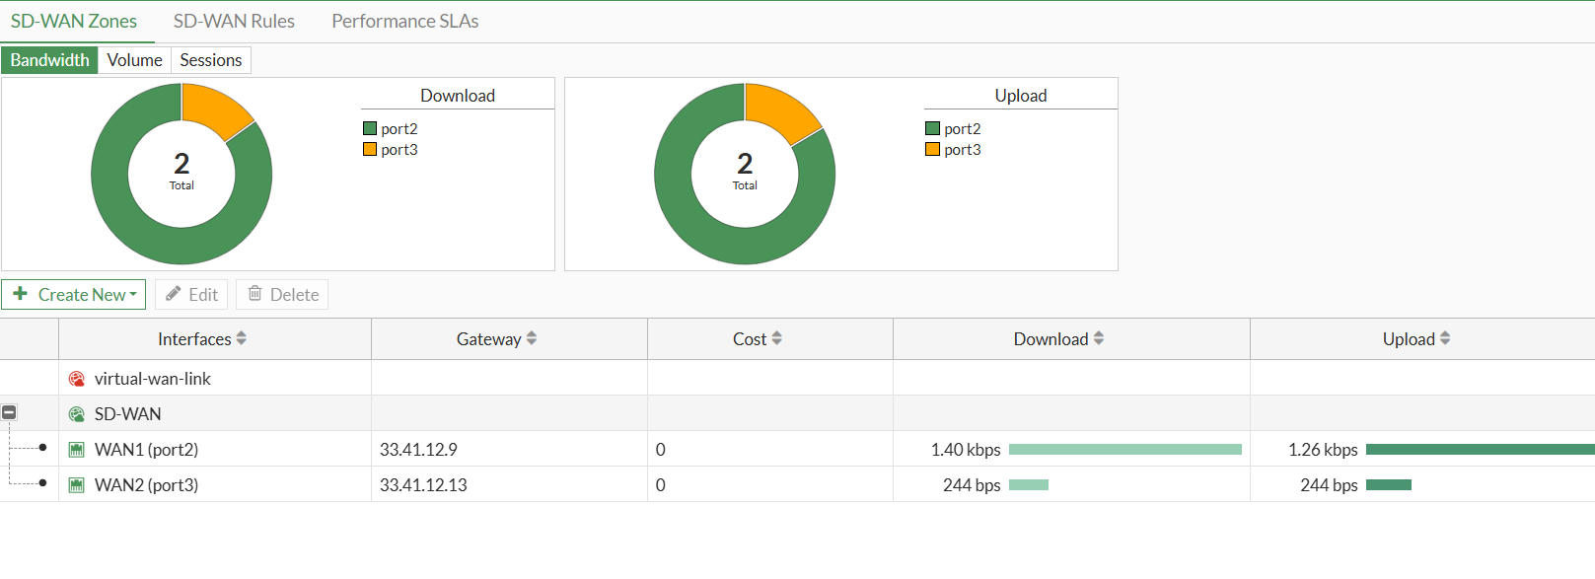
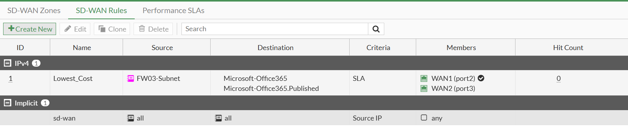
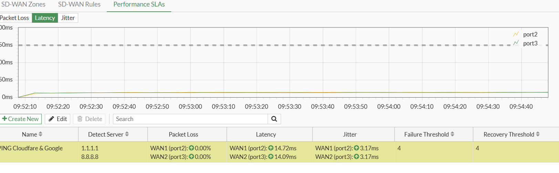
Static Routes

BGP
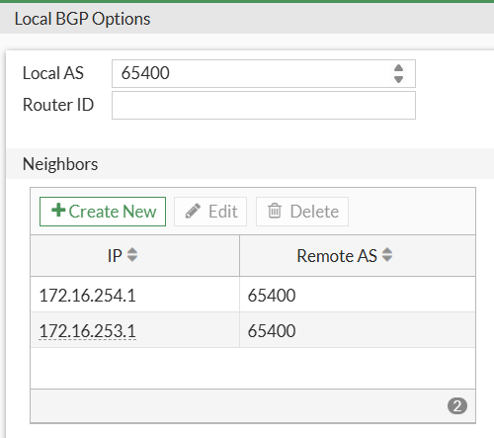
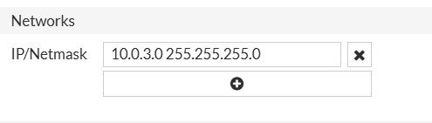
Firewall Policies:
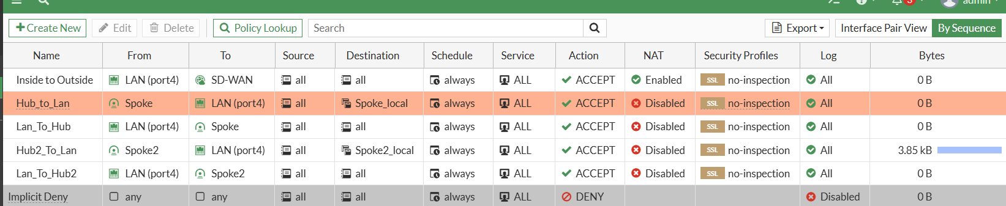

Addresses:
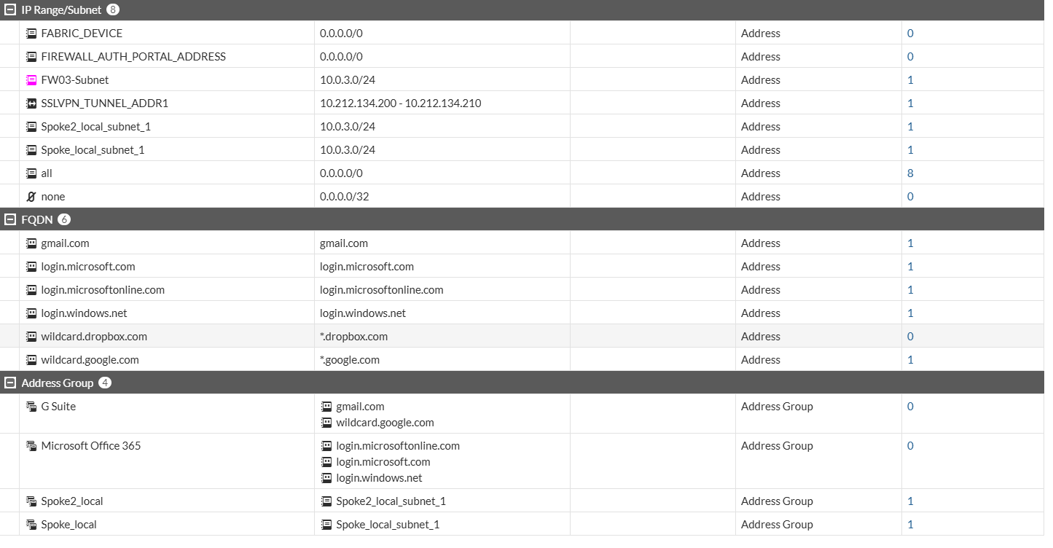
VPN:
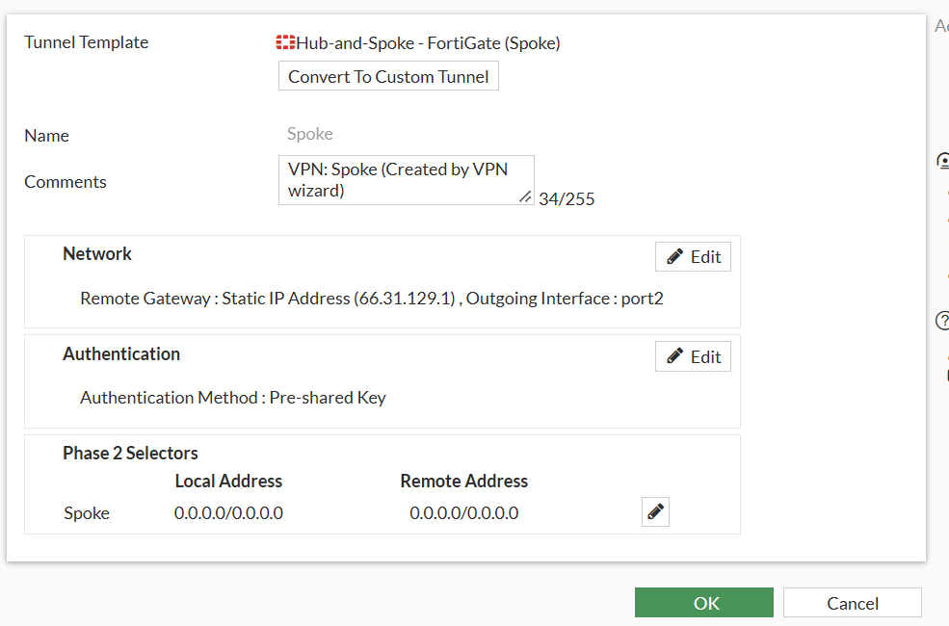
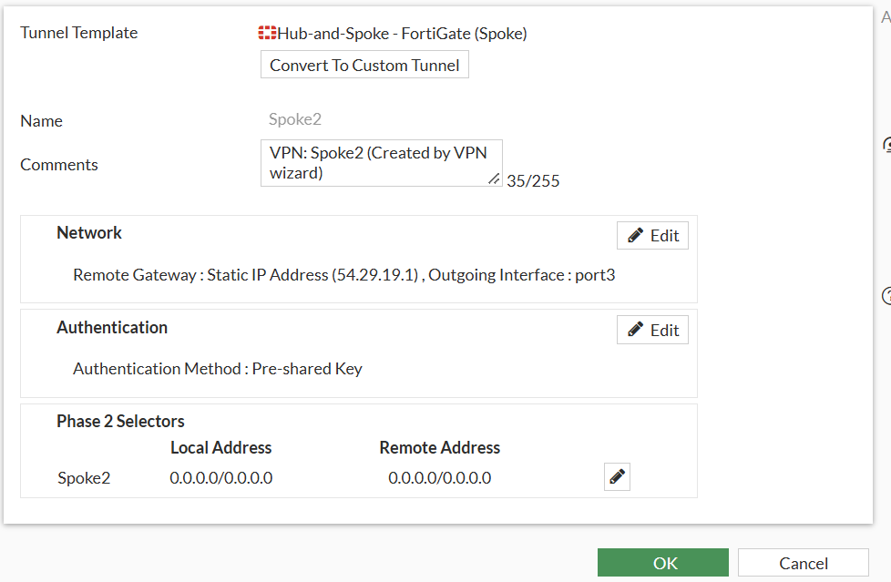
FW-04 Configuration
Interfaces:
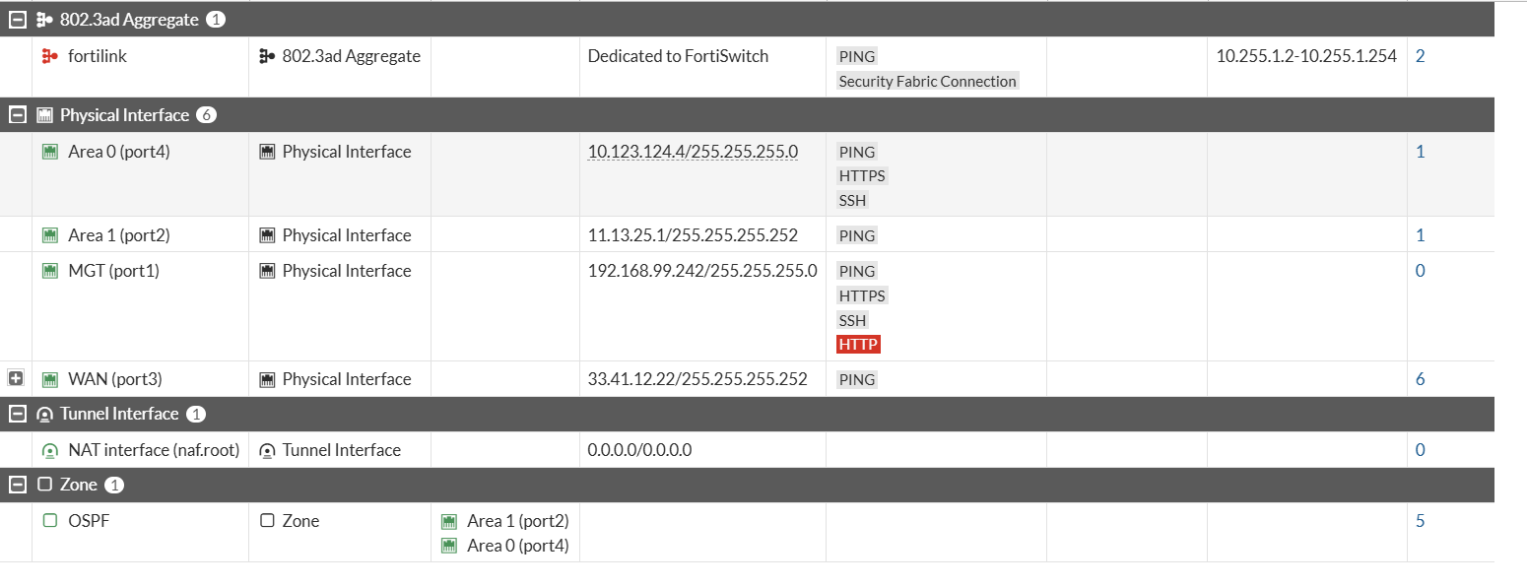

DNS
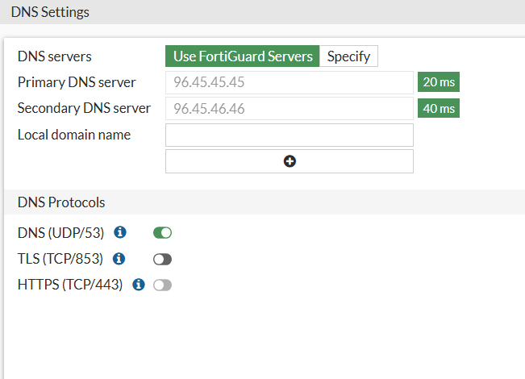
Static Route

OSPF
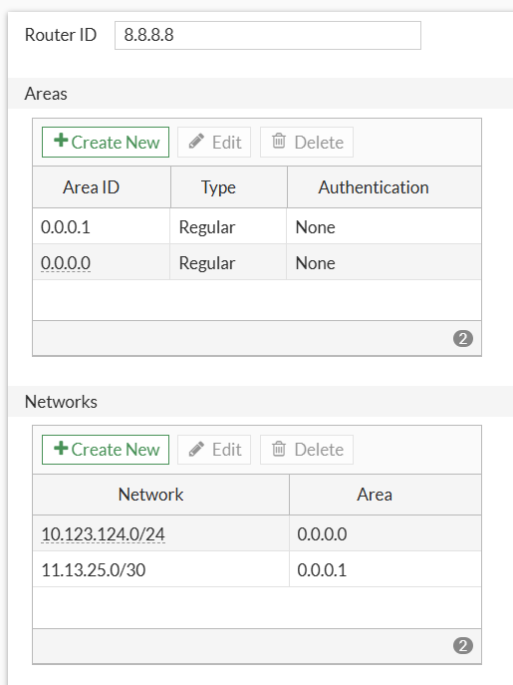

BGP
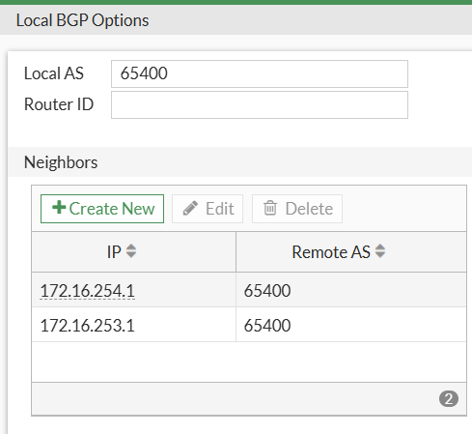
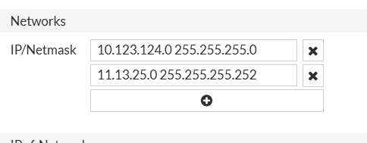

Firewall Policies
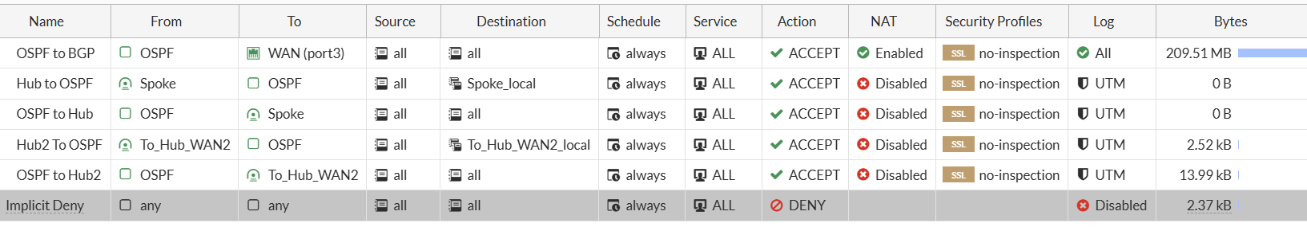

Addresses
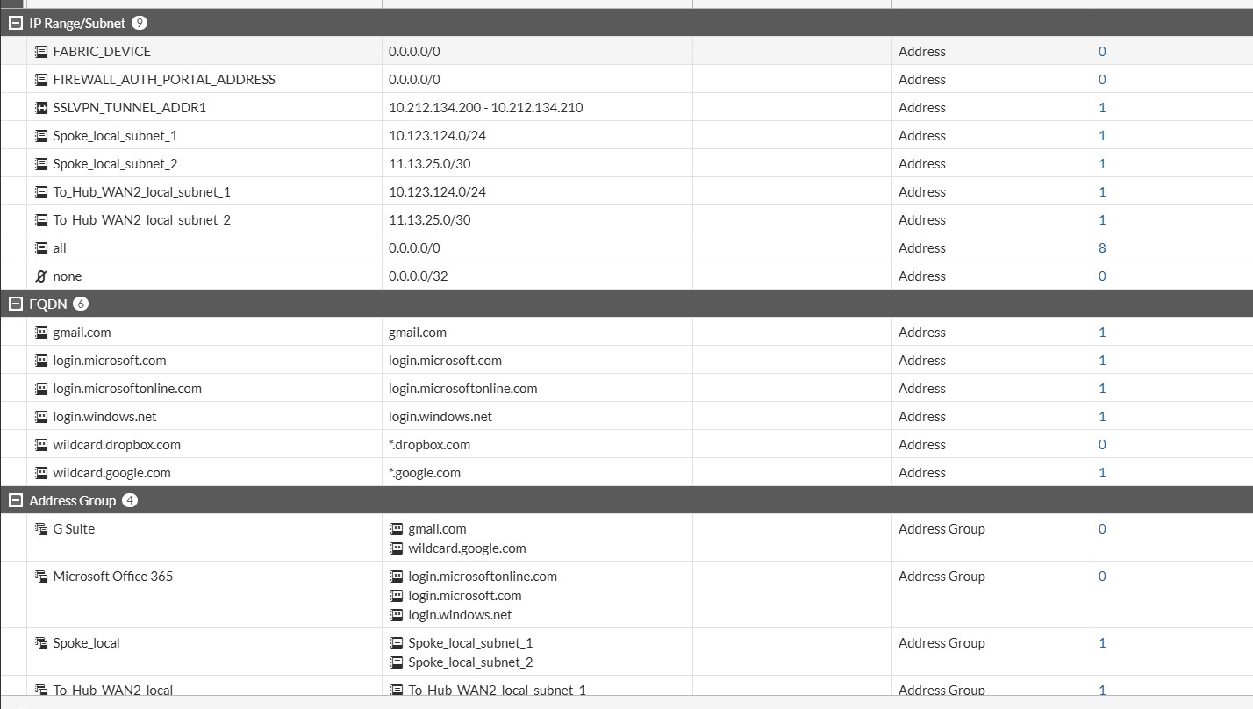
VPN
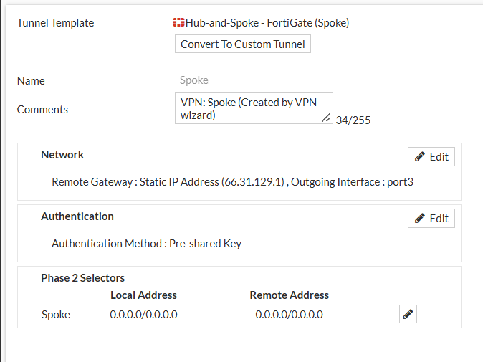

FW-05 Configuration
Interfaces:
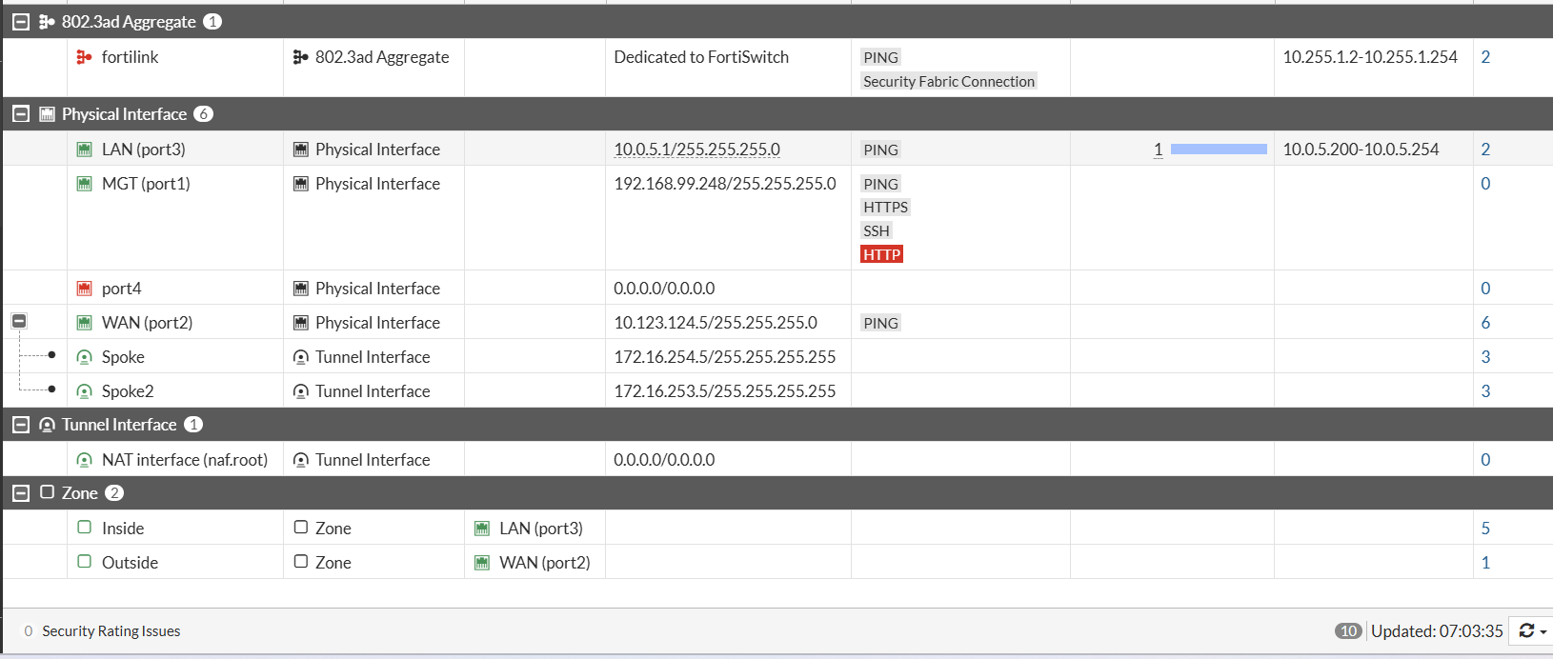

DNS
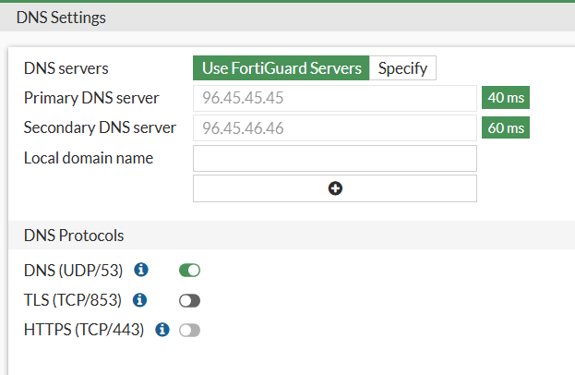
Static Route

OSPF
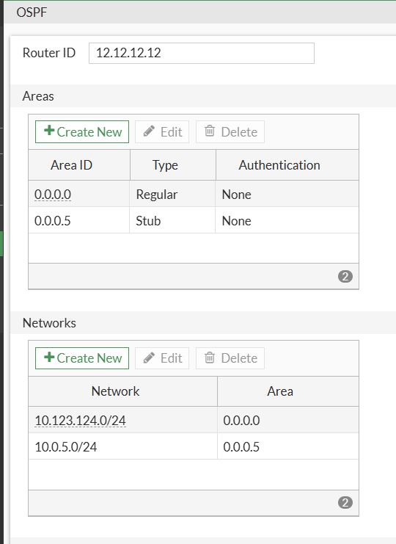

BGP
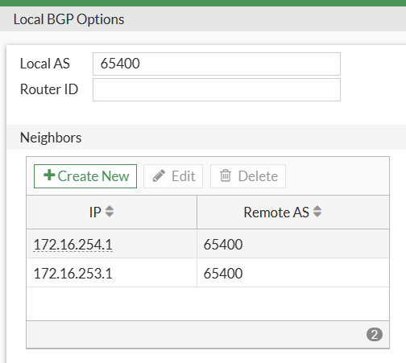
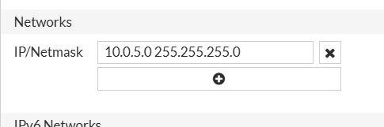
Firewall Policies
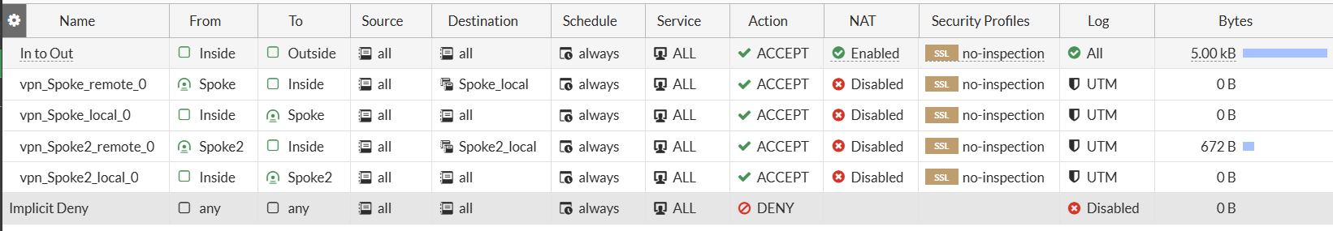

Addresses
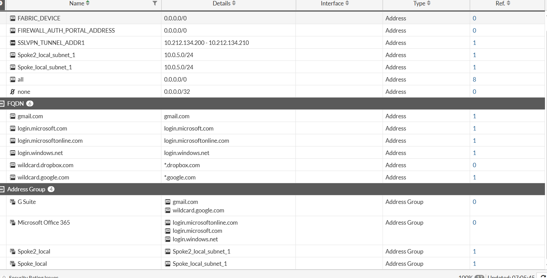
VPN
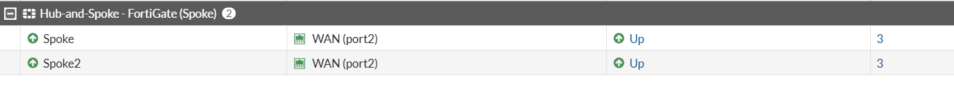
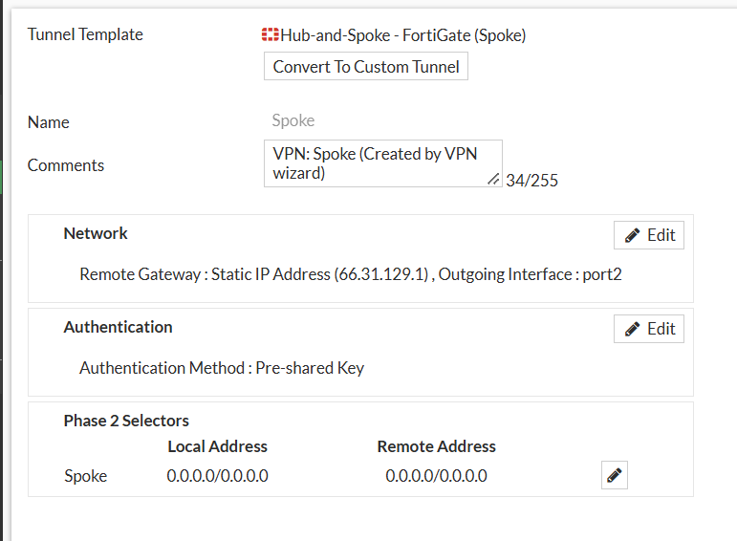
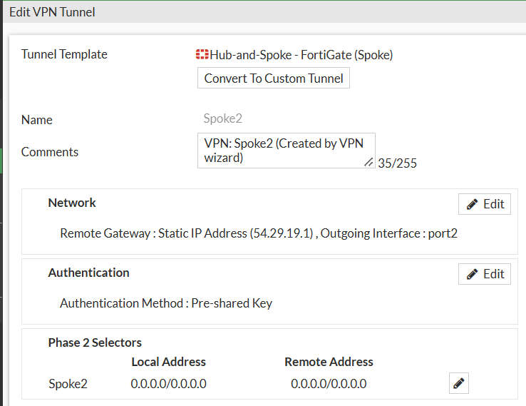
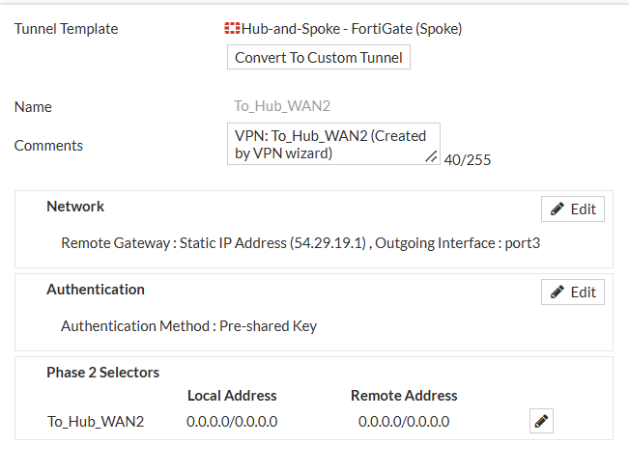

FW-06 Configuration
Interfaces:
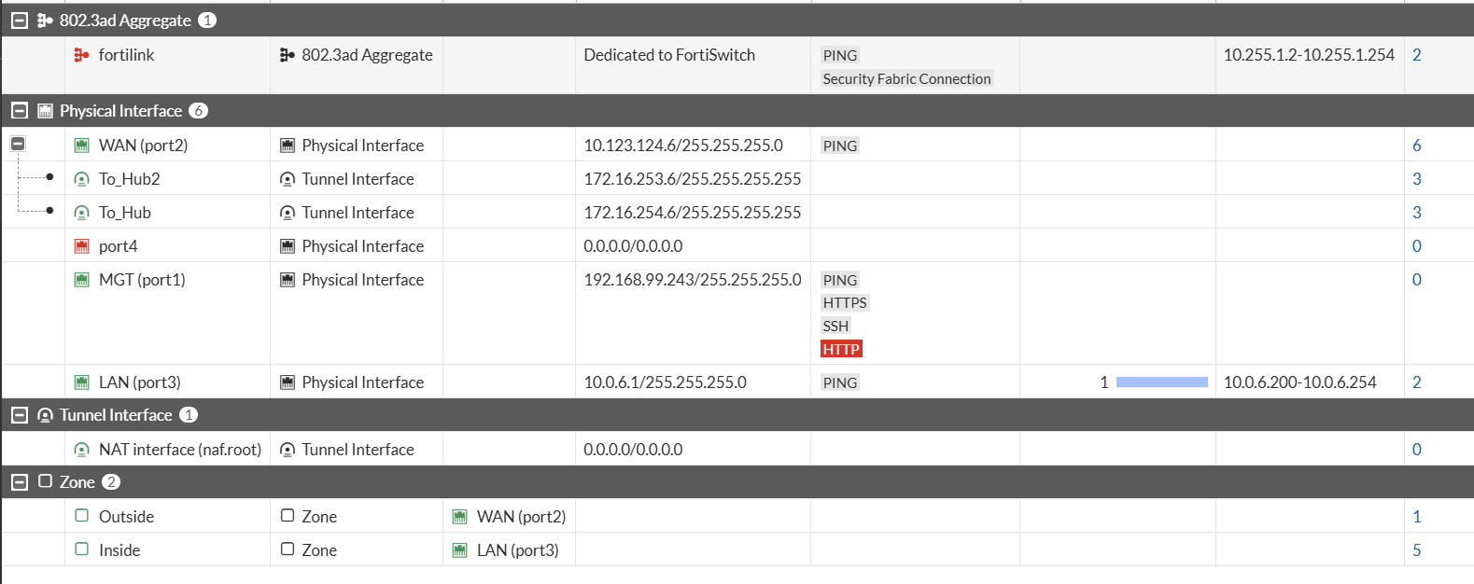
DNS
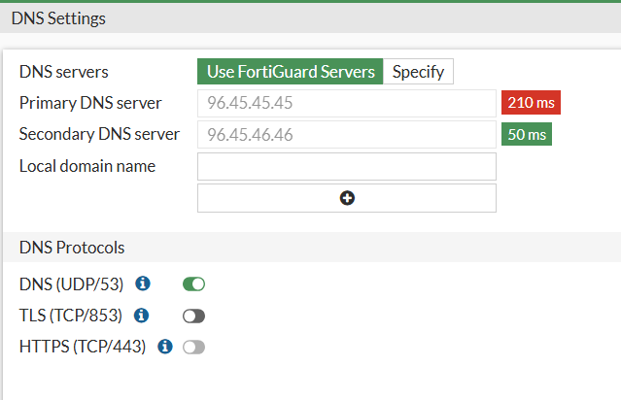

Static Routes
OSPF
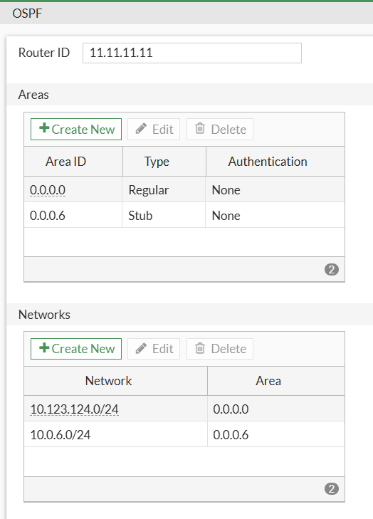

BGP

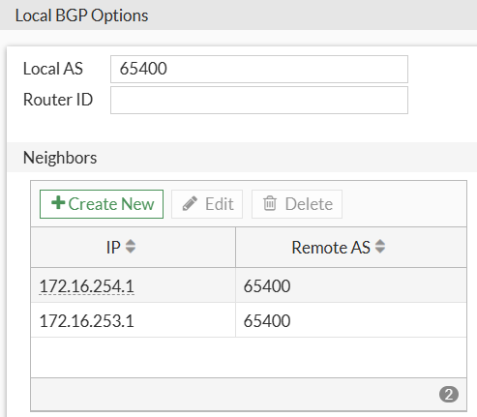
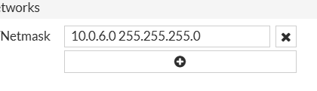
Firewall Policies
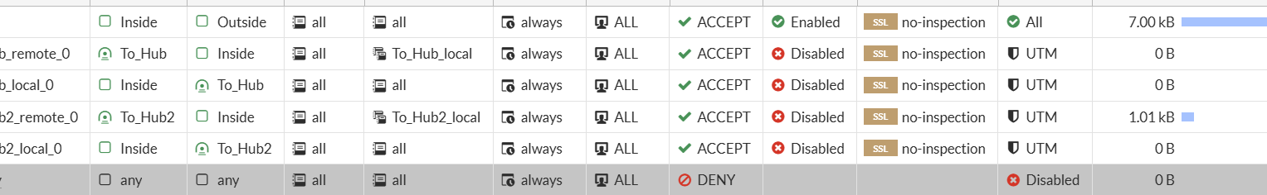

Addresses
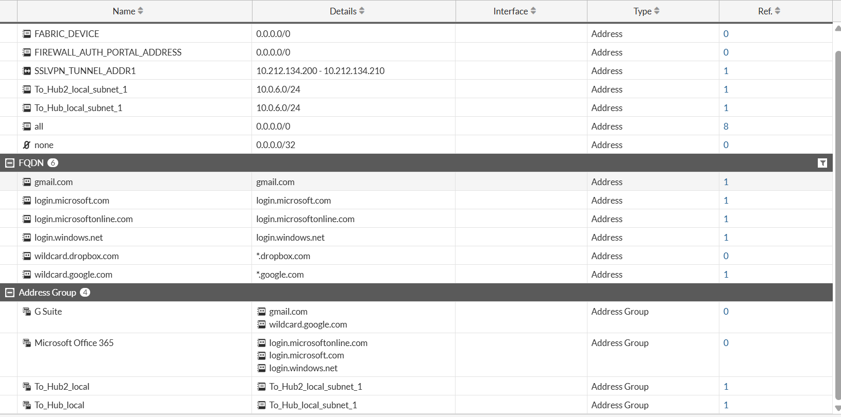
VPN
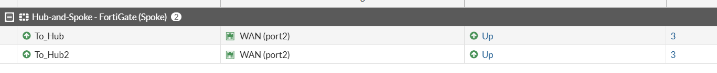
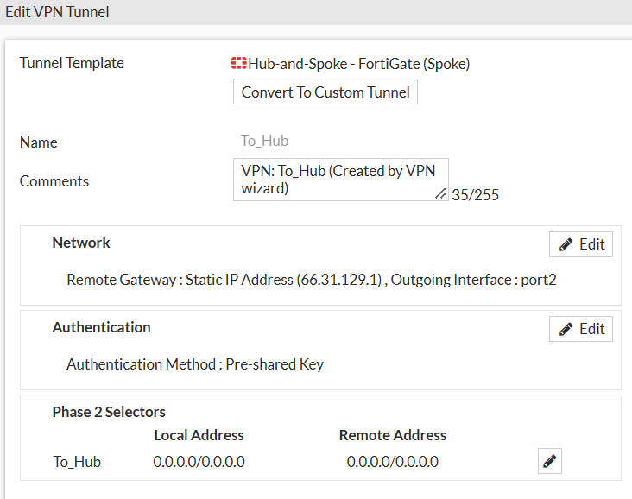
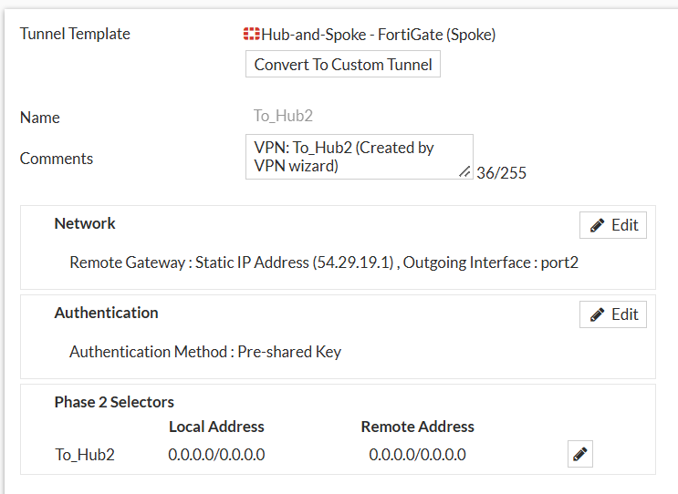

FW-07 Configuration
Interfaces:
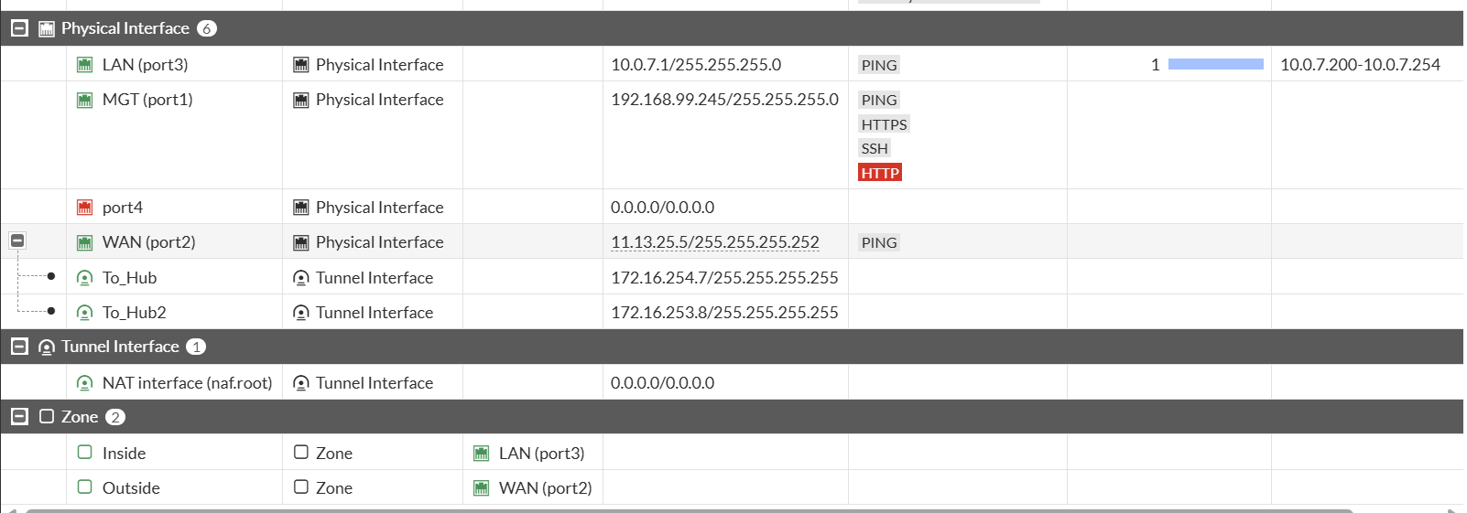

DNS
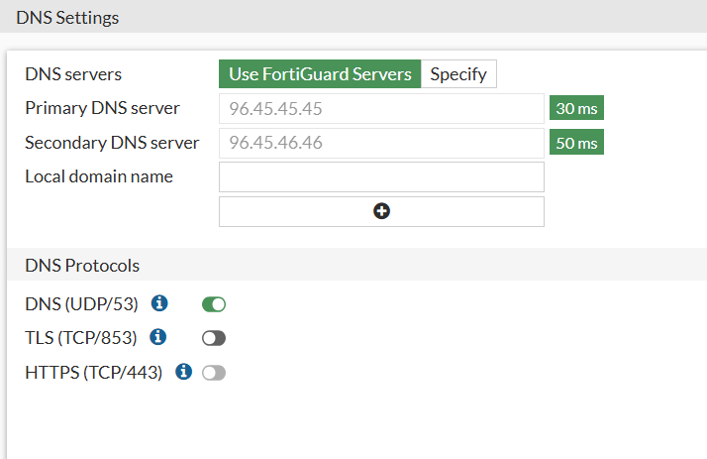
Static Routes
OSPF
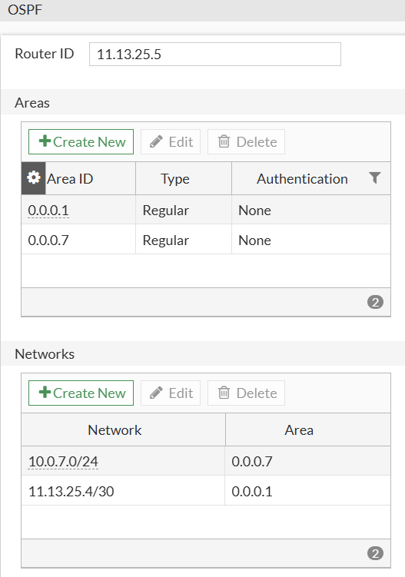

BGP
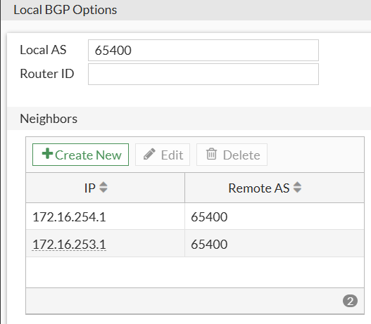
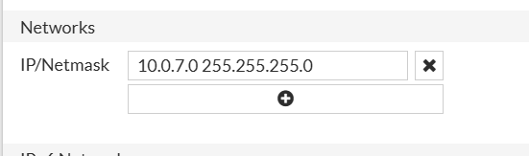
Firewall Policies
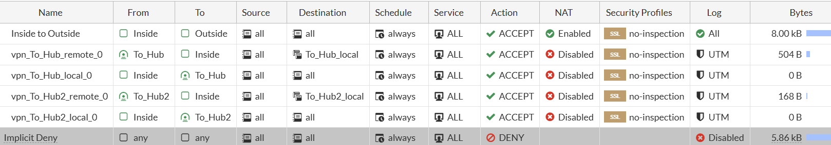

VPN

Virtual Link to FW-04
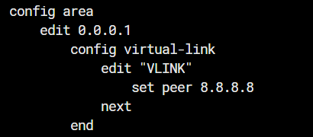
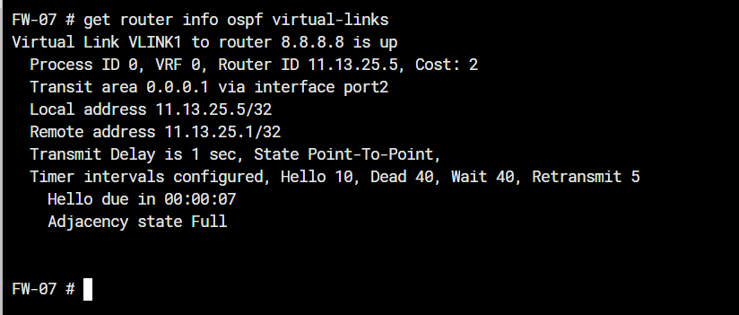
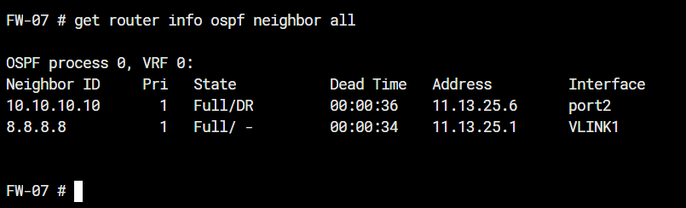
Filtering RIP Route 20.20.20.20
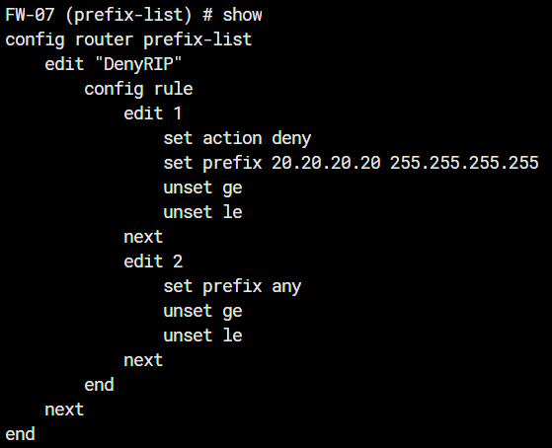
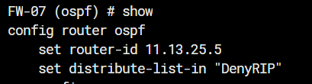
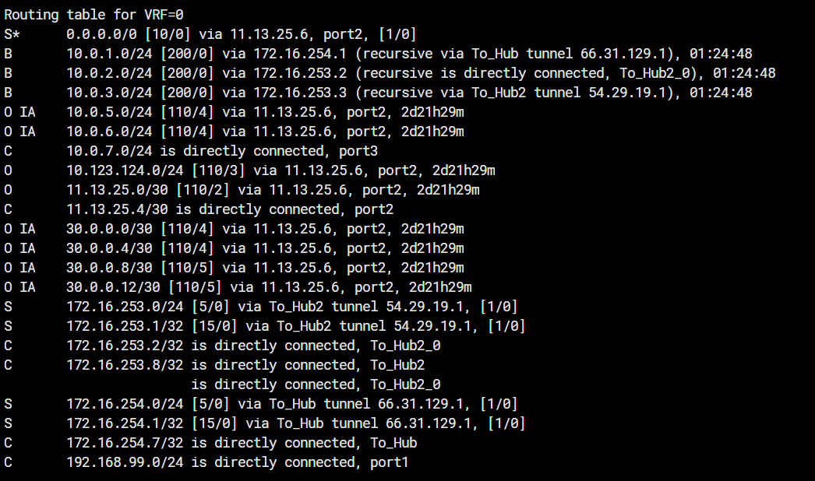
FW-08 Configuration
Interfaces:
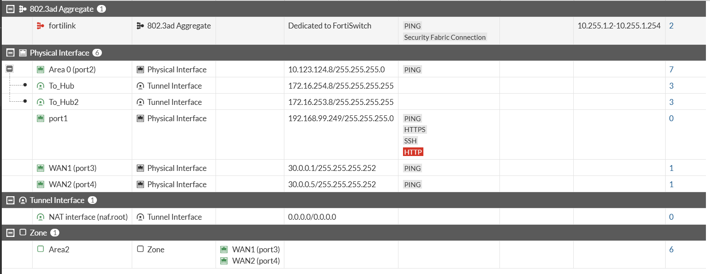
Static Routes

OSPF
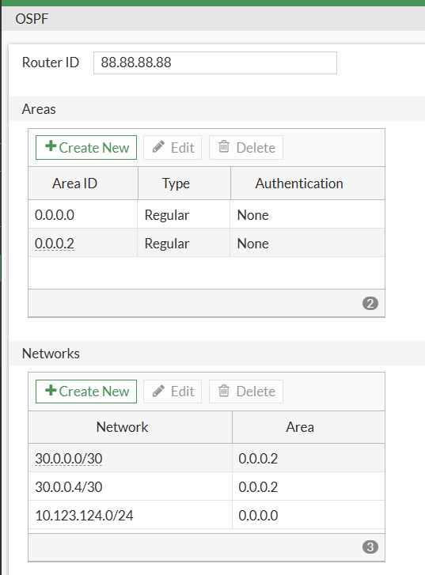

BGP
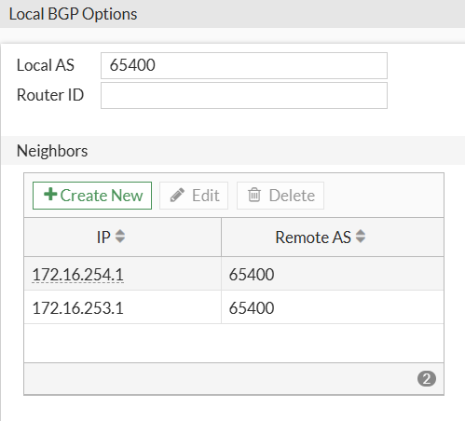
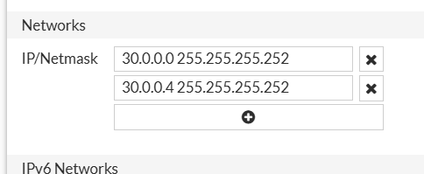

Firewall Policies
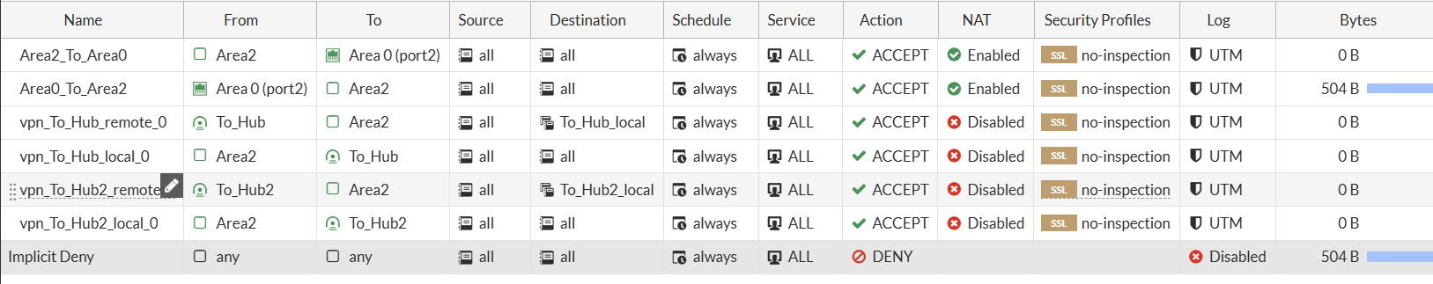
VPN
ECMP Route to RIP
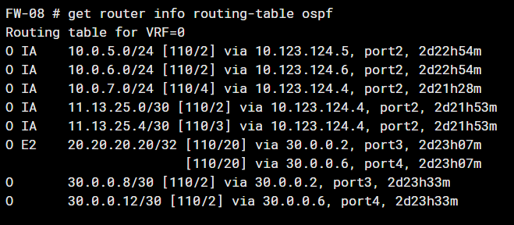

TESTING
Hub to Spokes LAN:
HUB # execute ping-options source 10.0.1.1

HUB # execute ping 10.0.2.1
PING 10.0.2.1 (10.0.2.1): 56 data bytes
64 bytes from 10.0.2.1: icmp_seq=0 ttl=255 time=7.3 ms
64 bytes from 10.0.2.1: icmp_seq=1 ttl=255 time=5.6 ms
64 bytes from 10.0.2.1: icmp_seq=2 ttl=255 time=6.0 ms
3 packets transmitted, 3 packets received, 0% packet loss
round-trip min/avg/max = 5.6/6.3/7.3 ms

HUB # execute ping 10.0.3.1
PING 10.0.3.1 (10.0.3.1): 56 data bytes
64 bytes from 10.0.3.1: icmp_seq=0 ttl=255 time=8.8 ms
64 bytes from 10.0.3.1: icmp_seq=1 ttl=255 time=12.0 ms
64 bytes from 10.0.3.1: icmp_seq=2 ttl=255 time=9.9 ms
3 packets transmitted, 3 packets received, 0% packet loss
round-trip min/avg/max = 8.8/10.2/12.0 ms

HUB # execute ping 10.0.5.1
PING 10.0.5.1 (10.0.5.1): 56 data bytes
64 bytes from 10.0.5.1: icmp_seq=0 ttl=255 time=21.0 ms
64 bytes from 10.0.5.1: icmp_seq=1 ttl=255 time=18.2 ms
64 bytes from 10.0.5.1: icmp_seq=2 ttl=255 time=17.1 ms
3 packets transmitted, 3 packets received, 0% packet loss
round-trip min/avg/max = 17.1/18.7/21.0 ms

HUB # execute ping 10.0.6.1
PING 10.0.6.1 (10.0.6.1): 56 data bytes
64 bytes from 10.0.6.1: icmp_seq=0 ttl=255 time=16.1 ms
64 bytes from 10.0.6.1: icmp_seq=1 ttl=255 time=18.2 ms
64 bytes from 10.0.6.1: icmp_seq=2 ttl=255 time=18.5 ms
3 packets transmitted, 3 packets received, 0% packet loss
round-trip min/avg/max = 16.1/17.6/18.5 ms

HUB # execute ping 10.0.7.1
PING 10.0.7.1 (10.0.7.1): 56 data bytes
64 bytes from 10.0.7.1: icmp_seq=0 ttl=255 time=18.2 ms
64 bytes from 10.0.7.1: icmp_seq=1 ttl=255 time=16.9 ms
64 bytes from 10.0.7.1: icmp_seq=2 ttl=255 time=18.8 ms
3 packets transmitted, 3 packets received, 0% packet loss
round-trip min/avg/max = 16.9/17.9/18.8 ms

HUB # execute ping 30.0.0.1
PING 30.0.0.1 (30.0.0.1): 56 data bytes
64 bytes from 30.0.0.1: icmp_seq=0 ttl=255 time=17.6 ms
64 bytes from 30.0.0.1: icmp_seq=1 ttl=255 time=17.8 ms
64 bytes from 30.0.0.1: icmp_seq=2 ttl=255 time=18.0 ms
3 packets transmitted, 3 packets received, 0% packet loss
round-trip min/avg/max = 17.6/17.8/18.0 ms

HUB # execute ping 30.0.0.5
PING 30.0.0.5 (30.0.0.5): 56 data bytes
64 bytes from 30.0.0.5: icmp_seq=0 ttl=255 time=16.3 ms
64 bytes from 30.0.0.5: icmp_seq=1 ttl=255 time=17.3 ms
64 bytes from 30.0.0.5: icmp_seq=2 ttl=255 time=17.3 ms
3 packets transmitted, 3 packets received, 0% packet loss
round-trip min/avg/max = 16.3/16.9/17.3 ms

Spokes to Spoke:
FW-02 # execute ping-options source 10.0.2.1

FW-02 # execute ping 10.0.1.1
PING 10.0.1.1 (10.0.1.1): 56 data bytes
64 bytes from 10.0.1.1: icmp_seq=0 ttl=255 time=6.5 ms
64 bytes from 10.0.1.1: icmp_seq=1 ttl=255 time=5.7 ms
64 bytes from 10.0.1.1: icmp_seq=2 ttl=255 time=5.0 ms
3 packets transmitted, 3 packets received, 0% packet loss
round-trip min/avg/max = 5.0/5.7/6.5 ms

FW-02 # execute ping 10.0.3.1
PING 10.0.3.1 (10.0.3.1): 56 data bytes
64 bytes from 10.0.3.1: icmp_seq=0 ttl=254 time=16.6 ms
64 bytes from 10.0.3.1: icmp_seq=2 ttl=255 time=10.9 ms
64 bytes from 10.0.3.1: icmp_seq=3 ttl=255 time=11.4 ms
4 packets transmitted, 3 packets received, 25% packet loss
round-trip min/avg/max = 10.9/12.9/16.6 ms

FW-02 # execute ping 10.0.5.1
PING 10.0.5.1 (10.0.5.1): 56 data bytes
64 bytes from 10.0.5.1: icmp_seq=0 ttl=254 time=21.1 ms
64 bytes from 10.0.5.1: icmp_seq=3 ttl=255 time=16.5 ms
64 bytes from 10.0.5.1: icmp_seq=4 ttl=255 time=16.6 ms
5 packets transmitted, 3 packets received, 40% packet loss
round-trip min/avg/max = 16.5/18.0/21.1 ms

FW-02 # execute ping 10.0.6.1
PING 10.0.6.1 (10.0.6.1): 56 data bytes
64 bytes from 10.0.6.1: icmp_seq=0 ttl=254 time=23.2 ms
64 bytes from 10.0.6.1: icmp_seq=2 ttl=255 time=16.8 ms
64 bytes from 10.0.6.1: icmp_seq=3 ttl=255 time=17.4 ms
4 packets transmitted, 3 packets received, 25% packet loss
round-trip min/avg/max = 16.8/19.1/23.2 ms

FW-02 # execute ping 10.0.7.1
PING 10.0.7.1 (10.0.7.1): 56 data bytes
64 bytes from 10.0.7.1: icmp_seq=0 ttl=254 time=21.3 ms
64 bytes from 10.0.7.1: icmp_seq=2 ttl=255 time=14.8 ms
64 bytes from 10.0.7.1: icmp_seq=3 ttl=255 time=16.8 ms
4 packets transmitted, 3 packets received, 25% packet loss
round-trip min/avg/max = 14.8/17.6/21.3 ms

Hub WAN1 Failing Over to WAN2 (BFD).
- Because BGP is very slow with convergence we are going to need to configure all Firewalls with BFD for faster convergence.
- Here’s what we did on the HUB and FW02 as a Spoke example:
SPOKE
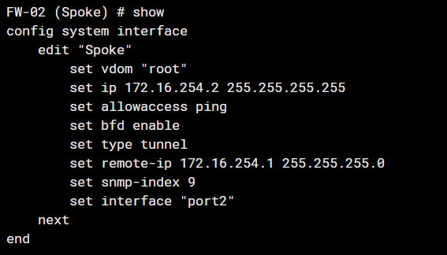
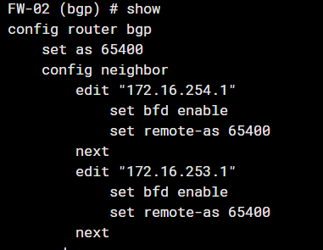
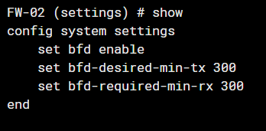

HUB:
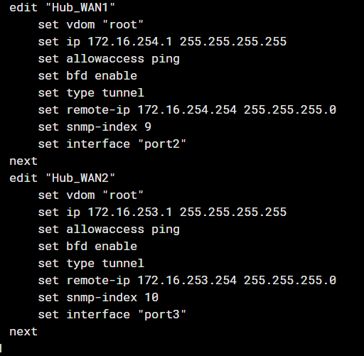
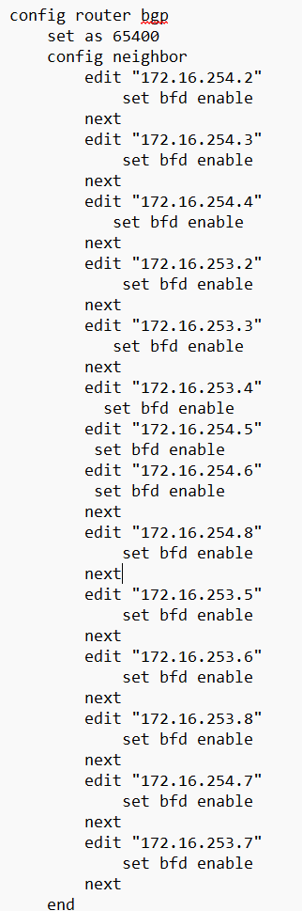

- We are going to ping from FW02 to 10.0.1.1 which is the LAN behind the HUB.
- We are going to shutdown WAN1 interface while pinging 10.0.1.1 from FW02 and capture the packet loss and how it would failover to Wan2 on the HUB live.
- This is the status of the BFD neighbors:
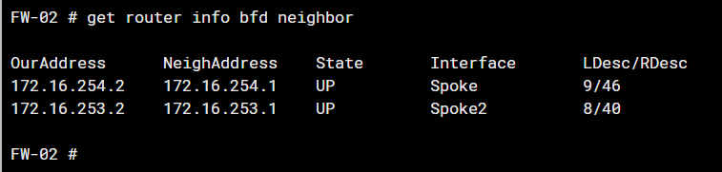
FW-02 # execute ping 10.0.1.1
PING 10.0.1.1 (10.0.1.1): 56 data bytes
64 bytes from 10.0.1.1: icmp_seq=0 ttl=255 time=4.9 ms
64 bytes from 10.0.1.1: icmp_seq=1 ttl=255 time=3.8 ms
64 bytes from 10.0.1.1: icmp_seq=2 ttl=255 time=8.4 ms
64 bytes from 10.0.1.1: icmp_seq=3 ttl=255 time=4.8 ms
64 bytes from 10.0.1.1: icmp_seq=4 ttl=255 time=5.3 ms
64 bytes from 10.0.1.1: icmp_seq=5 ttl=255 time=4.7 ms
64 bytes from 10.0.1.1: icmp_seq=6 ttl=255 time=3.9 ms
64 bytes from 10.0.1.1: icmp_seq=7 ttl=255 time=4.9 ms
64 bytes from 10.0.1.1: icmp_seq=8 ttl=255 time=4.1 ms
64 bytes from 10.0.1.1: icmp_seq=9 ttl=255 time=4.6 ms
64 bytes from 10.0.1.1: icmp_seq=10 ttl=255 time=4.7 ms
64 bytes from 10.0.1.1: icmp_seq=11 ttl=255 time=4.3 ms
64 bytes from 10.0.1.1: icmp_seq=12 ttl=255 time=3.9 ms
64 bytes from 10.0.1.1: icmp_seq=13 ttl=255 time=3.4 ms
64 bytes from 10.0.1.1: icmp_seq=14 ttl=255 time=5.7 ms
64 bytes from 10.0.1.1: icmp_seq=15 ttl=255 time=4.4 ms
64 bytes from 10.0.1.1: icmp_seq=16 ttl=255 time=5.9 ms
64 bytes from 10.0.1.1: icmp_seq=17 ttl=255 time=4.4 ms
64 bytes from 10.0.1.1: icmp_seq=18 ttl=255 time=3.8 ms
64 bytes from 10.0.1.1: icmp_seq=19 ttl=255 time=4.2 ms
64 bytes from 10.0.1.1: icmp_seq=20 ttl=255 time=7.0 ms
64 bytes from 10.0.1.1: icmp_seq=21 ttl=255 time=3.9 ms
64 bytes from 10.0.1.1: icmp_seq=22 ttl=255 time=4.5 ms
64 bytes from 10.0.1.1: icmp_seq=23 ttl=255 time=4.9 ms
64 bytes from 10.0.1.1: icmp_seq=24 ttl=255 time=4.1 ms
64 bytes from 10.0.1.1: icmp_seq=25 ttl=255 time=5.2 ms
26 packets transmitted, 26 packets received, 0% packet loss
round-trip min/avg/max = 3.4/4.7/8.4 ms
- There was 0 Packet loss after shutting down WAN1.

