Danzel Capers

Mr. Manaris

CSCI 380

09/16/2015

**Homework 2**

1. **Introduction**: Describe your first impressions:
   * What is good and bad about this interface?
     1. The website seems very creative using pictures that seem like the background as interactive video links.
     2. There is a lot going on at once, having over fifty different picture links that look similar. Position of links change when the website is refreshed.
   * What is good and bad about the user experience it produces?
     1. It's interesting to navigate through the site leaning more as you go. The screen looks amazing to look at with how all the pictures come together and move about the screen.
     2. At first the website is very fun navigating the website randomly looking at the different videos. You find things you may not have been looking for in the first place. Very easy to get confused when looking for anything specific. A lot of the videos have the similar search tags so using the search option still leave a lot of option to go through.
2. **Functionality**: Describe the system's functionality.
   * This website allows users to click and watch interviews with well-known professionals in the gaming industry. Videos are tag with certain phrases giving the ability to filter through them with a search option.
3. **Tasks**: List user tasks.
   * Read what an interview is about.
   * Watch full length interviews with knowledgeable people in this field.
   * The functionality is at less equal to what the user needs but is packaged in a way that makes it confusing to navigate for the user.
4. **Usability Breakdown**: Describe a usability breakdown caused by the system's design.
   * There are multiple icons with the same picture or design but have different context if clicked on by the mouse.
   * If you click on an area that a video link could be then the screen will go be covered with a black screen where the video usually is displayed.
   * While using the mobile version I wanted to scroll downward to look at more links but the empty space are considered links so instead the phone tried to play a video.
   * I expected to click on a certain person and get there full interview not parts of it on different section of the page.
   * 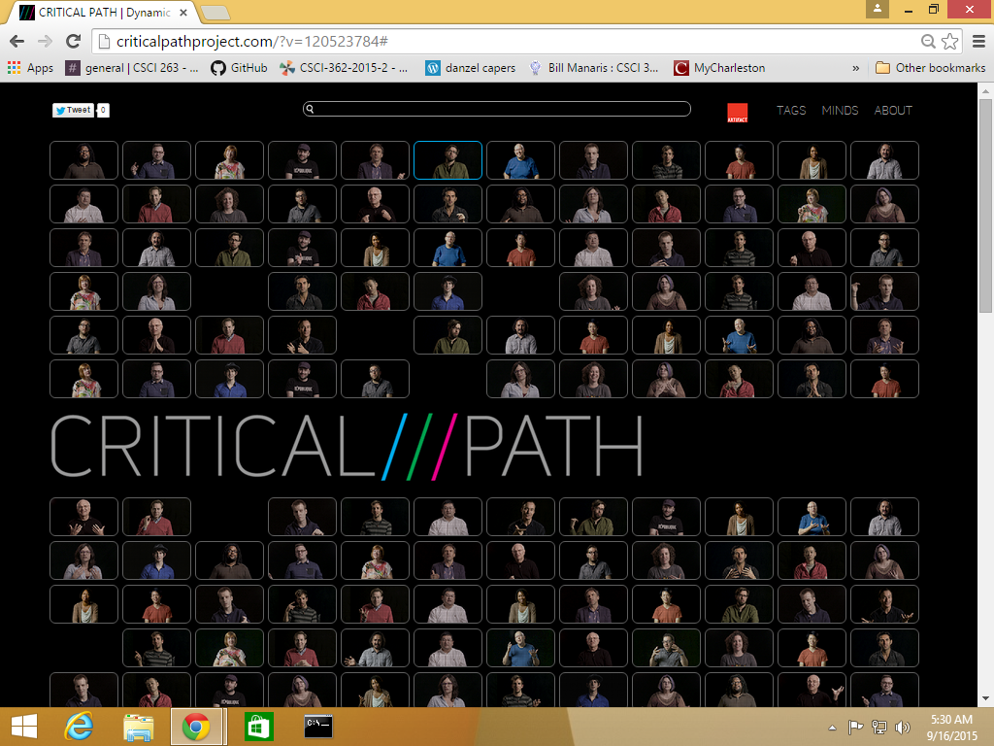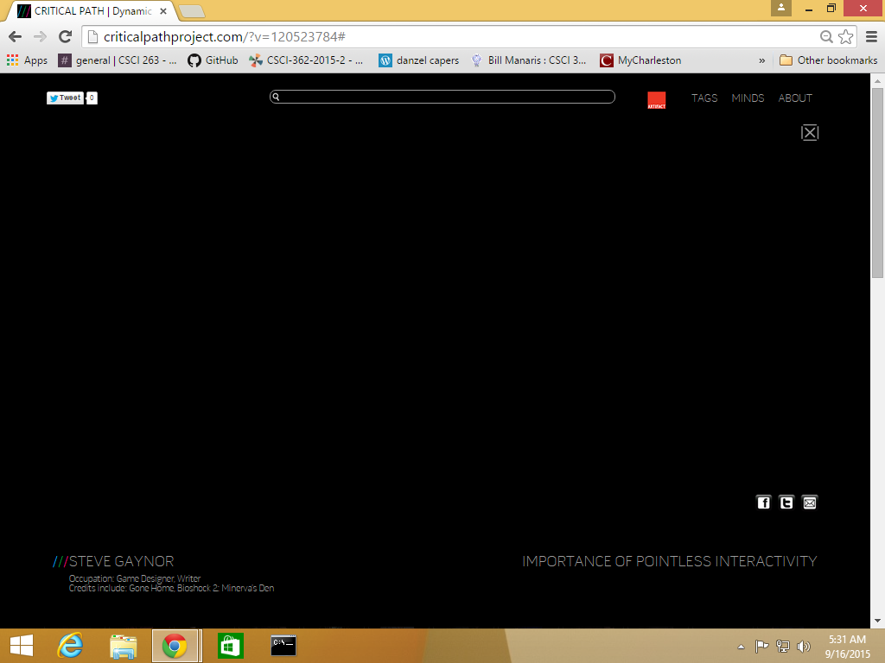
5. **Analysis**: Using design concepts and other principals from class/textbook, explain why this usability breakdown occurred.
   * Visibility - The home button is a logo of the title of the website in the middle of the page. The menu at the top of the screen gives no way of directly interacting with the videos of interviews. It is not obvious that by clicking the pictures you can activate a video to be played and there are no instructions saying so. These things limit the user's knowledge of what they can and can’t control.
   * Feedback - When moving your mouse over a blank space where a picture link could possible be place there is no response saying that a link marker lies here. When going of a picture it lights up saying
   * Consistency - The website is dynamic in that it is never consistent. Links move up and down the page to different positions changing the results of clicking each.
6. **Improvements**: Discuss possible design improvements to the interface, based on your usability evaluation.
   * A more organized setup, have an option to have videos put in an order or text view.
   * Have all places where a link could be light up when the mouse runs over then indicating that clicking here will change the state of the website by opening a video window.
   * Use tabs to place the videos into separate genres.
   * Straighten out the tags page to something less cluttered to make information is to read and pick out.

