Raquel Jones, Danzel Capers

Mr. Manaris

CSCI 380

Fall 2015

**Homework 5**

1. **Name of application:** Factaural
2. **User goal:**
   1. “I want to make art with my music”
3. **Hierarchical Task Analysis:**

0.Turn music into art (Plan 0: Do 1,2,3 in order and 2 can only be done after 1 is completed and 3 can only be done after 1 or 2 is completed)

1. Make Music ( Plan 1: according to requirements)

**1.1 Enter music** (Plan 1.1: 1.1.1-1.1.5)

**1.1.1 Click menu button**

**1.1.2 Select instrument**

**1.1.3.1 Drums**

**1.1.3.2 Strings**

**1.1.3.3 Keyboard**

**1.1.3.4 Other**

**1.1.3 Select version of instrument**

**1.1.4 Select pitch**

**1.1.4.1 Move slider**

**1.1.5 Press desired location on music sheet**

1.2 Load existing music (Plan 1.2: 1.2.1-1.2.4)

1.2.1 Click menu button

1.2.2 Click load

1.2.3 Select file

1.2.4 Press file

1.3 Edit music

1.3.1 Modify music

1.3.1.1 Delete section of music

1.3.1.1.1 Select music block

1.3.1.1.2 Click edit button

1.3.1.1.3 Press delete button

1.4 Save music

1.4.1 Click menu button

1.4.2 Click save

1.4.3 Enter file name

1.4.4 Press file

1.5 Play music

1.5.1 Click menu button

1.5.2 Click play

**2. Convert Music to Art**

**2.1 Sync with mobile device**

**2.1.1 Click sync button**

**2.2 Convert music**

**2.2.1 Click convert button**

2.3 Save art

2.3.1 Click menu button

2.3.2 Click save

2.3.3 Enter file name

2.3.4 Press file

3. Share Creation

3.1 Send to user

3.1.1 Click share button

3.1.1 Click email

3.1.3 Enter user email

3.1.4 Press Send

3.2 Post online

3.2.1 Click share button

3.2.2 Select media

3.2.2.1 Facebook

3.2.2.2 Twitter

3.2.2.3 Other

3.2.3 Press send

**Main menu** **Loading menu**

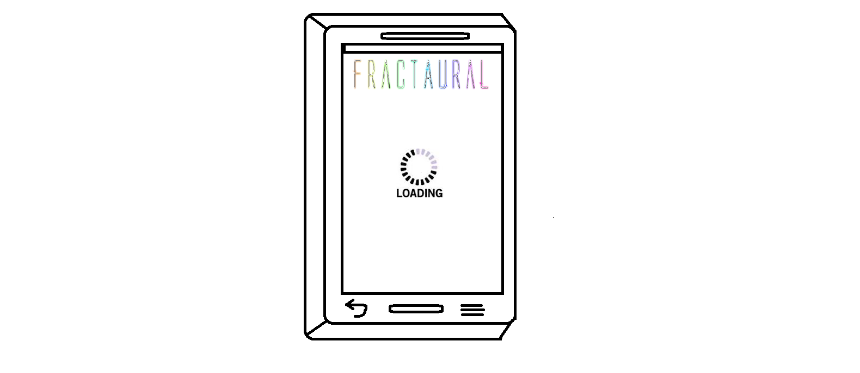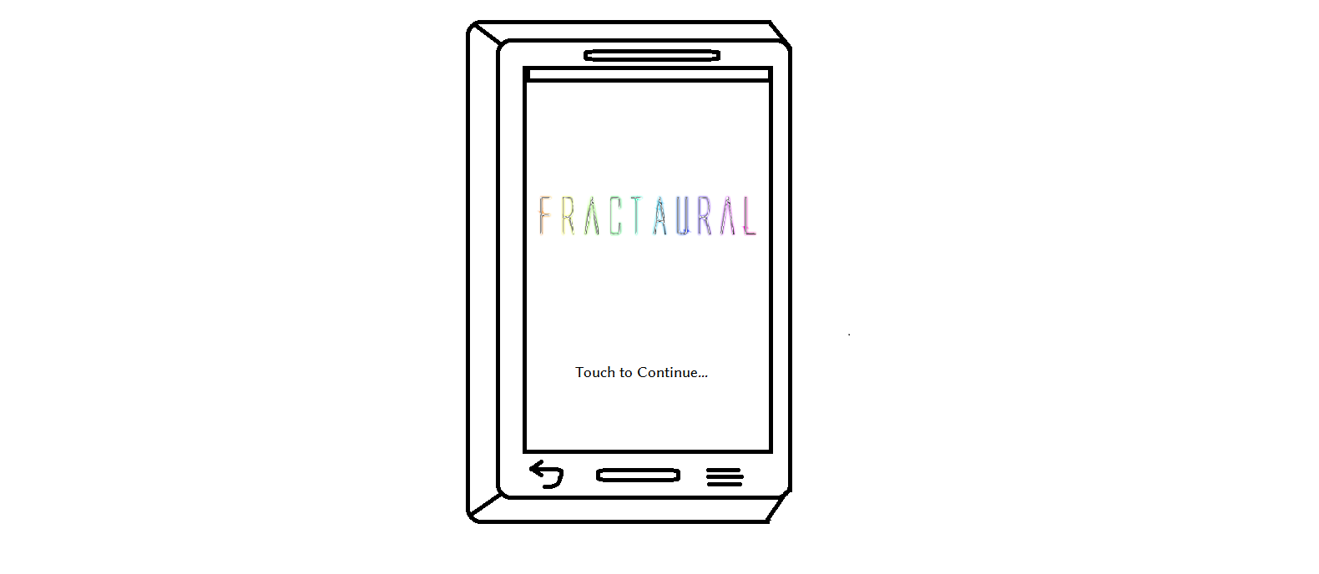

**1.1.1 Click menu button 1.1.2 Select instrument**

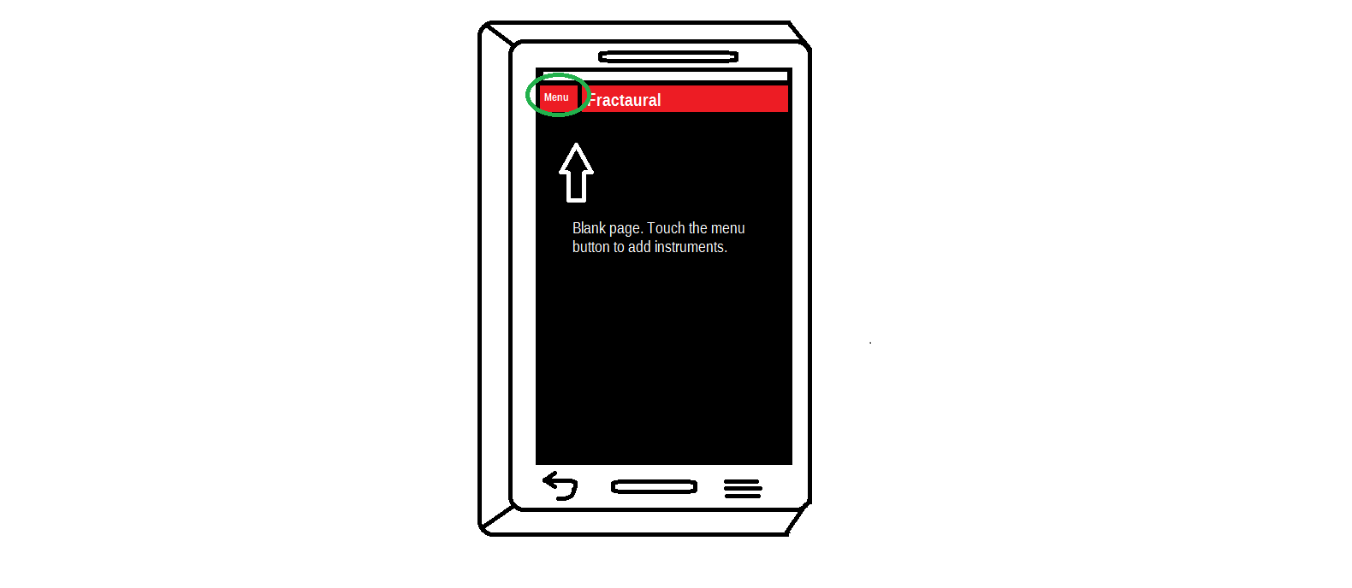

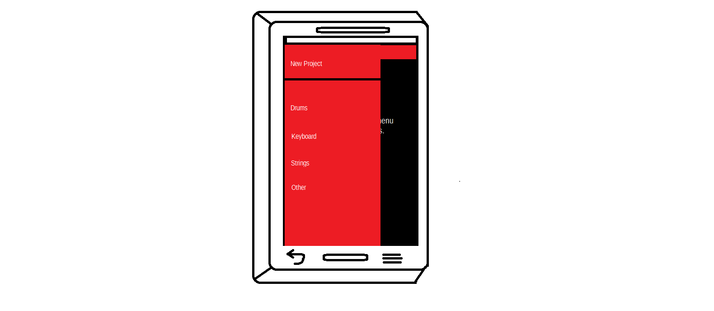

**1.1.3 Select version 1.1.4 Select pitch**

**1.1.4.1 Move slider User Note**

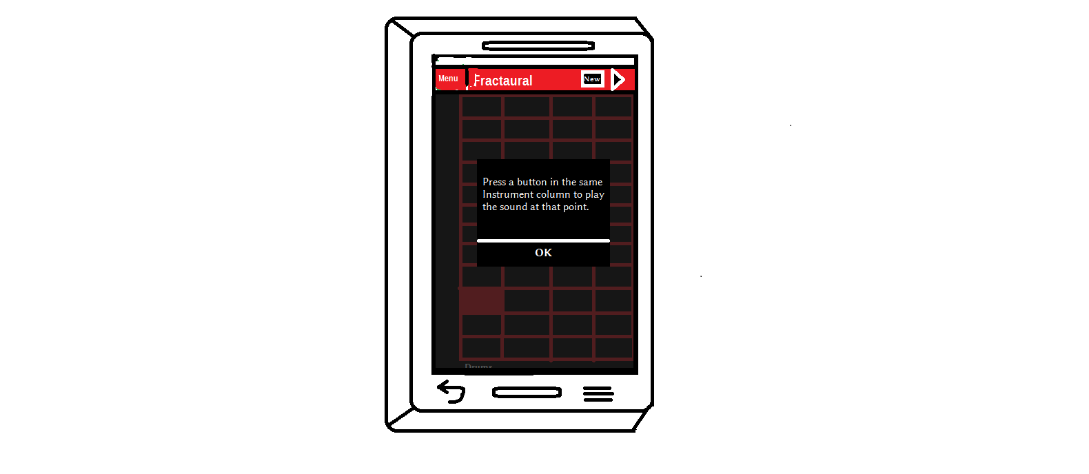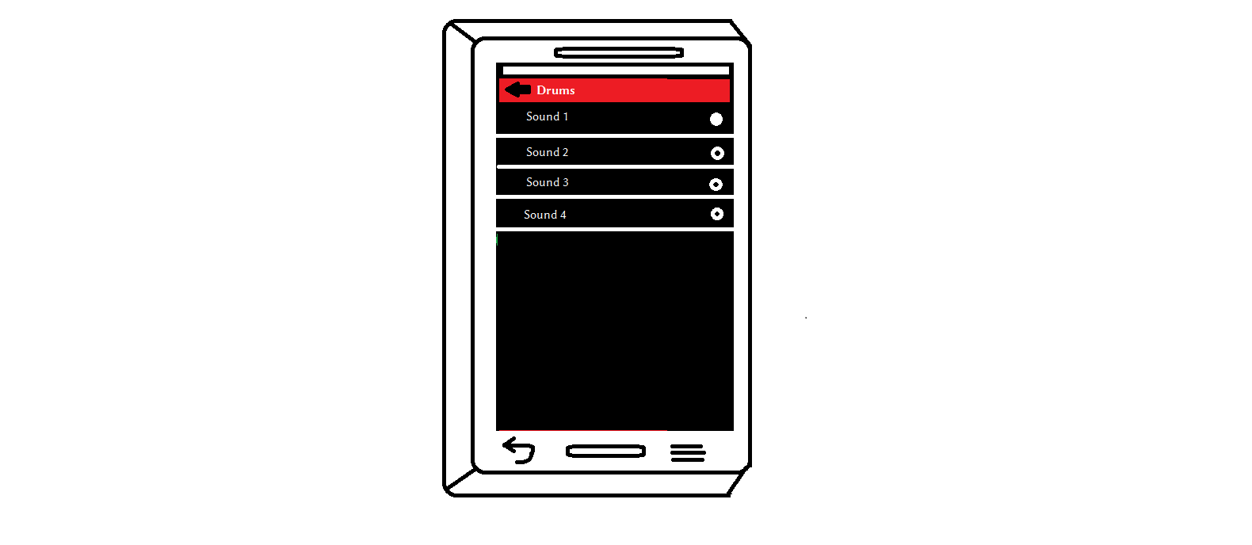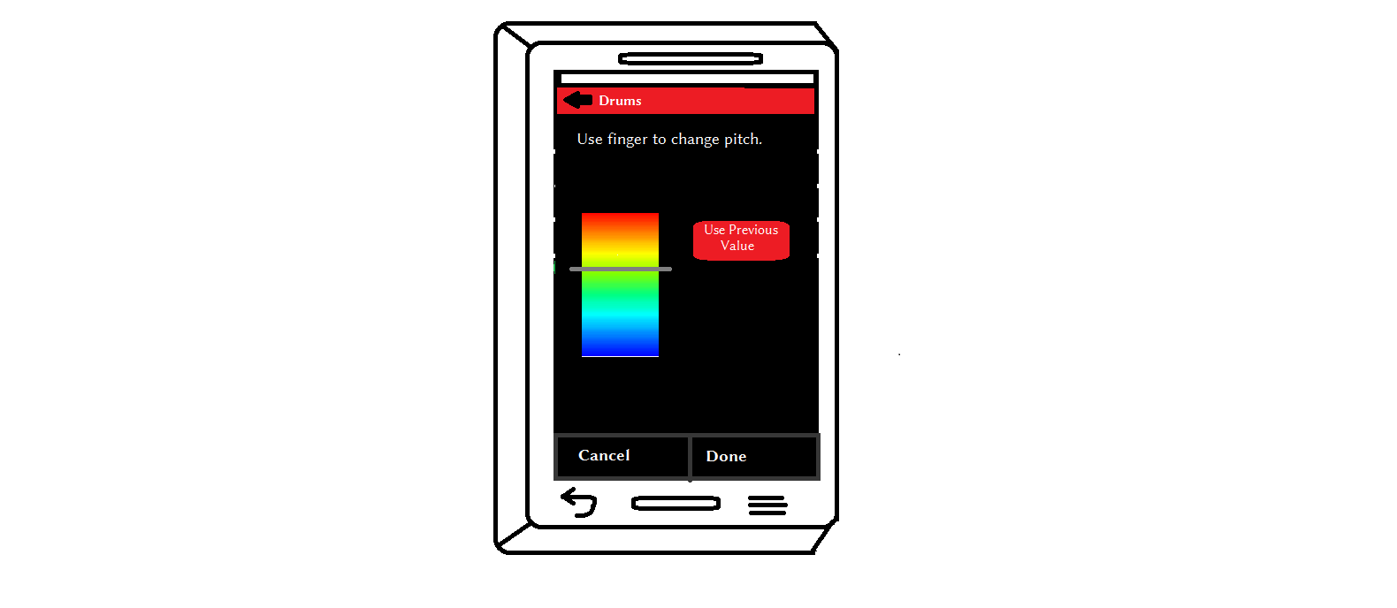

**1.1.5 Press desired location on music sheet Step repeated**

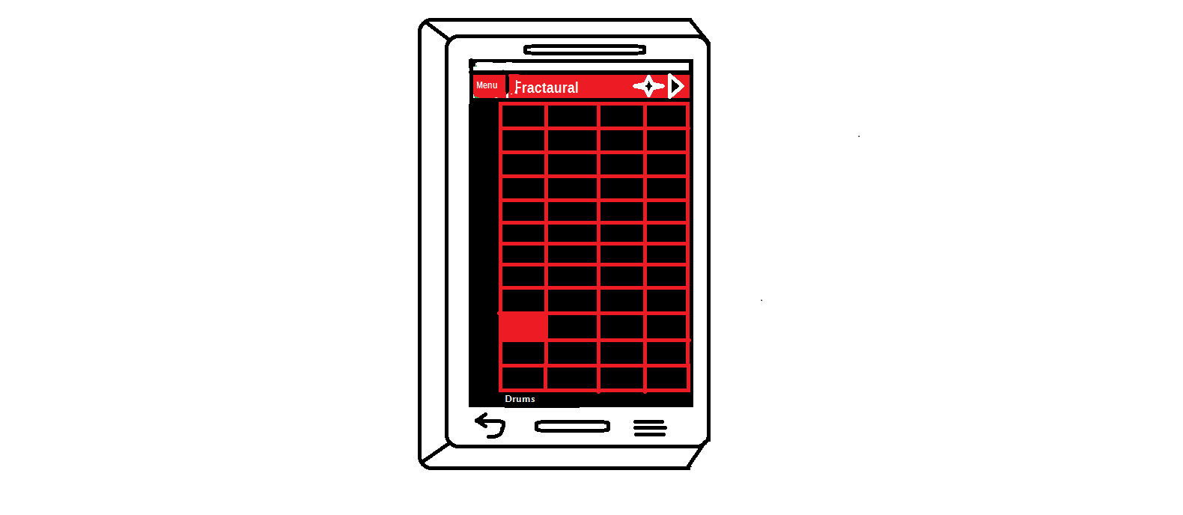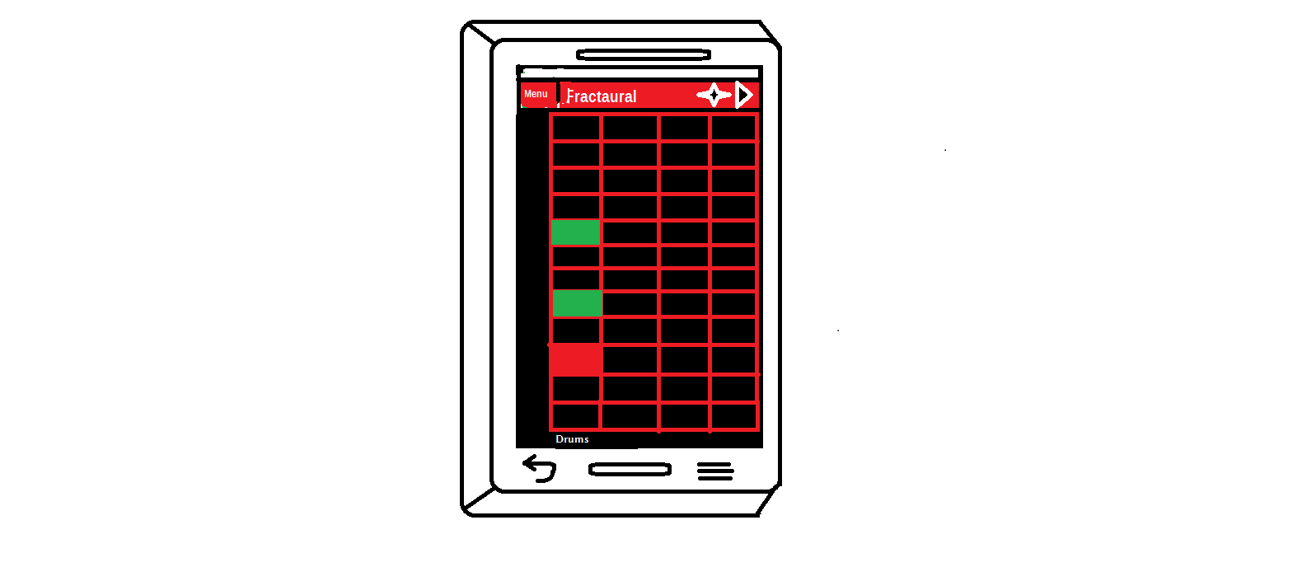

**2.1 Sync with mobile device**

**2.1.1 Click sync button**

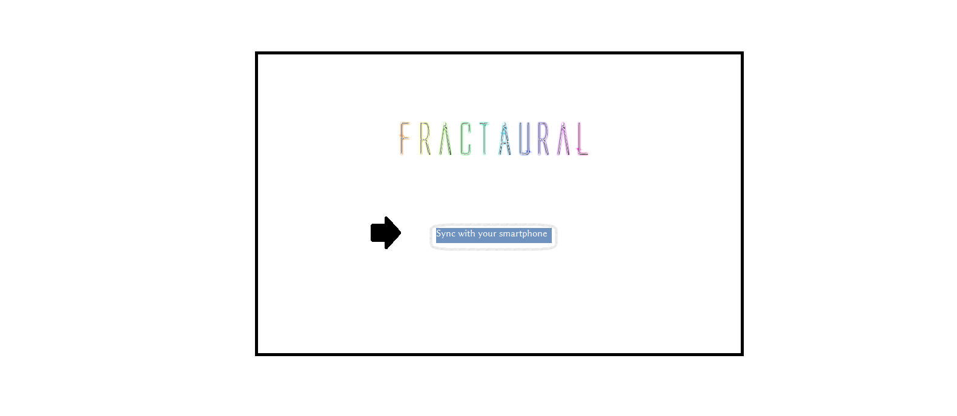

**Loading page**

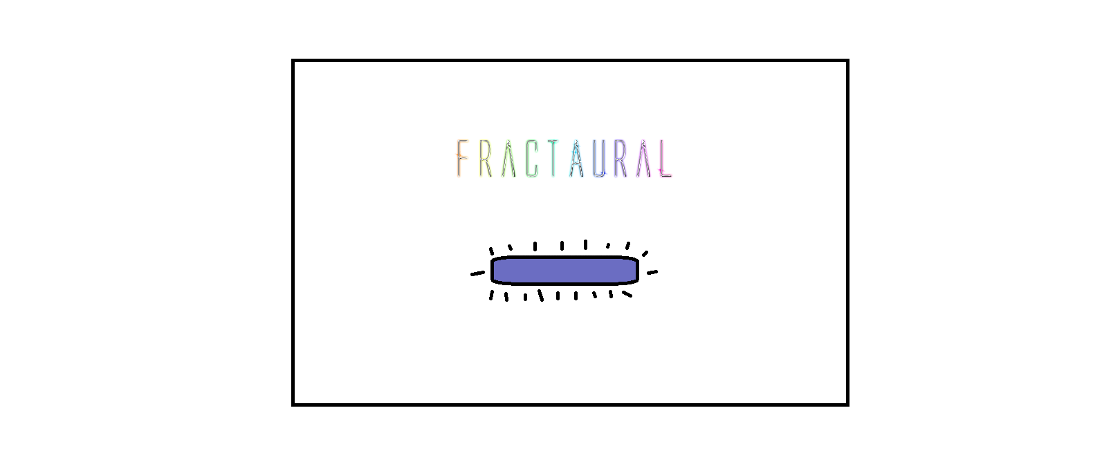

Waiting for mobile device to connect to the network

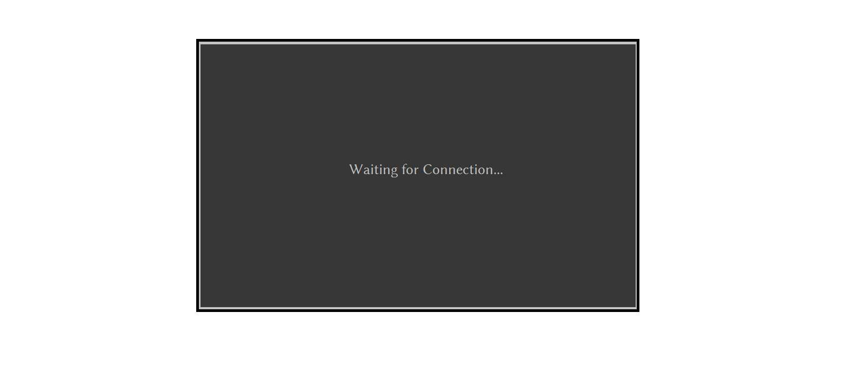

**2.2 Convert music**

**2.2.1 Click convert button Loading page**

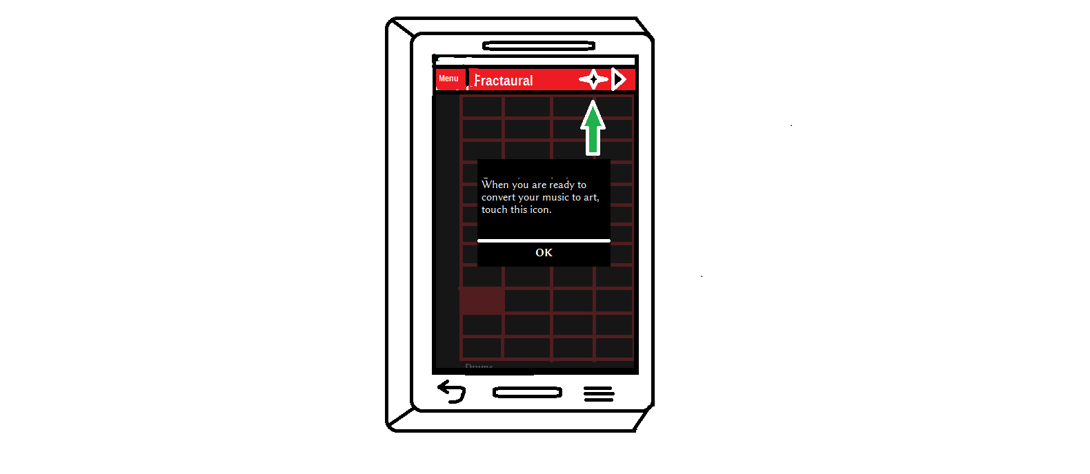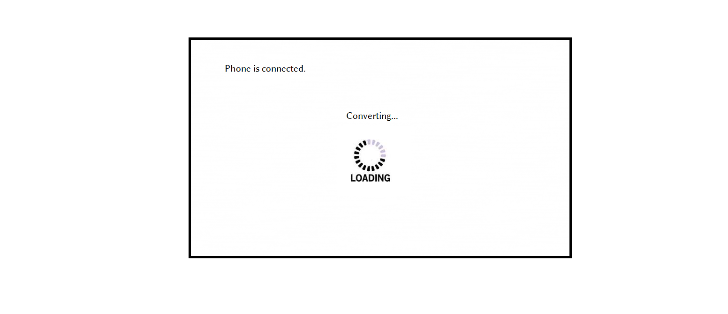

Final Product