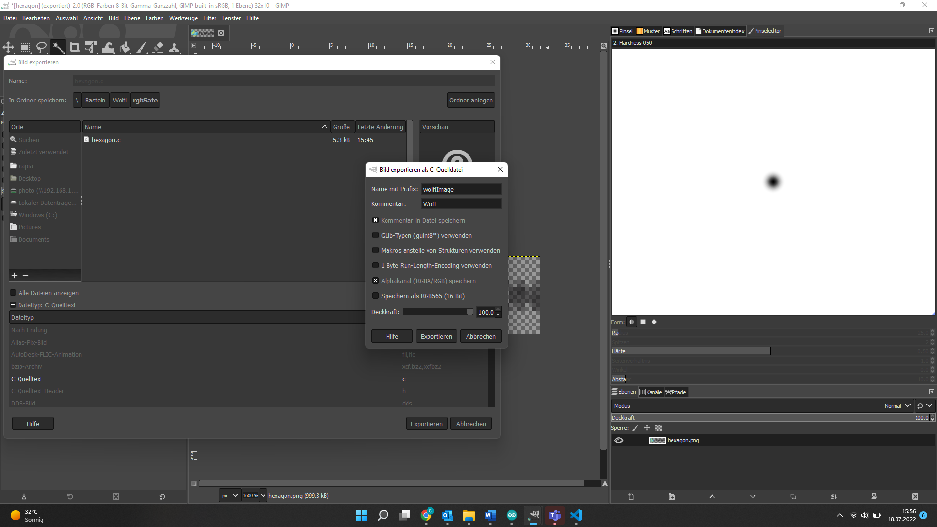

<https://learn.adafruit.com/adafruit-matrixportal-m4>

# Passthrough für z.B. hexos

void setup() {

Serial.begin(9600);

Serial1.begin(9600);

}

void loop() {

if (Serial.available()) { // If anything comes in Serial (USB),

Serial1.write(Serial.read()); // read it and send it out Serial1 (pins 0 & 1)

}

if (Serial1.available()) { // If anything comes in Serial1 (pins 0 & 1)

Serial.write(Serial1.read()); // read it and send it out Serial (USB)

}

}