**Cheef Botanicals CBD Full Spectrum Gummies**

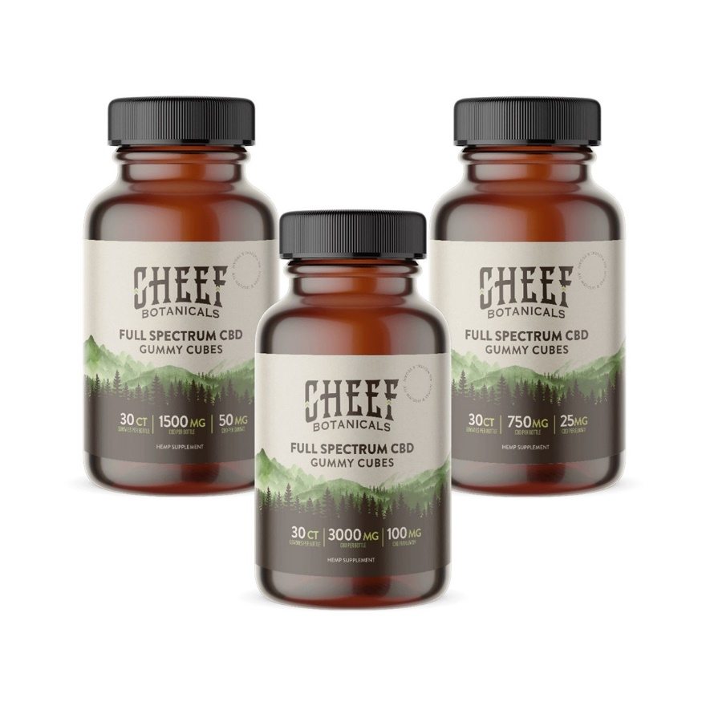

**Brand:** Cheef Botanicals

**Price:** 45.99 – 114.99

**Category:** CBD Edibles

**(H1) About Cheef CBD Gummies**

[Vegan CBD gummy cubes - full spectrum CBD - Cheef Botanicals](https://cheefbotanicals.com/cbd-gummies/cubes/)<br><br>

<Center>

**To order online use the link below to our Online Store**

<br><br>

<Center><a class="link-view-more-products" target="_blank" href="https://capitalcbd.shop/product/">Order Online</a></

<br><br><br>

<Center><a class="link-view-more-products" target="_blank" href="https://capitalamericanshaman.com/products">Take a look at our Products</a></Center>

<br><br>