**Hometown Hero Fudgy Brownies | 50mg D9 4ct**

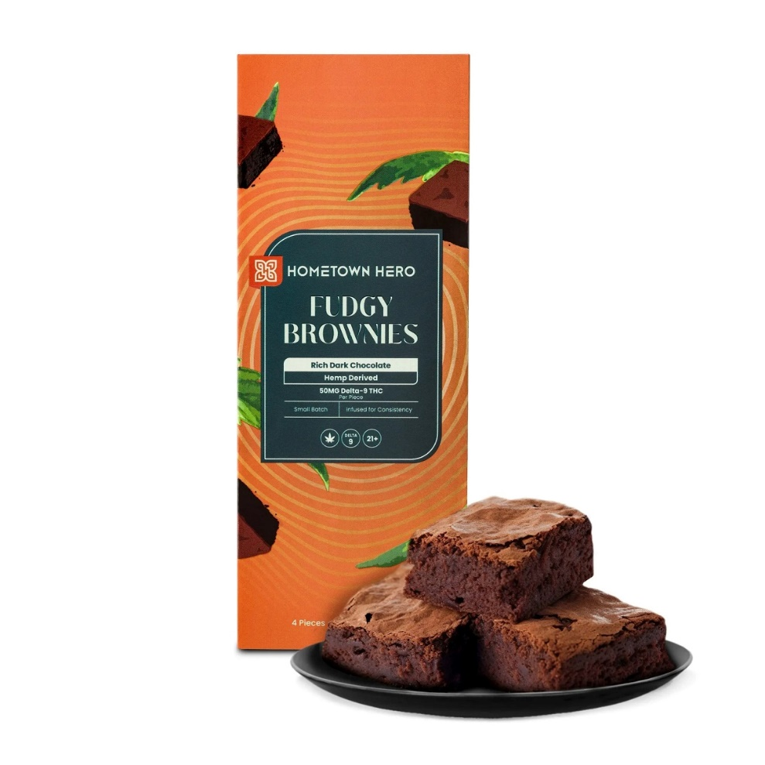

**Brand:** Hometown Hero

**Price:** 45.00

**Category:** Delta 9

About Hometown Hero Delta 9 Fudge Brownies (H1)

[Fudgy THC Brownies - 50mg | Hometown Hero](https://hometownhero.com/p/fudgy-delta-9-brownies/)

<br><br>

<Center>

**To order online use the link below to our Online Store**

<br><br>

<Center><a class="link-view-more-products" target="_blank" href=" https://capitalcbd.shop/shop-online/">Order Online</a></

<br><br><br>

<Center><a class="link-view-more-products" target="_blank" href="https://capitalamericanshaman.com/products">Take a look at our Products</a></Center>

<br><br>