TA Comment: Calculate the Floating Point operation in GFLOP/sec in the assignment although in the assignment it is mentioned FLOP/sec.

**C1 – output**

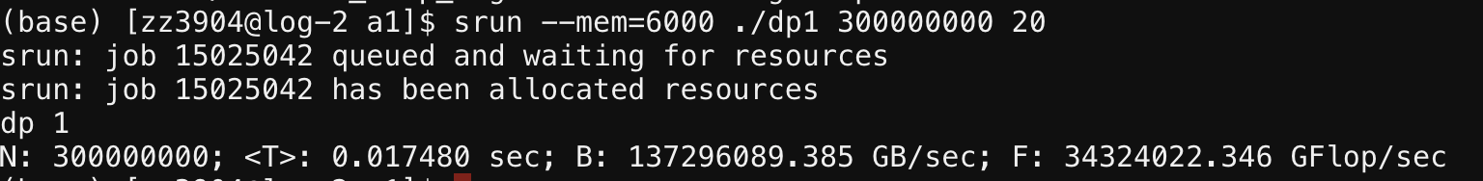

**C2 – output**

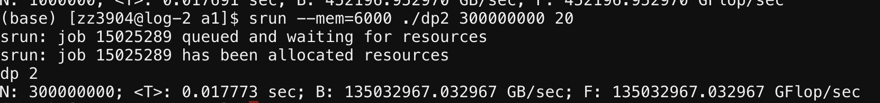

**C3 – output**

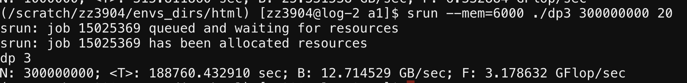

**C4 - output**

**C5 - output**

**Q1 (3 points):**

**Explain the consequence of only using the second half of the measurements for the computation of the mean.**

* using the second half of the measurements for the computation of the mean does not correctly reflect the execution time.
* Second half is faster
* Reason: more will be cached from disk in memory which speeds up the execution.

**Q2**

* I wrote a python script to plot the numbers. I first copied the results from c1-c5 to make a list and plot all the points.

**Q3 (5 points):**

**Using the N=300000000 simple loop as the baseline, explain the**

**the difference in performance for the other 5 measurements in the C variants.**

(TA comments: In Q3 it is written to compare the baseline (which C1) with 5 measurements in the C variants. It is a mistake you need to compare with other 2 (c2 and c3) measurements.)

Answer

**Q3 (6 points):**

**Check the result of the dot product computations against the analytically calculated result.**

**Explain your findings. (Hint: Floating point operations are not exact.)**

**Problems**

1. Only print one line 🡪 c1-c5
2. Use half time for calculation
3. How to verify if the calculation is correct
   1. Print numerator and denominator
   2. Check benchmark
4. Figure out root cause of the error
   1. Array too large …
5. Try allloc for C1,2, 3
6. Figure out how to download module and use it c3
7. Draw roofline model
   1. What is roofline model
   2. X-axis & y-axis
   3. What data?
   4. How to use gnuplot
8. Why C4 running too long
   1. Python3 loop? Any error
9. Dot product computation error
   1. Floating point operation error