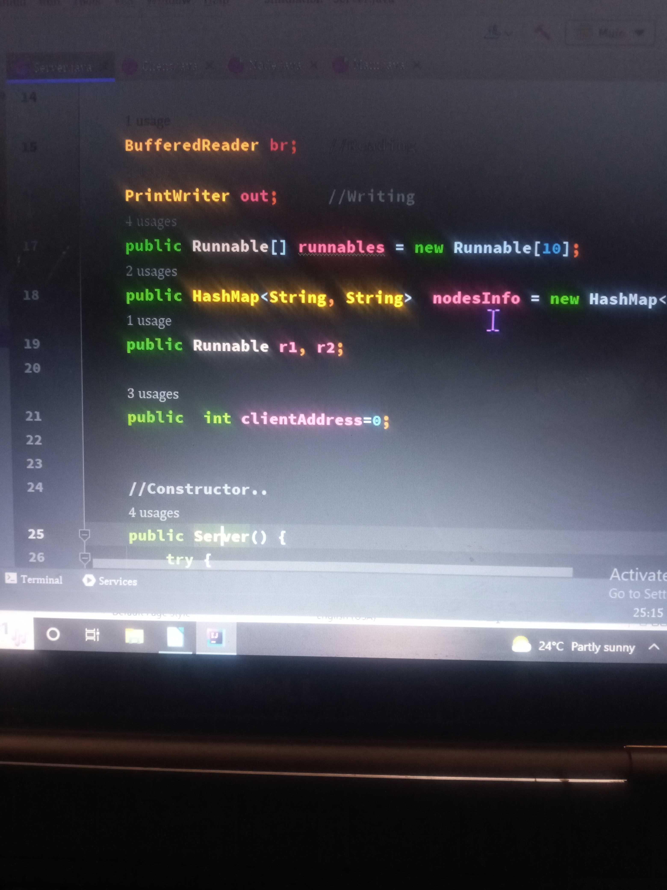
DEMONSTRATION OF MULTI-THREADING AND SINGLE THREADING IN JAVA

Single threads (The problem)

Messaging simulation project is software designed using java as a core language.
This is enclosed in a file called single
It simulates the real life client-server relationship, with core programming in multi threading and single threading. The server itself is programmed with single-threading capabilities but handle simultaneous connections from as many clients as possible.The when you create for example 10 clients to read and write from the server the time taken in milliseconds is around 2500 milliseconds;

Compiling

Since the project is grounded in java core language JDK must be there for compiling
the java source codes. Prefureblly JDK 1.8 since the project articulates moderm java.
For compiling this source code in any IDE download the zipe file and extract everything to remain with java files. Open IDE and find the main file which hosts main method(), and run it. This method will instantiate Server singular object for the clients to connect to. The main method then will pops a window to enter the number of prefferd clients(nodes) because the number of nodes to be created was suppose to br created from command line argument.
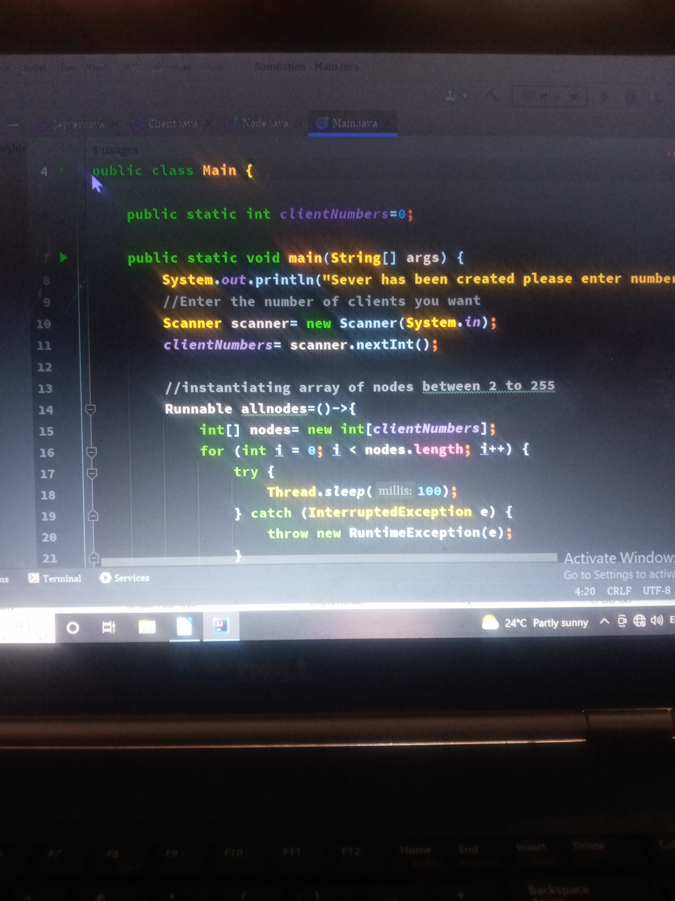
Once the input is taken then the main method goes on to instaniate nodes objects in accordance with the input.

In the above main() creates new thread for creaing new nodes as the main thread is responsible to check on the server connection.
Server file

This file contain all the server based code which opens connection for clients at port 7778
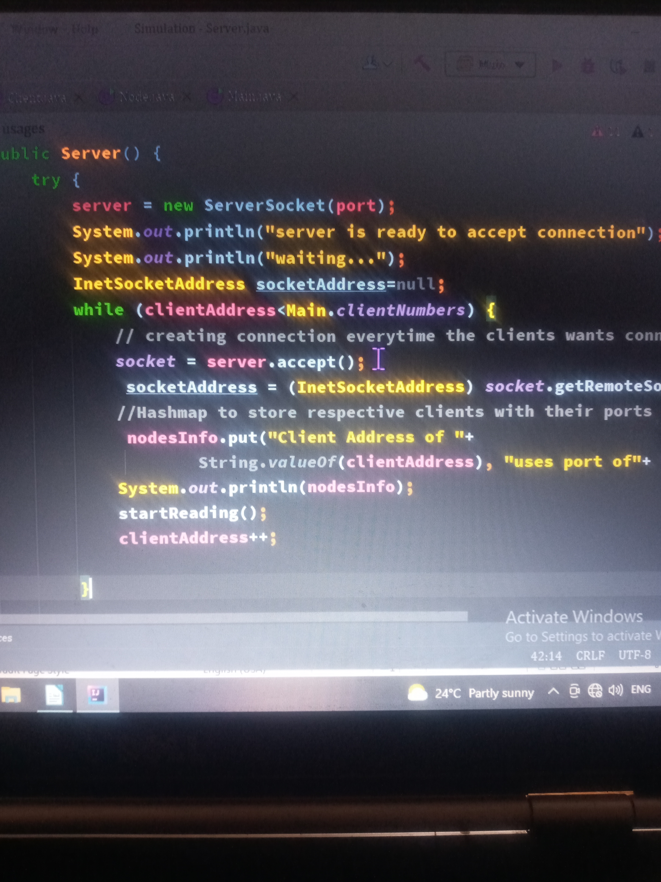
locally hosted machine. It defines methods such as startWritting() , which start to dispatch messages to various clients.

It has startReading() method which gets the clients message and the destination of the message.
Server has got infinite thread creation feature implemented through for loop which is called to create a number of threads as per instructed

Client file

This file is responsible for creating clients or nodes which feeds from the server file through the TCP/IP sockets.

Client is multithreaded to optimize it functionalities.
Client create files (input files) and read its content to send it to another node
Client also automatically creates the ouput file with refernce to its name, then stores message it recieves here.
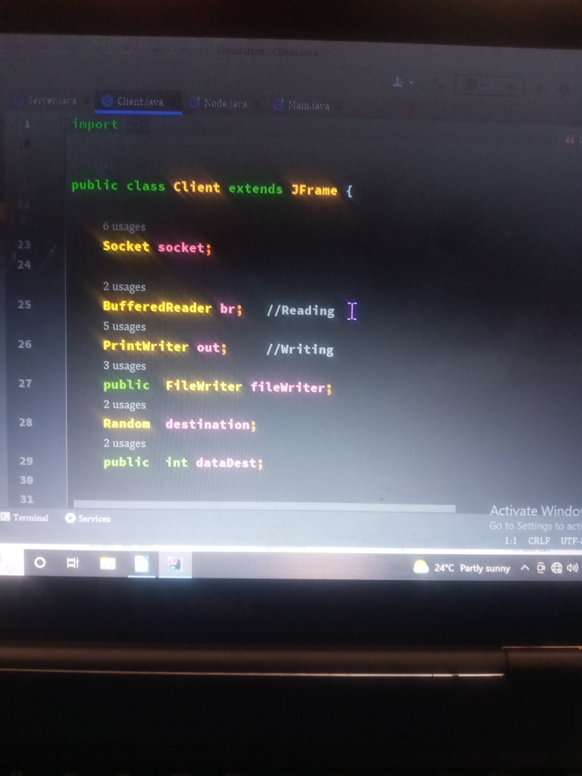

Main file

Its the beginning of program execution. It instantiate single server object and numerous nodes or clients as prescribed through an input feature in command line argument. The nodes ranges from 2 to infinite;
Clean exit

multithread( Solution)

It simulates the real life client-server relationship, with core programming in multi threading . The server itself is programmed with multi-threading capabilities to handle simultaneous connections from as many clients as possible. The screen shot below shows how I dynamically created array of threads using the Runnable interface.

Once the input is taken then the main method goes on to instantiate nodes objects in accordance with the input.

In the above main() creates new thread for creating new nodes as the main thread is responsible to check on the server connection.
Server file

This file contain all the server based code which opens connection for clients at port 7778
locally hosted machine. It defines methods such as startWritting() , which start to dispatch messages to various clients.

It has startReading() method which gets the clients message and the destination of the message.
Server has got infinite thread creation feature implemented through for loop which is called to create a number of threads as per instructed

Client file

This file is responsible for creating clients or nodes which feeds from the server file through the TCP/IP sockets.

Client is multithreaded to optimize it functionalities.
Client create files (input files) and read its content to send it to another node
Client also automatically creates the ouput file with refernce to its name, then stores message it recieves here.

Main file

Its the beginning of program execution. It instantiate single server object and numerous nodes or clients as prescribed through an input feature in command line argument. The nodes ranges from 2 to infinite;
When client and server are both multi threaded it takes around 5 milliseconds to create ten clients and serve the simultaneously .

Conclusion
As the difference has been observer it is advisable for programmers to code in multi threading paradigm to compete time and space complexities

