Tri Pham

Professor David Hamilton

User Interface Design Principles

April 15, 2018

Assignment #3 – SCADA Mimic

Assignment 3 is the implementation of a SCADA system, allowing user to monitor and control the activities of 6 oxygen tanks on a research submarine.

The screenshot of SCADA system:

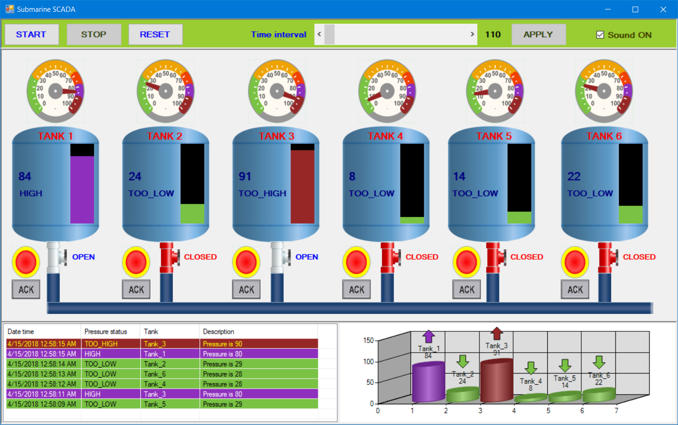

1. **Some assumptions about the SCADA system:**
2. **Gauges:**

It is used to display the level of pressure from the smallest number (0) to the biggest one (100).

There is a needle moving from the left to right indicating the increase of the pressure.

And when the needle moves from the right to the left, it is indicating the decrease of the pressure.

Each gauge has 5 different colors showing the level of pressure of each tank.

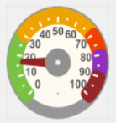 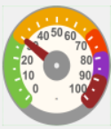 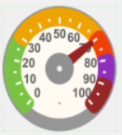 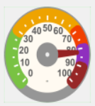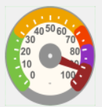

Green: indicating the level of pressure in 0-29, showing the status of pressure as TOO LOW.

Yellow: indicating the level of pressure in 30-69, showing the status of pressure as LOW.

Orange: indicating the level of pressure in 70-79, showing the status of pressure as NORMAL.

Magenta: indicating the level of pressure in 80-89, showing the status of pressure as HIGH.

Red: indicating the level of pressure in 90-100, showing the status of pressure as TOO HIGH.

1. **Pressure bar:**

Min pressure is 0 and max is 100 from the bottom to top.

Low pressure: when the pressure goes down and the level indicates 30 or lower.

High pressure: when the pressure goes up and the level indicates 90 or higher.

In both situations, the alarm will sound.

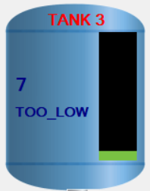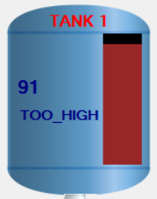

The pressure bar also has 5 colors like the gauge, showing different 5 status of pressure

When the pressure is in range of 0-29, it will change color to GREEN

When the pressure is in range of 30-69, it will change color to YELLOW.

When the pressure is in range of 70-79, it will change color to ORANGE.

When the pressure is in range of 80-89, it will change color to MAGENTA.

When the pressure is in range of 90-100, it will change color to RED.

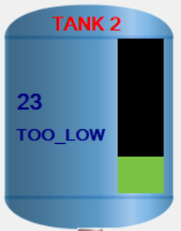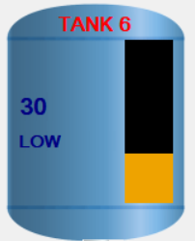 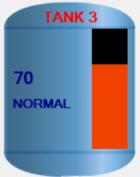 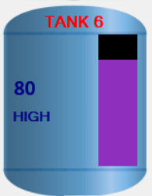 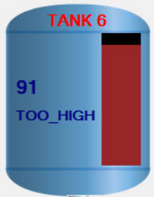

1. **Valves**

Each valve has 2 statuses: OPEN (white) and CLOSED (red).

To open or close the valve, user should click on it.

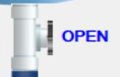 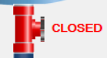

When the valve is open, the pressure will automatically go up.

When the valve is closed, the pressure will automatically go down.

1. **Alarm**

By default, the alarm is invisible. When it shows, it will blink continuously.

It will appear under the tank in one of these conditions:

* When the pressure goes down to a level <= 30, that is TOO_LOW
* When the pressure goes up to a level >= 80, that is HIGH
* When the pressure goes up to a level >= 90, that is TOO_HIGH

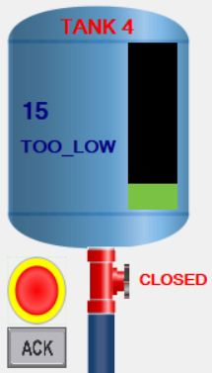 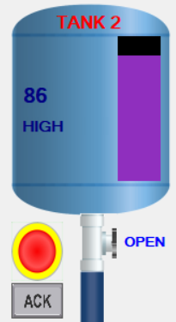 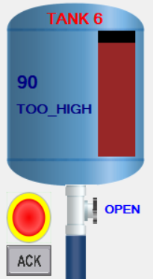

The alarm will disappear in one of these conditions:

* When the pressure is in the range of 31-79
* When user clicks the ACK button

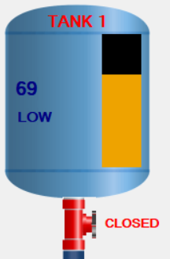 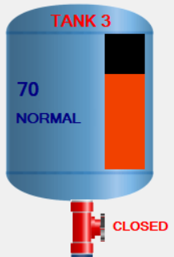 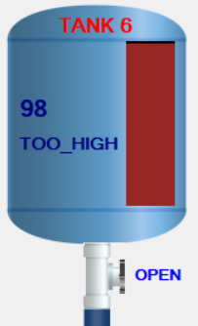

1. **Sound**

Alarm will sound when the pressure is too low, high or too high.

It can be turned off if user clicks on the Sound On checkbox in the top right of the screen.

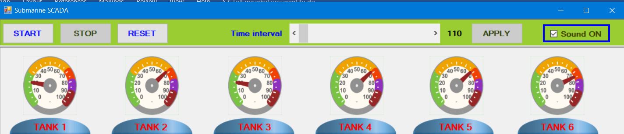

1. **ACK button**

When the alarm sounds, the ACK (Acknowledge) button will appear next to the alarm.

When user clicks the ACK button, the alarm goes off and the button will disappear.

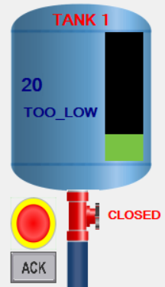 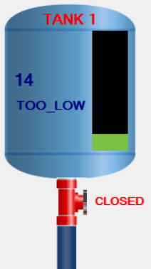

1. **Log**

In the bottom left of the screen, there is a Log view to display all alarms and acknowledge events, each line represents one event and its color varies according to its type. SCADA systems are often used to perform Data Monitoring.

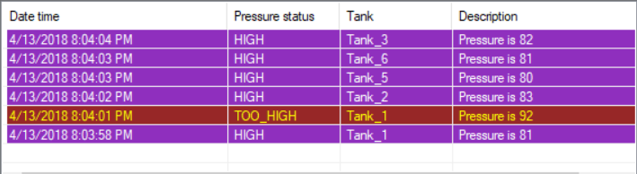

1. **Graph**

In the bottom right of the screen, there is a graph to display all tanks with the movement of the pressure. Each cylinder represents each tank and its color varies according to its current status of the pressure.

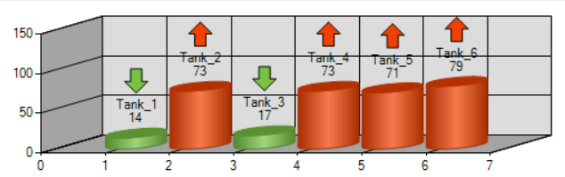

1. **The control buttons**

In the top left there are 3 buttons: START, STOP and RESET

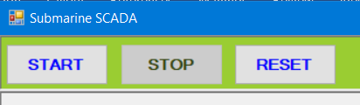

By default, the START button is enabled, STOP button is disabled and the RESET button is always enabled.

* START: start all the activities. When it is clicked, it will be disabled automatically.
* STOP: pause all the activities. When START is clicked, this button will be enabled.
* RESET: reset all the activities. When it is clicked, START will be enabled and STOP will be disabled.

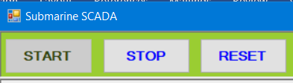

1. **Time interval**

An interval is a distinct measure of time between activities of the SCADA system.

By default, its value is 500 (0.5 second) and the APPLY button is disabled.



When user clicks and slides the slider, the time interval will change and the APPLY button will be enabled. User needs to click the APPLY button in order to apply the new interval.



1. **The SCADA user interface is based on SCADA user interface design principles:**
2. Make displays legible (or audible)

All pictures, labels, buttons and chart are legible, with distinguished colors and statuses



1. Avoid absolute judgement limits

The same pressure level is displayed in multiple places and controls, such as Gauge, Tank body or the graph, so user doesn’t have to predict or estimate the activities.

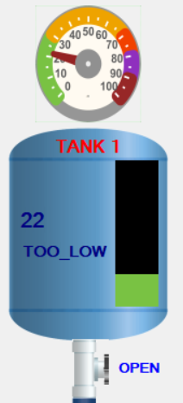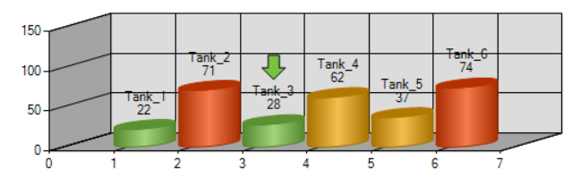

1. Top-down processing

Alarm comes up with blinking pictures and alarm sound.

The gauge is not only showing different colors, but also showing the number from 0 to 100. User is able to monitor and understand the pressure.

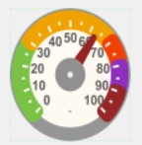

If the pressure level goes up the color of pressure changes from light to dark and vice versa.

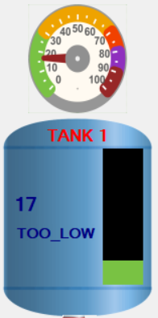 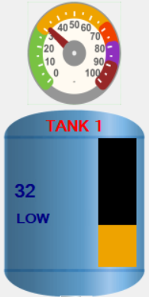 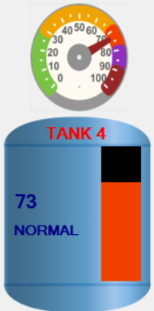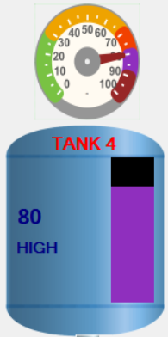 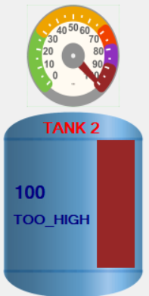

If the valve is closed, then its color is changed to Red.

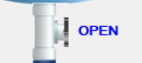 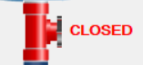

1. Redundancy gain

The pressure level is displayed in both text and gauge and even in the graph.

The color of the pressure is also expressed repeatedly in the tank, gauge and the graph

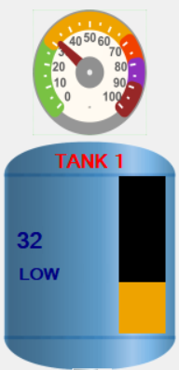 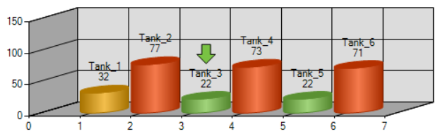

1. Similarity causes confusions:

Every tank has its simple name so it’s easy to follow the status or activity of each tank

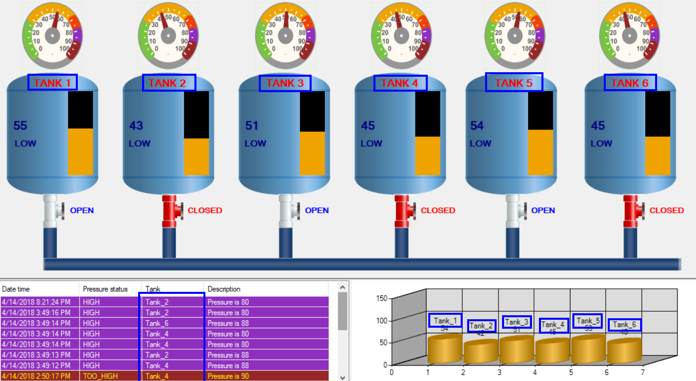

1. Principle of pictorial realism

The picture of the gauge and the level expresses the real status of the pressure.

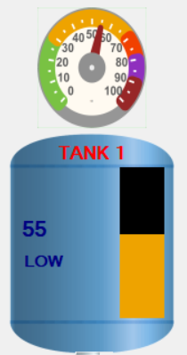

1. Principle of the moving part

The movement from left to right in the gauge expresses the increased pressure and vice versa.

The movement from bottom to up of the level expresses the increase of the pressure and vice versa.

The pressure bar moves in the vertically way, up or down, showing the change of the pressure.

1. Minimizing information access cost

All activities are placed in the center of the screen so it’s easy for user to monitor.

1. Proximity compatibility principle

All the related controls are put close to each other so it is easy for user to monitor all of them.

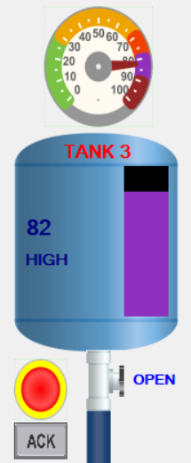

1. Principle of multiple resources

There are many ways to display the pressure on which the user can watch, to be sure about the data. Such as gauge number, gauge needle, pressure number in the tank, the graph.

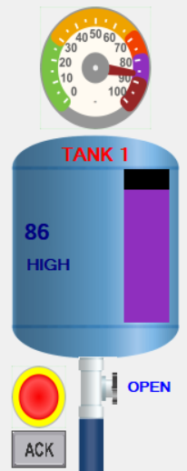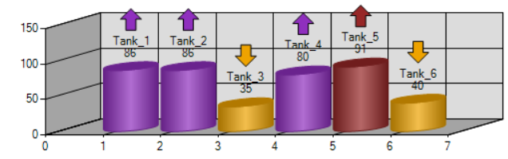

1. Replace memory with visual information: all activities are displayed in the center of the screen and can be accessed with less effort.
2. Principle of predictive aiding: the screen displays activities with simple meaning, that can be easily understood

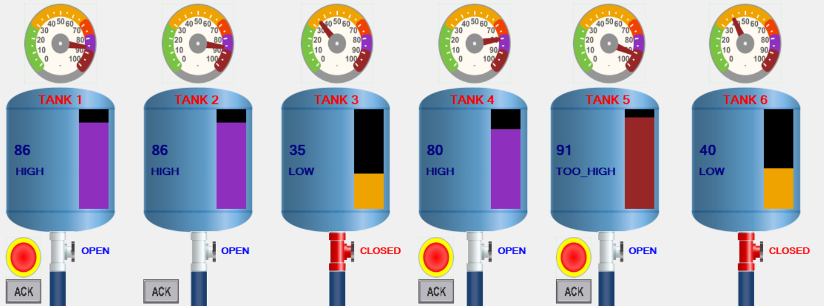



1. Principle of consistency: the system has multiple ways to express the status of pressure, and they are always synchronized keeping the consistency.

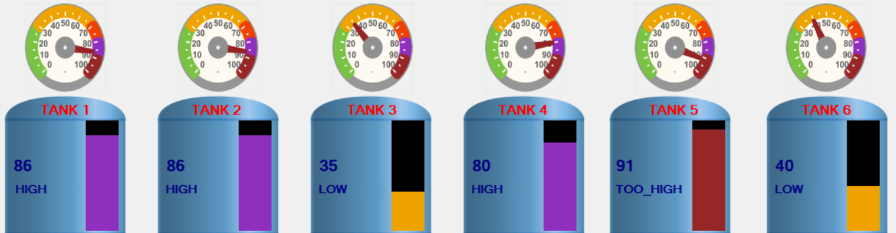



1. **Mimic Design Guidelines**
2. **MD1:** Do not use Indirect Referencing.

* No indirect referencing is used.

1. **MD2:** Limit the use of the following graphical enhancements.

* All the images are plain and lightweight.

1. **MD3:** Limit the use of tooltips which reference values of multiple database items.

* There is no tooltip in the system.

1. **MD4:** Do not make excessive use of polylines.

* No polylines in the system.

1. **MD5:** Ensure that polygon shapes are simple, using as few segments as possible.

* All images are in the simple shapes

1. **MD6:** Ensure that imported vector graphics are simplified as much as possible.

* No imported vector graphics are used in the system.

1. **MD7:** Ensure that single segmented lines or curved lines are used in place of separate lines.

* No separate lines were applied in the system.

1. **MD8:** Reduce, as far as possible, the number of objects on the mimic.

* No extra items were added to the system.

1. **MD9:** Create common symbols and reference these multiple times within each mimic, instead of creating multiple copies of individual objects.

* Six tanks are different, so it is necessary to create six copies.

1. **MD10:** Where possible, ensure that all embedded mimics have “Shared with other embedded mimics” checked.

* Not available**.**

1. **MD11:** Where possible use embedded mimics that are sourced direct from a common symbol and animated with appropriate parameters, instead of creating graphic(s) within a template and embedding the graphic from each instance onto the mimic**.**

* Not available.

1. **MD12:** Reduce the number of ‘levels’ within embedded mimics (a mimic embedded in a mimic embedded in a mimic…).

* Not available.

1. **MD13:** Configure common visibility settings for a specific layer and place relevant objects on this layer, instead of individually controlling visibility on multiple objects.

* Not available.

1. **MD14:** Vectorized graphics are used in lieu of embedded images (jpg, png, bmp) directly onto the mimic. If images are required use remote images hosted by Clear SCADA’s web server.

* Not available.