Algonquin College Logo

# SCHOOL OF ADVANCED TECHNOLOGY

### ICT - Applications & Programming

### Computer Engineering Technology – Computing Science



A11

Game Interface

Team:

[Student Name] - Id: [Student Id] / [Student Name] - Id: [Student Id]

Game Proposal - Picross

***This template is suggested (not mandatory) to answer A11 Specification.***

|  |  |
| --- | --- |
| **Part**  **1** | **GUI Definition** |

**EXPLANATION**

*The purpose of this assignment is to define the elements of the GUI application to be used in your game implementation.*

* ***Example (Prof. suggestion)****:*

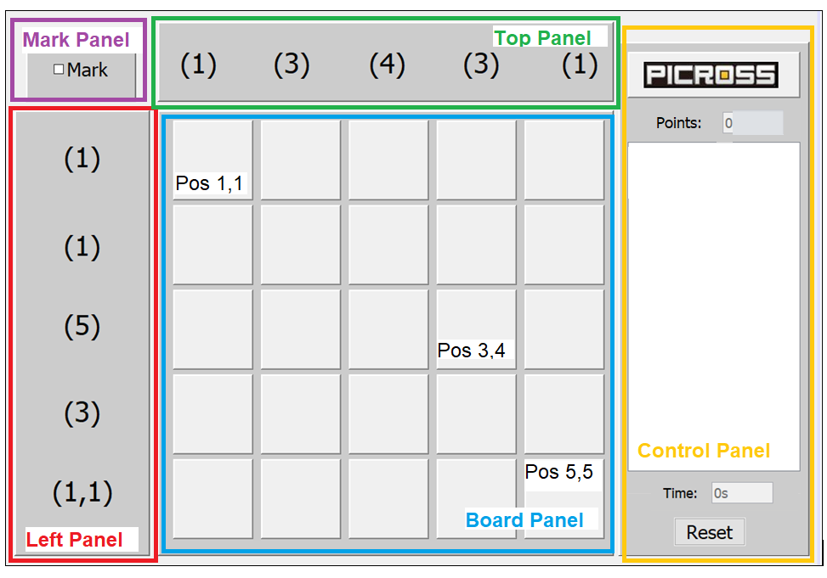

* ***Note****: The professor interface is also a proposal. It means that your own implementation can be different. What does matter is that the game functionality will be respected.*
  1. **Defining the Components**

**List of components**

*Include the list of components that you will use (they can be from Swing or JavaFX).*

**Functionalities and Behaviors**

*What are the behaviors and functionalities that you will provide? How these elements are related with functionalities.*

***Example****: The game mode can be selected by RadioButtons, etc.*

**Languages**

*Define (at least two) languages to be used – remembering that English is mandatory for one option.*

***Example****: The second language (French) will be chosen, since this is my natural (birthplace) language.*

**Details**

*Drawn your interface (ex: in an image from Paint / Powerpoint slide, or any sketch tool), describing:*

* *The components;*
* *The properties (ex: size, dimension, color, position, etc)*
* *Additional GUI components (ex: the layout to be used).*
  1. **User Manual**

**Basic cycle**

*Create a brief description about how your game can be used.*

***Example****: If you have to design the solution to be saved and played later, how are the stems. Most importantly, how someone can play the* ***Picross****.*

* *Note: your process does not need to be followed exactly when you are going to the implementation. For while, it is only a script about how to play.;*

**FINAL SUGGESTIONS**

*Here some ideas to think about your language....*

* *Try to create a game whose execution can be very intuitive (easy to be played).*
* *Remember that this game will be in fact implemented only in the next assignment.*

**References**

*[Include eventual references used here]*

* ***NOTE****: Even if you use one specific tool (ex: ChatGPT), report it here.*

Algonquin College

Winter, 2023