**How to install USBasp drivers on Windows 8**

* [by sanc04](http://letsmakerobots.com/node/31914)

[AVR](http://letsmakerobots.com/taxonomy/term/238), [how to](http://letsmakerobots.com/taxonomy/term/427), [programmer](http://letsmakerobots.com/taxonomy/term/1746), [usbasp](http://letsmakerobots.com/taxonomy/term/2104), [drivers](http://letsmakerobots.com/taxonomy/term/8883), [Windows 8](http://letsmakerobots.com/taxonomy/term/16186)

[Tip/walkthrough](http://letsmakerobots.com/view/node/list/robot_tip)

[](http://letsmakerobots.com/user/17926)

By [sanc04](http://letsmakerobots.com/user/17926) @ April 13, 2013

Allows you to use USBasp on windows 8

* Operating system: [windows 8](http://letsmakerobots.com/taxonomy/term/15957)

[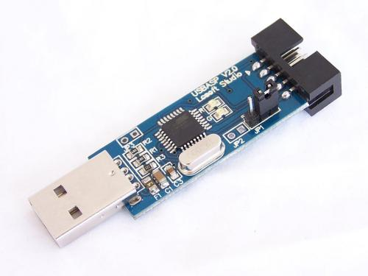](http://letsmakerobots.com/files/field_primary_image/usbaspver2.jpg?)

Are you having problems installing usbasp drivers on windows 8 ? This walkthrough will guide you to installing those drivers :)

Actually the main problem is that microsoft doesn't allow you to install drivers which are not 'digitally signed' directly (or easily) on windows vista and later versions (7 and 8).  To get around this you must temporarily disable the signature verification process. So, here is a way through which you can do this-

1) Move the cursor over the top or bottom right corner or the screen and it will show extra options on the right side of the screen.  Choose the Settings option (icon looks like a Gear).

2) After this chose 'Change PC Settings'

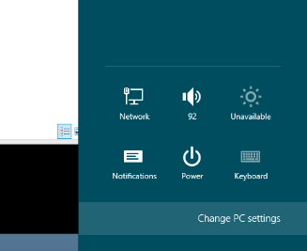

3) Choose General in the left menu and click on the 'Restart Now' in the bottom on the right side.

4) Select troubleshoot

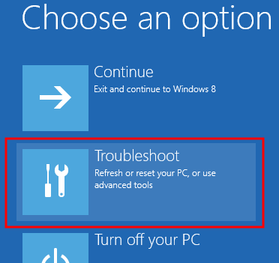

5) Then select 'Advanced options' and then 'Startup Settings'. After this you will see something like this-

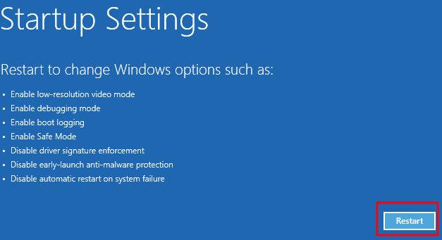

 6) Choose 'Disable Driver Signature Enforcement' and hit the Enter key to start Windows.

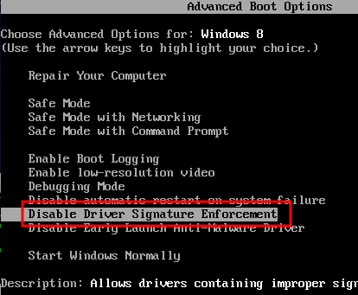

Now you have successfully disabled the driver signature verification and you can install whatever you want!

Now connect your USBasp programmer to the USB port of your PC/laptop. Ignore the message that 'Device driver software was not successfully installed'.

Download USBasp drivers here-  <http://www.fischl.de/usbasp/usbasp-windriver.2011-05-28.zip> and extract it somewhere on your PC/Laptop.

Go to Device Manager in control Panel and you will find 'LibUSB-Win32 Devices'. Click on it and select 'Update Driver Software...'

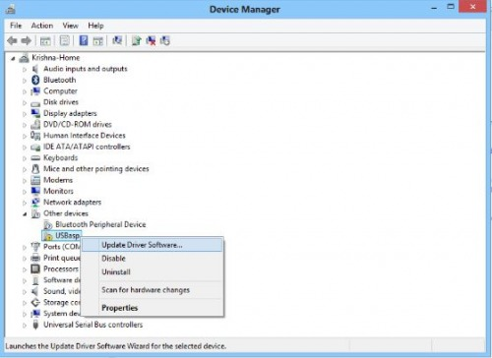

select 'Browse my computer for driver software'. After this browse to the location where you have extracted the USBasp drivers

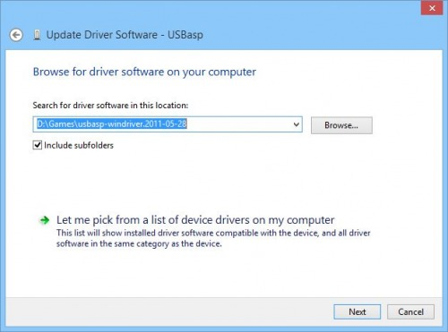

Click next and ignore the security warning 'Windows can't verify the publisher of this driver software' and select 'Install this driver software anyway'

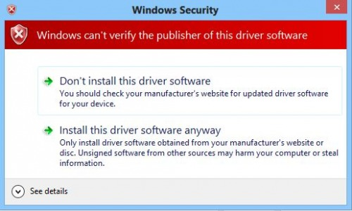

Woot! if everything goes alright you will see something like this -

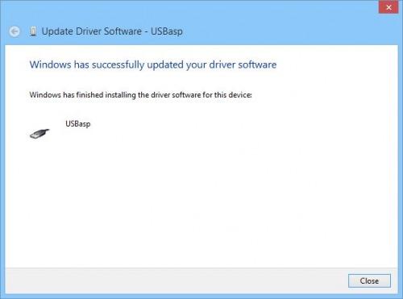

That's it! :D