**Installing Usbasp Driver Software in Windows 8.1**

Posted on [September 26, 2014](https://openchrysalis.wordpress.com/2014/09/26/installing-usbasp-driver-software-in-windows-8-1/) by [Niyaz](https://openchrysalis.wordpress.com/author/niyaz000/)

This will be a quick tutorial on how to install Usbasp Programmer on Windows 8 or 8.1.

Since the Usbasp Driver software does not have a proper digital signature we will get an error message like this

[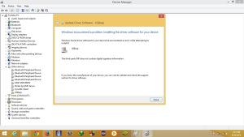](https://openchrysalis.files.wordpress.com/2014/09/usbasp-driver-install-error-messge.jpg)

So we need to Disable the Digital Signature before we can install the Driver

So here are the Steps.

**1)First we need the Driver software.Here is the link to download the software.**

<http://www.fischl.de/usbasp/usbasp-windriver.2011-05-28.zip>

**2)Extract the zip file.I prefer to save it in desktop.**

**3)Now you need to disable the Digital Signature In windows.For that follow these steps**

Press and Hold Shit key and Click on Restart.

This will bring a bunch of options when the computer restarts.

**4)Click Troubleshoot**

[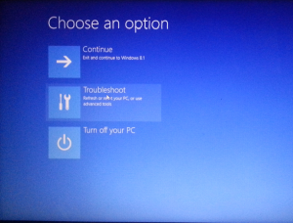](https://openchrysalis.files.wordpress.com/2014/09/digital-signature-turn-off-windows-8-1-step-1.png)

**5)Click Advanced Option**

[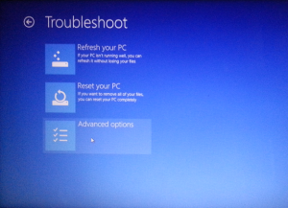](https://openchrysalis.files.wordpress.com/2014/09/digital-signature-turn-off-windows-8-1-step-2.png)

**6)Click Start up Settings**

**[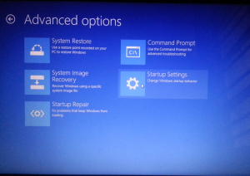](https://openchrysalis.files.wordpress.com/2014/09/digital-signature-turn-off-windows-8-1-step-3.png)**

**7)Click Restart**

[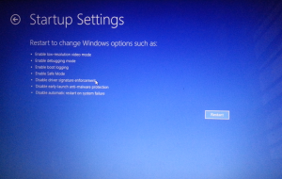](https://openchrysalis.files.wordpress.com/2014/09/digital-signature-turn-off-windows-8-1-step-4.png)

**8)Select the Option Disable Driver signature enforcement (i.e Pressing F7 here)**

**[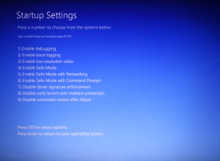](https://openchrysalis.files.wordpress.com/2014/09/digital-signature-turn-off-windows-8-1-step-5.png)**

**9)Now right Click on Start Icon and select Device manager**

[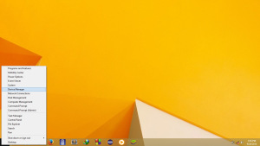](https://openchrysalis.files.wordpress.com/2014/09/usbasp-driver-install-step-1.jpg)

**10)Open “Other devices”**

[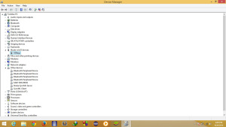](https://openchrysalis.files.wordpress.com/2014/09/usbasp-driver-install-step-2.jpg)

**11)Right click on Usbasp and select Update driver software**

[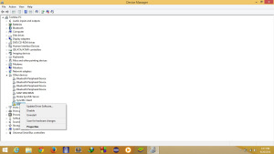](https://openchrysalis.files.wordpress.com/2014/09/usbasp-driver-install-step-3.jpg)

**12)Select “Browse My computer for driver software”**

[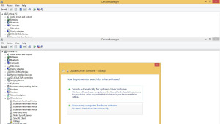](https://openchrysalis.files.wordpress.com/2014/09/usbasp-driver-install-step-4.jpg)

**13)Go to the location where you have extracted the zip folder**

[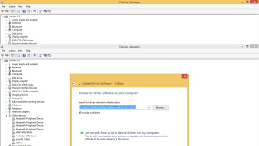](https://openchrysalis.files.wordpress.com/2014/09/usbasp-driver-install-step-5.jpg)

**14) Click next and when you are Prompted with this warning message please click “Install Driver Software Anyway”**

[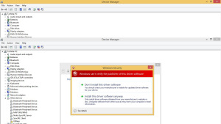](https://openchrysalis.files.wordpress.com/2014/09/usbasp-driver-install-step-6.jpg)

**15)If everything is correct you will get the following message.**

[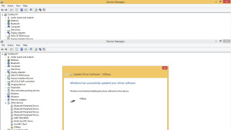](https://openchrysalis.files.wordpress.com/2014/09/usbasp-driver-install-step-7.jpg)

If you guys have any problem please leave a comment below….

Enjoy Programming your Micro controller………..!