Università Cattolica del Sacro Cuore
Master in Data Science for Management

Master's Thesis

Designing a KPI System for Academic Management: A Snowflake Semantic Model and Power BI Dashboards at Università Vita-Salute San Raffaele

Supervisor: Prof. Riccardo Bramante
Candidate: Alessio Capobianco

Academic Year 2026 / 2027

Abstract
This thesis documents the design and implementation of a Business Intelligence solution for academic management at Università Vita-Salute San Raffaele, carried out during an internship at KPMG Advisory as part of Project Kaleidos. Before the project, the university met its information needs through an IT-mediated process in which every figure was produced on request by a query against the ESSE3 student information system. The solution replaces this process with a governed data platform, a Snowflake data warehouse organised as a medallion architecture, and a reporting layer built in Power BI. The thesis focuses on the student careers domain, where the author built the gold layer tables, the semantic model, and the DAX measures. It describes the data architecture, the semantic model and its trade-offs, the KPI catalogue, the dashboards, and the data quality work, including the two-level User Acceptance Testing. It then compares the new system with the previous one along four qualitative dimensions: process efficiency, consistency and governance, standing visibility and self-service exploration, and the distribution of technical dependency. The analysis is qualitative, and the contribution is a detailed, documented case of a higher-education Business Intelligence transformation.
Keywords: Business Intelligence; higher education; Snowflake; Power BI; semantic model; KPI; data quality.

Table of Contents

1 Introduction

1.1 Data and decisions in higher education
Universities manage a set of interrelated activities: admissions, student progression, teaching, research, and the allocation of financial resources. Decisions in these areas increasingly draw on data held in the institution's own operational systems rather than on periodic reports or informal knowledge. In a systematic review of Business Intelligence adoption in higher education, Sequeira et al. (2024) note that decisions taken without the support of systematised institutional data can compromise both the effectiveness and the efficiency of institutional action.
The difficulty is that the systems which hold this data are built for transactions, not for analysis. A student information system records enrolments, exams, and careers one operation at a time. It does not provide, on its own, the aggregated and cross-domain views that academic management needs to monitor a cohort, compare programmes, or decide where to intervene. Closing this gap is the problem that a Business Intelligence layer addresses.

1.2 Setting: an internship at KPMG and a project for Università Vita-Salute San Raffaele
This thesis is based on the work carried out during an internship at KPMG Advisory, on a project for Università Vita-Salute San Raffaele. The project, named Kaleidos, was the programme through which the university set out to build a new reporting model on a centralised data platform: a Data Hub that integrates the university's operational data in a Snowflake warehouse, and a reporting layer built in Power BI on top of it (Section 2).
The project covers several domains of academic management. This thesis focuses on one of them, student careers and academic performance, which is the most information-intensive area of academic management and the domain in which the author worked directly, on the gold layer of the warehouse and on the Power BI semantic model and the DAX measures (Sections 3 and 5).

1.3 Motivation
Before the project, the university met its information needs through an IT-mediated process. Every figure was produced on request: a user asked the IT department for a piece of information, IT wrote and ran a query against the student information system, and the result was returned as a file (Section 4). This process was functional, but it made every figure depend on IT availability, it left the definition of each indicator to whoever wrote the query, and it offered no way to explore the data without opening a new request.
The motivation of this thesis is to document and analyse how a governed Business Intelligence system changes this situation: what it improves, at what cost, and where its limits are. The engagement offers a concrete, real case in which the change can be examined end to end, from the data platform to the dashboards that management consults.

1.4 Research question
The thesis addresses the following research question:
How does a Snowflake-based semantic model and Power BI KPI dashboard system improve reporting efficiency and decision-support for academic management at Università Vita-Salute San Raffaele, compared to the previous ESSE3-based process of ad hoc, IT-mediated query requests?
The notion of improvement is examined along four qualitative dimensions: process efficiency, consistency and governance, standing visibility and self-service exploration, and the distribution of technical dependency (Sections 4.4 and 6). The analysis is qualitative. It does not measure the size of the improvement through user studies or timing, a scoping choice explained in Section 4.4.

1.5 Contribution
The thesis contributes a documented case study of a Business Intelligence transformation in a higher education institution. It describes the technical design of the solution, the medallion data architecture, the semantic model, and the KPI catalogue for the student careers domain, at a level of detail that shows the real modelling and data quality decisions behind it. It then reads the solution against the previous reporting model along the four dimensions above. Throughout, the boundary between the work of the author and the work of the wider KPMG team is stated explicitly, so that the contribution of the internship is neither overstated nor hidden.

1.6 Structure of the thesis
Section 2 describes the hosting company, KPMG, and the setting of the internship. Section 3 states the learning objectives of the internship. Section 4 defines the problem, the pre-existing reporting model and its limitations, and states the research question. Section 5 describes the solution: the overall approach, the data architecture, the semantic model, the KPI design, the Power BI implementation, and the data quality considerations. Section 6 discusses the change along the four dimensions of improvement. Section 7 describes the skills acquired during the internship. Section 8 draws the conclusions and answers the research question directly.

2 The hosting company: KPMG

2.1 KPMG as a global organisation
KPMG is one of the four large international professional services networks, together with Deloitte, EY, and PwC. It is a global organisation of independent member firms that operate under the KPMG brand and are affiliated with KPMG International Limited. The member firms work in 143 countries and territories and employ more than 275,000 people (KPMG International, 2025). The organisation delivers three lines of service: Audit, Tax and Legal, and Advisory. Audit covers the assurance of financial statements, Tax and Legal covers fiscal and legal advice, and Advisory covers consulting on strategy, operations, risk, transactions, and technology.

2.2 KPMG in Italy and the Advisory practice
In Italy, KPMG operates through a set of member entities that cover the three service lines. According to KPMG's own reporting, the Italian organisation has around 5,000 professionals across about 25 offices and serves more than 6,000 clients (KPMG in Italy, 2026). Advisory services in Italy are delivered mainly through KPMG Advisory S.p.A., based in Milan.
The Advisory practice works with organisations on change programmes and on performance improvement. One area of this work is data and analytics: the design and construction of the data platforms, semantic models, and reporting systems that let an organisation use its own operational data for management decisions. The internship described in this thesis sits in this area, on an engagement for a university client.

2.3 The Junior Data Engineer role
The author joined KPMG Advisory as a Junior Data Engineer. The internship lasted three months and was extended by a further two, after which it converted into an apprenticeship contract.
A Junior Data Engineer on an Advisory engagement of this kind works on the data side of the delivery. The work covers the pipelines that move data from the source systems into the warehouse, the warehouse tables that the reporting layer consumes, and the semantic models and measures built on top of them. On the San Raffaele engagement, the author's work concentrated on the gold layer of the Snowflake warehouse and on the Power BI semantic model and the DAX measures for the student careers domain, within the framework and the conventions set by the delivery team. Sections 5.3 and 5.6 describe this contribution and its boundary with the work of the team.

2.4 The San Raffaele engagement as an example of the practice
The engagement analysed in this thesis, the design of a KPI and dashboard system for Università Vita-Salute San Raffaele, is an example of the data and analytics work of KPMG Advisory. It has the shape these engagements usually take: a client whose operational systems hold the data but not the analytical views that management needs, a delivery team that builds the data platform and the reporting layer, and the handover of a governed reporting product that the client can use without a technical intermediary for each question.
Sections 4 to 6 describe this engagement in detail. This section places it in its organisational context. It is one project within the Advisory practice, staffed by a delivery team, in which the author was the member responsible for the semantic model and the measures of the student careers domain.

3 Internship learning objectives
The internship took place inside Project Kaleidos, the programme through which Università Vita-Salute San Raffaele built a new university reporting model on a centralised data platform (Sections 1 and 2). The project ran in phases: a discovery phase that mapped the existing situation and collected the target requirements, a select-and-design phase that chose the technology stack and produced the source-to-target analysis and the solution design, a development phase that integrated the source systems, built the platform, and validated it through User Acceptance Testing, and the go-live and adoption phases that followed. The author's work concentrated in the select-and-design and development phases.
The learning objectives that oriented the internship fall into four groups: technical, methodological, professional, and academic. This section states them and connects each to the phase and the part of the project in which it was pursued. Sections 5 to 7 show how far they were met.

3.1 Technical objectives
The first objective was to learn a modern cloud data stack in practice rather than in theory. This meant working with Snowflake as the data warehouse, with the medallion architecture that organises the flow from raw to reporting-ready data, and with the patterns that make a gold layer usable by a reporting tool (Sections 5.2 and 5.3). In the project, this warehouse is the Data Hub that the development phase set out to build.
The second was to learn dimensional and semantic modelling for Business Intelligence: the design of fact and dimension tables, the discipline of an explicit grain, the relationships that carry filters through a model, and the translation of a warehouse into a Power BI semantic model (Section 5.3).
The third was to reach a level of DAX sufficient to implement measures that are not trivial, including measures that encode a business rule and handle the empty or edge case rather than failing on it (Section 5.4). Taken together, these objectives describe a move from a theoretical knowledge of data management to the ability to build a working reporting layer on real data.

3.2 Methodological objectives
One objective was to learn to translate a management question into a data model and a measure: to begin from what a manager needs to know and arrive at a KPI with an agreed grain and a single definition (Sections 5.4 and 5.6.2). The source-to-target analysis of the select-and-design phase, which maps each target field back to its source, is where this translation begins in a structured form.
A second was to learn to validate analytical output. The development phase closed with a User Acceptance Testing exercise, organised in automatic technical checks and functional checks carried out with the client (Section 5.6.2). Taking part in this, and reconciling a KPI definition with the client when the computed figure and the reference figure disagreed, taught the discipline of validating against an external benchmark rather than against one's own expectation.
A third was to absorb the discipline of a governed model: definitions that live in one place, a grain that is documented rather than assumed, and data quality safeguards built into the tables (Sections 5.3.4 and 5.6.3).

3.3 Professional objectives
The internship was also an opportunity to learn how a consulting engagement is delivered. The project ran with a defined governance. On the KPMG side it was led by the associate partners G. Palumbo and F. De Cassai, with change management directed by M. Lodigiani (Senior Manager) and the delivery run by a core team in which F. Scorpiniti (Manager) and A. Pessolano (Assistant Manager) led the technical work and M. Vanoli (Assistant Manager) the functional work. The author worked inside this technical team, to conventions set by more senior colleagues, with the author's work reviewed before it entered the shared model (Sections 2.3 and 5.3). On the client side, the project was sponsored at the level of the delegated councillor and steered by the university's directorates, among them the Operations Directorate, the Information Systems Directorate, and the Directorate for Teaching Development, Accreditation and Quality.
A related objective was to learn to communicate with a client and with people who are not technical: to gather requirements, to agree the definition of an indicator, and to hand over a reporting product that the client can use without a technical intermediary for each question. The requirement-gathering and the UAT sessions, both run with the university's directorates, were where this was practised. Behind these sits a simpler objective, to work to the standards and the pace of a professional services firm, which the conversion of the internship into an apprenticeship reflects.

3.4 Academic objectives
The academic objective was to connect the Master's programme in Data Science for Management to a real management setting, and to see how the methods studied in the programme apply to the decisions of an institution. The second academic objective was to produce the documented case study that this thesis is: a description and an analysis of a real Business Intelligence transformation, carried out with the rigour the Master requires.

4. Problem Definition

4.1 The managerial context: information needs in academic management
Universities manage a range of interrelated activities: student admissions and progression, teaching, research output, and the allocation of financial resources. Decisions in these areas increasingly draw on data from the institution's own operational systems rather than on informal knowledge or periodic reports. Sequeira et al. (2024), in a systematic review of Business Intelligence adoption in higher education, note that decisions taken without the support of systematised institutional data may compromise both the effectiveness and the efficiency of institutional action.
Within academic management, monitoring student careers is a particularly information-intensive area. It informs decisions on didactic offering, on tutoring interventions, on the way programs are resourced, and on measures to reduce dropout. For a reporting system to be useful to management, it must deliver information that is accurate, available when decisions are actually being taken, and consistent across the people who consult it.

4.2 The pre-existing situation: IT-mediated reporting through ESSE3
The internship engagement analysed in this thesis was carried out at Università Vita-Salute San Raffaele, an Italian private university whose student information system is ESSE3, the operational platform used by most Italian higher education institutions to manage student careers, exams, and administrative records. ESSE3 is designed for transactional use, not for analytical use: it does not natively provide the aggregated, cross-domain views that academic management needs to support its decisions.
Before the introduction of the Business Intelligence solution described in this thesis, the university addressed this gap through an IT-mediated reporting model. Information needs from administrative offices (such as the student registrar and the didactic services) and from academic management (program coordinators and departmental leadership) were channelled through requests to the IT department. Each request followed the same pattern:
1. A requester formulated an information need, for example the number of students in a cohort who had reached a given progression threshold.
2. The IT department translated the request into one or more SQL queries against the ESSE3 database.
3. The queries were executed and the results checked for correctness.
4. When the results appeared inconsistent or incomplete, the query was revised and re-executed. Several iterations were sometimes required.
5. Once the results were considered reliable, they were sent to the requester, typically as a spreadsheet or a static document.
The same workflow served both recurring reporting needs, such as periodic reports on enrolments or exam outcomes, and one-off requests tied to specific decisions. Each information cycle required a discrete manual intervention by IT staff.

4.3 Limitations of the pre-existing model
The IT-mediated model was functional but had several structural limitations that affected both the efficiency of the reporting process and the quality of the decision support it provided. These limitations are documented in the wider literature on self-service Business Intelligence (Pałys and Pałys, 2023; Passlick et al., 2023) and can be discussed under four headings.
Latency and IT bottleneck. Every information need required IT staff to write, run, and validate a query. The availability of reports was therefore constrained by IT capacity and workload. Recurring requests competed with one-off ones for the same limited resource, and the correction loop between requester and IT often extended the response time further. In practice, decisions were sometimes taken either without the most current information or after a delay that reduced its usefulness.
Inconsistency across requests. In the absence of a centrally governed set of metric definitions, similar questions asked at different moments, or by different requesters, could be answered by structurally different queries. Small differences in filters, join logic, or in the treatment of edge cases could produce results that were individually correct but not mutually comparable. When discrepancies emerged, the credibility of the reporting output was called into question and rework was needed to reconcile the figures.
Absence of standing visibility and self-service exploration. The pre-existing model was inherently pull-based: information existed only when explicitly requested. Management could not observe trends over time, drill down into a dashboard to investigate an anomaly, or refine a question without initiating a new IT request. This constrained the type of managerial questions that could realistically be asked, and effectively narrowed the analytical scope of the institution to what had already been extracted.
Concentration of technical dependency. Because the ability to answer any question resided with the IT department alone, both administrative and academic users depended structurally on IT availability. The literature on self-service BI identifies this concentration of dependency as one of the main drivers of BI transformation (Pałys and Pałys, 2023). For an academic institution, it also means that access to information does not follow the distribution of decisional responsibility.
Taken together, these limitations describe a reporting model whose cost, measured in IT effort, in decision latency, and in analytical opportunities that are never taken, grows with the information intensity of the institution.

4.4 Research question
On this basis, the thesis addresses the following research question:
How does a Snowflake-based semantic model and Power BI KPI dashboard system improve reporting efficiency and decision-support for academic management at Università Vita-Salute San Raffaele, compared to the previous ESSE3-based process of ad hoc, IT-mediated query requests?
The notion of "improvement" is operationalised along four qualitative dimensions that mirror the limitations set out in Section 4.3: process efficiency, consistency and governance, standing visibility and self-service access, and the distribution of technical dependency. The thesis does not attempt to quantify these dimensions through user studies or timing measurements. This is an intentional scoping choice, motivated by the confidentiality constraints of the internship engagement and by the qualitative nature of the observational evidence available.

4.5 Scope and delimitation
The Business Intelligence solution developed during the internship covers several KPI domains: student careers, admissions, teaching offering, research output, and economic-financial indicators. To keep the analysis at a sufficient depth within the length constraints of this report, the thesis focuses on the student careers and academic performance domain. This is the most information-intensive area of academic management. It also best illustrates the transition from IT-mediated reporting to a governed semantic model, and it is the domain in which the author was most directly involved during the internship. The other KPI domains are mentioned where relevant, as parallel components of the wider solution, but their KPI catalogue, semantic modelling choices, and dashboard implementation are not discussed in detail.

5. Research methods and analysis

5.1 Overall approach
The research presented in this chapter is applied and design-oriented. It documents the design and implementation of the Business Intelligence solution developed for Università Vita-Salute San Raffaele, and analyses it against the pre-existing reporting model discussed in Chapter 4.
The end-to-end architecture has four layers, illustrated in Figure 1:
1. ESSE3 as the operational source system.
2. A Snowflake data platform, organised according to the medallion pattern (bronze, silver, and gold layers), which ingests the data extracted from ESSE3 and progressively refines it.
3. A semantic model built in Power BI on top of the gold layer, which defines the entities, relationships, and DAX measures that underlie the KPI catalogue.
4. A set of Power BI dashboards published through Power BI Service and distributed to the client as a Power BI application, with access rights differentiated by user role.
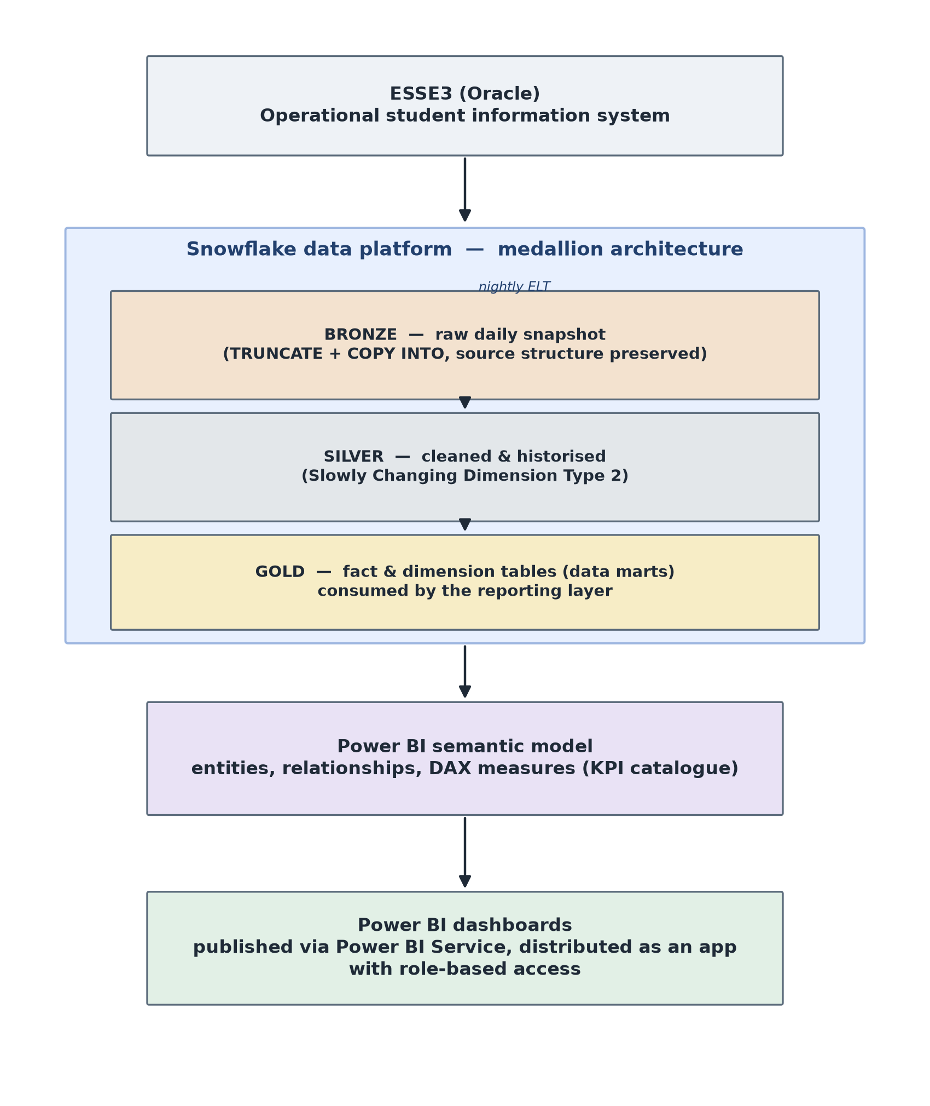
Figure 1. End-to-end architecture of the solution, from the ESSE3 source system through the Snowflake medallion layers (bronze, silver, gold) to the Power BI semantic model and dashboards.
Two clarifications on authorship are needed before the sections that follow. The semantic model and the DAX measures for the student careers domain were designed and implemented directly by the author, in collaboration with the KPMG delivery team; the team contributed to the overall architecture, to the design of the fact tables, and to the review of the modelling choices. The Snowflake medallion layers were built by the wider team, and the author's involvement in that part of the pipeline was limited to consuming the gold layer and to aligning with the team on the data structures it made available.
The remainder of the chapter follows the architecture in order. Section 5.2 describes the Snowflake medallion approach at a level of detail proportionate to its role in the thesis. Section 5.3 presents the semantic model, including the trade-offs adopted when a pure star-schema design was not feasible. Section 5.4 details the KPI catalogue for the student careers domain, Section 5.5 illustrates the Power BI implementation and its distribution model, and Section 5.6 discusses the data quality considerations that emerged during the project.

5.2 Data architecture: the Snowflake medallion approach
The data platform underlying the Business Intelligence solution is built on Snowflake and organised according to the medallion architecture, a layered pattern that has become common practice for analytical data platforms in the last few years. The pattern was originally popularised in the Databricks Lakehouse but is now widely adopted also on Snowflake and on other cloud data warehouses, because it addresses two recurring needs in analytical pipelines: the separation between raw ingestion and analytical consumption, and the ability to reprocess or audit the data at each stage without touching the source systems. The medallion pattern separates the data flow into three progressively refined layers, conventionally named bronze, silver, and gold. The following description focuses on how the pattern is instantiated in the specific pipeline that feeds data from ESSE3 into the reporting layer used in this project.

5.2.1 End-to-end flow
The pipeline moves data from the ESSE3 Oracle database into the Snowflake analytical platform through three sequential phases: an extraction phase carried out on an on-premise virtual machine, a bronze loading phase orchestrated within Snowflake, and a silver refinement phase implemented through stored procedures. The three phases are chained by a signalling mechanism designed around a fail-fast principle: if any phase does not complete correctly, the subsequent phases do not start, and the analytical layer keeps the data of the previous day rather than exposing partially updated information. The end-to-end flow is illustrated in Figure 2.
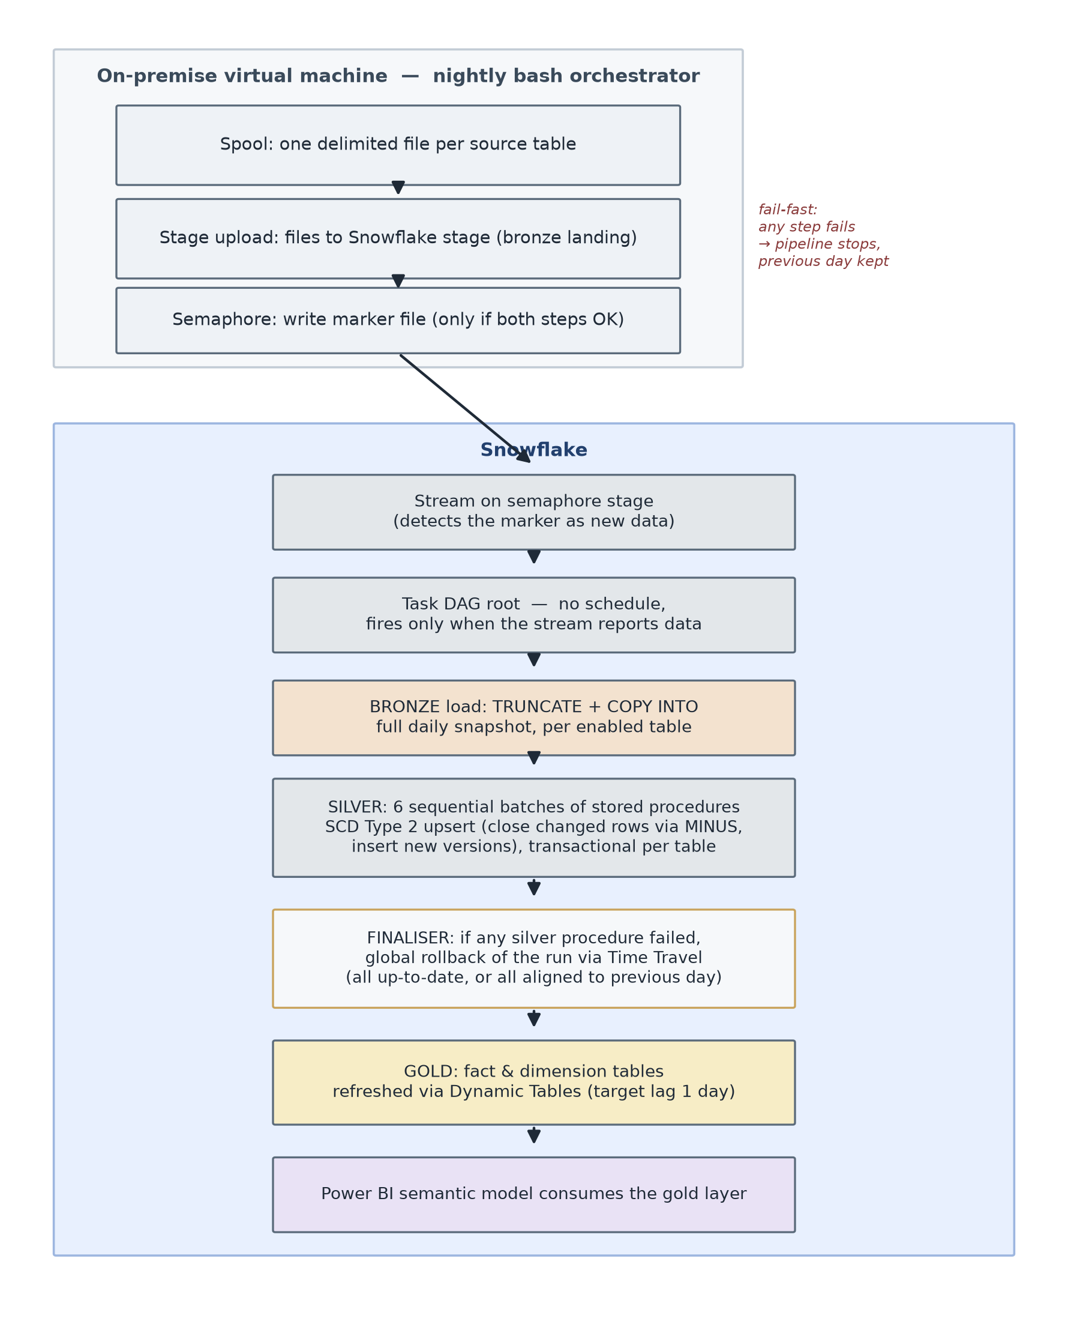
Figure 2. The end-to-end nightly pipeline, from extraction on the on-premise virtual machine through the bronze, silver, and gold layers in Snowflake, with the fail-fast checkpoints.

5.2.2 Extraction from ESSE3 to the Snowflake stage
The extraction phase runs each night, orchestrated by a bash script executed on an on-premise virtual machine. The script coordinates three sequential steps.
The first step is the spool: a delimited text file is produced for each source table, driven by a per-table configuration file that specifies the extraction query. If any single table fails to spool, the step as a whole is marked as failed and the pipeline stops.
The second step is the stage upload: the text files produced by the spool are transferred to a Snowflake stage located in the landing area of the bronze database. The upload only runs if the spool has completed successfully.
The third step is the semaphore: an empty marker file is uploaded to a dedicated semaphore stage in the ELT database. The semaphore is written only if both the spool and the stage upload have succeeded. Its absence, on any given night, is a sufficient condition to prevent Snowflake from starting the downstream processing.

5.2.3 The bronze layer
The bronze layer holds the raw data extracted from ESSE3. Its tables preserve the structure and the field names of the source system, and are not filtered, cleaned, or restructured. The role of the bronze layer is to provide a faithful copy of the source data at the moment of extraction, so that any subsequent transformation can be traced back to a well-defined starting point.
Loading into the bronze layer is triggered by a Snowflake stream defined on the semaphore stage: the arrival of the semaphore file is detected as new data on the stream, which activates a task DAG. The root task of the DAG has no schedule and fires only when the stream reports data, which encodes the fail-fast principle directly at the level of the Snowflake orchestrator: no semaphore, no run.
The bronze loading task iterates over a parameter table that lists the source tables enabled for the current run. For each enabled table, the loading procedure performs a TRUNCATE of the target bronze table and a COPY INTO from the landing stage, using pattern matching on the file name to associate each stage file with the corresponding table. The file format used is CSV with configurable NULL handling and optional field quoting. The choice of TRUNCATE + COPY INTO, rather than an incremental load, keeps the bronze layer aligned with a full daily snapshot of the source, which simplifies both traceability and reprocessing.
If any table fails to load, the loading procedure raises an exception, the task is marked as failed, and the downstream silver tasks do not start, again as a direct consequence of the fail-fast principle. Every operation is tracked in two logging tables: a job-level log that records one row per source table, and a step-level log that records one row per operation performed (TRUNCATE, COPY INTO, and any error captured during the run).

5.2.4 The silver layer
The silver layer contains the cleaned and historised version of the source data. In this project, the silver layer is not a simple cleansing layer but implements a full Slowly Changing Dimension of Type 2 (SCD Type 2), so that the analytical model has access not only to the current state of each entity but also to its history over time.
The silver tables are populated by a collection of stored procedures, one per silver table. The procedures are grouped into six sequential batches, with up to seven procedures running in parallel within each batch. Batch N+1 waits for the completion of every procedure in batch N before starting.
Each silver procedure applies the same two-step SCD Type 2 upsert. The first step closes the records whose values have changed with respect to the source: an UPDATE sets the end-of-validity timestamp of the currently active version to the run time, for every silver record that no longer matches the corresponding bronze record. The comparison is expressed as a MINUS between the bronze extract and the currently active silver records, so that only genuinely changed or new records are returned. The second step inserts the new versions: an INSERT writes into the silver table the rows returned by the same MINUS, with an open end-of-validity timestamp conventionally represented as 9999-12-31. New records are handled by the same mechanism, since they appear in the bronze but not in the silver and are therefore returned by the MINUS as well.
Every silver table carries four audit columns in addition to the source attributes: an insertion timestamp, a last-update timestamp, a validity-from timestamp, and a validity-to timestamp. The active version of a record is identified by the conventional value of the validity-to timestamp; any earlier value corresponds to a historical version. This allows any KPI that requires point-in-time reconstruction to be computed correctly against the state of the data as of a specific date, without additional infrastructure.

5.2.5 Transactional guarantees and the finaliser
The error-handling strategy of the silver layer is different from that of the bronze layer, and reflects the different consequences that a partial success would have.
Each silver stored procedure is written as a single transaction: it opens with BEGIN TRANSACTION, applies both steps of the SCD Type 2 upsert, and closes with COMMIT. If any step fails, the procedure performs a local ROLLBACK and returns the error message rather than raising an exception. The reason for not raising is operational: raising an exception would abort the entire silver batch and prevent the other procedures from running, whereas the transactional local rollback keeps the failure contained to the affected table and allows the rest of the batch to proceed.
However, allowing a run to end with some silver tables updated and others reverted is not acceptable from a consistency standpoint, because a report that consumes the gold layer built on top might mix values from different points in time. To handle this case, the DAG ends with a finaliser task, whose responsibility is to enforce a global consistency guarantee across the silver layer.
The finaliser inspects the logs of the current run and checks whether any silver procedure has failed. If at least one procedure failed, the finaliser performs a global rollback of every silver table that was updated successfully in the same run, using Snowflake Time Travel to restore each table to its state before the run began. The net effect is that the silver layer is either entirely up-to-date or entirely aligned with the previous day, and never in an intermediate state. This design applies the fail-fast principle at the end of the pipeline as well as at its beginning: partial data is treated as worse than stale data.

5.2.6 The gold layer
The gold layer contains the tables that are directly consumed by the Power BI semantic model. Its structure reflects the analytical needs of the reporting layer rather than the structure of the source system: the tables are shaped as fact and dimension entities and are pre-aggregated where the reporting logic makes it convenient. Because the semantic model developed in the student careers domain adopted a hybrid modelling approach, discussed in detail in Section 5.3, the gold layer includes a mix of shared dimensions and of wider, page-specific fact tables designed to serve individual sections of the report without generating ambiguous relationships in the semantic model.

5.2.7 Summary and role in the thesis
The three-phase pipeline described above provides two properties that are relevant for the rest of the thesis. First, it exposes to the analytical layer a data foundation whose consistency is guaranteed at the level of the run as a whole, rather than at the level of the individual table: for the semantic model built on top, this means that the values displayed in a dashboard reflect a coherent state of the source data, not a mixture of times. Second, the SCD Type 2 historisation makes point-in-time analysis available to the KPI layer without requiring additional infrastructure, which is a precondition for several of the KPIs discussed in Section 5.4.
The scope of the thesis does not extend to the detailed contents of the transformations applied to individual source tables at the silver layer, which were developed by the wider team. The remainder of the chapter focuses on the layers where the author's direct contribution is concentrated: the semantic model built on top of the gold layer (Section 5.3), the KPI catalogue implemented within it (Section 5.4), and the Power BI dashboards and their distribution model (Section 5.5).

5.3 The semantic model
The semantic model sits between the data warehouse and the reporting layer. Its purpose is to expose the analytical entities and the metrics of the domain in a form that reporting tools can consume without exposing the physical complexity of the underlying tables, and to guarantee that the same metric is defined in one place regardless of how many dashboards or reports refer to it. In the project analysed in this thesis, the semantic model is implemented across two technical layers: the gold layer in Snowflake, which materialises the fact and dimension tables in a governed physical structure, and the Power BI semantic model built on top of the gold layer, which defines relationships, calculated columns, and DAX measures.
The gold layer framework, including the naming conventions and the modelling patterns described in Section 5.3.1, was defined by the wider KPMG delivery team and applied consistently across all KPI domains of the project. Within this framework, the author built the gold tables for the student careers domain and designed and implemented the Power BI semantic model and the associated DAX measures on top of them. The trade-off described in Section 5.3.3 emerged during the design of this model and was discussed and validated with the team.

5.3.1 Design principles and naming conventions
The gold layer adopts a dimensional modelling approach in the sense established by Kimball and Ross (2013): every fact table has an explicit and documented grain, every measure is aggregable along the dimensions related to the fact, and every dimension carries the descriptive attributes needed to slice the facts along the analytical axes required by the business.
The grain of each fact table is not left implicit. It is written into the header of the SQL definition together with the entity being counted or measured (for example, one row per student per subject per academic year), so that a reader of the code, or a subsequent maintainer, can reconstruct the intended level of aggregation without inferring it from the data. This is a governance choice at least as much as a technical one, because most of the errors that emerge downstream in dimensional models originate from a mismatch between the assumed and the actual grain of a fact.
Naming conventions play the same governance role. Every table in the gold layer follows a fixed pattern that identifies its role in the model: TFCT_<PREFIX>_<NAME> for fact tables, TDIM_<PREFIX>_<NAME> for dimension tables, and VW_<NAME> for views used to aggregate facts at a coarser grain than the underlying entities. Column names carry a two-part prefix that identifies the entity to which they belong and the type of the value they hold: ID for identifiers, NR for numeric values, SD for descriptive strings, DT for dates, TS for timestamps, CD for codes, FL for boolean flags, PR for percentages, and HK for hash keys used as foreign keys towards dimension tables. The convention is not decorative. It allows any reader of a query, including a reader who is not familiar with a particular table, to infer the semantics and the expected type of a column without opening its definition.

5.3.2 Structure of the gold layer
Fact tables in the gold layer contain the measures of interest for the reporting layer, together with the foreign keys towards the dimensions that describe them. Dimension tables contain the descriptive attributes of the entities that are shared across facts, such as the study programme, the student, or the academic year. Views are used when a report requires an aggregation across multiple facts at a grain that is coarser than the grain of the individual facts, without materialising an additional fact table.
Every foreign key in a fact is a hash key of type BINARY, computed as the MD5 of the business key of the corresponding dimension. This choice keeps the physical structure of the joins independent from the specific codes used in the source systems, and allows the same dimension to be referenced by facts that originate from different sources. To handle the case in which a fact record does not have a corresponding dimension record, the join expression uses a ghost record pattern: COALESCE(dim.HK, MD5_BINARY('GHOST_RECORD')). A dedicated ghost record in the dimension collects all the fact rows whose dimensional attributes are unknown, which prevents unmatched joins from silently dropping rows and makes the incompleteness visible in the dashboards.
Dimensions are deduplicated at load time. Because a dimension aggregates multiple versions of the same entity coming from the silver layer, which is historised in SCD Type 2, the gold layer must select a single version of each business key. The pattern used is QUALIFY ROW_NUMBER() OVER (PARTITION BY <business_key> ORDER BY <selection_criterion> DESC) = 1, where the selection criterion depends on the entity: for a study programme, for example, the most recent activation date is used. The deduplication is performed in the gold layer rather than in the silver layer to preserve the historical detail in the silver, which remains available for point-in-time analyses when needed.
Joins that cross the source systems (mainly ESSE3, but also UGOV and other operational systems) are never performed on numeric identifiers, because different systems can assign identifiers in overlapping numeric ranges that do not refer to the same entity. The join is instead performed on the business code (for example, the code of a study programme), which is the only key that carries the same meaning across systems. Where a direct code-level join is not sufficient, the two systems are reconciled through a shared dimension in which both mappings are represented.
The physical refresh of the gold layer is managed through Snowflake Dynamic Tables, configured with a target lag of one day. The lag was chosen to match the refresh cadence of the upstream layers described in Section 5.2, and it aligns with the analytical needs of academic management, whose decisions on student careers do not require sub-daily latency.

5.3.3 The trade-off between shared dimensions and page-specific fact tables
The textbook shape of a dimensional model is a star schema in which one fact table is connected to a set of dimension tables, and in which dimensions are shared across facts whenever the same descriptive entity applies (Kimball and Ross, 2013). Shared dimensions are what allow a single filter, such as the academic year, to propagate consistently across all the facts that reference it, and they are the mechanism through which the model expresses conformity between different analytical subjects.
During the design of the semantic model for the student careers domain, this shape was adopted as the starting point. As the model grew to cover multiple report pages, however, a structural constraint emerged. When several fact tables share several dimensions, Power BI can find multiple paths between the same pair of tables in the relationship graph. The tool signals this situation as ambiguous relationships and either refuses to activate some of the relationships or forces one of them to be inactive, which breaks the intended filter propagation and produces incorrect or unpredictable results in the reports.
Two alternatives were considered to resolve the ambiguity. The first was to break the sharing and create dimension tables that were independent for each fact. This alternative was discarded because dimensions at different granularities cannot always be reconciled with the granularity of the facts that reference them: in practice, the same dimension used with different granularities produced repeated or incorrect values in the aggregated measures, which is a class of error that is difficult to detect visually in a dashboard and easy to propagate downstream. The second alternative, which was the one adopted, was to design page-specific fact tables that carry the descriptive attributes needed to serve one report page directly as columns of the fact, rather than through foreign keys towards shared dimensions. This design keeps the number of relationships in the semantic model small enough to avoid ambiguity in Power BI, and reduces the size of the model file by removing joins that are computed at query time.
The trade-off of this choice is that filters are not synchronised across all the pages of the report: because the same descriptive attribute (for example, the study programme) can appear as a column of two different fact tables that are not related to each other in the model, a filter applied to one page does not propagate to the other. This was discussed with the client, who confirmed that the lack of cross-page filter synchronisation was acceptable in the context of their intended use of the dashboards. The choice is therefore not presented in this thesis as a general recommendation, but as a documented trade-off between three competing requirements: the fidelity of the model to the ideal shared-dimension design, the ability of Power BI to activate the intended relationships without ambiguity, and the correctness of the aggregated measures at the grain of the individual reports.

5.3.4 Safeguards for data quality in the model
Several data quality safeguards are built directly into the definition of the gold tables, so that the model itself contributes to the quality of the numbers that reach the dashboards rather than delegating this responsibility entirely to downstream verification. Three patterns are used systematically and are worth mentioning at this level.
The first is the deduplication of dimensions through QUALIFY ROW_NUMBER(), already described in Section 5.3.2. Without this pattern, a dimension that inherits multiple SCD Type 2 versions from the silver layer would produce fan-out when joined to a fact, and every measure aggregated over that dimension would be inflated by the number of historical versions of the matching business key.
The second is the systematic use of NULLIF on the denominators of every ratio and percentage computed in the gold layer. This guarantees that a divide-by-zero situation returns a NULL rather than an error, which allows the reporting layer to render an empty value in the dashboard instead of interrupting the refresh of the visual.
The third is the ghost record pattern in the foreign keys, described in Section 5.3.2, which prevents unmatched joins from silently dropping fact rows and instead concentrates them under a dedicated ghost dimension row that is visible in the reports.
Beyond these embedded patterns, the design of a new fact table follows a verification step in which the row count of the fact is compared before and after each join with a dimension. A change in the row count that is not expected from the modelling logic signals a fan-out or a missing filter, and is treated as a blocker until it is resolved. Section 5.6 discusses the broader implications of these choices for the data quality of the reporting system as a whole.

5.4 KPI design for student careers
The semantic model described in Section 5.3 exposes to the reporting layer the entities and the relationships of the student careers domain. The KPIs discussed in this section are, for the most part, the DAX measures defined on top of that model, together with a small number of classifications computed in the gold layer and exposed through it. They translate the operational questions of academic management into calculations that Power BI evaluates in the context of the filters selected by the user of the dashboard. The measures documented in this section were designed and implemented by the author together with the semantic model on which they operate, within the framework and the naming conventions defined by the KPMG delivery team.

5.4.1 KPI design methodology and organisation
The KPI catalogue was built iteratively during the internship, starting from a first list of information needs collected from academic management at Università Vita-Salute San Raffaele and refined over successive review cycles between the author, the KPMG delivery team, and the client. Each candidate KPI was defined by three attributes before being implemented as a DAX measure: the business question it answered, the grain at which it applied (for example, one row per student per academic year), and the analytical dimensions along which it needed to be sliced in the reports. Only after these three attributes were agreed with the client was the measure implemented in the semantic model and validated against reference values supplied by the university. Where a measure did not reproduce the reference value, its definition was reconciled with the client, as described in Section 5.6.2.
Two design choices at the level of the semantic model support the KPI catalogue as a whole.
The first is a hybrid approach to the location of the measures within the model. A dedicated table named KPI, unrelated to any fact or dimension table, holds the measures that summarise the state of the domain at the top level of the reports (for example, # Iscritti, Media Ponderata, % Lode) and are typically used across several report pages. Measures that are strongly bound to a specific entity, such as those that aggregate the hours of a specific fact or that classify the students of a specific dimension, are defined directly on the corresponding table. The distribution is not accidental: it reflects the criterion of proximity between the measure and its primary owning entity, and follows the principle that a measure whose logic is inseparable from a specific entity should live on that entity. All measures of the model, whether they reside in the KPI table or in one of the fact or dimension tables, are exposed to the report developer and available for use in the dashboards; the location determines only where the measure appears in the field list of the reporting tool.
The second is the use of display folders to group the measures thematically. Within the KPI table, two folders were adopted for the student careers domain, Iscrizione for the population-and-enrolment measures and Rendimento for the academic performance measures, so that the report developer sees the top-level KPIs organised by business meaning rather than in alphabetical order. Measures that reside outside the KPI table inherit the grouping given by their owning entity, which places them naturally alongside the columns and the other measures of that entity in the field list.

5.4.2 The KPI catalogue
The full catalogue of KPIs implemented in the student careers semantic model is presented in Table 1. The KPIs are grouped into six thematic families, ordered by their proximity to the core focus of the thesis and by their frequency of use in the dashboards. Families 1, 2, and 3 (enrolment and population, academic performance, risk and attendance) are the direct focus of this section and are discussed in detail in Section 5.4.3. Families 4, 5, and 6 (didactic organisation, teaching staff, classrooms) are components of the wider solution and are included in the catalogue for completeness, without an individual discussion.
Family | KPI | Type | Focus
1. Enrolment & population | # Iscritti | Count of distinct students | Active or enrolled students
1 | # Matricole | Count | First-year new entries
1 | Iscritti primo anno | Count | Students enrolled with course year = 1
1 | % Donne / % Uomini | Ratio | Gender distribution
1 | % Pre-Laurea / % Post-Laurea | Ratio | Distribution by academic-cycle level
1 | Studenti In corso / Studenti fuori corso | Count | Career-progression status
2. Academic performance | # Attività Didattica | Distinct count | Distinct courses/exams in students' booklets
2 | # Corsi | Distinct count | Distinct study programmes
2 | Attivita Superate / Programmate / Frequentate | Count | Booklet state segmentation
2 | Media CFU per Studente | Average | Credits earned per student
2 | Media Aritmetica | Average of grades | Passed exams contributing to average
2 | Media Ponderata | Weighted average by CFU | Passed exams contributing to average
2 | % Lode | Ratio | Share of exams passed with honours
2 | Media Voto Laurea Adj | Average with adjustment | Degree grade, honours weighted
2 | Durata Carriera (anni) | Average year-difference | Enrolment-to-graduation, per graduate
3. Risk & attendance | % Mancato Superamento | Ratio | Share of exam failures
3 | % Assenze con almeno 5 lezioni | Ratio | Absence rate, statistically relevant lectures
3 | Fascia Studente CdS | Categorical (traffic light) | Risk band per student × programme × year
4. Didactic organisation | # Attività didattiche | Count | Scheduled didactic activities
4 | Ore Programmate / Ore Effettive | Sum of hours | Scheduled and delivered hours
4 | Media Ore per Attività Didattica | Ratio | Delivered hours per activity
5. Teaching staff | Ore Docenti A Contratto / Ore Docenti Di Ruolo | Sum | Delivered hours by teacher type
5 | Lezioni Totali | Count | Lectures in the teacher registry
5 | Durata Media Lezione (ore) | Average | Average lecture duration
6. Classrooms | % Capienza Aula | Ratio | Attendance over classroom capacity
6 | Numero Studenti (aule) | Distinct count | Distinct students per classroom
6 | Nr Iscrizioni (aule) | Count | Enrolments per classroom
Table 1 — KPI catalogue for the student careers domain.

5.4.3 Design choices in representative KPIs
Five KPIs from families 1, 2, and 3 are discussed in detail below. They were selected because they illustrate design choices representative of the catalogue as a whole: filter encapsulation, denominator alignment, use of relationships for cross-fact computations, delegation of categorical logic to dimensions, and the encoding of business rules in the model.
Media Ponderata. The weighted average of exam grades by credits is the standard summary of a student's academic performance in the Italian university system. Its DAX implementation uses SUMX to compute grade × credits at the row level of the booklet fact, then divides by SUM of credits. Three filters restrict the calculation to the exams that must contribute to the average: state of the activity equal to "S" (passed), no-media flag equal to false, and evaluation mode equal to "V" (numeric evaluation, as opposed to pass/fail). Each of the three filters removes a class of records that would otherwise inflate or deflate the average, and their omission is a common source of error when the same computation is done ad hoc against the operational system. Encapsulating the three filters inside the measure guarantees that every dashboard using Media Ponderata computes it consistently.
% Lode. The share of exams passed with honours is another standard performance indicator. The DAX code is a DIVIDE between two CALCULATE blocks. The design choice that matters for this discussion is the definition of the denominator. The denominator uses the same set of records that populates Media Ponderata: passed exams that contribute to the average and are evaluated with a numeric grade. Alignment of denominators across related KPIs is a governance requirement that a semantic model can enforce and an ad hoc query cannot, because in the ad hoc case the denominator is redefined by every analyst who writes the query.
Durata Carriera (anni). The average duration of a student's career is computed as the average, over the graduates in the current filter context, of the year difference between the enrolment date on the career dimension and the graduation date on the graduation fact. Two design details are worth noting. First, the enrolment date is not on the same fact as the graduation date and must be retrieved through the RELATED function against the career dimension; the measure therefore relies on the fact-to-dimension relationship defined in the semantic model and would not work outside it. Second, the measure applies an average over graduates rather than computing a single date-to-date difference, which makes it correctly aggregable in the presence of dashboard filters that select multiple graduates.
Studenti fuori corso. The count of out-of-schedule students is defined as the count of rows in the enrolment dimension whose calculated column Corso o fuori corso is equal to "Fuori corso". The interesting design choice here is the delegation of the categorisation to a calculated column of the dimension rather than to the DAX measure itself. Keeping the categorisation in the dimension has two effects: the same categorisation is available to any measure or visual that uses the enrolment dimension, without redefining the logic; and if the definition of "fuori corso" needs to be revised in the future, the revision happens in one place. The reciprocal measure Studenti In corso follows the same pattern with the opposite filter value.
Fascia Studente CdS. The student risk band is the most elaborate rule of the catalogue, and the one that best shows the value of pushing a business rule into the governed layer. It is not a DAX measure but a categorical attribute computed in the gold Dynamic Table TFCT_PRST_PRESENZE_STUDENTE, at the grain of one row per student per didactic activity per study programme per academic year, and exposed to the semantic model as a column. For each row it takes the ratio between the student's absences and the maximum programmed hours of the activity and assigns one of four bands: green up to 11%, yellow up to 22%, red up to 33%, and black above 33%. When the data is not sufficient for the classification to mean anything, the row is labelled "N/D" rather than forced into a band; this happens when the student has two recorded lectures or fewer, or when the maximum programmed hours of the activity are missing or zero. The same logic is computed a second time at the coarser grain of the study programme, where the absences are compared against an absence budget aggregated across the activities of the programme, so that a report can show a band both per activity and per programme. Three design choices are worth commenting.
The first is that the rule lives in the gold layer rather than in a report. The thresholds of 11%, 22%, and 33%, the four band labels, and the related rules (a non-admission flag raised when the absence rate exceeds 33% for an activity with mandatory attendance, and a below-threshold flag raised when the presence rate falls under the required percentage) are computed once, in the definition of the fact table. Every report that shows a band reads the same value, and a change in the policy is applied by editing one table rather than several reports.
The second is the explicit handling of the denominator and of the missing dimension. The ratio is guarded so that a zero or missing number of hours produces an "N/D" label rather than an error or a misleading band, and a fact row whose study programme cannot be matched is attached to a ghost record rather than dropped. These are the safeguards described in Section 5.3.4, visible here in one definition.
The third is that the classification is stable across the filters of the dashboard. Because the band is materialised at a defined grain in the gold layer, its value for a given student, activity, programme, and year does not change when the user changes the level of aggregation shown on the page; the report aggregates or counts the pre-computed bands rather than recomputing them in a way that could depend on the visible context. Listing 1 shows a simplified extract of the rule, with the personal attributes of the student removed.
CREATE OR REPLACE DYNAMIC TABLE TFCT_PRST_PRESENZE_STUDENTE
TARGET_LAG = '1 day', WAREHOUSE = WH_ELT_XS_DEV, REFRESH_MODE = AUTO
AS
WITH stats_studente AS ( -- per student x activity x programme x year
SELECT PRES_ID_STU_ID, ELEN_ID_AD_ID, ELEN_ID_CDS_ID, ELEN_NR_AA_OFF_ID,
COUNT(*) AS NR_LEZIONI_TOTALI,
COUNT(CASE WHEN PRES_CD_PRESENZA = 'FALSE' THEN 1 END) AS NR_ASSENZE
FROM ... -- silver attendance joined to lecture context
GROUP BY 1, 2, 3, 4
)
SELECT
COALESCE(dcds.COST_HK, MD5_BINARY('GHOST_RECORD')) AS FK_COST_HK,
ROUND(st.NR_ASSENZE / NULLIF(st.NR_LEZIONI_TOTALI, 0), 4) AS PRST_PR_ASSENZE,
CASE
WHEN st.NR_LEZIONI_TOTALI <= 2
OR omax.ORE_MAX IS NULL OR omax.ORE_MAX = 0 THEN 'N/D'
WHEN st.NR_ASSENZE / omax.ORE_MAX <= 0.11 THEN 'VERDE'
WHEN st.NR_ASSENZE / omax.ORE_MAX <= 0.22 THEN 'GIALLO'
WHEN st.NR_ASSENZE / omax.ORE_MAX <= 0.33 THEN 'ROSSO'
ELSE 'NERO'
END AS PRST_CD_FASCIA_RISCHIO
FROM stats_studente st
LEFT JOIN dim_corso dcds ON dcds.COST_ID_CDS_ID = st.ELEN_ID_CDS_ID
LEFT JOIN ore_max omax ON omax.AD_GEN_ID = st.ELEN_ID_AD_ID
AND omax.ADMO_NR_AA_OFF_ID = st.ELEN_NR_AA_OFF_ID;

Listing 1 — Simplified extract of the risk-band logic in the gold layer, with the student's personal attributes omitted.

5.4.4 Design patterns across the catalogue
The KPIs described in Section 5.4.3 illustrate a small set of design patterns that recur across the catalogue and follow from the choice to centralise the definitions in the semantic model rather than in the individual reports or in ad hoc queries.
The first pattern is the encapsulation of filter conditions inside the measure. Filters that identify the correct subset of records for a given KPI, such as the three filters of Media Ponderata, are written once inside the measure and reused implicitly by every visual that consumes it. This removes a well-known class of error caused by re-implementing the same filters differently across queries.
The second pattern is the reuse of measures inside other measures. Several KPIs of the catalogue are defined by referring to a previously defined KPI as their building block: # Matricole refers to # Iscritti, and the gender percentages are defined against # Iscritti. This composition guarantees that a change to the base definition propagates to the derived KPIs consistently, and it makes the intent of the derived KPI explicit in its expression.
The third pattern is the delegation of categorical logic to calculated columns of the dimensions, illustrated by Studenti In corso / Studenti fuori corso. When a categorisation is applied by many measures or visuals, defining it at the dimension level rather than at the measure level reduces the number of places at which it must be maintained.
Taken together, these patterns implement in the semantic model the governance principle discussed in Section 4.3 as the second limitation of the pre-existing reporting model: the same metric, asked at different moments or by different users, must return the same value.

5.5 Power BI implementation
The semantic model and the KPIs described in Sections 5.3 and 5.4 are consumed by a set of Power BI reports that expose the analytical output of the project to academic management. This section describes how the reports are organised, how the interaction with the data is structured across pages, and how the reports are distributed to the users through Power BI Service.

5.5.1 Report organisation
The Business Intelligence solution is not delivered as a single monolithic report. It is organised as an application that groups six thematic reports, each built on its own semantic model: Report_Didattica for student careers and academic performance, Report_Servizi_Studenti for student services, Report_Ammissioni for admissions, Report_Amministrazione_Finanza for administration and finance, Report_Accreditamento_Qualità for accreditation and quality, and Report_Frequenze_Aule for attendance and classrooms. This organisation was preferred over a single-report design for three reasons: it aligns the boundary of each report with a well-defined semantic model, it keeps the maintenance surface of each report contained, and it allows the differentiation of access rights across audiences to be applied at the level of the individual report rather than at the level of the pages of a shared one.
The report at the centre of this thesis is Report_Didattica, which corresponds to the student careers domain. It is built on the semantic model documented in Section 5.3 and consumes the KPIs catalogued in Section 5.4. Its pages are organised around the thematic families of the KPI catalogue: pages dedicated to enrolment and population, pages dedicated to academic performance, and pages dedicated to attendance and risk monitoring. The families beyond the direct focus of the thesis (didactic organisation, teaching staff, classrooms) are covered in the KPI catalogue and, where relevant, in the other reports of the application, and are not analysed in detail here, consistently with the scope delimitation stated in Section 4.5.
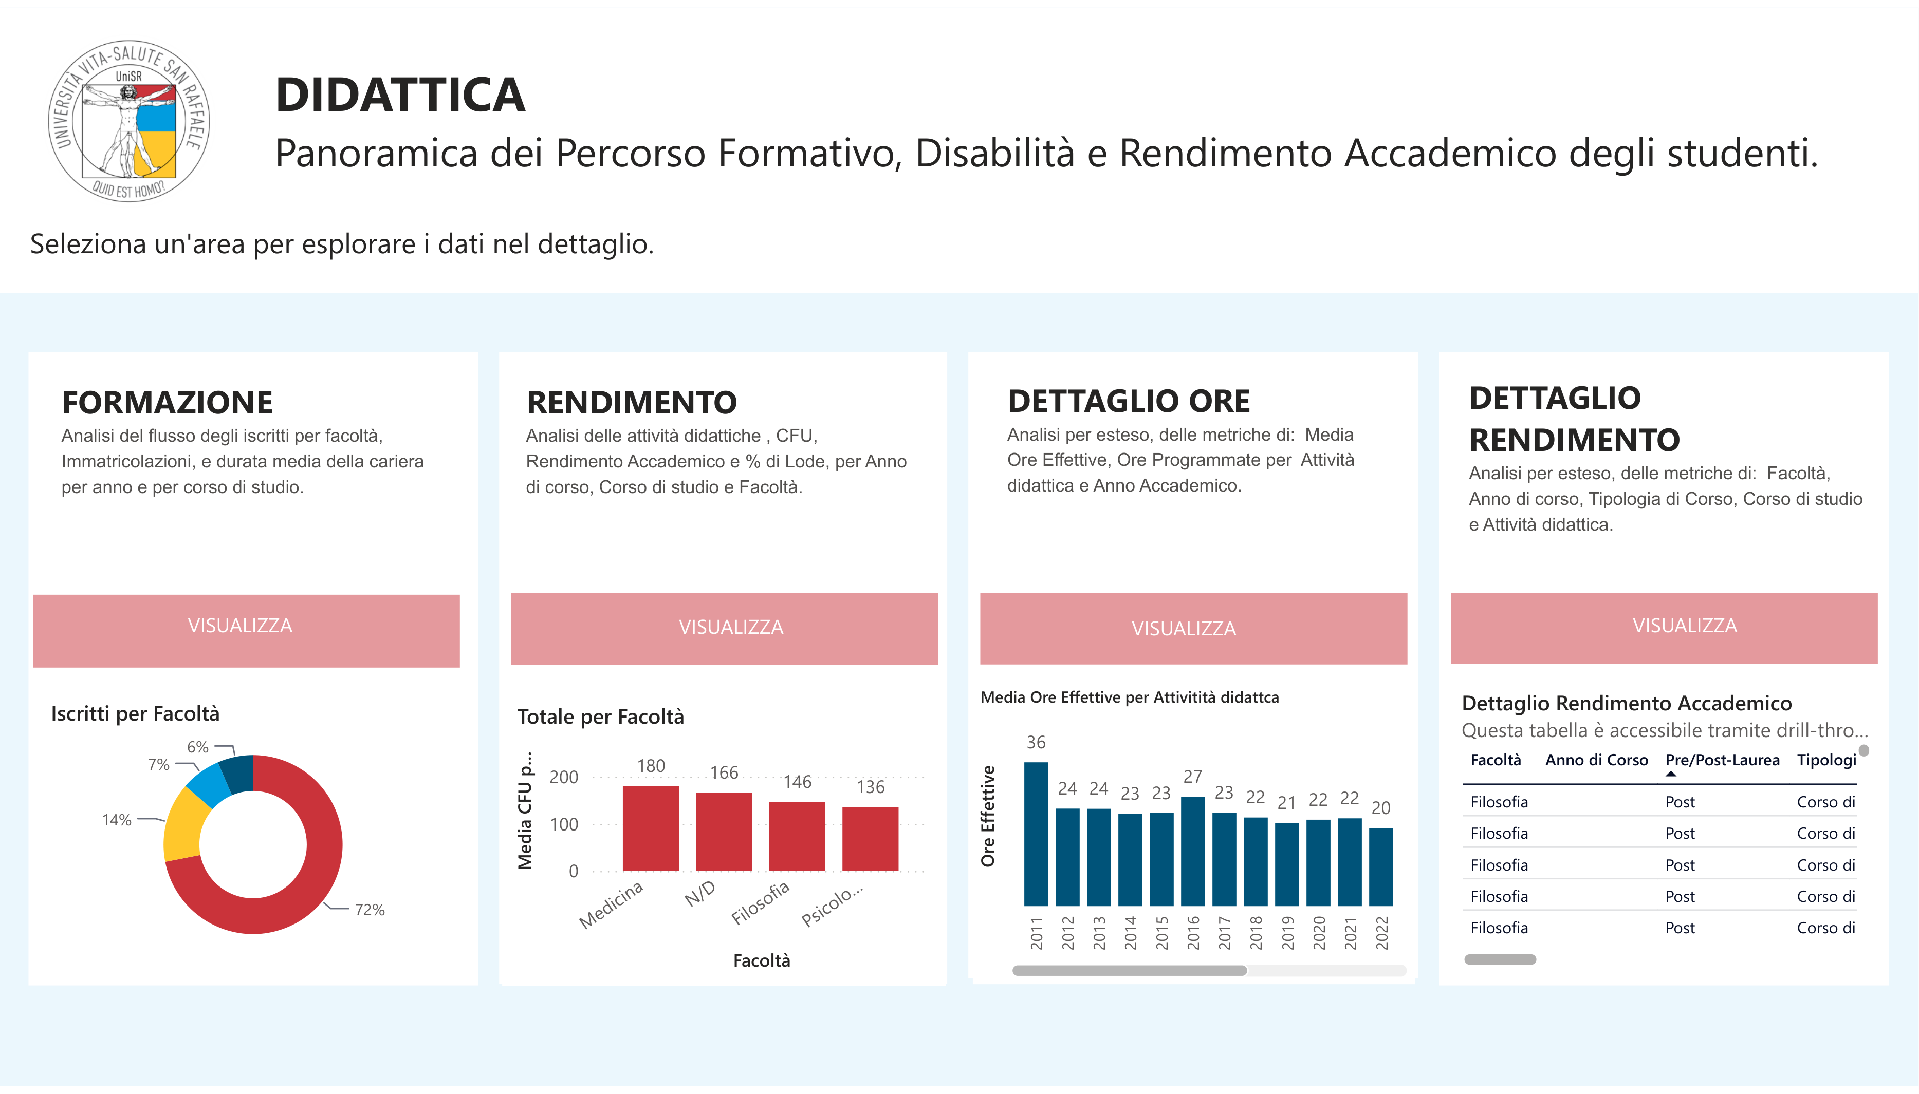
Figure 3. The landing page of the Report_Didattica report in the Power BI application, with the navigation to its thematic pages.

5.5.2 Interaction patterns across pages
The pages of the report follow one of two complementary interaction patterns, depending on the nature of the management question they support.
The first pattern is the standing overview. A standing overview page displays a curated set of KPIs at the aggregated level, typically for the entire institution or for a selected study programme, with slicers that allow the user to change the temporal or the categorical context (academic year, cycle, gender). The user reads the page as a periodic snapshot of the domain, without navigating further. This pattern is applied to the pages that summarise the state of enrolment and of academic performance at the institutional level, where the primary question of the management is one of ongoing monitoring rather than of investigation.
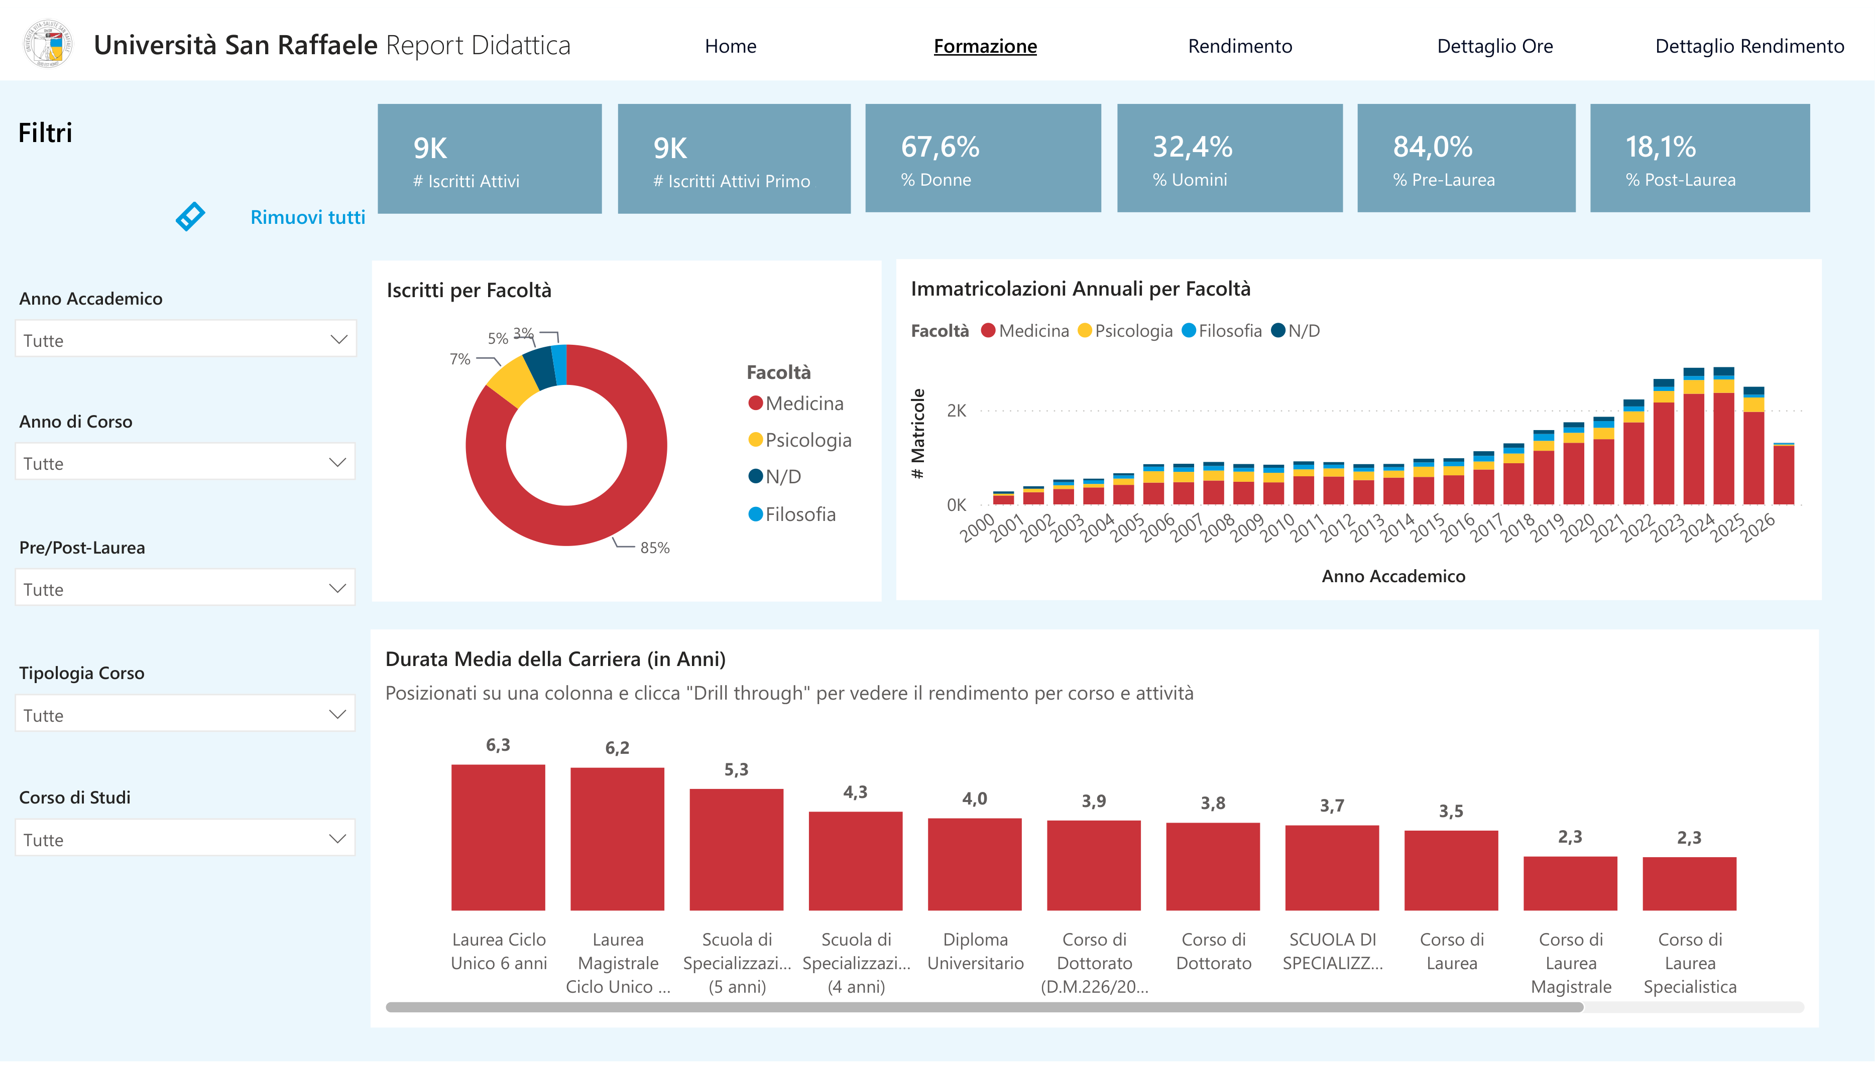
Figure 4. A standing overview page of Report_Didattica (enrolment and population): KPI cards and charts at the institutional level, with slicers on the left.
The second pattern is overview with drill-down. A drill-down page starts from the same kind of aggregated view but provides visuals through which the user can navigate to a finer grain: from the institution to the study programme, from the study programme to the cohort, and where relevant from the cohort to the individual student. This pattern is applied selectively, on the pages where the management question typically requires the identification of specific cases behind an aggregated indicator (for example, the identification of the students in the yellow or red risk band of the Fascia Studente CdS KPI). The drill-down was not applied to every page of the report as a default, in order to keep the pages that serve a monitoring purpose visually simple and fast to consult.

5.5.3 Distribution and access model
The reports are published to the Power BI Service and grouped into a single Power BI application that is made available to the client. From the perspective of the user, the application is the entry point to the whole Business Intelligence solution: a single interface from which each thematic report can be opened, without the user having to be aware of the underlying separation into distinct files.
Access to the application is differentiated by user role. The three main audiences configured for the project are the rectorate, whose members have access to the institutional-level views across all domains; the study programme directors, whose access is oriented towards the reports and the pages relevant to didactic and academic performance monitoring; and the administrative offices (student registrar and didactic services), whose access is oriented towards the operational reporting relevant to their functions. The differentiation is defined at the level of the report and of the audience within the application, so that a change in the role of a user is applied by updating the group membership rather than by rebuilding the report.
The refresh cadence of the reports is aligned with the refresh cadence of the underlying gold layer (Section 5.3), configured with a target lag of one day. In practical terms, the users of the application see a version of the data that reflects the state of the source systems at the end of the previous day. This cadence matches the analytical needs of academic management, whose decisions on student careers do not require sub-daily latency.

5.5.4 Contribution to the research question
Read against the four dimensions of "improvement" introduced in Section 4.4, the Power BI implementation described in this section contributes to three of them. The publication of the reports on the Power BI Service, together with the daily refresh, provides standing visibility: the reports exist as a persistent artefact that the user can consult when needed, rather than as a one-off answer produced on request. The organisation of the reports into an application with differentiated access aligns the distribution of technical dependency with the distribution of decisional responsibility, so that the user who consults a report does not need to interact with the IT department to obtain the information. The interaction patterns described in Section 5.5.2, in particular the selective drill-down, contribute to self-service exploration: within the boundaries of what the report designer has enabled, the user can refine a question without initiating a new request. The fourth dimension, consistency and governance, is addressed structurally by the semantic model discussed in Sections 5.3 and 5.4, and is preserved end-to-end by the fact that all the reports consume the same governed set of KPIs.

5.6 Data quality considerations
The value of the KPIs described in the previous sections depends on the quality of the data that feeds them. This section discusses the data quality problems encountered while building the student careers domain, the mechanisms through which the gold layer and the semantic model addressed them, and the limitations that remain. The problems fall under two of the data quality dimensions identified by Wang and Strong (1996): completeness, whether the data a KPI needs is present, and accuracy, whether the value a KPI returns agrees with the figure the organisation recognises as correct.
The scope of this discussion is the gold layer and the reporting model. The ingestion of the source data into the bronze and silver layers, and the correctness of the records held in the operational systems, sit upstream of this boundary and were handled by the wider delivery team and by the client. The author's contribution to data quality was at the gold layer and above: the construction of the gold tables for the student careers domain within the framework defined by the team, the semantic model, and the DAX measures.

5.6.1 Problems encountered
Two classes of problem affected the construction of the student careers KPIs.
The first is incompleteness of the source data. For a number of records, the data a KPI needed was not present, either because it had never been registered in the operational system or because it was not available for other reasons. Attendance is the clearest case. A student with no recorded lectures for a given programme and academic year has no absence rate to compute, and a calculation that ignores this returns either an error or a value that places the student in a risk band that does not mean anything.
The second is the risk of duplication in the joins, which inflates a measure by matching each row on one side to several rows on the other. It has two causes in this model. One is historisation: a dimension in the gold layer inherits several versions of the same business key from the silver layer, so a fact row joined to it without deduplication matches every version. The other is a mismatch in grain between two tables that are related directly. A concrete instance of the second appeared in the programmed teaching hours. When the fact table of the didactic activities was related to the students, the hours of each activity were repeated once for every student connected to it, and the total programmed hours for a single study programme rose above twenty thousand, a figure with no physical meaning. The hours belong to the activity, not to the pair of activity and student. The problem was resolved by computing the hours at the grain at which they are defined, with one table reporting programmed and delivered hours per study programme and a separate table reporting them per teacher, which is the page-specific fact design discussed in Section 5.3.3. In neither case does the fan-out appear in the dashboard as an error. It appears as numbers that are too high, which is why it has to be prevented in the model rather than found by inspecting the output.

5.6.2 Validating the data: the UAT of the pipeline and the reconciliation of the KPIs
The data behind the reports was validated on two levels. The pipeline that loads the warehouse was checked through a User Acceptance Testing exercise run by the delivery team on the flow from ESSE3 to the Snowflake silver layer, and the KPIs built on top of the warehouse were reconciled against reference values supplied by the university.
The UAT was organised in two levels of control. The first level was a set of automatic technical checks, run with the OpenMetadata tool on every silver table before the session with the client: a comparison of the row count between the bronze and the silver table, a check that the primary key, including composite keys, is unique, and a check that no field of the key is null. The second level was a functional validation carried out with the client: a sampling of representative records compared against the source, a check of the table structure against the expected schema, and a matching of the element counts between ESSE3 and the silver layer. Each control was recorded as pass, fail, or warning, where a warning is a difference within a tolerated threshold that is documented rather than treated as a defect. The dimensions these controls address, completeness, uniqueness, accuracy, validity, and consistency, are data quality dimensions in the sense of Wang and Strong (1996).
One finding of this exercise shows the kind of problem a count-based control catches. A reconciliation of the student careers loaded into the warehouse, about 38,600 records, against the source found nine that were present in the warehouse but no longer in ESSE3. These were careers deleted at the source after they had been loaded, whose deletion had not propagated downstream. The number is small, but the case is instructive: a record that is correct when it is loaded can become stale if it is later removed at the source, and only a control that compares the two systems will surface it.
The KPIs built on the validated data were then reconciled against reference values supplied by Università Vita-Salute San Raffaele, which provided sample figures for a set of indicators. A measure was treated as validated only when its output matched these figures. In several cases the first computation did not match. The mismatch was not always a coding error in the measure. For some indicators it came from a difference between the definition assumed in the semantic model and the definition the university had used to produce its own figures. When this happened, the team asked the university directly for the logic behind the reference values, that is, for the way each figure was calculated at the source, and aligned the definition in the semantic model to it.
The count of active students is an example. The first definition treated a student as active when the student was enrolled and had paid the enrolment fee. The figure matched the university's only after a third condition was added, that the career status of the student is active, a condition the university applied in its own definition and the model had not. The correction touched a limited number of records, but it changed the meaning of the indicator, and it is the kind of difference that stays invisible until a computed figure is placed next to a reference figure.
This process did more than correct individual numbers. It fixed the definition of the affected KPIs at the value the client recognised as correct, which is the consistency requirement set out in Section 4.3, and it placed that definition inside the semantic model, where it is applied once for every dashboard instead of being rewritten in each ad hoc query.

5.6.3 Safeguards in the gold layer and the model
The safeguards already described in Section 5.3.4 address the two classes of problem of Section 5.6.1 at the point where the data enters the model.
Deduplication of dimensions through QUALIFY ROW_NUMBER() removes the version-based fan-out, by selecting a single version of each business key before the dimension is joined to a fact. This pattern belongs to the shared gold framework and is applied across the student careers tables.
The ghost record pattern handles the incompleteness of the joins. A fact row whose dimensional attributes are unknown is matched to a dedicated ghost row rather than dropped, so the incomplete records stay visible in the dashboard as a distinct category instead of disappearing from the totals.
At the measure level, the Fascia Studente CdS KPI handles the missing-attendance case directly. When a student has no recorded lectures for a programme and year, the measure returns the label "N/D" rather than a risk band, which surfaces the gap in the report instead of hiding it behind a colour. The systematic use of NULLIF on the denominators of the ratios computed in the gold layer plays the same preventive role for divide-by-zero situations, returning an empty value that the report renders as a blank cell.
A further check is procedural rather than embedded in the code. During the construction of a fact table, the row count is compared before and after each join with a dimension. A change that is not explained by the modelling logic signals a fan-out or a missing filter, and is treated as a blocker until it is understood. The programmed hours case of Section 5.6.1 is exactly the kind of problem this check catches. At the pipeline level, the bronze-to-silver count control of the UAT plays the same role for the loads that feed the gold layer.

5.6.4 Residual limitations
The safeguards above prevent or expose data quality problems inside the reporting system, but they do not remove the limitations that originate outside it.
Completeness at the source is the main one. If a value was never recorded in the operational system, no layer downstream can reconstruct it. The same holds in reverse for records deleted at the source after they were loaded: unless a reconciliation detects them, as in the case of the nine careers in Section 5.6.2, they persist in the warehouse until the next check. The system makes these gaps visible, through the ghost record, the "N/D" label, and the count controls, but it cannot fill them on its own, and a KPI computed over incomplete source data is only as complete as the source. This is a property of the data rather than a defect of the model, but it constrains how some indicators can be read.
The refresh lag is a second limitation. The reports reflect the state of the source at the end of the previous day, so a correction made at the source during the day is not visible until the next refresh. For the decisions this system supports, a latency of one day is acceptable, as discussed in Section 5.3, but it is a limitation to keep in mind when a figure is checked against the live operational system.
The absence of cross-page filter synchronisation, described in Section 5.3.3, has a data quality consequence as well as a usability one. A figure read on one page and a figure read on another are not guaranteed to sit under the same filter context, so a user who reconciles two pages has to set the filters consistently on each.
Finally, the reconciliation of Section 5.6.2 is bounded by the availability of reference values. It was possible for the indicators for which the university provided sample figures. For indicators without an external reference, validation relied on internal consistency checks, which catch a computation that contradicts itself but not one that is internally consistent and still wrong.

6 Discussion: before and after
The previous sections described the reporting model that existed before the project (Section 4.2) and the Business Intelligence solution built during the internship (Section 5). This section reads one against the other, using the four dimensions of improvement set out in Section 4.4: process efficiency, consistency and governance, standing visibility and self-service exploration, and the distribution of technical dependency. The comparison is qualitative. No user study and no timing measurement were carried out, for the reasons given in Section 4.4, so the claims below are structural: they follow from how the two processes work, not from measured effect.
In the previous model, every figure was produced by a manual cycle. A user asked the IT department for a piece of information, IT wrote and ran a query against ESSE3, checked the result, and returned it as a file (Section 4.2). The solution replaces that cycle, for the information the dashboards cover, with an automated flow that moves data from the source systems through the medallion pipeline into the gold layer and into a set of governed dashboards that the user consults directly.

6.1 Process efficiency
In the previous model each information need cost one manual intervention by IT: write the query, run it, validate it, and, when the result looked wrong, revise and re-run it before delivering. The availability of a figure was bounded by IT capacity, and recurring needs competed with one-off ones for the same people (Section 4.3).
In the solution, the flow from source to dashboard runs without a per-request step. Data moves from the operational systems through the pipeline into the gold layer, and the dashboards refresh with a lag of one day (Sections 5.2 and 5.3). For a question the dashboards already cover, the manual cycle is gone: the user opens a report instead of filing a request, and the IT effort that used to be spent once per request is spent once, at design time.
This does not remove development work altogether. A genuinely new question, outside what the reports expose, still requires a change to the model or a new visual. What changes is that the recurring needs, which were the bulk of the manual load, are served without a manual query each time.

6.2 Consistency and governance
The previous model had no central set of metric definitions. The same question, asked at different moments or by different people, could be answered by structurally different queries, and small differences in filters or edge-case handling produced figures that were each defensible but not comparable. When the figures disagreed, the reporting lost credibility and the discrepancy had to be reconciled by hand (Section 4.3).
In the solution, each KPI is defined once in the semantic model, and every dashboard that shows it uses that definition (Section 5.4). The filters that select the right records sit inside the measure rather than in the query of whoever happens to write it. The reconciliation against the university's reference values (Section 5.6.2) fixed the affected definitions at the values the institution recognises as correct, as in the active students case, where the agreed definition required the career status to be active on top of enrolment and payment. A figure read in one report is the figure read in another.

6.3 Standing visibility and self-service exploration
The previous model was pull-based: information existed only when it was requested. Management could not follow a KPI over time, drill into an anomaly, or refine a question without opening a new IT request, which narrowed the range of questions that were realistic to ask (Section 4.3).
In the solution, the reports are a standing artefact refreshed daily (Section 5.5). A KPI can be read as a trend, and on the drill-down pages the user moves from the institution to the study programme, to the cohort, and to the individual student where the report allows it (Section 5.5.2). This is the self-service that the literature associates with a shift away from IT-mediated reporting (Pałys and Pałys, 2023; Passlick et al., 2023). It is guided self-service rather than open-ended querying: the user explores within what the report designer enabled, and a question nobody anticipated still needs development. The gain is in the range of questions that can now be answered without a request, not in unlimited freedom to ask any question.

6.4 Distribution of technical dependency
In the previous model the ability to answer any question sat with the IT department, so both administrative and academic users depended on IT availability, and access to information did not follow the distribution of decisional responsibility. The self-service BI literature identifies this concentration as one of the main drivers of BI transformation (Pałys and Pałys, 2023).
In the solution, the reports are distributed through a Power BI application with access differentiated by role, for the rectorate, the study programme directors, and the administrative offices (Section 5.5.3). A user who consults a report no longer needs IT to obtain the figure, so access to information is aligned with the responsibility for the decisions it supports.
Dependency is not removed by this. It moves. The institution now depends on the pipeline and the semantic model working correctly, and on whoever maintains them, rather than on IT being available for each request. The dependency changes in kind, from per-request and manual to structural and shared, and it becomes visible in a smaller number of well-defined artefacts rather than in a queue of individual requests.

6.5 Limitations of the analysis
The comparison above has clear limits, and they bound what can be claimed from it.
It is qualitative and it is a single case. The analysis maps the design of the solution onto the four dimensions of Section 4.4; it does not measure how large the improvement is. One engagement at one institution cannot support a general quantitative claim.
There was no user study and no timing measurement. The statements about latency and effort are structural, drawn from the two processes, not from interviews or before-and-after timings. The confidentiality of the engagement, stated in Section 4.4, is part of the reason this evidence was not collected.
The author is not a neutral observer. Having taken part in building the solution gives direct knowledge of its design, but it is not a detached standpoint from which to judge its effect in use.
Finally, the evaluation is of the solution as delivered. Its value in practice depends on adoption by the intended audiences, which fell outside the observation window of the internship.

6.6 Managerial implications for higher education institutions
The bottleneck that a governed BI layer removes is organisational as much as technical. What made the previous model slow was that every figure passed through one team, and what the semantic model changes is that the definition of a figure moves out of individual queries into a shared object that many reports reuse. An institution that adopts the tool without governing the definitions would keep much of the old inconsistency.
For a higher education institution weighing a similar move, the case suggests that the return is largest where the information need is recurring and shared across roles, which is the student careers domain, and where a single agreed definition carries governance weight, such as the figures reported to academic authorities. This is consistent with the conditions for BI adoption in higher education discussed by Sequeira et al. (2024).
The design choices in this project are trade-offs, not defaults. The page-specific fact tables and the daily refresh fit the needs observed here (Sections 5.3.3 and 5.6.4). An institution with a stronger requirement for cross-page consistency, or with decisions that need sub-daily data, would weigh those choices differently.

7 Skills acquired during the internship
This section describes the skills the internship developed, grouped as technical, methodological, and professional. Where the learning objectives of Section 3 stated what the internship set out to build, this section states what the work actually produced in terms of competence, with reference to the parts of the project that provided the evidence.

7.1 Technical skills
The internship built a working command of a cloud data warehouse. The author learned to model and construct the gold layer of a Snowflake warehouse for the student careers domain: writing the fact and dimension tables to a documented grain, applying the hash-key and ghost-record patterns for the foreign keys, deduplicating dimensions with QUALIFY ROW_NUMBER(), and guarding the ratios with NULLIF (Sections 5.3 and 5.6). These are the patterns of a governed gold layer, learned by applying them to real tables rather than by reading about them.
On top of the warehouse, the author learned semantic modelling and DAX in Power BI. This covered the design of a semantic model for a report domain, the management of relationships to avoid ambiguity, and the implementation of the KPIs of Section 5.4, including the more complex measures that encode a business rule and handle the empty case, such as Fascia Studente CdS. Reading a management indicator and expressing it as a correct, reusable DAX measure is the single most transferable technical skill the internship produced.
The author also gained familiarity with the analysis and testing artefacts that surround the build: the source-to-target mapping that documents how each target field derives from its source, and the data quality testing carried out in the User Acceptance Testing phase, including the automatic checks run with OpenMetadata and the functional checks run with the client (Section 5.6.2).

7.2 Methodological skills
The internship taught a way of working that starts from a management question and ends at a governed metric. The author learned to define a KPI by its business question, its grain, and the dimensions along which it is analysed before writing any code (Section 5.4.1), and to hold a definition in one place so that every report that uses it returns the same value.
A second methodological skill is validation. The author learned to test an analytical output against an external reference rather than against personal expectation: to compare a measure with the figure the client recognises as correct, and, when the two disagree, to trace the difference to a definition and reconcile it (Section 5.6.2). This is a habit of not trusting a number until it has been checked against something outside the model.

7.3 Professional skills
The internship was the author's first experience of consulting delivery, and it developed the skills that this setting requires. The author learned to work inside a delivery team, to conventions and naming standards set by more senior colleagues, and to have his work reviewed before it entered the shared model. Working to a shared standard, rather than to personal preference, is a professional skill in its own right.
The author also developed the ability to communicate about data with people who are not data specialists: to gather a reporting requirement from a directorate, to agree the definition of an indicator with the people who will use it, and to present a result in terms of the management question it answers rather than the query that produced it. The conversion of the internship into an apprenticeship reflects the level of professional integration reached by the end of the period.

8 Conclusions

8.1 Summary
This thesis has described and analysed a Business Intelligence solution built for Università Vita-Salute San Raffaele during an internship at KPMG Advisory. The solution replaces an IT-mediated reporting process, in which every figure was produced on request through a query against the student information system, with a governed data platform and a set of Power BI dashboards. The thesis focused on the student careers domain: the gold layer of the Snowflake warehouse, the semantic model, and the KPI catalogue built on top of them, together with the data quality work that supports the numbers the dashboards show.

8.2 Answer to the research question
The research question asked how the new system improves reporting efficiency and decision support for academic management, compared to the previous ad hoc, IT-mediated process. Read along the four dimensions of Section 4.4, the answer is the following.
Process efficiency improves because the flow from the source systems to the dashboards is automated. For a question the dashboards already cover, the manual query cycle is gone, and the effort that used to be spent once per request is spent once, at design time.
Consistency and governance improve because each KPI is defined in one place, in the semantic model, and every report that uses it returns the same value. The reconciliation of the definitions against the values the university recognises as correct fixed this consistency at a figure the client agrees with.
Standing visibility and self-service improve because the dashboards are a persistent artefact, refreshed daily, that management can consult and, within what the report enables, explore through drill-down, without opening a new request each time.
The distribution of technical dependency changes rather than disappears. Access to information is aligned with the responsibility for the decisions it supports, through role-based access to the reports, and the user no longer depends on IT to obtain a figure. The dependency moves to the pipeline and the semantic model and to whoever maintains them, and it becomes a dependency on a small number of governed artefacts rather than on a queue of individual requests.
The improvement is therefore real along all four dimensions, and it is qualitative. This thesis does not measure its size, and the dependency is transformed rather than removed.

8.3 Contribution
The main contribution of the thesis is a documented case of a Business Intelligence transformation in a higher education institution, described from the data architecture to the dashboards, with the real modelling and data quality decisions that shaped it and with an explicit account of what the author built and what the wider team built. Cases at this level of detail are useful to other institutions considering a similar move, because the value of such a project depends on decisions, about grain, about definitions, about trade-offs, that are usually invisible in a higher-level description.

8.4 Limitations
The analysis is qualitative and rests on a single case, observed by someone who took part in building the solution. It does not include user interviews or timing measurements, for the reasons of confidentiality and scope stated in Section 4.4, and its claims about efficiency and dependency are structural rather than measured (Section 6.5).

8.5 Future work
Three directions would extend this work. The first is a quantitative evaluation: a study with the users of the dashboards, and a measurement of the time and the effort a reporting need now takes compared with the previous process, would put a size on the improvement this thesis describes qualitatively. The second is the extension of the analysis to the other domains of the project, and to the areas planned for the later waves, to see whether the findings for student careers hold where the information needs and the governance stakes are different. The third is a study of the solution in use over time, which would test the maintainability of the design choices made here, in particular the page-specific fact tables, once the system has been running and evolving for a longer period.

References
Kimball, R. and Ross, M. (2013). The Data Warehouse Toolkit: The Definitive Guide to Dimensional Modeling. John Wiley & Sons, third edition.
KPMG in Italy (2026). KPMG in Italy. https://kpmg.com/it/it.html (accessed 11 September 2026).
KPMG International (2025). About KPMG. KPMG International Limited. https://kpmg.com/xx/en/home/about.html (accessed 11 September 2026).
Pałys, M. and Pałys, A. (2023). "Benefits and challenges of self-service business intelligence implementation". Procedia Computer Science, 225: 795–803.
Passlick, J., Grützner, L., Schulz, M., and Breitner, M. H. (2023). "Self-service business intelligence and analytics application scenarios: a taxonomy for differentiation". Information Systems and e-Business Management, 21(1): 159–191.
Sequeira, R., Reis, A., Alves, P., and Branco, F. (2024). "Roadmap for implementing business intelligence systems in higher education institutions: systematic literature review". Information, 15(4): 208.
Wang, R. Y. and Strong, D. M. (1996). "Beyond accuracy: what data quality means to data consumers". Journal of Management Information Systems, 12(4): 5–33.

