Università Cattolica del Sacro Cuore
Master in Data Science for Management

Master's Thesis

Designing a KPI System for Academic Management: A Snowflake Semantic Model and Power BI Dashboards at Università Vita-Salute San Raffaele

Supervisor: Prof. Riccardo Bramante
Candidate: Alessio Capobianco

Academic Year 2026 / 2027

Abstract
Università Vita-Salute San Raffaele met the information needs of its academic management through an IT-mediated process: each figure was requested from the IT department and produced by an ad hoc query against the ESSE3 student information system. This thesis examines how a governed Business Intelligence system, built during an internship at KPMG Advisory within Project Kaleidos, changes that process. The research question asks how a Snowflake-based semantic model and a set of Power BI KPI dashboards improve reporting efficiency and decision support compared with the previous process.
The study is a single, design-oriented case study of the student careers domain, written from the position of a participant: the author built the gold layer tables, the Power BI semantic model, and the DAX measures of that domain. The evidence consists of the design artefacts of the project (source-to-target mappings, gold layer definitions, the semantic model and its measures), the records of the User Acceptance Testing, the reconciliation of the KPIs against reference values supplied by the university, and the author's direct observation. The previous and the new process are compared along four qualitative dimensions: process efficiency, consistency and governance, standing visibility and self-service exploration, and the distribution of technical dependency.

The analysis finds structural improvements along all four dimensions. Recurring information needs no longer require a query for each request, each KPI has a single definition reconciled with the university's own figures, and management can monitor and explore the indicators directly. Technical dependency is not removed: it moves from per-request IT work to the maintenance of the pipeline and the semantic model. The improvement is structural and was not measured. The thesis contains no timing study and no user study, and adoption fell outside the observation window. Its contribution is a detailed account of the modelling, data quality, and governance decisions behind a Business Intelligence transformation in higher education, together with the conditions on which its benefits depend.
Keywords: Business Intelligence; higher education; Snowflake; Power BI; semantic model; KPI; data quality.

Table of Contents

1 Introduction

1.1 Data and decisions in higher education
Universities manage a set of interrelated activities: admissions, student progression, teaching, research, and the allocation of financial resources. Decisions in these areas increasingly draw on data held in the institution's own operational systems rather than on periodic reports or informal knowledge. In a systematic review of Business Intelligence adoption in higher education, Sequeira et al. (2024) note that decisions taken without the support of systematised institutional data can compromise both the effectiveness and the efficiency of institutional action.
The difficulty is that the systems which hold this data are built for transactions, not for analysis. A student information system records enrolments, exams, and careers one operation at a time. It does not provide, on its own, the aggregated and cross-domain views that academic management needs to monitor a cohort, compare programmes, or decide where to intervene. Closing this gap is the problem that a Business Intelligence layer addresses.

1.2 Setting: an internship at KPMG and a project for Università Vita-Salute San Raffaele
This thesis is based on the work carried out during an internship at KPMG Advisory, on a project for Università Vita-Salute San Raffaele. The project, named Kaleidos, was the programme through which the university set out to build a new reporting model on a centralised data platform: a Data Hub that integrates the university's operational data in a Snowflake warehouse, and a reporting layer built in Power BI on top of it (Chapter 2).
The project covers several domains of academic management. This thesis focuses on one of them, student careers and academic performance, which is the most information-intensive area of academic management and the domain in which the author worked directly (Section 5.1.3).

1.3 Motivation
Before the project, the university met its information needs through an IT-mediated process. Every figure was produced on request: a user asked the IT department for a piece of information, IT wrote and ran a query against the student information system, and the result was returned as a file (Chapter 4). This process was functional, but it made every figure depend on IT availability, it left the definition of each indicator to whoever wrote the query, and it offered no way to explore the data without opening a new request.
The motivation of this thesis is to document and analyse how a governed Business Intelligence system changes this situation: what it improves, at what cost, and where its limits are. The engagement offers a concrete, real case in which the change can be examined end to end, from the data platform to the dashboards that management consults.

1.4 Research aim

The thesis asks how a governed Business Intelligence system, built on a Snowflake semantic model and Power BI dashboards, improves reporting efficiency and decision support for academic management at Università Vita-Salute San Raffaele, compared with the previous process of ad hoc, IT-mediated queries against ESSE3. Section 4.4 states the research question in full and defines the four qualitative dimensions along which the improvement is assessed. Section 5.1.1 describes the research design and the evidence used.

1.5 Contribution
The thesis contributes a documented case study of a Business Intelligence transformation in a higher education institution. It describes the technical design of the solution, the medallion data architecture, the semantic model, and the KPI catalogue for the student careers domain, at a level of detail that shows the real modelling and data quality decisions behind it. It then reads the solution against the previous reporting model along the four dimensions defined in Section 4.4, and identifies the conditions on which the improvement depends. The boundary between the work of the author and that of the wider KPMG team is set out once, in Table 1, so that the contribution of the internship is neither overstated nor hidden.

1.6 Structure of the thesis
Chapter 2 describes the hosting company, KPMG, and the setting of the internship. Chapter 3 states the learning objectives of the internship. Chapter 4 defines the problem, describes the pre-existing reporting model and its limitations, and states the research question with the four dimensions used to answer it. Chapter 5 sets out the research design and the contribution of the author, and then describes the solution: the data architecture, the semantic model, the KPI design, the Power BI implementation, and the data quality considerations. Chapter 6 interprets this evidence along the four dimensions and discusses the conditions and trade-offs on which the change depends. Chapter 7 describes the skills acquired during the internship, and Chapter 8 answers the research question.

2 The hosting company: KPMG

2.1 KPMG as a global organisation
KPMG is one of the four large international professional services networks, together with Deloitte, EY, and PwC. It is a global organisation of independent member firms that operate under the KPMG brand and are affiliated with KPMG International Limited. The member firms work in 143 countries and territories and employ more than 275,000 people (KPMG International, 2025). The organisation delivers three lines of service: Audit, Tax and Legal, and Advisory. Audit covers the assurance of financial statements, Tax and Legal covers fiscal and legal advice, and Advisory covers consulting on strategy, operations, risk, transactions, and technology.

2.2 KPMG in Italy and the Advisory practice
In Italy, KPMG operates through a set of member entities that cover the three service lines. According to KPMG's own reporting, the Italian organisation has around 5,000 professionals across about 25 offices and serves more than 6,000 clients (KPMG in Italy, 2026). Advisory services in Italy are delivered mainly through KPMG Advisory S.p.A., based in Milan.
The Advisory practice works with organisations on change programmes and on performance improvement. One area of this work is data and analytics: the design and construction of the data platforms, semantic models, and reporting systems that let an organisation use its own operational data for management decisions. The internship described in this thesis sits in this area, on an engagement for a university client.

2.3 The Junior Data Engineer role
The author joined KPMG Advisory as a Junior Data Engineer. The internship lasted three months and was extended by a further two, after which it converted into an apprenticeship contract.
A Junior Data Engineer on an Advisory engagement of this kind works on the data side of the delivery. The work covers the pipelines that move data from the source systems into the warehouse, the warehouse tables that the reporting layer consumes, and the semantic models and measures built on top of them. On the San Raffaele engagement, the author's work concentrated on the gold layer of the Snowflake warehouse and on the Power BI semantic model and the DAX measures for the student careers domain, within the framework and the conventions set by the delivery team. Table 1 in Section 5.1.3 sets out this contribution and its boundary with the work of the team.

2.4 The San Raffaele engagement as an example of the practice
The engagement analysed in this thesis, the design of a KPI and dashboard system for Università Vita-Salute San Raffaele, is an example of the data and analytics work of KPMG Advisory. It has the shape these engagements usually take: a client whose operational systems hold the data but not the analytical views that management needs, a delivery team that builds the data platform and the reporting layer, and the handover of a governed reporting product that the client can use without a technical intermediary for each question.
Chapters 4 to 6 describe this engagement in detail. This section places it in its organisational context. It is one project within the Advisory practice, staffed by a delivery team, in which the author was the member responsible for the semantic model and the measures of the student careers domain.

3 Internship learning objectives
The internship took place inside Project Kaleidos, the programme through which Università Vita-Salute San Raffaele built a new university reporting model on a centralised data platform (Chapters 1 and 2). The project ran in phases: a discovery phase that mapped the existing situation and collected the target requirements, a select-and-design phase that chose the technology stack and produced the source-to-target analysis and the solution design, a development phase that integrated the source systems, built the platform, and validated it through User Acceptance Testing, and the go-live and adoption phases that followed. The author's work concentrated in the select-and-design and development phases.
The learning objectives that oriented the internship fall into four groups: technical, methodological, professional, and academic. This section states them and connects each to the phase and the part of the project in which it was pursued. Chapters 5 to 7 show how far they were met.

3.1 Technical objectives
The first objective was to learn a modern cloud data stack in practice rather than in theory. This meant working with Snowflake as the data warehouse, with the medallion architecture that organises the flow from raw to reporting-ready data, and with the patterns that make a gold layer usable by a reporting tool (Sections 5.2 and 5.3). In the project, this warehouse is the Data Hub that the development phase set out to build.
The second was to learn dimensional and semantic modelling for Business Intelligence: the design of fact and dimension tables, the discipline of an explicit grain, the relationships that carry filters through a model, and the translation of a warehouse into a Power BI semantic model (Section 5.3).
The third was to reach a level of DAX sufficient to implement measures that are not trivial, including measures that encode a business rule and handle the empty or edge case rather than failing on it (Section 5.4). Taken together, these objectives describe a move from a theoretical knowledge of data management to the ability to build a working reporting layer on real data.

3.2 Methodological objectives
One objective was to learn to translate a management question into a data model and a measure: to begin from what a manager needs to know and arrive at a KPI with an agreed grain and a single definition (Sections 5.4 and 5.6.2). The source-to-target analysis of the select-and-design phase, which maps each target field back to its source, is where this translation begins in a structured form.
A second was to learn to validate analytical output. The development phase closed with a User Acceptance Testing exercise, organised in automatic technical checks and functional checks carried out with the client (Section 5.6.2). Taking part in this, and reconciling a KPI definition with the client when the computed figure and the reference figure disagreed, taught the discipline of validating against an external benchmark rather than against one's own expectation.
A third was to absorb the discipline of a governed model: definitions that live in one place, a grain that is documented rather than assumed, and data quality safeguards built into the tables (Sections 5.3.4 and 5.6.3).

3.3 Professional objectives
The internship was also an opportunity to learn how a consulting engagement is delivered. The project ran with a defined governance. On the KPMG side it was led by the associate partners G. Palumbo and F. De Cassai, with change management directed by M. Lodigiani (Senior Manager) and the delivery run by a core team in which F. Scorpiniti (Manager) and A. Pessolano (Assistant Manager) led the technical work and M. Vanoli (Assistant Manager) the functional work. The author worked inside this technical team, to conventions set by more senior colleagues, with the author's work reviewed before it entered the shared model (Sections 2.3 and 5.3). On the client side, the project was sponsored at the level of the delegated councillor and steered by the university's directorates, among them the Operations Directorate, the Information Systems Directorate, and the Directorate for Teaching Development, Accreditation and Quality.
A related objective was to learn to communicate with a client and with people who are not technical: to gather requirements, to agree the definition of an indicator, and to hand over a reporting product that the client can use without a technical intermediary for each question. The requirement-gathering and the UAT sessions, both run with the university's directorates, were where this was practised. Behind these sits a simpler objective, to work to the standards and the pace of a professional services firm, which the conversion of the internship into an apprenticeship reflects.

3.4 Academic objectives
The academic objective was to connect the Master's programme in Data Science for Management to a real management setting, and to see how the methods studied in the programme apply to the decisions of an institution. The second academic objective was to produce the documented case study that this thesis is: a description and an analysis of a real Business Intelligence transformation, carried out with the rigour the Master requires.

4 Problem definition

4.1 The managerial context: information needs in academic management
Universities manage a range of interrelated activities: student admissions and progression, teaching, research output, and the allocation of financial resources. Decisions in these areas increasingly draw on data from the institution's own operational systems rather than on informal knowledge or periodic reports. Sequeira et al. (2024), in a systematic review of Business Intelligence adoption in higher education, note that decisions taken without the support of systematised institutional data may compromise both the effectiveness and the efficiency of institutional action.
Within academic management, monitoring student careers is a particularly information-intensive area. It informs decisions on the academic offering, on tutoring interventions, on the way programmes are resourced, and on measures to reduce dropout. For a reporting system to be useful to management, it must deliver information that is accurate, available when decisions are actually being taken, and consistent across the people who consult it.

4.2 The pre-existing situation: IT-mediated reporting through ESSE3
The internship engagement analysed in this thesis was carried out at Università Vita-Salute San Raffaele, an Italian private university whose student information system is ESSE3, the operational platform used by most Italian higher education institutions to manage student careers, exams, and administrative records. ESSE3 is designed for transactional use, not for analytical use: it does not natively provide the aggregated, cross-domain views that academic management needs to support its decisions.
Before the introduction of the Business Intelligence solution described in this thesis, the university addressed this gap through an IT-mediated reporting model. Information needs from administrative offices (such as the student registrar and the teaching services office) and from academic management (programme coordinators and departmental leadership) were channelled through requests to the IT department. Each request followed the same pattern:
1. A requester formulated an information need, for example the number of students in a cohort who had reached a given progression threshold.
2. The IT department translated the request into one or more SQL queries against the ESSE3 database.
3. The queries were executed and the results checked for correctness.
4. When the results appeared inconsistent or incomplete, the query was revised and re-executed. Several iterations were sometimes required.
5. Once the results were considered reliable, they were sent to the requester, typically as a spreadsheet or a static document.
The same workflow served both recurring reporting needs, such as periodic reports on enrolments or exam outcomes, and one-off requests tied to specific decisions. Each information cycle required a discrete manual intervention by IT staff.

4.3 Limitations of the pre-existing model
The IT-mediated model was functional but had several structural limitations that affected both the efficiency of the reporting process and the quality of the decision support it provided. These limitations are documented in the wider literature on self-service Business Intelligence (Pałys and Pałys, 2023; Passlick et al., 2023) and can be discussed under four headings.
Latency and IT bottleneck. Every information need required IT staff to write, run, and validate a query. The availability of reports was therefore constrained by IT capacity and workload. Recurring requests competed with one-off ones for the same limited resource, and the correction loop between requester and IT often extended the response time further. In practice, decisions were sometimes taken either without the most current information or after a delay that reduced its usefulness.
Inconsistency across requests. In the absence of a centrally governed set of metric definitions, similar questions asked at different moments, or by different requesters, could be answered by structurally different queries. Small differences in filters, join logic, or in the treatment of edge cases could produce results that were individually correct but not mutually comparable. When discrepancies emerged, the credibility of the reporting output was called into question and rework was needed to reconcile the figures.
Absence of standing visibility and self-service exploration. The pre-existing model was inherently pull-based: information existed only when explicitly requested. Management could not observe trends over time, drill down into a dashboard to investigate an anomaly, or refine a question without initiating a new IT request. This constrained the type of managerial questions that could realistically be asked, and effectively narrowed the analytical scope of the institution to what had already been extracted.
Concentration of technical dependency. Because the ability to answer any question resided with the IT department alone, both administrative and academic users depended structurally on IT availability. The literature on self-service BI identifies this concentration of dependency as one of the main drivers of BI transformation (Pałys and Pałys, 2023). For an academic institution, it also means that access to information does not follow the distribution of decisional responsibility.
Taken together, these limitations describe a reporting model whose cost, measured in IT effort, in decision latency, and in analytical opportunities that are never taken, grows with the information intensity of the institution.

4.4 Research question
On this basis, the thesis addresses the following research question:
How does a Snowflake-based semantic model and Power BI KPI dashboard system improve reporting efficiency and decision support for academic management at Università Vita-Salute San Raffaele, compared to the previous ESSE3-based process of ad hoc, IT-mediated query requests?
The notion of "improvement" is operationalised along four qualitative dimensions, each the counterpart of one limitation set out in Section 4.3: process efficiency, consistency and governance, standing visibility and self-service exploration, and the distribution of technical dependency. For each dimension the question is, respectively, whether the per-request IT cycle is removed, whether each KPI has one agreed definition, whether management can monitor and explore the indicators without a new request, and where the dependency on technical staff sits after the change. The rest of the thesis refers to these as the four dimensions of Section 4.4.
The thesis does not attempt to quantify these dimensions through user studies or timing measurements. This is an intentional scoping choice, motivated by the confidentiality constraints of the internship engagement and by the qualitative nature of the observational evidence available. Section 5.1.1 describes the evidence used and the procedure by which the comparison is made.

4.5 Scope and delimitation
The Business Intelligence solution developed during the internship covers several KPI domains: student careers, admissions, teaching offering, research output, and economic-financial indicators. To keep the analysis at a sufficient depth within the length constraints of this report, the thesis focuses on the student careers and academic performance domain. This is the most information-intensive area of academic management. It also best illustrates the transition from IT-mediated reporting to a governed semantic model, and it is the domain in which the author was most directly involved during the internship. The other KPI domains are mentioned where relevant, as parallel components of the wider solution, but their KPI catalogue, semantic modelling choices, and dashboard implementation are not discussed in detail.

5 Research methods and analysis

5.1 Research design and overall approach
This chapter combines three parts that are worth keeping apart. Section 5.1.1 states the research design: the case, the evidence, and the procedure by which the conclusions are reached. Sections 5.2 to 5.6 describe the technical implementation that constitutes the case, from the data architecture to the reports and the data quality work. The evaluation, which compares the new process with the previous one along the four dimensions of Section 4.4, follows in Chapter 6.

5.1.1 Research design and evidence
The research is a single case study with a design-oriented character. The unit of analysis is the reporting process of the student careers domain at Università Vita-Salute San Raffaele, observed in two states: the IT-mediated process that existed before Project Kaleidos (Chapter 4) and the governed system that replaced it (Sections 5.2 to 5.6). The case is the one the internship gave access to. Within it, the student careers domain was selected because it is the most information-intensive area of academic management and the one in which the author worked directly (Section 4.5).
The evidence comes from five sources:
1. Project documentation: the kick-off material of Project Kaleidos, which sets out the phases and the objectives of the project, and the table descriptions of the source systems.
2. Design artefacts: the source-to-target and bronze-to-silver mappings, the SQL definitions of the gold tables, and the Power BI semantic model with its DAX measures.
3. Testing records: the documentation of the User Acceptance Testing of the pipeline, with its automatic and functional checks (Section 5.6.2).
4. Reconciliation results: the comparison of the KPIs with the reference values supplied by the university, and the definitions agreed as a result (Section 5.6.2).
5. Participant observation: the author's own work in the delivery team, including the requirement-gathering and validation sessions held with the university's directorates.
The description of the previous process in Chapter 4 draws on the project's account of the existing situation and on the exchanges with the university's staff during requirement gathering and testing. The description of the new system draws on the design artefacts and on the testing and reconciliation records.
The analysis proceeds in two steps. The first describes the solution at the level of the design decisions that matter for the research question: what each layer does, which alternatives were considered, and which safeguards were built in (Sections 5.2 to 5.6). The second compares the two states of the process along the four dimensions of Section 4.4 (Chapter 6). For each dimension the comparison asks which mechanism of the new system addresses the corresponding limitation of Section 4.3, what evidence shows that the mechanism works as designed, and what the mechanism leaves unresolved or introduces. The result is a structural answer. It establishes what the system makes possible and what it removes from the process, not how much time or effort it saves in practice.
Two limits follow from this design. The first is that the author was a participant. Direct access to the artefacts and to the reasons behind each decision is what makes the account detailed, but it is not a detached standpoint, and an external evaluation might read the design less favourably. The second is that quantitative evidence on the effect of the change, such as request volumes, response times, or the use of the reports after go-live, was not available within the observation window and the confidentiality constraints of the engagement. The conclusions are qualified accordingly (Sections 6.6 and 8.4).

5.1.2 Architecture of the solution

The end-to-end architecture has four layers, illustrated in Figure 1:
1. ESSE3 as the operational source system.
2. A Snowflake data platform, organised according to the medallion pattern (bronze, silver, and gold layers), which ingests the data extracted from ESSE3 and progressively refines it.
3. A semantic model built in Power BI on top of the gold layer, which defines the entities, relationships, and DAX measures that underlie the KPI catalogue.
4. A set of Power BI dashboards published through Power BI Service and distributed to the client as a Power BI application, with access rights differentiated by user role.
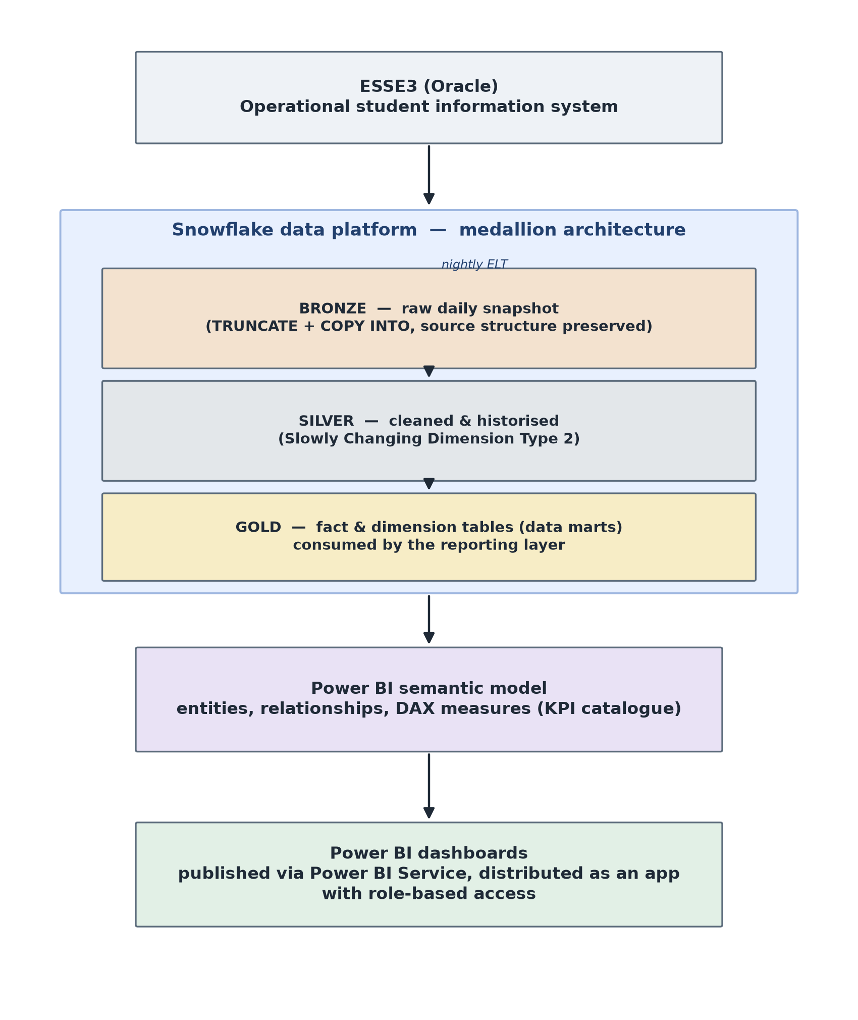
Figure 1. End-to-end architecture of the solution, from the ESSE3 source system through the Snowflake medallion layers (bronze, silver, gold) to the Power BI semantic model and dashboards.

The remainder of the chapter follows the architecture in order. Section 5.2 describes the Snowflake medallion approach at a level of detail proportionate to its role in the thesis. Section 5.3 presents the semantic model, including the trade-offs adopted when a pure star-schema design was not feasible. Section 5.4 details the KPI catalogue for the student careers domain, Section 5.5 illustrates the Power BI implementation and its distribution model, and Section 5.6 discusses the data quality considerations that emerged during the project.

5.1.3 Contribution of the author
Table 1 sets out the boundary between the work of the author and that of the KPMG delivery team and the client. It is the reference for the rest of the thesis, which does not restate it section by section. In short, the author built the gold tables, the Power BI semantic model, and the DAX measures of the student careers domain, within a framework defined by the team, while the pipeline that feeds the gold layer was built by the team.
Component (section) | Contribution | Detail
Overall architecture and technology stack (5.1) | Delivery team; used by the author | Chosen in the select-and-design phase.
Extraction, bronze and silver layers, including the SCD Type 2 logic and the finaliser (5.2) | Delivery team; used by the author | The gold tables built by the author read from the silver layer.
Gold layer framework: naming conventions, hash keys, ghost record, deduplication (5.3.1, 5.3.2) | Delivery team; applied by the author | Shared across all KPI domains of the project.
Gold tables of the student careers domain (5.3, 5.4) | Author, within the team framework | Reviewed by the team before entering the shared model.
Power BI semantic model of the student careers domain (5.3) | Author | Designed and implemented by the author; reviewed by the team.
Page-specific fact tables in place of shared dimensions (5.3.3) | Author; validated with the team and the client | The trade-off emerged in the author's design work; the client accepted the loss of cross-page filter synchronisation.
DAX measures and KPI catalogue (5.4) | Author, with definitions agreed with the client | Business question, grain, and dimensions of each KPI agreed with the client before implementation.
Reports and their distribution as a Power BI application (5.5) | Delivery team | Built on the semantic model and the measures of the author.
UAT of the pipeline (5.6.2) | Delivery team and client; the author took part | Automatic checks run by the team, functional checks run with the client.
Reconciliation of the KPIs with reference values (5.6.2) | Author and team, jointly with the client | The university supplied the reference values and the logic behind them.
Table 1 — Contribution of the author, the KPMG delivery team, and the client, by component of the solution.

5.2 Data architecture: the Snowflake medallion approach
The data platform underlying the solution is built on Snowflake and organised according to the medallion architecture. The pattern separates the data flow into three progressively refined layers, conventionally named bronze, silver, and gold (Databricks, 2026). It was popularised on the Databricks lakehouse platform and is now common on Snowflake and other cloud data warehouses. It addresses two recurring needs of analytical pipelines: separating raw ingestion from analytical consumption, and being able to reprocess or audit the data at each stage without touching the source systems. The description that follows focuses on how the pattern is instantiated in the pipeline that feeds data from ESSE3 into the reporting layer of this project.

5.2.1 End-to-end flow
The pipeline moves data from the ESSE3 Oracle database into the Snowflake analytical platform through three sequential phases: an extraction phase carried out on an on-premises virtual machine, a bronze loading phase orchestrated within Snowflake, and a silver refinement phase implemented through stored procedures. The three phases are chained by a signalling mechanism designed around a fail-fast principle: if any phase does not complete correctly, the subsequent phases do not start, and the analytical layer keeps the data of the previous day rather than exposing partially updated information. The end-to-end flow is illustrated in Figure 2.
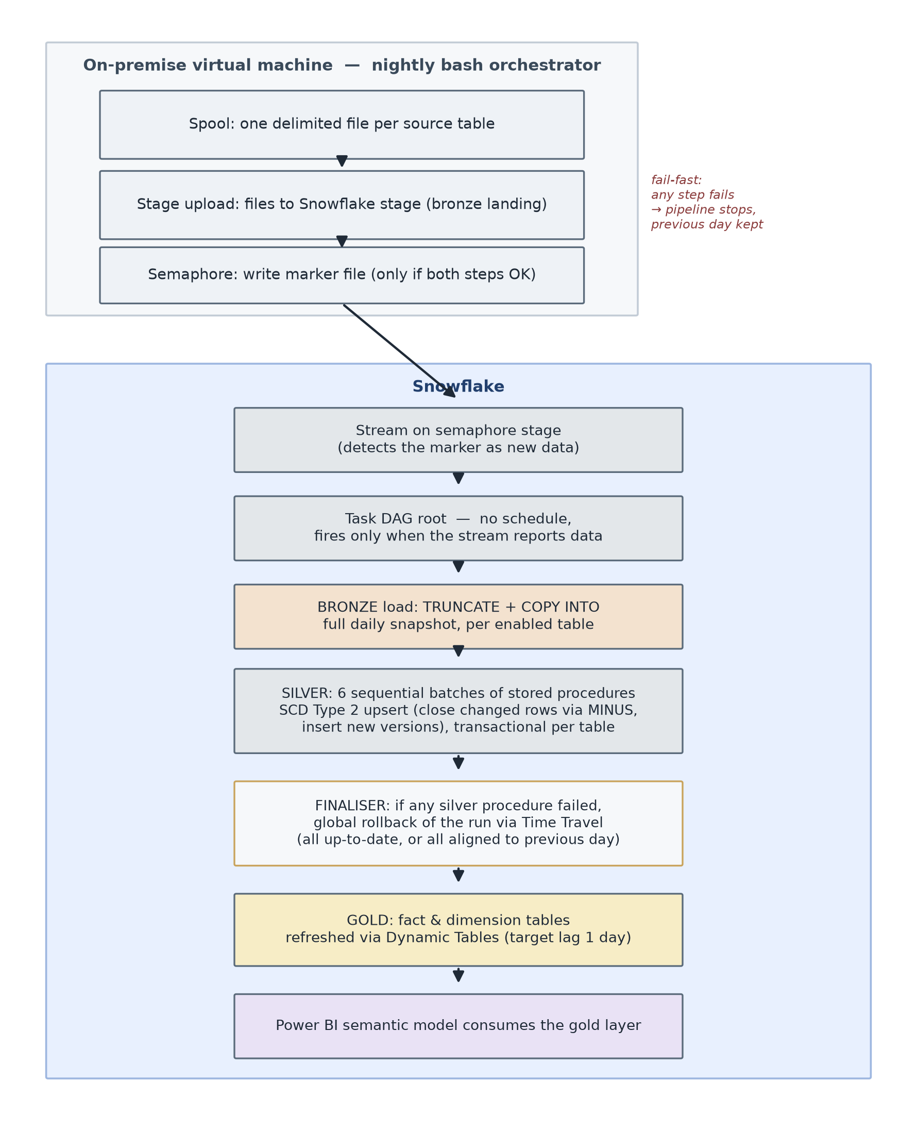
Figure 2. The end-to-end nightly pipeline, from extraction on the on-premises virtual machine through the bronze, silver, and gold layers in Snowflake, with the fail-fast checkpoints.

5.2.2 Extraction from ESSE3 to the Snowflake stage
The extraction phase runs each night, orchestrated by a bash script executed on an on-premises virtual machine. The script coordinates three sequential steps.
The first step is the spool: a delimited text file is produced for each source table, driven by a per-table configuration file that specifies the extraction query. If any single table fails to spool, the step as a whole is marked as failed and the pipeline stops.
The second step is the stage upload: the text files produced by the spool are transferred to a Snowflake stage located in the landing area of the bronze database. The upload only runs if the spool has completed successfully.
The third step is the semaphore: an empty marker file is uploaded to a dedicated semaphore stage in the ELT database. The semaphore is written only if both the spool and the stage upload have succeeded. Its absence, on any given night, is a sufficient condition to prevent Snowflake from starting the downstream processing.

5.2.3 The bronze layer
The bronze layer holds the raw data extracted from ESSE3. Its tables preserve the structure and the field names of the source system, and are not filtered, cleaned, or restructured. The role of the bronze layer is to provide a faithful copy of the source data at the moment of extraction, so that any subsequent transformation can be traced back to a well-defined starting point.
Loading into the bronze layer is triggered by a Snowflake stream defined on the semaphore stage: the arrival of the semaphore file is detected as new data on the stream, which activates a task DAG. The root task of the DAG has no schedule and fires only when the stream reports data, which encodes the fail-fast principle directly at the level of the Snowflake orchestrator: no semaphore, no run.
The bronze loading task iterates over a parameter table that lists the source tables enabled for the current run. For each enabled table, the loading procedure performs a TRUNCATE of the target bronze table and a COPY INTO from the landing stage, using pattern matching on the file name to associate each stage file with the corresponding table. The file format used is CSV with configurable NULL handling and optional field quoting. The choice of TRUNCATE + COPY INTO, rather than an incremental load, keeps the bronze layer aligned with a full daily snapshot of the source, which simplifies both traceability and reprocessing.
If any table fails to load, the loading procedure raises an exception, the task is marked as failed, and the downstream silver tasks do not start, again as a direct consequence of the fail-fast principle. Every operation is tracked in two logging tables: a job-level log that records one row per source table, and a step-level log that records one row per operation performed (TRUNCATE, COPY INTO, and any error captured during the run).

5.2.4 The silver layer
The silver layer contains the cleaned and historised version of the source data. In this project, the silver layer is not a simple cleansing layer but implements a full Slowly Changing Dimension of Type 2 (SCD Type 2), so that the analytical model has access not only to the current state of each entity but also to its history over time.
The silver tables are populated by a collection of stored procedures, one per silver table. The procedures are grouped into six sequential batches, with up to seven procedures running in parallel within each batch. Batch N+1 waits for the completion of every procedure in batch N before starting.
Each silver procedure applies the same two-step SCD Type 2 upsert. Both steps rest on one comparison: a MINUS between the bronze extract and the currently active silver records, which returns only the rows that are new or have changed. In the first step, an UPDATE closes the active version of every changed record by setting its end-of-validity timestamp to the run time. In the second step, an INSERT writes the rows returned by the MINUS as new versions, with an open end-of-validity timestamp conventionally set to 9999-12-31. New records need no separate treatment: they appear in the bronze but not in the silver, so the MINUS returns them and the INSERT adds them.

Every silver table carries four audit columns in addition to the source attributes: insertion, last-update, validity-from, and validity-to timestamps. The active version of a record is the one whose validity-to timestamp holds the conventional value; any earlier value marks a historical version. A KPI that needs the state of the data at a past date can therefore be computed against that date without additional infrastructure.

5.2.5 Transactional guarantees and the finaliser
The error-handling strategy of the silver layer is different from that of the bronze layer, and reflects the different consequences that a partial success would have.
Each silver stored procedure is written as a single transaction: it opens with BEGIN TRANSACTION, applies both steps of the SCD Type 2 upsert, and closes with COMMIT. If any step fails, the procedure performs a local ROLLBACK and returns the error message rather than raising an exception. The reason for not raising is operational: raising an exception would abort the entire silver batch and prevent the other procedures from running, whereas the transactional local rollback keeps the failure contained to the affected table and allows the rest of the batch to proceed.
However, allowing a run to end with some silver tables updated and others reverted is not acceptable from a consistency standpoint, because a report that consumes the gold layer built on top might mix values from different points in time. To handle this case, the DAG ends with a finaliser task, whose responsibility is to enforce a global consistency guarantee across the silver layer.
The finaliser inspects the logs of the current run and checks whether any silver procedure has failed. If at least one procedure failed, the finaliser performs a global rollback of every silver table that was updated successfully in the same run, using Snowflake Time Travel to restore each table to its state before the run began (Snowflake, 2026b). The net effect is that the silver layer is either entirely up to date or entirely aligned with the previous day, and never in an intermediate state. This design applies the fail-fast principle at the end of the pipeline as well as at its beginning: partial data is treated as worse than stale data.

5.2.6 The gold layer
The gold layer contains the tables that are directly consumed by the Power BI semantic model. Its structure reflects the analytical needs of the reporting layer rather than the structure of the source system: the tables are shaped as fact and dimension entities and are pre-aggregated where the reporting logic makes it convenient. Because the semantic model developed in the student careers domain adopted a hybrid modelling approach, discussed in detail in Section 5.3, the gold layer includes a mix of shared dimensions and of wider, page-specific fact tables designed to serve individual sections of the report without generating ambiguous relationships in the semantic model.

5.2.7 Summary and role in the thesis
The three-phase pipeline described above provides two properties that are relevant for the rest of the thesis. First, it exposes to the analytical layer a data foundation whose consistency is guaranteed at the level of the run as a whole, rather than at the level of the individual table: for the semantic model built on top, this means that the values displayed in a dashboard reflect a coherent state of the source data, not a mixture of times. Second, the SCD Type 2 historisation makes point-in-time analysis available to the KPI layer without requiring additional infrastructure, which is a precondition for several of the KPIs discussed in Section 5.4.
Table 2 summarises the responsibility of each stage, the mechanism that loads it, and what happens when it fails.
Stage | Responsibility | Load mechanism | On failure
Extraction (on-premises virtual machine) | Spool each ESSE3 table to a delimited file and upload it to the Snowflake stage | Nightly bash script; a semaphore file is written only if the spool and the upload both succeed | No semaphore is written, so no downstream processing starts
Bronze | Raw daily snapshot of the source, with structure and field names unchanged | A stream on the semaphore stage triggers the task DAG; TRUNCATE and COPY INTO for each enabled table | The procedure raises an exception, the task fails, and the silver tasks do not start
Silver | Cleaned and historised data (SCD Type 2) | One stored procedure per table, in six sequential batches of up to seven parallel procedures | Each procedure rolls back locally; if any failed, the finaliser restores every table of the run with Time Travel
Gold | Fact and dimension tables consumed by the Power BI semantic model | Dynamic Tables with a target lag of one day | Reads a silver layer that is either fully updated or at the previous day's state
Table 2 — Responsibilities, load mechanisms, and failure handling of the pipeline stages.
The detailed transformations applied to individual source tables in the silver layer were developed by the delivery team and are outside the scope of the thesis. The rest of the chapter moves to the gold layer and the semantic model (Section 5.3), where the author's contribution is concentrated, and to the KPI catalogue, the reports, and the data quality work built on them (Sections 5.4 to 5.6).

5.3 The semantic model
The semantic model sits between the data warehouse and the reporting layer. Its purpose is to expose the analytical entities and the metrics of the domain in a form that reporting tools can consume without exposing the physical complexity of the underlying tables, and to guarantee that the same metric is defined in one place regardless of how many dashboards or reports refer to it. In the project analysed in this thesis, the semantic model is implemented across two technical layers: the gold layer in Snowflake, which materialises the fact and dimension tables in a governed physical structure, and the Power BI semantic model built on top of the gold layer, which defines relationships, calculated columns, and DAX measures.
The gold layer framework described in Section 5.3.1 was defined by the delivery team and applied across all KPI domains of the project. The student careers tables built within it, the semantic model, and the measures are the author's work, and the trade-off of Section 5.3.3 emerged in that work (Table 1).

5.3.1 Design principles and naming conventions
The gold layer adopts a dimensional modelling approach in the sense established by Kimball and Ross (2013): every fact table has an explicit and documented grain, every measure is aggregable along the dimensions related to the fact, and every dimension carries the descriptive attributes needed to slice the facts along the analytical axes required by the business.
The grain of each fact table is not left implicit. It is written into the header of the SQL definition together with the entity being counted or measured (for example, one row per student per subject per academic year), so that a reader of the code, or a subsequent maintainer, can reconstruct the intended level of aggregation without inferring it from the data. This is a governance choice at least as much as a technical one, because most of the errors that emerge downstream in dimensional models originate from a mismatch between the assumed and the actual grain of a fact.
Naming conventions play the same governance role. Every table in the gold layer follows a fixed pattern that identifies its role in the model: TFCT_<PREFIX>_<NAME> for fact tables, TDIM_<PREFIX>_<NAME> for dimension tables, and VW_<NAME> for views used to aggregate facts at a coarser grain than the underlying entities. Column names carry a two-part prefix that identifies the entity to which they belong and the type of the value they hold: ID for identifiers, NR for numeric values, SD for descriptive strings, DT for dates, TS for timestamps, CD for codes, FL for boolean flags, PR for percentages, and HK for hash keys used as foreign keys towards dimension tables. The convention is not decorative. It allows any reader of a query, including a reader who is not familiar with a particular table, to infer the semantics and the expected type of a column without opening its definition.

5.3.2 Structure of the gold layer
Fact tables in the gold layer contain the measures of interest for the reporting layer, together with the foreign keys towards the dimensions that describe them. Dimension tables contain the descriptive attributes of the entities that are shared across facts, such as the study programme, the student, or the academic year. Views are used when a report requires an aggregation across multiple facts at a grain that is coarser than the grain of the individual facts, without materialising an additional fact table.
Every foreign key in a fact is a hash key of type BINARY, computed as the MD5 of the business key of the corresponding dimension. This choice keeps the physical structure of the joins independent from the specific codes used in the source systems, and allows the same dimension to be referenced by facts that originate from different sources. To handle the case in which a fact record does not have a corresponding dimension record, the join expression uses a ghost record pattern: COALESCE(dim.HK, MD5_BINARY('GHOST_RECORD')). A dedicated ghost record in the dimension collects all the fact rows whose dimensional attributes are unknown, which prevents unmatched joins from silently dropping rows and makes the incompleteness visible in the dashboards.
Dimensions are deduplicated at load time. Because a dimension aggregates multiple versions of the same entity coming from the silver layer, which is historised in SCD Type 2, the gold layer must select a single version of each business key. The pattern used is QUALIFY ROW_NUMBER() OVER (PARTITION BY <business_key> ORDER BY <selection_criterion> DESC) = 1, where the selection criterion depends on the entity: for a study programme, for example, the most recent activation date is used. The deduplication is performed in the gold layer rather than in the silver layer to preserve the historical detail in the silver, which remains available for point-in-time analyses when needed.
Joins that cross the source systems (mainly ESSE3, but also UGOV and other operational systems) are never performed on numeric identifiers, because different systems can assign identifiers in overlapping numeric ranges that do not refer to the same entity. The join is instead performed on the business code (for example, the code of a study programme), which is the only key that carries the same meaning across systems. Where a direct code-level join is not sufficient, the two systems are reconciled through a shared dimension in which both mappings are represented.
The physical refresh of the gold layer is managed through Snowflake Dynamic Tables, configured with a target lag of one day (Snowflake, 2026a). The target lag states how fresh the data must be relative to the tables that the Dynamic Table reads. One day was chosen to match the refresh cadence of the upstream layers described in Section 5.2, and it fits the needs of academic management, whose decisions on student careers do not require sub-daily latency.

5.3.3 The trade-off between shared dimensions and page-specific fact tables
The textbook shape of a dimensional model is a star schema in which one fact table is connected to a set of dimension tables, and in which dimensions are shared across facts whenever the same descriptive entity applies (Kimball and Ross, 2013). Shared dimensions are what allow a single filter, such as the academic year, to propagate consistently across all the facts that reference it, and they are the mechanism through which the model expresses conformity between different analytical subjects. Microsoft's guidance recommends the same shape for Power BI semantic models (Microsoft, 2026b).
During the design of the semantic model for the student careers domain, this shape was the starting point. As the model grew to cover more report pages, a structural constraint emerged. When several fact tables share several dimensions, Power BI can find more than one filter path between the same pair of tables. Only one path between two tables can be active, so the tool either refuses to activate some relationships or forces them to be inactive, and it reports an error when it cannot choose between paths (Microsoft, 2026a). In both cases the intended filter propagation breaks, and the reports return incorrect or unpredictable results.
Two alternatives were considered. The first was to stop sharing the dimensions and give each fact its own. It was discarded because dimensions at different granularities cannot always be reconciled with the grain of the facts that reference them. In practice, the same dimension used at different granularities produced repeated or incorrect values in the aggregated measures, a class of error that is hard to see in a dashboard and easy to propagate downstream.
The second alternative, which was adopted, was to design page-specific fact tables. Each carries as its own columns the descriptive attributes that one report page needs, instead of reaching them through foreign keys to shared dimensions. Power BI modelling guidance accepts keeping on a fact table an attribute that is needed for filtering, as an exception to the separation between fact and dimension tables (Microsoft, 2026b); the page-specific design applies this exception more widely. It keeps the number of relationships low enough for every filter path to be unambiguous, and it reduces the size of the model file because fewer joins are computed at query time. Table 3 compares the three options.
Approach | Outcome | Benefit | Cost
Shared dimensions across all facts (textbook star schema) | Starting point, abandoned | One filter propagates consistently to every fact; dimensions are conformed | Several paths between the same tables; Power BI deactivates relationships or reports ambiguity, and filters propagate incorrectly
Independent dimensions for each fact | Considered, discarded | Removes the ambiguous paths | Dimensions at a grain that does not match the fact; repeated or incorrect values in aggregated measures, hard to detect
Page-specific fact tables carrying the descriptive attributes as columns | Adopted | Few relationships and no ambiguity; measures correct at the grain of each page; smaller model file | No cross-page filter synchronisation; the same attribute is stored in more than one fact
Table 3 — Alternatives for resolving ambiguous relationships in the student careers semantic model.
The cost of this choice is that filters are not synchronised across the pages of the report. The same descriptive attribute, for example the study programme, can appear as a column of two fact tables that are not related in the model, so a filter applied on one page does not reach the other. This was discussed with the client, who confirmed that the lack of cross-page filter synchronisation was acceptable for the intended use of the dashboards. The choice is therefore presented as a documented trade-off, not as a general recommendation. It balances the fidelity of the model to the shared-dimension design, the ability of Power BI to activate the intended relationships without ambiguity, and the correctness of the measures at the grain of each report.

5.3.4 Safeguards for data quality in the model
Several data quality safeguards are built directly into the definition of the gold tables, so that the model itself contributes to the quality of the numbers that reach the dashboards rather than delegating this responsibility entirely to downstream verification. Three patterns are used systematically and are worth mentioning at this level.
The first is the deduplication of dimensions through QUALIFY ROW_NUMBER(), already described in Section 5.3.2. Without this pattern, a dimension that inherits multiple SCD Type 2 versions from the silver layer would produce fan-out when joined to a fact, and every measure aggregated over that dimension would be inflated by the number of historical versions of the matching business key.
The second is the systematic use of NULLIF on the denominators of every ratio and percentage computed in the gold layer. This guarantees that a divide-by-zero situation returns a NULL rather than an error, which allows the reporting layer to render an empty value in the dashboard instead of interrupting the refresh of the visual.
The third is the ghost record pattern in the foreign keys, described in Section 5.3.2, which prevents unmatched joins from silently dropping fact rows and instead concentrates them under a dedicated ghost dimension row that is visible in the reports.
Beyond these embedded patterns, the design of a new fact table follows a verification step in which the row count of the fact is compared before and after each join with a dimension. A change in the row count that is not expected from the modelling logic signals a fan-out or a missing filter, and is treated as a blocker until it is resolved. Section 5.6 discusses the broader implications of these choices for the data quality of the reporting system as a whole.

5.4 KPI design for student careers
The semantic model described in Section 5.3 exposes to the reporting layer the entities and the relationships of the student careers domain. The KPIs discussed in this section are, for the most part, the DAX measures defined on top of that model, together with a small number of classifications computed in the gold layer and exposed through it. They translate the operational questions of academic management into calculations that Power BI evaluates in the context of the filters selected by the user of the dashboard.

5.4.1 KPI design methodology and organisation
The KPI catalogue was built iteratively. It started from a first list of information needs collected from academic management and was refined over successive review cycles between the author, the delivery team, and the client. Before a candidate KPI was implemented, three attributes were agreed with the client: the business question it answers, the grain at which it applies (for example, one row per student per academic year), and the dimensions along which the reports need to slice it. The measure was then implemented in the semantic model and validated against reference values supplied by the university. Where it did not reproduce the reference value, its definition was reconciled with the client (Section 5.6.2).
Two design choices at the level of the semantic model support the KPI catalogue as a whole.
The first is a hybrid placement of the measures in the model. A dedicated table named KPI, unrelated to any fact or dimension, holds the top-level measures that summarise the domain and are used across several report pages, such as # Iscritti, Media Ponderata, and % Lode. Measures bound to a specific entity, such as those that aggregate the hours of one fact or classify the students of one dimension, are defined on that table instead. The criterion is proximity: a measure whose logic cannot be separated from an entity lives on that entity. The placement does not restrict use. Every measure is available to the report developer wherever it resides, and its location only decides where it appears in the field list.

The second is the use of display folders to group the measures thematically. Within the KPI table, two folders were adopted for the student careers domain, Iscrizione for the population-and-enrolment measures and Rendimento for the academic performance measures, so that the report developer sees the top-level KPIs organised by business meaning rather than in alphabetical order. Measures that reside outside the KPI table inherit the grouping given by their owning entity, which places them naturally alongside the columns and the other measures of that entity in the field list.

5.4.2 The KPI catalogue
The full catalogue of KPIs implemented in the student careers semantic model is presented in Table 4. The KPIs are grouped into six thematic families, ordered by their proximity to the core focus of the thesis and by their frequency of use in the dashboards. Families 1, 2, and 3 (enrolment and population, academic performance, risk and attendance) are the direct focus of this section and are discussed in Section 5.4.3. Families 4, 5, and 6 (teaching organisation, teaching staff, classrooms) are components of the wider solution and are included for completeness, without an individual discussion.
Family | KPI | Type | Focus
1. Enrolment & population | # Iscritti | Count of distinct students | Active or enrolled students
1 | # Matricole | Count | First-year new entries
1 | Iscritti primo anno | Count | Students enrolled with course year = 1
1 | % Donne / % Uomini | Ratio | Gender distribution
1 | % Pre-Laurea / % Post-Laurea | Ratio | Distribution by academic-cycle level
1 | Studenti In corso / Studenti fuori corso | Count | Career-progression status
2. Academic performance | # Attività Didattica | Distinct count | Distinct courses/exams in students' booklets
2 | # Corsi | Distinct count | Distinct study programmes
2 | Attivita Superate / Programmate / Frequentate | Count | Booklet state segmentation
2 | Media CFU per Studente | Average | Credits earned per student
2 | Media Aritmetica | Average of grades | Passed exams contributing to average
2 | Media Ponderata | Weighted average by CFU | Passed exams contributing to average
2 | % Lode | Ratio | Share of exams passed with honours
2 | Media Voto Laurea Adj | Average with adjustment | Degree grade, honours weighted
2 | Durata Carriera (anni) | Average year-difference | Enrolment-to-graduation, per graduate
3. Risk & attendance | % Mancato Superamento | Ratio | Share of exam failures
3 | % Assenze con almeno 5 lezioni | Ratio | Absence rate, statistically relevant lectures
3 | Fascia Studente CdS | Categorical (traffic light) | Risk band per student × programme × year
4. Teaching organisation | # Attività didattiche | Count | Scheduled teaching activities
4 | Ore Programmate / Ore Effettive | Sum of hours | Scheduled and delivered hours
4 | Media Ore per Attività Didattica | Ratio | Delivered hours per activity
5. Teaching staff | Ore Docenti A Contratto / Ore Docenti Di Ruolo | Sum | Delivered hours by teacher type
5 | Lezioni Totali | Count | Lectures in the teacher registry
5 | Durata Media Lezione (ore) | Average | Average lecture duration
6. Classrooms | % Capienza Aula | Ratio | Attendance over classroom capacity
6 | Numero Studenti (aule) | Distinct count | Distinct students per classroom
6 | Nr Iscrizioni (aule) | Count | Enrolments per classroom
Table 4 — KPI catalogue for the student careers domain.

5.4.3 Design choices in representative KPIs
Five KPIs from families 1, 2, and 3 are discussed in detail below. They were selected because they illustrate design choices representative of the catalogue as a whole: filter encapsulation, denominator alignment, use of relationships for cross-fact computations, delegation of categorical logic to dimensions, and the encoding of business rules in the model.
Media Ponderata. The weighted average of exam grades by credits is the standard summary of a student's academic performance in the Italian university system. Its DAX implementation uses SUMX to compute grade × credits at the row level of the booklet fact, then divides by SUM of credits. Three filters restrict the calculation to the exams that must contribute to the average: state of the activity equal to "S" (passed), no-media flag equal to false, and evaluation mode equal to "V" (numeric evaluation, as opposed to pass/fail). Each of the three filters removes a class of records that would otherwise inflate or deflate the average, and their omission is a common source of error when the same computation is done ad hoc against the operational system. Encapsulating the three filters inside the measure guarantees that every dashboard using Media Ponderata computes it consistently.
% Lode. The share of exams passed with honours is another standard performance indicator. The DAX code is a DIVIDE between two CALCULATE blocks. The design choice that matters for this discussion is the definition of the denominator. The denominator uses the same set of records that populates Media Ponderata: passed exams that contribute to the average and are evaluated with a numeric grade. Alignment of denominators across related KPIs is a governance requirement that a semantic model can enforce and an ad hoc query cannot, because in the ad hoc case the denominator is redefined by every analyst who writes the query.
Durata Carriera (anni). The average duration of a student's career is computed as the average, over the graduates in the current filter context, of the year difference between the enrolment date on the career dimension and the graduation date on the graduation fact. Two design details are worth noting. First, the enrolment date is not on the same fact as the graduation date and must be retrieved through the RELATED function against the career dimension; the measure therefore relies on the fact-to-dimension relationship defined in the semantic model and would not work outside it. Second, the measure applies an average over graduates rather than computing a single date-to-date difference, which makes it correctly aggregable in the presence of dashboard filters that select multiple graduates.
Studenti fuori corso. The count of out-of-schedule students is defined as the count of rows in the enrolment dimension whose calculated column Corso o fuori corso is equal to "Fuori corso". The interesting design choice here is the delegation of the categorisation to a calculated column of the dimension rather than to the DAX measure itself. Keeping the categorisation in the dimension has two effects: the same categorisation is available to any measure or visual that uses the enrolment dimension, without redefining the logic; and if the definition of "fuori corso" needs to be revised in the future, the revision happens in one place. The reciprocal measure Studenti In corso follows the same pattern with the opposite filter value.
Fascia Studente CdS. The student risk band is the most elaborate rule of the catalogue, and the one that best shows the value of pushing a business rule into the governed layer. It is not a DAX measure but a categorical attribute computed in the gold Dynamic Table TFCT_PRST_PRESENZE_STUDENTE, at the grain of one row per student per teaching activity per study programme per academic year, and exposed to the semantic model as a column. For each row it takes the ratio between the student's absences and the maximum programmed hours of the activity and assigns one of four bands: green up to 11%, yellow up to 22%, red up to 33%, and black above 33%. When the data is not sufficient for the classification to mean anything, the row is labelled "N/D" rather than forced into a band; this happens when the student has two recorded lectures or fewer, or when the maximum programmed hours of the activity are missing or zero. The same logic is computed a second time at the coarser grain of the study programme, where the absences are compared against an absence budget aggregated across the activities of the programme, so that a report can show a band both per activity and per programme. Three design choices are worth commenting.
The first is that the rule lives in the gold layer rather than in a report. The thresholds of 11%, 22%, and 33%, the four band labels, and the related rules (a non-admission flag raised when the absence rate exceeds 33% for an activity with mandatory attendance, and a below-threshold flag raised when the presence rate falls under the required percentage) are computed once, in the definition of the fact table. Every report that shows a band reads the same value, and a change in the policy is applied by editing one table rather than several reports.
The second is the explicit handling of the denominator and of the missing dimension. The ratio is guarded so that a zero or missing number of hours produces an "N/D" label rather than an error or a misleading band, and a fact row whose study programme cannot be matched is attached to a ghost record rather than dropped. These are the safeguards described in Section 5.3.4, visible here in one definition.
The third is that the classification is stable across the filters of the dashboard. Because the band is materialised at a defined grain in the gold layer, its value for a given student, activity, programme, and year does not change when the user changes the level of aggregation shown on the page; the report aggregates or counts the pre-computed bands rather than recomputing them in a way that could depend on the visible context. Listing 1 shows a simplified extract of the rule, with the personal attributes of the student removed.
CREATE OR REPLACE DYNAMIC TABLE TFCT_PRST_PRESENZE_STUDENTE
TARGET_LAG = '1 day', WAREHOUSE = WH_ELT_XS_DEV, REFRESH_MODE = AUTO
AS
WITH stats_studente AS ( -- per student x activity x programme x year
SELECT PRES_ID_STU_ID, ELEN_ID_AD_ID, ELEN_ID_CDS_ID, ELEN_NR_AA_OFF_ID,
COUNT(*) AS NR_LEZIONI_TOTALI,
COUNT(CASE WHEN PRES_CD_PRESENZA = 'FALSE' THEN 1 END) AS NR_ASSENZE
FROM ... -- silver attendance joined to lecture context
GROUP BY 1, 2, 3, 4
)
SELECT
COALESCE(dcds.COST_HK, MD5_BINARY('GHOST_RECORD')) AS FK_COST_HK,
ROUND(st.NR_ASSENZE / NULLIF(st.NR_LEZIONI_TOTALI, 0), 4) AS PRST_PR_ASSENZE,
CASE
WHEN st.NR_LEZIONI_TOTALI <= 2
OR omax.ORE_MAX IS NULL OR omax.ORE_MAX = 0 THEN 'N/D'
WHEN st.NR_ASSENZE / omax.ORE_MAX <= 0.11 THEN 'VERDE'
WHEN st.NR_ASSENZE / omax.ORE_MAX <= 0.22 THEN 'GIALLO'
WHEN st.NR_ASSENZE / omax.ORE_MAX <= 0.33 THEN 'ROSSO'
ELSE 'NERO'
END AS PRST_CD_FASCIA_RISCHIO
FROM stats_studente st
LEFT JOIN dim_corso dcds ON dcds.COST_ID_CDS_ID = st.ELEN_ID_CDS_ID
LEFT JOIN ore_max omax ON omax.AD_GEN_ID = st.ELEN_ID_AD_ID
AND omax.ADMO_NR_AA_OFF_ID = st.ELEN_NR_AA_OFF_ID;

Listing 1 — Simplified extract of the risk-band logic in the gold layer, with the student's personal attributes omitted.

5.4.4 Design patterns across the catalogue
The KPIs described in Section 5.4.3 illustrate a small set of design patterns that recur across the catalogue and follow from the choice to centralise the definitions in the semantic model rather than in the individual reports or in ad hoc queries.
The first pattern is the encapsulation of filter conditions inside the measure. Filters that identify the correct subset of records for a given KPI, such as the three filters of Media Ponderata, are written once inside the measure and reused implicitly by every visual that consumes it. This removes a well-known class of error caused by re-implementing the same filters differently across queries.
The second pattern is the reuse of measures inside other measures. Several KPIs of the catalogue are defined by referring to a previously defined KPI as their building block: # Matricole refers to # Iscritti, and the gender percentages are defined against # Iscritti. This composition guarantees that a change to the base definition propagates to the derived KPIs consistently, and it makes the intent of the derived KPI explicit in its expression.
The third pattern is the delegation of categorical logic to calculated columns of the dimensions, illustrated by Studenti In corso / Studenti fuori corso. When a categorisation is applied by many measures or visuals, defining it at the dimension level rather than at the measure level reduces the number of places at which it must be maintained.
Taken together, these patterns implement in the semantic model the governance principle discussed in Section 4.3 as the second limitation of the pre-existing reporting model: the same metric, asked at different moments or by different users, must return the same value.

5.5 Power BI implementation
The semantic model and the KPIs described in Sections 5.3 and 5.4 are consumed by a set of Power BI reports that expose the analytical output of the project to academic management. This section describes how the reports are organised, how the interaction with the data is structured across pages, and how the reports are distributed to the users through Power BI Service.

5.5.1 Report organisation
The Business Intelligence solution is not delivered as a single monolithic report. It is organised as an application that groups six thematic reports, each built on its own semantic model: Report_Didattica for student careers and academic performance, Report_Servizi_Studenti for student services, Report_Ammissioni for admissions, Report_Amministrazione_Finanza for administration and finance, Report_Accreditamento_Qualità for accreditation and quality, and Report_Frequenze_Aule for attendance and classrooms. This organisation was preferred over a single-report design for three reasons: it aligns the boundary of each report with a well-defined semantic model, it keeps the maintenance surface of each report contained, and it allows the differentiation of access rights across audiences to be applied at the level of the individual report rather than at the level of the pages of a shared one.
The report at the centre of this thesis is Report_Didattica, which corresponds to the student careers domain. It is built on the semantic model documented in Section 5.3 and consumes the KPIs catalogued in Section 5.4. Its pages are organised around the thematic families of the KPI catalogue: pages dedicated to enrolment and population, pages dedicated to academic performance, and pages dedicated to attendance and risk monitoring. The families beyond the direct focus of the thesis (teaching organisation, teaching staff, classrooms) are covered in the KPI catalogue and, where relevant, in the other reports of the application, and are not analysed in detail here, consistently with the scope delimitation stated in Section 4.5.
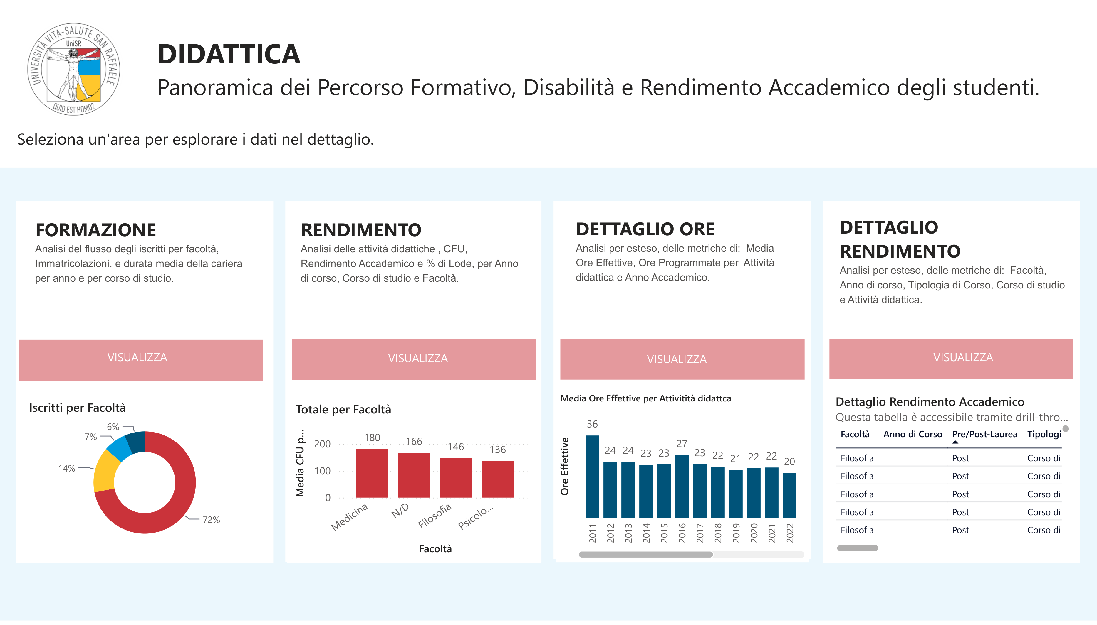
Figure 3. The landing page of the Report_Didattica report in the Power BI application, with the navigation to its thematic pages.

5.5.2 Interaction patterns across pages
The pages of the report follow one of two complementary interaction patterns, depending on the nature of the management question they support.
The first pattern is the standing overview. A standing overview page displays a curated set of KPIs at the aggregated level, typically for the entire institution or for a selected study programme, with slicers that allow the user to change the temporal or the categorical context (academic year, cycle, gender). The user reads the page as a periodic snapshot of the domain, without navigating further. This pattern is applied to the pages that summarise the state of enrolment and of academic performance at the institutional level, where the primary question of the management is one of ongoing monitoring rather than of investigation.
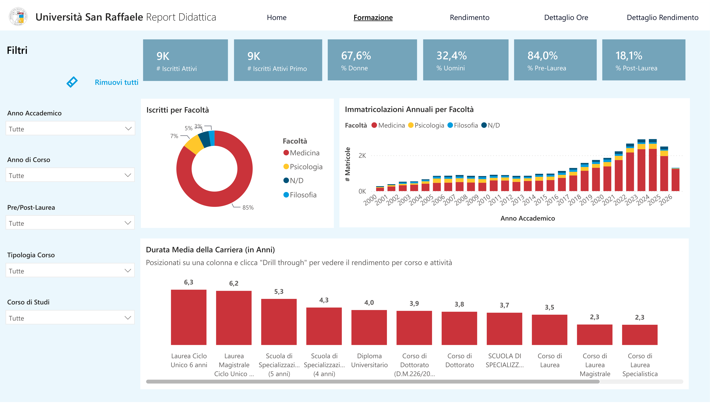
Figure 4. A standing overview page of Report_Didattica (enrolment and population): KPI cards and charts at the institutional level, with slicers on the left.
The second pattern is overview with drill-down. A drill-down page starts from the same kind of aggregated view but lets the user navigate to a finer grain: from the institution to the study programme, from the programme to the cohort, and where relevant from the cohort to the individual student. This pattern is applied where the management question requires finding the specific cases behind an aggregated indicator, for example the students in the higher risk bands of the Fascia Studente CdS classification. It was not applied to every page by default, so that the pages that serve a monitoring purpose stay simple and fast to consult.

5.5.3 Distribution and access model
The reports are published to the Power BI Service and grouped into a single Power BI application that is made available to the client. From the perspective of the user, the application is the entry point to the whole Business Intelligence solution: a single interface from which each thematic report can be opened, without the user having to be aware of the underlying separation into distinct files.
Access to the application is differentiated by user role. The three main audiences configured for the project are the rectorate, whose members have access to the institutional-level views across all domains; the study programme directors, whose access is oriented towards the reports and the pages relevant to teaching and academic performance monitoring; and the administrative offices (student registrar and teaching services office), whose access is oriented towards the operational reporting relevant to their functions. The differentiation is defined at the level of the report and of the audience within the application, so that a change in the role of a user is applied by updating the group membership rather than by rebuilding the report.
The refresh cadence of the reports is aligned with the refresh cadence of the underlying gold layer (Section 5.3), configured with a target lag of one day. In practical terms, the users of the application see a version of the data that reflects the state of the source systems at the end of the previous day. This cadence matches the analytical needs of academic management, whose decisions on student careers do not require sub-daily latency.

5.5.4 Contribution to the research question
The implementation choices described in this section bear mainly on two of the four dimensions of Section 4.4. The published reports, refreshed daily, and the drill-down pages support standing visibility and self-service exploration; the application with role-based access aligns the distribution of technical dependency with the distribution of decisional responsibility. Consistency and governance rest on the semantic model of Sections 5.3 and 5.4, which every report consumes. Chapter 6 assesses these effects.

5.6 Data quality considerations
The value of the KPIs described in the previous sections depends on the quality of the data that feeds them. This section discusses the data quality problems encountered while building the student careers domain, the mechanisms through which the gold layer and the semantic model addressed them, and the limitations that remain. The problems fall under two of the data quality dimensions identified by Wang and Strong (1996): completeness, whether the data a KPI needs is present, and accuracy, whether the value a KPI returns agrees with the figure the organisation recognises as correct.
The discussion is limited to the gold layer and the reporting model. The ingestion of the source data into the bronze and silver layers, and the correctness of the records held in the operational systems, sit upstream of this boundary and were handled by the delivery team and by the client (Table 1).

5.6.1 Problems encountered
Two classes of problem affected the construction of the student careers KPIs.
The first is incompleteness of the source data. For a number of records, the data a KPI needed was not present, either because it had never been registered in the operational system or because it was not available for other reasons. Attendance is the clearest case. A student with no recorded lectures for a given programme and academic year has no absence rate to compute, and a calculation that ignores this returns either an error or a value that places the student in a risk band that does not mean anything.
The second is the risk of duplication in the joins, which inflates a measure by matching each row on one side to several rows on the other. It has two causes in this model. One is historisation: a dimension in the gold layer inherits several versions of the same business key from the silver layer, so a fact row joined to it without deduplication matches every version. The other is a mismatch in grain between two tables that are related directly. A concrete instance of the second appeared in the programmed teaching hours. When the fact table of the teaching activities was related to the students, the hours of each activity were repeated once for every student connected to it, and the total programmed hours for a single study programme rose above twenty thousand, a figure with no physical meaning. The hours belong to the activity, not to the pair of activity and student. The problem was resolved by computing the hours at the grain at which they are defined, with one table reporting programmed and delivered hours per study programme and a separate table reporting them per teacher, which is the page-specific fact design discussed in Section 5.3.3. In neither case does the fan-out appear in the dashboard as an error. It appears as numbers that are too high, which is why it has to be prevented in the model rather than found by inspecting the output.

5.6.2 Validating the data: the UAT of the pipeline and the reconciliation of the KPIs
The data behind the reports was validated on two levels. The pipeline that loads the warehouse was checked through a User Acceptance Testing exercise run by the delivery team on the flow from ESSE3 to the Snowflake silver layer, and the KPIs built on top of the warehouse were reconciled against reference values supplied by the university.
The UAT was organised in two levels of control. The first level consisted of automatic technical checks, run with the OpenMetadata tool on every silver table before the session with the client. They compared the row count of each bronze table with its silver counterpart, checked that the primary key was unique, composite keys included, and checked that no field of the key was null. The second level was a functional validation carried out with the client. It compared a sample of representative records with the source, checked the structure of each table against the expected schema, and matched the element counts of ESSE3 and of the silver layer. Each control was recorded as pass, fail, or warning; a warning marks a difference within a tolerated threshold, which is documented rather than treated as a defect. In the terms of Wang and Strong (1996), these controls bear mainly on completeness and accuracy, the two dimensions introduced at the start of this section, while the key checks add a test of uniqueness that follows from the structure of the tables.

One finding of this exercise shows the kind of problem a count-based control catches. A reconciliation of the student careers loaded into the warehouse, about 38,600 records, against the source found nine that were present in the warehouse but no longer in ESSE3. These were careers deleted at the source after they had been loaded, whose deletion had not propagated downstream. The number is small, but the case is instructive: a record that is correct when it is loaded can become stale if it is later removed at the source, and only a control that compares the two systems will surface it.
The KPIs built on the validated data were then reconciled against reference values supplied by Università Vita-Salute San Raffaele, which provided sample figures for a set of indicators. A measure was treated as validated only when its output matched these figures. In several cases the first computation did not match. The mismatch was not always a coding error in the measure. For some indicators it came from a difference between the definition assumed in the semantic model and the definition the university had used to produce its own figures. When this happened, the team asked the university directly for the logic behind the reference values, that is, for the way each figure was calculated at the source, and aligned the definition in the semantic model to it.
The count of active students is an example. The first definition treated a student as active when the student was enrolled and had paid the enrolment fee. The figure matched the university's only after a third condition was added, that the career status of the student is active, a condition the university applied in its own definition and the model had not. The correction touched a limited number of records, but it changed the meaning of the indicator, and it is the kind of difference that stays invisible until a computed figure is placed next to a reference figure.
This process did more than correct individual numbers. It fixed the definition of the affected KPIs at the value the client recognised as correct, which is the consistency requirement set out in Section 4.3, and it placed that definition inside the semantic model, where it is applied once for every dashboard instead of being rewritten in each ad hoc query.

5.6.3 Safeguards in the gold layer and the model
The safeguards already described in Section 5.3.4 address the two classes of problem of Section 5.6.1 at the point where the data enters the model.
Deduplication of dimensions through QUALIFY ROW_NUMBER() removes the version-based fan-out, by selecting a single version of each business key before the dimension is joined to a fact. This pattern belongs to the shared gold framework and is applied across the student careers tables.
The ghost record pattern handles the incompleteness of the joins. A fact row whose dimensional attributes are unknown is matched to a dedicated ghost row rather than dropped, so the incomplete records stay visible in the dashboard as a distinct category instead of disappearing from the totals.
In the gold layer, the Fascia Studente CdS classification handles the case of insufficient attendance data directly. When a student has two or fewer recorded lectures for an activity, or the programmed hours of the activity are missing, the row is labelled "N/D" rather than placed in a risk band, which surfaces the gap in the report instead of hiding it behind a colour. The systematic use of NULLIF on the denominators of the ratios computed in the gold layer plays the same preventive role for divide-by-zero situations, returning an empty value that the report renders as a blank cell.
A further check is procedural rather than embedded in the code. During the construction of a fact table, the row count is compared before and after each join with a dimension. A change that is not explained by the modelling logic signals a fan-out or a missing filter, and is treated as a blocker until it is understood. The programmed hours case of Section 5.6.1 is exactly the kind of problem this check catches. At the pipeline level, the bronze-to-silver count control of the UAT plays the same role for the loads that feed the gold layer.

5.6.4 Residual limitations
The safeguards above prevent or expose data quality problems inside the reporting system, but they do not remove the limitations that originate outside it.
Completeness at the source is the main one. If a value was never recorded in the operational system, no layer downstream can reconstruct it. The same holds in reverse for records deleted at the source after they were loaded: unless a reconciliation detects them, as in the case of the nine careers in Section 5.6.2, they persist in the warehouse until the next check. The system makes these gaps visible, through the ghost record, the "N/D" label, and the count controls, but it cannot fill them on its own, and a KPI computed over incomplete source data is only as complete as the source. This is a property of the data rather than a defect of the model, but it constrains how some indicators can be read.
The refresh lag is a second limitation. The reports reflect the state of the source at the end of the previous day, so a correction made at the source during the day is not visible until the next refresh. For the decisions this system supports, a latency of one day is acceptable, as discussed in Section 5.3, but it is a limitation to keep in mind when a figure is checked against the live operational system.
The absence of cross-page filter synchronisation, described in Section 5.3.3, has a data quality consequence as well as a usability one. A figure read on one page and a figure read on another are not guaranteed to sit under the same filter context, so a user who reconciles two pages has to set the filters consistently on each.
Finally, the reconciliation of Section 5.6.2 is bounded by the availability of reference values. It was possible for the indicators for which the university provided sample figures. For indicators without an external reference, validation relied on internal consistency checks, which catch a computation that contradicts itself but not one that is internally consistent and still wrong.
Table 5 brings together the problems discussed in this section, the safeguard that addresses each one, the way it is checked, and the risk that remains.
Issue | Safeguard | How it is checked | Residual risk
Fan-out from historised dimensions (several SCD Type 2 versions of one key) | Deduplication with QUALIFY ROW_NUMBER() in the gold layer | Row count before and after each join | Depends on the selection criterion choosing the right version
Fan-out from a grain mismatch (for example, programmed hours repeated for each student) | Measures computed at the grain at which they are defined; page-specific fact tables | Row count check; reconciliation with reference values | A new fact table can reintroduce it if its grain is not documented
Fact rows without a matching dimension record | Ghost record in the dimension | The ghost category is visible in the reports | The rows stay unclassified until the source is corrected
Too little attendance data, or missing programmed hours | "N/D" label in the risk band; NULLIF on every denominator | Shown as N/D or as a blank value in the reports | The indicator cannot be computed for those rows
Records deleted at the source after loading | Count reconciliation between ESSE3 and the silver layer | Functional checks of the UAT | Stale records persist until the next reconciliation
A definition different from the one the university uses (for example, active students) | One definition per KPI in the semantic model, aligned to the reference logic | Reconciliation against reference values | KPIs without a reference value rely on internal consistency checks only
Table 5 — Data quality issues in the student careers domain: safeguard, check, and residual risk.

6 Discussion: before and after
This chapter interprets the evidence of Chapter 5 along the four dimensions defined in Section 4.4. As explained in Section 5.1.1, the comparison is structural: for each dimension it identifies the mechanism of the new system that addresses the corresponding limitation of the previous process, and what that mechanism leaves open or introduces. It does not measure the size of the effect. Sections 6.1 to 6.4 take the dimensions in turn, Section 6.5 considers which findings transfer beyond this case, and Sections 6.6 and 6.7 set out the limits of the analysis and its implications for management.

6.1 Process efficiency
The per-request cost of the previous process (Section 4.3) disappears for one category of need: recurring questions that the reports already answer, such as the size of the active population, the performance of a cohort, or the attendance risk in a programme. For these, the query, the check, and the correction loop are carried out once, when the measure is designed and validated against the university's reference values (Section 5.6.2). After that, the figure is refreshed daily without further work (Sections 5.2 and 5.3).
Two categories of need remain outside this gain. A question that combines the existing indicators in a new way, or that needs a dimension the model does not expose, still requires development: a new measure, a new column, or a new page. A question about data that the warehouse does not hold still goes back to the source systems. The size of the efficiency gain therefore depends on the share of the demand that is recurring and already covered by the catalogue. That share was not measured in this case, so the thesis can establish where the gain occurs but not how large it is.
The work that remains also changes in nature. It moves from writing and checking queries to maintaining the pipeline, the gold tables, and the measures, and to extending the model when a new need appears. In place of many small, repeated tasks there are fewer and larger ones, and they call for skills in data modelling rather than in querying the source system.

6.2 Consistency and governance

Each KPI now has a single definition, held in the semantic model and reused by every visual that shows it (Section 5.4.4). The filters that select the right records sit inside the measure rather than in the query of whoever writes it. The reconciliation against the university's reference values fixed the affected definitions at the figures the institution recognises, as in the case of the active students, where the agreed definition added the condition that the career status is active (Section 5.6.2). For the indicators in the catalogue, the inconsistency described in Section 4.3 is removed by construction.
Centralising the definitions also creates a new point of control, and with it a possible new bottleneck. When a definition has to change, for example after a change in regulation or in an internal policy, the change has to go through whoever maintains the semantic model. If the institution does not decide who owns each definition after the handover, and how a change is requested, approved, and released, the queue of requests to IT may become a queue of requests to the maintainers of the model. The governance gain is therefore conditional. It holds as long as the ownership of the definitions is assigned and the process for changing them is lighter than the one it replaced. How ownership was arranged after the handover fell outside the internship and is not observed in this thesis.

6.3 Standing visibility and self-service exploration

The reports are a standing artefact, refreshed daily, so a KPI can be followed over time instead of being requested at a point in time (Section 5.5). On the drill-down pages the user moves from the institution to the study programme, the cohort, and the individual student where the report allows it (Section 5.5.2). This is the kind of self-service the literature associates with the move away from IT-mediated reporting (Pałys and Pałys, 2023; Passlick et al., 2023). It is guided self-service rather than open-ended querying: the user explores within what the report designer enabled, and a question nobody anticipated still needs development. The gain lies in the range of questions that can be answered without a request.
The lack of cross-page filter synchronisation, the cost accepted in Section 5.3.3, bears on this dimension more than its technical description suggests. A user who sets a filter on one page and then opens another may read a figure under a different filter context without noticing. If two figures that should agree then appear to disagree, the user may conclude that the data is wrong, which is the loss of credibility that the previous process suffered from (Section 4.3). The report pages keep their slicers in a fixed, visible panel (Figure 4), which reduces the risk, but the trust that users place in the reports depends in part on their understanding of this limit of the model.

6.4 Distribution of technical dependency
Access to the reports is differentiated by role, for the rectorate, the study programme directors, and the administrative offices (Section 5.5.3). A user who consults a report no longer needs IT to obtain a figure, so access to information follows the responsibility for the decisions it supports. The self-service BI literature identifies the concentration of this dependency as one of the main drivers of BI transformation (Pałys and Pałys, 2023).

Dependency is not removed. It moves. The institution now depends on the pipeline and the semantic model working correctly, and on whoever maintains them, rather than on IT being available for each request. The dependency changes in kind, from manual and per request to structural and shared, and it is concentrated in a few well-defined artefacts instead of a queue of individual requests. A structural dependency is easier to see and to plan for, but it is also less forgiving: a failed run affects every report at once. The fail-fast design of the pipeline limits the damage, because the reports keep the previous day's data instead of showing a partial update (Section 5.2.5), but it cannot make the figures current until the next successful run.

6.5 Transferability of the findings
Some findings depend on this case and some are likely to hold elsewhere. Specific to San Raffaele are the data held in its source systems, the KPI definitions agreed with this university, the structure of its reports, and the decision that cross-page filter synchronisation could be given up for the intended use of the dashboards. Another institution would reach different definitions and might weigh the same trade-off differently.
Other findings rest on mechanisms rather than on local conditions. ESSE3 is the student information system of most Italian universities (Section 4.2), so the gap between a transactional system and the views that academic management needs is common. The mechanisms that close it here do not depend on the size or the organisation of San Raffaele: a pipeline that refuses to publish partial data, historised data for point-in-time indicators, definitions held once in a semantic model, and reconciliation against the institution's own figures. What depends on the institution is whether the two conditions identified above hold: that a large part of the demand for information is recurring, and that the ownership of the definitions is settled once the system is handed over.

6.6 Limitations of the analysis
The comparison above has clear limits, and they bound what can be claimed from it.
It is qualitative and it is a single case. The analysis maps the design of the solution onto the four dimensions of Section 4.4; it does not measure how large the improvement is. One engagement at one institution cannot support a general quantitative claim.
There was no user study and no timing measurement. The statements about latency and effort are structural, drawn from the two processes, not from interviews or before-and-after timings. The confidentiality of the engagement, stated in Section 4.4, is part of the reason this evidence was not collected.
The author is not a neutral observer. Having taken part in building the solution gives direct knowledge of its design, but it is not a detached standpoint from which to judge its effect in use (Section 5.1.1).
Finally, the evaluation is of the solution as delivered. Its value in practice depends on adoption by the intended audiences, which fell outside the observation window of the internship.

6.7 Managerial implications for higher education institutions
The bottleneck that a governed BI layer removes is organisational as much as technical. What made the previous model slow was that every figure passed through one team, and what the semantic model changes is that the definition of a figure moves out of individual queries into a shared object that many reports reuse. An institution that adopts the tool without governing the definitions would keep much of the old inconsistency, and one that governs them without assigning their ownership risks a new bottleneck (Section 6.2).
For a higher education institution weighing a similar move, the case suggests that the return is largest where the information need is recurring and shared across roles, which is the student careers domain, and where a single agreed definition carries governance weight, such as the figures reported to academic authorities. This is consistent with the conditions for BI adoption in higher education discussed by Sequeira et al. (2024).
The design choices in this project are trade-offs, not defaults. The page-specific fact tables and the daily refresh fit the needs observed here (Sections 5.3.3 and 5.6.4). An institution with a stronger requirement for cross-page consistency, or with decisions that need sub-daily data, would weigh those choices differently.

7 Skills acquired during the internship
This chapter describes the skills the internship developed, grouped as technical, methodological, and professional. Where the learning objectives of Chapter 3 stated what the internship set out to build, this chapter states what the work actually produced in terms of competence, with reference to the parts of the project that provided the evidence.

7.1 Technical skills
The internship built a working command of a cloud data warehouse. The author learned to model and construct the gold layer of a Snowflake warehouse for the student careers domain: writing the fact and dimension tables to a documented grain, applying the hash-key and ghost-record patterns for the foreign keys, deduplicating dimensions with QUALIFY ROW_NUMBER(), and guarding the ratios with NULLIF (Sections 5.3 and 5.6). These are the patterns of a governed gold layer, learned by applying them to real tables rather than by reading about them.
On top of the warehouse, the author learned semantic modelling and DAX in Power BI. This covered the design of a semantic model for a report domain, the management of relationships to avoid ambiguity, and the implementation of the KPIs of Section 5.4, including the rules that encode a business policy and handle the empty case, such as the Fascia Studente CdS classification. Reading a management indicator and expressing it as a correct, reusable DAX measure is the single most transferable technical skill the internship produced.
The author also gained familiarity with the analysis and testing artefacts that surround the build: the source-to-target mapping that documents how each target field derives from its source, and the data quality testing carried out in the User Acceptance Testing phase, including the automatic checks run with OpenMetadata and the functional checks run with the client (Section 5.6.2).

7.2 Methodological skills
The internship taught a way of working that starts from a management question and ends at a governed metric. The author learned to define a KPI by its business question, its grain, and the dimensions along which it is analysed before writing any code (Section 5.4.1), and to hold a definition in one place so that every report that uses it returns the same value.
A second methodological skill is validation. The author learned to test an analytical output against an external reference rather than against personal expectation: to compare a measure with the figure the client recognises as correct, and, when the two disagree, to trace the difference to a definition and reconcile it (Section 5.6.2). This is a habit of not trusting a number until it has been checked against something outside the model.

7.3 Professional skills
The internship was the author's first experience of consulting delivery, and it developed the skills that this setting requires. The author learned to work inside a delivery team, to conventions and naming standards set by more senior colleagues, and to have his work reviewed before it entered the shared model. Working to a shared standard, rather than to personal preference, is a professional skill in its own right.
The author also developed the ability to communicate about data with people who are not data specialists: to gather a reporting requirement from a directorate, to agree the definition of an indicator with the people who will use it, and to present a result in terms of the management question it answers rather than the query that produced it. The conversion of the internship into an apprenticeship reflects the level of professional integration reached by the end of the period.

8 Conclusions

8.1 Summary
This thesis examined a Business Intelligence system built for Università Vita-Salute San Raffaele during an internship at KPMG Advisory. The system replaced an IT-mediated reporting process, in which each figure was produced on request by a query against the student information system, with a governed data platform and a set of Power BI dashboards. The analysis focused on the student careers domain, where the author built the gold layer tables, the semantic model, and the KPI catalogue.

8.2 Answer to the research question
The research question asked how the new system improves reporting efficiency and decision support for academic management, compared with the previous ad hoc, IT-mediated process. The answer this case gives is that the design provides structural improvements along all four dimensions of Section 4.4, although the magnitude of these improvements and their realised organisational effect were not measured.
For the recurring needs that the reports cover, the per-request query cycle is removed and the effort moves to the design and validation of each measure. Each KPI in the catalogue has one definition, reconciled with the figures the university recognises as correct. Management can monitor the indicators over time and explore them within the paths the reports provide, without opening a request. Technical dependency is transformed rather than removed: it moves from the availability of IT for each request to the pipeline and the semantic model, and to whoever maintains them.
Two conditions bound these gains (Chapter 6). The first is the share of the demand for information that is recurring and covered by the catalogue, which determines how much of the previous workload disappears. The second is the ownership of the KPI definitions after the handover, which determines whether governance removes the old bottleneck or creates a new one.

8.3 Contribution
The main contribution of the thesis is a documented case of a Business Intelligence transformation in a higher education institution, described from the data architecture to the dashboards, with the real modelling and data quality decisions that shaped it and an explicit account of what the author built and what the wider team built. Cases at this level of detail are useful to other institutions considering a similar move, because the value of such a project depends on decisions about grain, definitions, and trade-offs that a higher-level description usually leaves out. The thesis also identifies the conditions on which the benefits of such a system depend, which an institution can check before it starts.

8.4 Limitations
The analysis is qualitative and rests on a single case, observed by someone who took part in building the solution. It does not include user interviews or timing measurements, for the reasons of confidentiality and scope stated in Section 4.4, and its claims about efficiency and dependency are structural rather than measured (Section 6.6).

8.5 Future work
Three directions would extend this work. The first is a quantitative evaluation: a study with the users of the dashboards, and a measurement of the time and effort a reporting need now takes compared with the previous process, would put a size on the improvement described here. The second is the extension of the analysis to the other domains of the project, and to the areas planned for later waves, to see whether the findings for student careers hold where the information needs and the governance stakes differ. The third is a study of the solution in use over time, which would test the maintainability of the design choices made here, in particular the page-specific fact tables, and the way the ownership of the KPI definitions is organised after the handover.

References
Databricks (2026). "What is the medallion lakehouse architecture?". Databricks Documentation. https://docs.databricks.com/aws/en/lakehouse/medallion (accessed 14 October 2026).
Kimball, R. and Ross, M. (2013). The Data Warehouse Toolkit: The Definitive Guide to Dimensional Modeling. John Wiley & Sons, third edition.
KPMG in Italy (2026). "KPMG in Italy". KPMG in Italy. https://kpmg.com/it/it.html (accessed 11 September 2026).
KPMG International (2025). "About KPMG". KPMG International Limited. https://kpmg.com/xx/en/home/about.html (accessed 11 September 2026).
Microsoft (2026a). "Model relationships in Power BI Desktop". Microsoft Learn. https://learn.microsoft.com/en-us/power-bi/transform-model/desktop-relationships-understand (accessed 14 October 2026).
Microsoft (2026b). "Understand star schema and the importance for Power BI". Microsoft Learn. https://learn.microsoft.com/en-us/power-bi/guidance/star-schema (accessed 14 October 2026).
Pałys, M. and Pałys, A. (2023). "Benefits and challenges of self-service business intelligence implementation". Procedia Computer Science, 225: 795–803.
Passlick, J., Grützner, L., Schulz, M., and Breitner, M. H. (2023). "Self-service business intelligence and analytics application scenarios: a taxonomy for differentiation". Information Systems and e-Business Management, 21(1): 159–191.
Sequeira, R., Reis, A., Alves, P., and Branco, F. (2024). "Roadmap for implementing business intelligence systems in higher education institutions: systematic literature review". Information, 15(4): 208.
Snowflake (2026a). "Dynamic tables". Snowflake Documentation. https://docs.snowflake.com/en/user-guide/dynamic-tables-about (accessed 14 October 2026).
Snowflake (2026b). "Understanding & using Time Travel". Snowflake Documentation. https://docs.snowflake.com/en/user-guide/data-time-travel (accessed 14 October 2026).
Wang, R. Y. and Strong, D. M. (1996). "Beyond accuracy: what data quality means to data consumers". Journal of Management Information Systems, 12(4): 5–33.

