Annotation Instructions

Introduction
In this session, you will annotate concepts in police documents so that we can compare the annotations made with the output of an LLM. To do this, we will use the Label Studio application. On the first page of these annotation instructions, we will provide a concise explanation of the assignment, the definitions of the concepts, and the step-by-step plan to follow.
On pages 3 and 4, examples are given for Strategies, Goals, and Trends. We will also discuss a number of possible stumbling blocks in the definitions that have arisen during the test runs. This information will hopefully help you get a better sense of what each concept entails.

The Model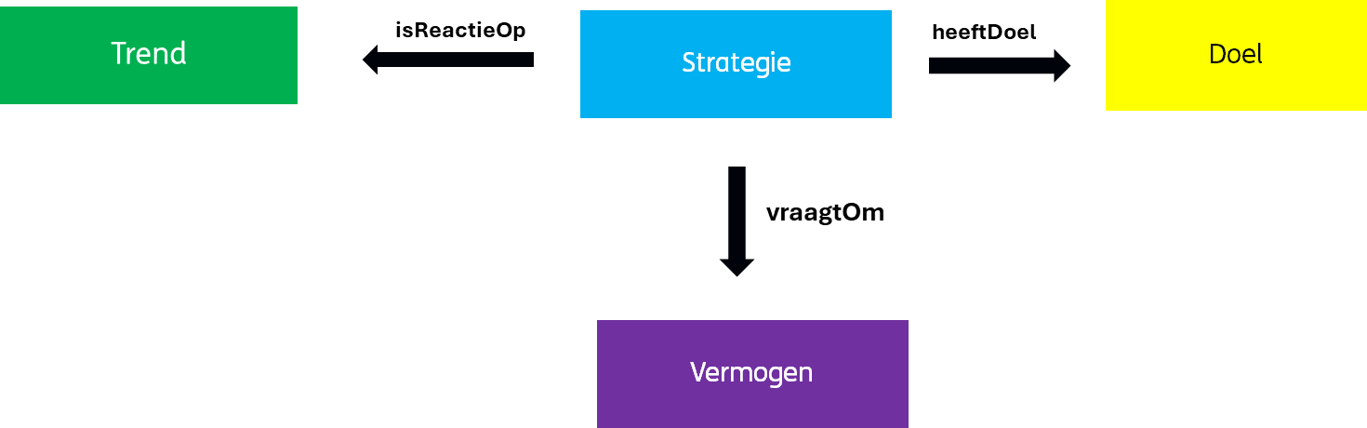
Definitions:
- Strategy
  - Definition: A strategy is a plan of action or internal program intended to achieve a goal or solve a problem. For this plan, certain facilities are used and resources are allocated. Strategy is a broad concept that can encompass many things. A strategy can be a long-term vision (e.g. Invest in online infrastructure), but it can also be more concrete short-term actions (e.g. update the website politie.nl).
- Purpose
  - Definition: A goal is the desired outcome of a strategy.
- Trend
  - Definition: A trend is a general development or change in the world and the way people behave. A trend is something that is external to the organization, the organization does not create the trend but reacts to it. A reaction to a certain trend is a strategy.

- Ability
  - Definition: Capabilities or (business) capabilities define what the police must and want to be able to do in order to successfully achieve their goals. Strategies can be used to strengthen these abilities, ask for capabilities, or are related to them in some other way. In this experiment, we use a selection of the capabilities that the police themselves use.
  - Example: Investigations, maintaining public order, capacity management.
Relationships:
- Strategy --> Goal
  - The "hasGoal" relationship indicates that a strategy is pursuing a certain goal. The aim is to achieve the set goal by applying the strategy.
- Strategy --> Trend
  - The "isReactionOn" relationship indicates that a particular strategy was developed in response to a particular trend.
- Strategy --> Power
  - The "asksOm" relationship indicates that a certain strategy requires a certain ability from the organization.

Annotating
During annotation, the aim is to perform the following task. You are going to "apply" the above model to the text. The intention is to do this by applying the following steps. We also ask you to pay attention to certain things.

The steps:
- Select all strategies in the text.
- Select all goals related to these strategies.
- Select all the trends that the strategies are a response to.
- Group the selected instances of a trend/strategy/goal when they refer to the same concept in your opinion.
- Link the goals to the strategies they are the goal of.
- Link the Trends to the Strategy they relate to. So the Strategy that has been set up in response to that trend.
- Link Capabilities to Strategies they require within the organization. The relationship that is made here is "asksOm".
  - Example: The "labour market strategy" strategy requires the ability to "manage capacity".

Please note:
- When a certain concept (strategy/goal/trend) is mentioned several times, you have to annotate all the different instances (different ways in which a certain concept can appear in the text) separately.
  - Example: "Due to increasing digitization, there is more and more cybercrime. (…) In the coming years, the police will invest extra in the ICT infrastructure to better deal with the increasing digitization.". In this example, there are two instances of one draft.
- Each trend/strategy/goal/asset does not have to be exclusively linked to one other trend/strategy/goal/ability.
  - Example: A strategy can have multiple goals and each goal can also have multiple strategies.
- If you make a link between a group of concepts and another concept or group of concepts, we assume that this link applies to all examples from that group. So you don't have to draw a relationship to the adhering concept for every example from a group.

Stumbling blocks:
Difference between Purpose & Strategy
A strategy and a goal can be difficult to tell apart. A strategy is something you can do, a goal something that can be achieved. Sometimes, however, the difference is nuanced. There are two ways in which a Strategy can be distinguished from a Goal.
- Context from the text: when it is explicitly mentioned in the text that the Police wants to carry out a certain plan to achieve a goal:
(Strategy = blue, goal = yellow)
By investing in modern ICT infrastructure, the police can strengthen their effectiveness, increase the safety of citizens and strengthen their position as a reliable and innovative organisation.
- The definition of goal vs. strategy: The difference between a goal and a strategy is that a strategy must refer to a plan, program or strategic line, while a goal is a desired outcome. A sub-goal can be called to achieve a larger goal, then a goal can be confused with a strategy, or vice versa. We will illustrate this with two examples:
Example sentence with two purposes:
To increase capacity, the focus is on employee retention.
Example sentence with two strategies:
To make the "Police of the Future" program successful, we are going to invest in the ICT infrastructure.

Sub-goal and sub-strategy
The documents often mention main strategies with sub-strategies underneath. We do not establish these relationships during this experiment. When you encounter a main strategy and sub-strategy, annotate both and don't group them. The goals and trends associated with the main and sub-strategy are linked to both strategies.

To make the "Police of the Future" program successful, we are going to invest in the ICT infrastructure. With this, the police want to strengthen its position as a reliable and innovative organization.

"Police of the Future" programme – aims to strengthen its position as a reliable and innovative organisation.

investing in ICT infrastructure. – has strengthened its position as a reliable and innovative organization.

Examples
Here we will mention some examples of Strategies, Trends and Goals.
Strategies
Major strategic lines (main themes)
- The Police at the heart of society
- With and for people
Medium scope:
- Setting up new security coalitions
- Developing state-of-the-art intelligence technology
Concrete strategies:
- Include evidence collected by citizens more in research
- Attract more data analytics specialists

Trends
Advancing digitization
Hardening of organised crime
Changes in society follow each other in rapid succession

Goals
Improving capacity
Be able to process a large amount of information
Making everyone within the Police feel safe, seen and valued.

Capabilities
[Capabilities can be found in the repository]

