1. 确定优先关系矩阵

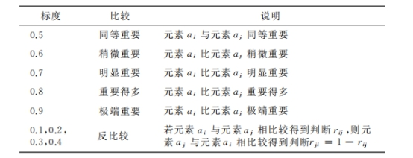

其中：C1：与分数相关数据（P1:AC率，P2:1A率，P3：均分）

C2：与提交时间相关数据（P4:平均debug时间，P5：平均提交次数）

|  |  |  |  |
| --- | --- | --- | --- |
| O | C1 | C2 | Ri |
| C1 | 0.5 | 0.8 | 1.3 |
| C2 | 0.2 | 0.5 | 0.7 |

表F1

|  |  |  |  |  |
| --- | --- | --- | --- | --- |
| C1 | P1 | P2 | P3 | Ri |
| P1 | 0.5 | 0.7 | 0.6 | 1.8 |
| P2 | 0.3 | 0.5 | 0.6 | 1.4 |
| P3 | 0.4(0.5) | 0.4 | 0.5 | 1.3 |

表F2

|  |  |  |  |
| --- | --- | --- | --- |
| C2 | P4 | P5 | Ri |
| P4 | 0.5 | 0.6 | 1.1 |
| P5 | 0.4 | 0.5 | 0.9 |

表F3

1. 确定模糊矩阵：（ｒｉｊ ＝（ｒｉ －ｒｊ）／２ｓ＋0.5,s：层数）

|  |  |  |  |
| --- | --- | --- | --- |
| O | C1 | C2 | ∑ｒｉｊ |
| C1 | 0.5 | 0.65 | 1.15 |
| C2 | 0.35 | 0.5 | 0.85 |

表H1

|  |  |  |  |  |
| --- | --- | --- | --- | --- |
| C1 | P1 | P2 | P3 | ∑ｒｉｊ |
| P1 | 0.5 | 0.567 | 0.583 | 1.650 |
| P2 | 0.433 | 0.5 | 0.517 | 1.450 |
| P3 | 0.417 | 0.483 | 0.5 | 1.400 |

表H2

|  |  |  |  |
| --- | --- | --- | --- |
| C2 | P4 | P5 | ∑ｒｉｊ |
| P4 | 0.5 | 0.55 | 1.05 |
| P5 | 0.45 | 0.5 | 0.95 |

表H3

1. 计算指标权重

C:\Users\lenovo\AppData\Local\Temp\ksohtml23236\wps2.jpgC:\Users\lenovo\AppData\Local\Temp\ksohtml23236\wps3.jpg

得：ωＣＯ ＝（ωＣ１Ｏ, ωＣ２Ｏ ）＝（0.65,0.35），

ωＰＣ１ ＝（ωＰ１Ｃ１ ,ωＰ２Ｃ１ ,ωＰ３Ｃ１ ）=(0.383,0.317,0.3)

ωＰＣ２ ＝（ωＰ4Ｃ２ ,ωＰ5Ｃ２）=(0.55,0.45)