# 3. Technology

The types of application in which the gestures are used appear to influence the type of technology used to capture, track and recognize these gestures. Some examples of the types of application are medical imagery, where the risk of contamination is reduced by using touchless interaction, driving, where people need to stay focused, or for industrial workers with dirty hands that need information from their equipment. Depending on the application and the accuracy needed you can use infrared cameras, such as Kinect, depth Camera, Leap sensors or wearables, such as accelerometers, gyroscopes.

## 3.1 Types of application

First gesture-based application appeared in a literature from 1980 [1], where voice and gesture where used to command simple shapes on a display. After this occurrence, gestures begun to be used in multiple domains, from 3D/VR object manipulation to robot control and Computer Aided Design (CAD) and further technological developments in technology in the form of infrared camera, depth sensing camera or motion sensors made the research more affordable and easier to get into, thus the interest in this domain started raising.

Another domain that became very popular and had seen a lot of interest was gaming, where 3D games became more widely spread and companies began searching for more ways of interacting with the games. One of the earliest gesture-based controllers was the Wii Remote developed and released by Nintendo in 2005, followed in 2010 by the Kinect, but more information on those in 3.1.3 Data input/authentication.

According to [2] application can be separated in five categories : 3D modeling, assistive application, data input/ authentication, manipulation/navigation and touchless control.

### 3.1.1 3D modelling

This type of application revolves in using gesture to create new forms, modify them by changing geometric characteristics or changing their position and shape in 3D space.

Such an example is shown in [3] where simple hand movement is used for the manipulation of objects. Hands are the best alternative because the connection between the user and computer is wireless, the movement of the hands has no constraints in the 3D space. But this implies other problems, because the user can move freely there needs to be a robust recognition of the gestures. Therefore, there must be a careful selection when it comes to the gesture spectrum because there is a fine balance between gesture complexion and functionality.



Figure 1. User interacts with a 3D virtual model by using non-instrumented hand gestures.

In applications like the one mention before, prescribed gestures are often used because they are connected to certain actions in the program which is easier to manage and implement a feasible system that can recognize them.

### 3.1.2 Assistive application

Assistive applications are being targeted at elderly people or people with some impairment to help them interact with electronic devices, computers providing additional aid in assistive living environments. For example, in [4] gestures are used to aid blind people by implementing and online news reader. Prescribed gestures are chosen for this application too for the same reason as seen in 3.1.1 3D modelling, having functions like stop, pause, restart and resume for communicating with the application.

### 3.1.3 Data input/authentication

Data input/ authentication applications are generally used for easing the interactions between the user and computes. Another application is recognizing handwriting or sign language which can be used in education purposes too.

### 3.1.3 Manipulation/navigation

These types of applications offer the user a more intuitive way to interact with object or navigate with some unique environments. Some examples of the usage of gesture for manipulation/navigation can be seen in:

* Interaction with a display or a projection.
* Interaction with augmented reality which enables overlapping 3D objects with the environment that you are working in.
* Navigating in an application
* Robot interaction

This use cases use gesture control more like an add-on because of the hardware and software limitations and mostly use prescribed gestures for actions.

### 3.1.4 Touchless control

Touchless control applications have a wider spectrum of usage, from games, home appliance control to interacting whit car controls and robots.

As discussed before touchless control in games has seen a lot of interest. Nintendo Wii was one of the earliest implementations of such a technology. The Wii Remote controller had as inputs an accelerometer and a gyroscope and paired with a motion sensor bar mounted onto a television screen enabled motion tracking.

More gaming companies followed soon after and released they own versions in the form of PlayStation Move (Sony) and Kinect 360 (Microsoft)

Despite the initial interest in those technologies the implementations in games were poorly designed and were not very successful in the long run. This fall was accentuated by the rising popularity of VR which had much more potential in the gaming industry, but the efforts in improving the technology helped in bringing the more affordable options for research using infrared cameras and motion sensors, especially Kinect which was refreshed in 2014 with an improved performance in tracking and furthermore in 2019 was released Azure Kinect which is a developer kit for the use of artificial intelligence (AI) sensors for computer vision and speech models.

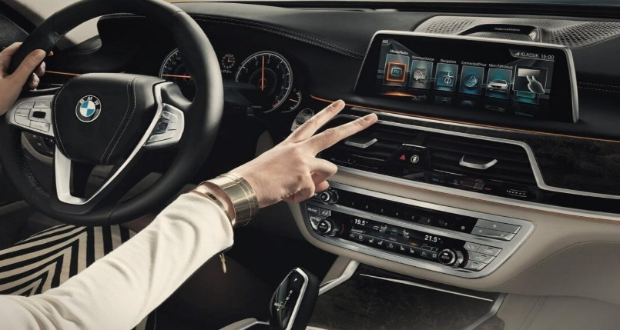

Another use for gestures touchless controls is interacting with car entertainment system, for examples BMW implemented such a system that help drivers be more focused on the road and use gesture for music volume control, managing calls or selecting infotainment settings (Rommel, 2020)

Figure 2. Example of use case for BMW gesture controls

## 3.2 Technology used

Technology used for gesture tracking can be divided into two categories:

* Use of cameras: gestures are recorded at a distance by a camera or sensor.
* Use of wearable: users wear certain devices (gloves, bracelets, rings) with sensors.

Primarily the cameras are more popular because it is easier to work with them and in spite of the superior accuracy that wearables provide, cameras have a lot more flexibility and functionality being only dependent on the ones that use them.

For our specific research we will focus more on the Microsoft Kinect because it is our camera of choice and one of the most popular for gesture tracking and recognition.

### 3.2.1 Microsoft Kinect

Microsoft Kinect was initially developed for use in combination with an Xbox console to eliminate the game controller.

The Kinect 360 was originally launched in 2010 and incorporated an RGB camera, infrared projectors and detectors that mapped depth through though structural light calculations, a microphone array, along with software and artificial intelligence to allow real time gesture and speech recognition and body skeletal detection, up to 4 people.

However, Kinect had found an unexpected interest from academic and commercial application because was cheaper and more robust compared to other depth-sensing technology on the market, being thus considered for application in robotics, medicine and health care. In 2012, Microsoft released Kinect for Windows, a development kit for commercial applications.

In 2014, Microsoft released a refresh in the form of Kinect One, with had improved RGB camera, improved Depth Camera and a new way to calculate depth: time-of-flight. In the past, it was hard to use more than one Kinect since they interfere a lot with each other because they calculate depth using an IR light pattern projection, whereas the Kinect One computes the depth of objects it has in front of it throwing some infrared light rays and looking how much time these rays need to bounce on surfaces and come back. This method is more stable, precise and less prone to interferences.

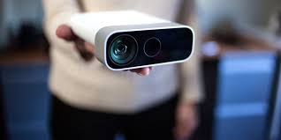 Ultimately Kinect line for Xbox was discontinued and Microsoft released a non-gaming version as the Azure Kinect, which incorporates Microsoft Azure computing applications among the device's functionalities.