VISTA: A NLP-BASED CHATBOT FOR CITIZEN INQUIRY
AND LOCAL GOVERNMENT SERVICES


A Capstone Project Presented to
Faculty of the Institute of Computing
Davao del Norte State College
New Visayas, Panabo City

Jeverly Shane B. Capote
Honey Mariel S. Corpuz
Axl Bien Meñoza

May 2026
CHAPTER 1
INTRODUCTION
Background of the Project
[REVISED] Comment 1 Fix: Removed author names from in-text citations. Using strict IEEE [X] format.
The rapid advancement of digital technologies has fundamentally transformed how governments deliver public services and communicate with citizens across the globe. Public institutions worldwide are adopting electronic government (e-government) initiatives to improve service efficiency, transparency, and accessibility through information and communication technologies (ICT) [1]. Digital platforms allow citizens to access official information remotely, reducing the need for physical visits and helping standardize service communication across channels. Research highlights that chatbots, a conversational interface capable of interpreting user questions and providing automated responses, can support organizations by delivering consistent answers to frequently asked questions and reducing the workload associated with repetitive inquiries [2]. In government settings, AI-guided chatbots enhance citizen–government communication by improving responsiveness and standardizing information delivery [3]. From a governance perspective, digital platforms support "doing more with less" by enabling government offices to allocate human resources to complex, judgment-based tasks while routine information delivery is supported by technology [4].
The core problem identified in this study is the inefficient and fragmented handling of citizen inquiries at the local government level, specifically in Panabo City, Davao del Norte. Citizens commonly inquire about frontline services documented in the Citizen's Charter, including business permitting, civil registry, and local treasury services. Although the Citizen's Charter serves as an official reference, accessing information can still be inconvenient for citizens when it is not easily searchable in natural language. The root causes include the absence of a centralized automated response system, limited personnel capacity during peak inquiry periods, the lack of a 24/7 accessible digital inquiry platform, and the absence of multilingual support for local languages such as Cebuano/Bisaya and Filipino/Tagalog. These conditions produce cascading effects: frustrated citizens unable to access timely information, delayed and inconsistent dissemination of service requirements, overwhelmed frontline staff burdened by high volumes of repetitive inquiries, and reduced public trust in LGU responsiveness.
Globally, one of the persistent challenges in public service delivery is the large volume of repetitive citizen inquiries, particularly questions about service requirements, documentary needs, step-by-step procedures, office schedules, fees, and processing timelines. According to the United Nations E-Government Survey 2022, digital government initiatives are critical for strengthening institutional transparency, improving public service delivery, and fostering citizen participation in governance processes [1]. Several international studies demonstrate the effectiveness of AI-driven chatbot systems in government service delivery. Research has shown how AI-guided chatbots transform citizen–government communication by providing consistent, round-the-clock responses to municipal service inquiries, significantly reducing the burden on frontline staff [3]. Further studies highlight how Natural Language Processing techniques enable machines to interpret the semantic meaning of human text, making NLP the foundational technology for any modern chatbot system [2]. A comprehensive historical and technical survey of chatbot evolution establishes that retrieval-based chatbots, which match user inputs against a predefined knowledge base, are the most suitable architecture for domains requiring verified, accurate responses, such as government services [5].
In the Philippines, national programs continue to promote digital transformation through ICT-enabled initiatives, as outlined in the Department of Information and Communications Technology (DICT) E-Government Masterplan 2022 [6]. To streamline services, Republic Act No. 11032, also known as the Ease of Doing Business and Efficient Government Service Delivery Act, mandates all local government units (LGUs) to establish a Citizen's Charter detailing step-by-step procedures, requirements, fees, and processing times for all frontline services [7]. Despite these policies, many LGUs still face significant gaps in implementing centralized, automated inquiry systems, with most relying on basic social media auto-replies or manual front-desk handling [8]. The Anti-Red Tape Authority (ARTA) further reinforces the Citizen's Charter requirement through reference guidelines that standardize how government agencies should present service information to the public [9], yet localized digital application in municipal and city governments remains a significant challenge due to resource constraints. Furthermore, Filipino and Cebuano are classified as low-resource languages in NLP research, meaning there is a critical scarcity of publicly available, labeled datasets for tasks such as intent classification and text categorization in these languages [10].
At the local level, existing digital inquiry solutions, where available, remain largely inaccessible to local government units due to their reliance on proprietary platforms, computationally heavy deep learning models, or English-only interfaces, leaving a critical gap between nationally available technologies and the operational realities of city-level government offices in linguistically diverse regions like Mindanao. In Panabo City, a first-class component city in Davao del Norte with a population of 184,599 as of the 2020 Census [11], citizen inquiries are still handled through manual and fragmented channels such as front-desk assistance, phone calls, and social media messaging. While these channels remain important, they may lead to delayed responses during peak hours, inconsistent answers depending on staff availability, and inefficiencies for both citizens and government personnel.
This study addresses that gap by developing VISTA (Virtual Intelligent Services and Transactions Assistant): An NLP-based Chatbot for Citizen Inquiry and Local Government Services. VISTA is a knowledge-based, retrieval-oriented chatbot that integrates Natural Language Processing (NLP) with supervised machine learning algorithms to classify citizen inquiries and retrieve validated responses from the LGU's Citizen's Charter [5]. The system supports multilingual inquiries in English, Filipino/Tagalog, and Cebuano/Bisaya, and features a controlled retraining mechanism where only administrator-validated queries are incorporated into the model, ensuring that the chatbot provides only verified, official information. Conducted under the research, development, and extension mandate of Davao del Norte State College as provided under Republic Act 7879 [12], this study aims to deliver an accessible, locally deployable, and technically reliable solution tailored to the needs of citizens and frontline offices in Panabo City.
This study is aligned with several national and international development agendas. At the institutional level, the project supports the Davao del Norte State College Research, Development, and Extension (DNSC RDE) Agenda, which prioritizes the development of technology-driven solutions that address community-level concerns and contribute to local governance improvement [13]. At the national level, the study aligns with the Commission on Higher Education (CHED) Achieve Agenda, which encourages higher education institutions to produce research outputs that are responsive to societal needs and contribute to national development goals through innovation and technology [14]. The study also supports the Department of Science and Technology (DOST) Harmonized Research and Development Agenda, which promotes the development of smart technologies and digital platforms for improving public service delivery and governance efficiency in the Philippines [15]. At the international level, this study directly contributes to three United Nations Sustainable Development Goals (UN SDGs): SDG 9 (Industry, Innovation, and Infrastructure), specifically Target 9.c, which promotes the development of information and communication technology to increase access to the internet and digital services in developing countries [16]; SDG 11 (Sustainable Cities and Communities), specifically Target 11.3, which advocates for inclusive, participatory, and integrated planning and management of urban services; and SDG 16 (Peace, Justice, and Strong Institutions), specifically Target 16.6, which calls for the development of effective, accountable, and transparent institutions at all levels [16].
Objectives of the Study
[REVISED] Comments 2, 3, 4 Fix: Named the 3 algorithms, specified Descriptive Analytics, rewrote Objective 4 to be research-level.
This study aims to develop a web-based system for citizen inquiry and local government services integrating an NLP-based chatbot to automate the delivery of verified public service information and streamline inquiry management. Specifically, the project aims to:
1. Develop a structured, multilingual knowledge base (English, Filipino/Tagalog, Cebuano/Bisaya) from LGU-approved sources such as the Citizen's Charter and FAQs.
2. Preprocess the textual data using NLP techniques and apply TF-IDF vectorization to convert text into numerical representations suitable for machine learning classification and response retrieval.
3. Train and evaluate three supervised machine learning algorithms, Support Vector Machine (SVM), Logistic Regression, and Neural Network (Multilayer Perceptron/MLP) to identify the most accurate intent classification model based on accuracy, precision, recall, and F1-score.
4. Develop an administrator module with a Descriptive Analytics dashboard that enables LGU administrators to monitor citizen inquiry trends, manage the knowledge base, and implement a controlled retraining mechanism that incorporates only validated unmatched queries to continuously improve model performance.
Significance of the Study
[REVISED] Comment 5 Fix: Merged 'Local Government Frontline Offices', 'Frontline Government Personnel', and 'LGU Management' into a single beneficiary.
This study is significant as it provides an automated, real-time, and multilingual information retrieval system that transforms traditional reactive service delivery into proactive citizen inquiry management. The following are the study's main beneficiaries:
Citizens and Residents of Panabo City. VISTA will enable citizens to access official service information — including requirements, procedures, fees, schedules, and processing times — instantly and in their preferred language (English, Filipino/Tagalog, or Cebuano/Bisaya) without requiring immediate office visits. The chatbot provides consistent, validated answers sourced from the Citizen's Charter, reducing waiting time, repeated visits, and the frustration of receiving inconsistent information across different inquiry channels.
Local Government Unit (LGU) Personnel and Management. The system will help frontline offices of Panabo City Hall reduce the volume of repetitive inquiries handled manually, supporting the consistent dissemination of official service requirements anchored on LGU-approved references. By automating routine information delivery, VISTA allows frontline offices to operate more efficiently, particularly during peak service hours and high-demand periods. Frontline staff can prioritize case-specific concerns, complex transactions, and tasks that require human judgment, reducing staff fatigue and minimizing the risk of providing inconsistent answers. Furthermore, VISTA's Descriptive Analytics dashboard will provide LGU management and planning units with data-driven insights into citizen inquiry trends, including the most frequently asked service categories, peak inquiry periods, and common unresolved questions, supporting evidence-based communication planning, resource allocation, and service improvement decisions.
Davao del Norte State College (DNSC). The development of VISTA will strengthen DNSC's research, development, and extension (RDE) portfolio by producing an applied technological output that directly addresses a real challenge in local government service delivery, reinforcing DNSC's mandate under Republic Act 7879 [12].
Future Researchers and Developers. This study lays the foundation for future research on NLP-based smart governance systems applicable to citizen service delivery in linguistically diverse regions. VISTA may serve as a baseline system for extensions such as voice interaction, sentiment analysis, and improved algorithm architectures.
Scope and Limitation
This project focuses on the development of VISTA, a web-based multilingual (English, Filipino/Tagalog, Cebuano/Bisaya) chatbot that provides automated responses to citizen inquiries about selected Panabo City Hall frontline services. The system will be tested and evaluated within Panabo City, Davao del Norte. The system encompasses four primary operational components: a citizen-facing chatbot interface for multilingual inquiry submission and response retrieval, an NLP-based intent classification module using supervised machine learning algorithms (SVM, Logistic Regression, Neural Network), an administrator portal for knowledge base management and controlled model retraining, and a Descriptive Analytics dashboard for inquiry logging and trend visualization.
The initial deployment and testing of the system will be limited to a baseline of approximately 1,500 pre-defined question variations distributed across five (5) selected frontline offices of Panabo City Hall. These five offices and their approximate question allocations are as follows: City Mayor's Office with approximately 1,000 question variations covering its extensive range of services, City Civil Registrar's Office with approximately 100 question variations, City Treasurer's Office with approximately 100 question variations, City Assessor's Office with approximately 150 question variations, and City Social Welfare and Development Office with approximately 150 question variations. The questions for each service consist of the most common frequently asked questions (FAQs) gathered from the Citizen's Charter and historical citizen inquiries from the LGU's public communication channels. This 1,500-question baseline exists because it is not feasible to anticipate every possible citizen inquiry phrasing during the initial data gathering phase.
However, the system is not limited in its capacity to accept additional questions. VISTA includes a controlled retraining feature that allows the administrator to continuously expand the knowledge base beyond the initial baseline over time. When citizens submit inquiries that the system cannot match to an existing intent (unmatched queries), these queries are logged and queued for administrator review. Once the administrator reviews and resolves an unmatched query by assigning it to the correct intent or creating a new intent, the resolved query is permanently added to the knowledge base and training dataset. This mechanism serves as the system's room for improvement; it ensures that the chatbot continuously learns from real-world citizen interactions while maintaining the accuracy and trustworthiness of its responses, since all additions require explicit human validation before being incorporated into the model.
The administrator of the system is the designated authorized LGU personnel, such as the Public Information Officer or IT staff of Panabo City Hall, who is responsible for monitoring the chatbot, resolving unmatched queries, updating the knowledge base, and triggering model retraining through the administrator portal. The system is built around a Python-based backend server integrated with a TF-IDF feature extraction pipeline and supervised machine learning classifiers that classify citizen text inquiries into predefined service intent categories in real time. Development and testing of the prototype will be conducted using service information documented in the Panabo City Citizen's Charter, and while the system is designed to be adaptable to other LGU contexts, findings and system configurations may require modification before deployment in other municipal or provincial government offices.
VISTA is limited to providing information support and will not process official government transactions, payments, or document submissions. The accuracy of the chatbot's responses is highly dependent on the quality and completeness of the manually curated knowledge base maintained by LGU administrators. NLP classification performance may vary across languages due to local slang, code-switching, and spelling variations inherent in Cebuano/Bisaya and Filipino/Tagalog text inputs. The system does not feature automatic real-time self-learning to prevent the AI from adopting incorrect or malicious user inputs; all learning requires explicit administrator review and validation. The web application requires a stable internet connection and modern web browsers to function effectively as a prototype.
Review of Related Literature and Works
Related Literature
The integration of information and communication technologies in public administration has fundamentally shifted how governments interact with citizens. According to the United Nations E-Government Survey 2022, digital government initiatives are critical for strengthening institutional transparency, improving public service delivery, and fostering citizen participation in governance processes [1]. As these platforms mature, chatbots have emerged as a primary interface for navigating complex government portals and delivering automated responses to citizen inquiries [2]. In the public sector, studies show that AI-guided chatbots significantly reduce response times and mitigate the workload of frontline personnel who handle high volumes of repetitive inquiries [3]. This aligns with the principles of "lean government," where technology handles routine tasks, allowing human workers to focus on specialized service delivery that requires professional judgment [4].
Several studies demonstrate the effectiveness of AI-driven chatbot systems in government service delivery. Research on AI-guided chatbots shows how they transform citizen–government communication by providing consistent, round-the-clock responses to municipal service inquiries, significantly reducing the burden on frontline staff [3]. The Bologna City chatbot implementation validated the use of Support Vector Machines (SVM) combined with TF-IDF feature extraction for classifying citizen inquiries into service categories with high accuracy. Similarly, other studies highlight how Natural Language Processing techniques enable machines to interpret the semantic meaning of human text, making NLP the foundational technology for any modern chatbot system [2]. A comprehensive historical and technical survey of chatbot evolution establishes that retrieval-based chatbots, which match user inputs against a predefined knowledge base, are the most suitable architecture for domains requiring verified, accurate responses, such as government services [5].
In the Philippine context, the push for automated, accessible e-governance is mandated by national frameworks including the DICT E-Government Masterplan 2022 [6] and the Anti-Red Tape Authority (ARTA) guidelines on the Citizen's Charter [9], yet localized application in municipal and city governments remains a significant challenge due to resource constraints [8]. Republic Act No. 11032 requires all LGUs to maintain a Citizen's Charter [7], providing a standardized, official data source that can serve as the foundation for a knowledge-based chatbot system.
A dominant theme across the literature is the reliance on Natural Language Processing to accurately classify user intentions [5]. To process text, raw user input must be converted into numerical data. Literature heavily supports the use of Term Frequency-Inverse Document Frequency (TF-IDF) for feature extraction, as it effectively weighs the importance of specific keywords in a query while filtering out common conversational noise (stop words) [17]. TF-IDF has been shown to outperform simpler bag-of-words approaches in structured domain classification tasks due to its ability to distinguish meaningful terms from generic vocabulary.
Regarding classification, the literature justifies the use of traditional machine learning algorithms over computationally heavy deep learning models for text categorization in structured domains. Support Vector Machine (SVM) is widely utilized because it excels in high-dimensional text spaces and provides robust accuracy for classification tasks, particularly when the number of features exceeds the number of training samples [18]. Logistic Regression is also favored as a reliable probabilistic model for multiclass text problems, offering interpretable probability estimates for each predicted class [19]. Neural Networks, specifically the Multilayer Perceptron (MLP), have demonstrated strong performance in text classification tasks due to their ability to learn non-linear patterns and complex feature interactions that linear models may miss [20]. By utilizing robust machine learning libraries such as Scikit-learn to evaluate these three specific algorithms [21], developers can ensure a mathematically sound, lightweight, and highly accurate intent classification pipeline suitable for deployment on resource-constrained LGU servers.
Across these studies, key themes and patterns emerged. The common findings confirm that NLP-based chatbots using supervised machine learning classifiers provide accurate, consistent, and efficient responses to structured domain inquiries. Common methodological trends include the use of TF-IDF for feature extraction, SVM and neural network-based classifiers for text classification, and retrieval-based architectures for response generation. On the other hand, most existing systems are limited to single-language (English) support and lack controlled retraining mechanisms that allow administrators to validate and approve new training data before it is incorporated into the model.
Despite the proven benefits of AI chatbots and algorithms like SVM and neural network classifiers, a significant research gap exists at the local government level. Many LGUs rely on basic social media auto-replies or manual handling [8]. Furthermore, existing advanced government chatbots are predominantly built for the English language and do not account for local Philippine dialects (Cebuano/Bisaya) or code-switching. Moreover, Filipino and Cebuano are classified as low-resource languages in NLP research, meaning there is a critical scarcity of publicly available, labeled datasets for tasks such as intent classification and text categorization in these languages [10]. This absence is even more pronounced in the government services domain, where no pre-built training corpus exists for Philippine LGU citizen inquiries — forcing system developers to construct their own datasets from primary documents such as the Citizen's Charter. Finally, many chatbot systems lack a "controlled retraining workflow," meaning they either remain static and become outdated, or they use unsupervised learning which risks providing citizens with unverified information.
The literature confirms that an NLP-based chatbot using TF-IDF and supervised learning algorithms (SVM, Logistic Regression, Neural Network) is a highly effective solution for managing routine inquiries. However, the lack of localized, multilingual systems anchored on verified documents like the Citizen's Charter highlights a clear gap. VISTA addresses this by providing a controlled, governable AI framework tailored specifically for Panabo City's linguistic and administrative context.
Related Works
There are five existing automated inquiry systems and published studies that can be compared to the proposed VISTA system. These systems utilize natural language processing, government knowledge bases, and conversational interfaces to automate public service inquiries. However, the proposed VISTA system introduces additional critical functionalities tailored for local government units (LGUs), such as multilingual support for English, Tagalog, and Cebuano/Bisaya, a controlled retraining mechanism, an admin analytics dashboard, and an open-source, locally deployable architecture.
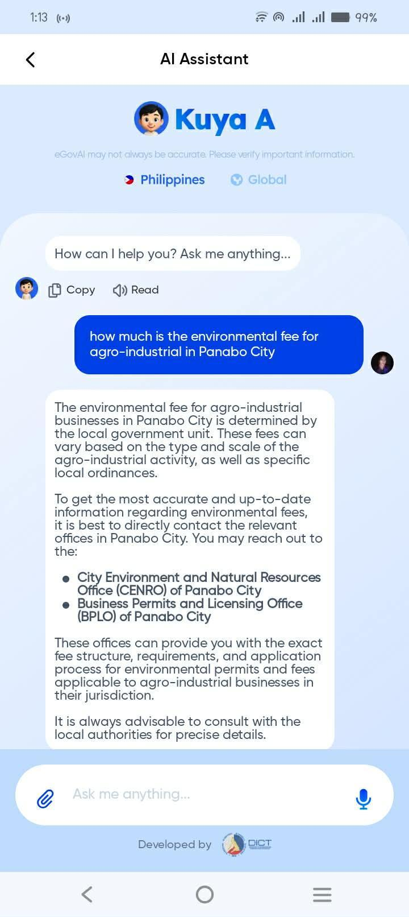
The first related system is the eGovPH Portal [22]. This system is primarily designed as a centralized platform for Philippine government services, providing citizens with access to a verified knowledge base of national and local government transactions. Through its recent eGovAI integration, the platform utilizes Natural Language Processing (NLP) to handle conversational inquiries and offers multilingual support for various Philippine dialects [6]. Although the system is highly reliable and advanced, it functions as a centralized, closed-source national platform. There is no open-source, locally deployable framework that individual Local Government Units (LGUs) can host, govern, and customize on their own servers.

Figure 1. eGovPH Ai Assistant Interface
The second related system is AskGov Singapore [23]. This system focuses on answering citizen queries through an AI-guided conversational interface utilizing advanced NLP models, specifically BERT, to classify user intents and retrieve information from verified government databases [3]. Although the system successfully demonstrates NLP intent classification and a verified knowledge base, it mainly focuses on single-language interactions and lacks multilingual support for Philippine regional languages.
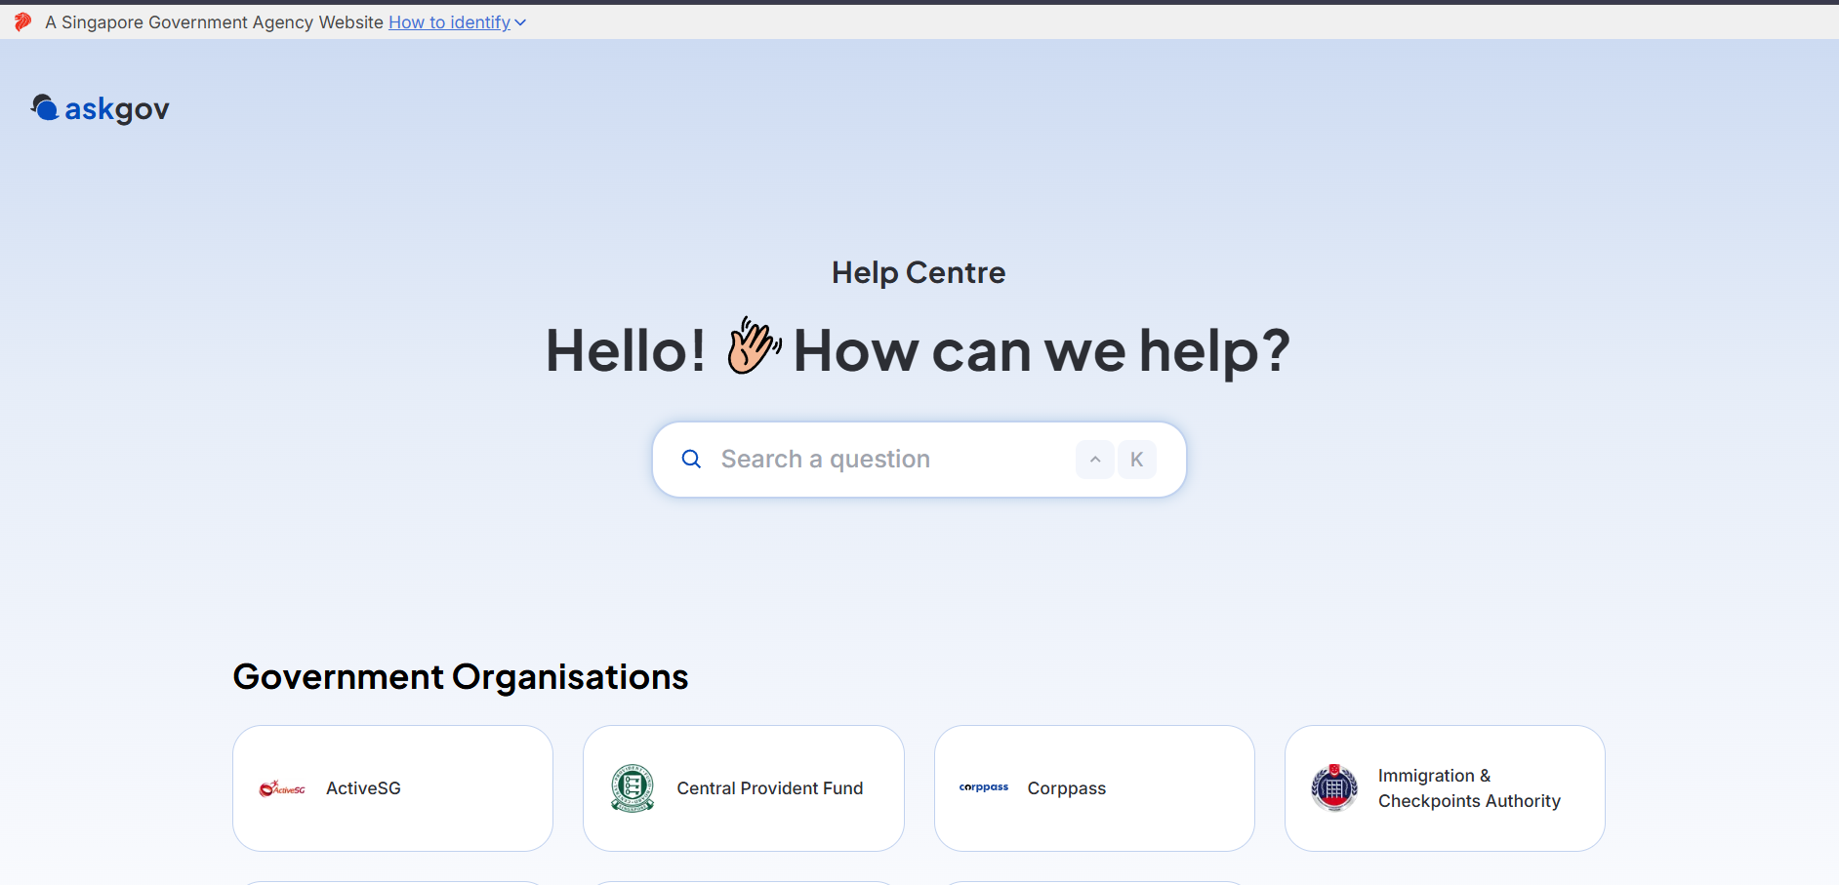

Figure 2. AskGov Conversational Interface

The third related study is the Bologna City Chatbot [24] developed for municipal citizen services. This system utilizes Support Vector Machines (SVM) combined with TF-IDF feature extraction to classify citizen text inquiries into specific municipal service categories. However, the study primarily focuses on European languages and does not support the linguistic nuances and code-switching common in the Philippines.
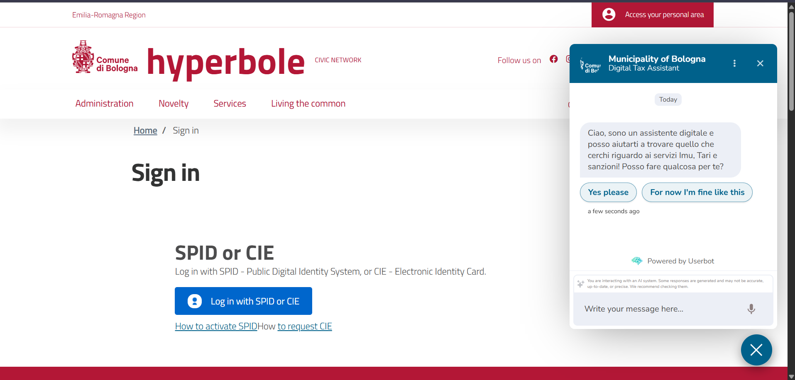

Figure 3. Bologna City Chatbot Interface
The fourth related system is the PhilHealth Virtual Assistant [25]. This system uses Google Dialogflow to provide automated assistance to members regarding their health insurance benefits, contributions, and membership status. Although it demonstrates the effectiveness of intent classification in the Philippine public sector, its knowledge base is strictly limited to national health insurance rather than comprehensive local government services.


Figure 4. PhilHealth Virtual Assistant Interface

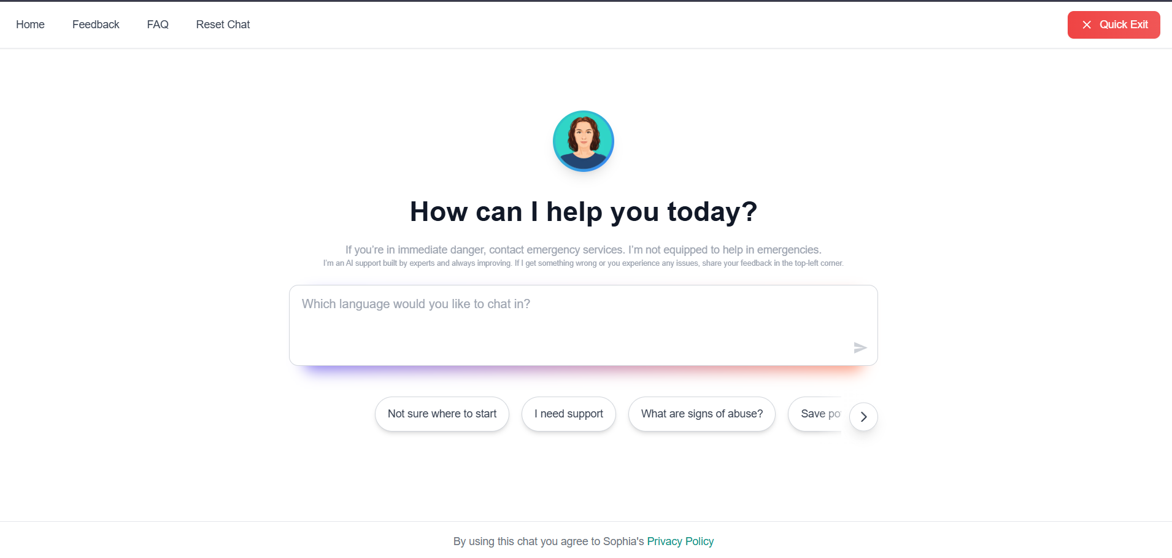
The fifth related system is the Sophia Chatbot [26], an AI-powered conversational assistant adopted by the Quezon City local government to support victim-survivors of domestic violence. While it successfully demonstrates AI chatbot integration within a Philippine LGU and supports local languages, its knowledge base is strictly domain-locked to domestic violence advocacy rather than comprehensive local government services like the Citizen's Charter.

Figure 5. Sophia Chatbot Interface

Title of the Study / System | NLP Intent Classification | Multilingual Support | Verified Knowledge Base | Controlled Retraining | Admin Analytics Dashboard | Open-Source / Locally Deployable
eGovPH Portal [6] |  |  | ✓
AskGov Singapore [3] | ✓ (BERT) |  | ✓
Bologna City Chatbot [4] | ✓ (SVM) |  | ✓
PhilHealth Virtual Assistant | ✓ (Dialogflow) |  | Partial
Jakarta e-Gov Bot | ✓ (Naïve Bayes) |  | Partial |  |  | Partial
VISTA (Proposed System) | ✓  (SVM/LR/MLP) | ✓ (EN/TL/BS) | ✓ (Citizen's Charter) | ✓ | ✓ | ✓
Comparison of Existing Systems

Definition of Terms
[REVISED] Comment 6 Fix: Definition of Terms are now arranged in strict alphabetical order.

Administrator Portal | A secured web-based module used by authorized LGU personnel to manage VISTA's knowledge base, review unmatched citizen queries, update FAQ entries, and trigger controlled model retraining.
Analytics Dashboard | The system component that visualizes inquiry frequency, top service intents, peak inquiry periods, and unmatched query statistics based on aggregated inquiry logs.

.
. Artificial Intelligence (AI). Computing methods that enable systems to perform tasks that typically require human intelligence, such as language interpretation, pattern recognition, and decision-making. In this study, AI refers specifically to the machine learning algorithms used for intent classification.
Cebuano/Bisaya. A local language widely used in Mindanao; included as a supported inquiry language in VISTA to serve the linguistic diversity of the Panabo City community.
Chatbot. A conversational system that interacts with users through text-based interfaces and provides automated responses using NLP techniques and a structured knowledge base.
Citizen's Charter. An official LGU document mandated by Republic Act No. 11032, describing all frontline services, requirements, procedures, fees, and processing times. It serves as the primary validated data source for VISTA's knowledge base.
Confidence Threshold. The minimum probability score (set at 35%) that the machine learning classifier must produce for a predicted intent before the system considers the classification valid and returns a response.
Confusion Matrix. A classification evaluation table used to compute the accuracy, precision, recall, and F1-score of the machine learning models by comparing predicted intent labels against actual intent labels.
Controlled Retraining. A supervised learning mechanism where only administrator-reviewed and validated unmatched queries are incorporated into the training dataset before triggering a model retrain cycle.
Intent. A predefined category representing a specific citizen service inquiry (e.g., "business_permit_fee", "birth_certificate_process") used by the classifier to route queries to the correct knowledge base response.
Intent Classification. The process of utilizing machine learning algorithms to assign a user's text inquiry to a specific service category (intent) in order to retrieve the appropriate validated response from the knowledge base.
Knowledge Base. A structured repository of validated service information — including requirements, procedures, schedules, fees, and processing times — sourced from the Citizen's Charter and used for automated response retrieval.
Logistic Regression. A probabilistic machine learning algorithm used for multiclass text classification that estimates the probability that a given input belongs to each possible intent category.
Multilayer Perceptron (MLP). A type of artificial neural network consisting of an input layer, one or more hidden layers, and an output layer that learns non-linear patterns in text features through backpropagation.
Natural Language Processing (NLP). A subfield of artificial intelligence that provides techniques enabling computers to process, clean, and interpret human language text for automated understanding and response generation.
Stop Words. Common conversational words (e.g., "the," "is," "and," "ang," "sa") that are removed during text preprocessing to improve the algorithm's focus on meaningful, domain-specific key terms.
Support Vector Machine (SVM). A supervised machine learning algorithm that creates an optimal hyperplane to separate different intent categories in high-dimensional feature space.
TF-IDF (Term Frequency–Inverse Document Frequency). A statistical method used to convert text into numerical feature vectors by evaluating how relevant a word is to a document within a collection of documents.
VISTA. Virtual Intelligent Services and Transactions Assistant; the name of the proposed NLP-based chatbot system designed to automate citizen inquiry handling for Panabo City local government services.

CHAPTER 2
METHODOLOGY
The methodology used in the development of VISTA, an NLP-based chatbot for citizen inquiry and local government services, is discussed in this chapter. It covers the overall development process of the web-based chatbot system, including the chosen System Development Life Cycle (SDLC) model, the PADIM framework, and the specific step-by-step process used in planning, analysis, design, implementation, testing, and maintenance of the system. This chapter also outlines the tools, diagrams, requirements, and processes involved in ensuring the success of this proposed project.
[REVISED] Comment 7 Fix: PADIM section now presents only the five stages. Activities are discussed in WBS and Gantt.
VISTA adopts an Agile SDLC model, which is essential for web-based systems that integrate machine learning pipelines, as it requires continuous improvement, iterative testing, and incremental development [27]. The Agile framework used in this study follows the PADIM cycle, consisting of five iterative stages: Planning, Analysis, Design, Implementation, and Maintenance. Each phase is executed iteratively, allowing the development team to revisit and refine components based on testing feedback and evolving requirements. The specific activities and deliverables within each phase are discussed in the Work Breakdown Structure (WBS) and Gantt Chart sections that follow.
Figure 6. PADIM / Agile SDLC Cycle
System Planning
Systems Planning sets the groundwork for VISTA by outlining the goals, scope, feasibility, resources, risks, and timeline of the project. Major activities involve identifying the needs of citizens and LGU administrators in receiving prompt and accurate responses to frontline service inquiries. The researchers will define the main objective of the system, which is to develop a web-based, multilingual chatbot powered by Natural Language Processing (NLP) that can accurately classify citizen inquiries and retrieve validated responses from the knowledge base through a centralized interface.
Project Team Organization
Figure 7. Project Team Organization
The project team is organized to ensure effective coordination and clear distribution of responsibilities. The Adviser provides overall guidance and ensures that the project meets academic and technical standards. The Project Manager is responsible for managing the overall workflow, handling technical writing, ensuring all parts of the system are coordinated, finalizing the capstone manuscript, and communicating with stakeholders (LGU Administrators). The System Analyst is primarily responsible for designing the database structure, developing the web interfaces, ensuring a user-friendly conversational UI, and verifying responsive design principles. The System Developer focuses on designing, writing, and testing the core application logic, implementing the machine learning classification models, and integrating the backend with the frontend environment.
Work Breakdown Structure (WBS)
Figure 8. Work Breakdown Structure (WBS)
The Work Breakdown Structure of the project presents a hierarchical decomposition of the entire system development process into manageable phases and tasks that are specifically aligned with the PADIM framework. It begins with the Planning phase where problems are identified, objectives are defined, and the outline and scope of the project is established. It is then followed by Analysis where existing LGU inquiry systems are studied, gaps identified, and functional and non-functional requirements determined. The Design phase covers system architecture development, ERD and database schema creation, UI/UX prototyping, and NLP pipeline design. The Implementation phase encompasses backend API development, frontend integration, NLP model training and evaluation, and user acceptance testing. Finally, the Maintenance phase focuses on monitoring classification accuracy, executing the controlled retraining loop, expanding the knowledge base, and addressing system bugs and updates.
Gantt Chart
Figure 9. Gantt Chart
The Gantt chart presents the timeline and planned schedule for the activities for the development of VISTA, aligning tasks with the PADIM framework. The chart showcases the sequence and the duration of phases from Planning to Maintenance, ensuring that all essential activities are completed within the specified timeline.
System Analysis
System Architecture
Figure 10. System Architecture
The system architecture of VISTA presents a structured framework that illustrates how the different components of the system interact to support real-time citizen inquiry classification, multilingual response retrieval, and administrative knowledge base management. The architecture is composed of three main tiers: Client Tier (Frontend Interface), Application Tier (Backend Server), and Data Tier.
At the Client Tier, the system provides two web-based interfaces: (1) the Citizen Chat Interface, where citizens submit natural language inquiries in English, Filipino/Tagalog, or Cebuano/Bisaya and receive automated responses; and (2) the LGU Admin Dashboard, where authorized administrators manage the knowledge base, review unmatched queries, trigger model retraining, and view analytics.
At the Application Tier, the Python-based backend server (FastAPI) receives HTTP/REST requests from both client interfaces. When a citizen submits a query, the server routes the raw text through the Machine Learning and NLP Pipeline, which consists of three sequential stages: (1) the Text Preprocessor performs tokenization, lowercasing, and stop word removal; (2) the TF-IDF Feature Extractor converts the cleaned text into numerical feature vectors; and (3) the Intent Classifier — using the best-performing model among SVM, Logistic Regression, and Neural Network (MLP) as determined during evaluation — predicts the most probable service intent. The predicted intent is returned to the server, which retrieves the corresponding validated response from the knowledge base.
At the Data Tier, the system utilizes a dual-storage approach. A structured file system (utilizing JSON and CSV formats) serves as the Knowledge Base, storing the training data, intent classifications, and validated multilingual answers for fast in-memory retrieval. Simultaneously, an SQLite relational database stores transactional and historical data, specifically the chat logs for descriptive analytics, citizen feedback records, and unmatched query logs for future active learning.
Conceptual Framework
Figure 11. Conceptual Framework
The conceptual framework illustrates how VISTA receives citizen text inquiries, processes them through its NLP classification pipeline, and produces automated service responses and administrative analytics. The Input consists of raw natural language text submitted by citizens through the chatbot interface (English, Filipino/Tagalog, or Cebuano/Bisaya) and administrator inputs including knowledge base updates, unmatched query resolutions, and retraining commands. The Process begins when a citizen submits a text query: the backend passes it through the NLP pipeline consisting of Text Preprocessing, TF-IDF Feature Extraction, and Intent Classification. If the similarity score exceeds the predefined threshold (35%), the system retrieves the validated response; otherwise, the query is logged as unmatched for administrator review. The Output is a web-based chatbot interface delivering automated, validated responses and an administrator dashboard displaying inquiry analytics.
Functional and Non-Functional Requirements
The functional and non-functional requirements define the expected capabilities and quality attributes of VISTA.
Functional Requirements:
1. The system shall accept natural language text inputs from citizens in English, Filipino/Tagalog, and Cebuano/Bisaya through a web-based chatbot interface.
2. The system shall preprocess raw text input using tokenization, lowercasing, and stop word removal, then extract features using TF-IDF vectorization.
3. The system shall classify the preprocessed input into a predefined service intent category using a trained supervised machine learning model (SVM, Logistic Regression, or Neural Network).
4. The system shall retrieve and display the corresponding validated response from the knowledge base when the classification confidence exceeds the predefined threshold.
5. The system shall log unmatched queries (below confidence threshold) for administrator review and potential incorporation into the training dataset.
6. The system shall provide an administrator dashboard to view inquiry analytics, manage knowledge base intents, review unmatched queries, and trigger controlled model retraining.
7. The system shall allow administrators to securely log in using Firebase Authentication.
8. The system shall display inquiry frequency, top service categories, and peak usage periods through a Descriptive Analytics visualization interface.
9. The system shall support a controlled retraining mechanism where only administrator-validated queries are incorporated into the model.
Non-Functional Requirements:
1. Performance Efficiency. The chatbot shall return responses within 2 seconds of the user query.
2. Reliability. The backend shall gracefully handle fallback conditions if the intent confidence falls below the 35% threshold.
3. Usability. The web interface shall be responsive and accessible on both desktop and mobile devices.
4. Security. Administrator passwords shall be securely encrypted via Firebase Authentication.
5. Compatibility. The system shall be accessible through modern web browsers (Chrome, Firefox, Edge, Safari).
6. Maintainability. The system shall be designed with modular code for easy debugging and future enhancements.
7. Scalability. The system shall support the addition of new service categories without fundamental architectural changes.
Use Case Diagram
Figure 12. Use Case Diagram
The primary actors identified in VISTA are the Citizen/Resident and the LGU Administrator, with supporting roles played by Firebase Authentication and the NLP Classification Engine. The Citizen interacts with the system primarily through inquiry and response activities. The LGU Administrator is responsible for the overall management and governance of the system.
Context Flow Diagram (Level 0 Data Flow Diagram)
[REVISED] Comment 8 Fix: CFD simplified — data flows are combined into broader categories to reduce clutter.
Figure 13. Context Flow Diagram (Level 0 DFD)
The Context Flow Diagram presents a high-level view of VISTA. The three external entities interacting with the system are the Citizen (User), the LGU Administrator, and Firebase Auth. The Citizen provides text queries and language preferences, receiving AI responses and service information. The LGU Administrator provides admin credentials and management commands, receiving system analytics and knowledge base data. Firebase Auth handles authentication token exchange for secure access.
Level 1 Data Flow Diagram
[REVISED] Comment 9 Fix: DFD redesigned so that lines do not cross or overlap.
Figure 14. Level 1 Data Flow Diagram
The Level 1 Data Flow Diagram decomposes the VISTA system into eight key operational modules: (1.0) User Authentication, (2.0) Chat Query Processing, (3.0) Feedback Management, (4.0) Content & Service Display, (5.0) Knowledge Base Management, (6.0) Model Retraining, (7.0) Analytics & Reporting, and (8.0) Directory Management. The data stores are consolidated into two primary stores: D1 (Knowledge Base) containing intents, training data, and the service directory; and D2 (System Logs) containing chat logs, unmatched queries, and analytics data.
System Design
Entity Relationship Diagram (ERD)
[REVISED] Comment 10 Fix: ERD revised with proper PK/FK keys, data types, and relationship lines.
Figure 15. Entity Relationship Diagram (ERD)
The Entity Relationship Diagram illustrates the relational database schema supporting the VISTA system. The ANSWERS entity serves as a core component, storing validated response texts in multiple languages. The INTENTS entity stores training data with assigned intent tags, languages, and source documents. The NLP_MODEL entity stores metadata about trained classification models. Citizen inquiries are recorded in CHAT_LOGS, feedback in FEEDBACK, and unmatched queries in UNRESOLVED_QUERIES. The OFFICE_DIRECTORY manages organizational data and the ARTICLES entity stores supplementary knowledge base content. Relationships between entities are defined through primary and foreign keys, ensuring data integrity.
Data Dictionary
Table Name | Description
OFFICE_DIRECTORY | Manages organizational data including department names, locations, contacts, and descriptions.
ARTICLES | Stores supplementary knowledge base content and announcements linked to specific departments.
ANSWERS | Core repository for official, validated LGU service responses in English, Tagalog, and Bisaya.
INTENTS | Dataset of labeled sample questions and intent tags used for training the machine learning model.
NLP_MODEL | Stores metadata about trained classification models, including accuracy and file paths.
TRAINING_METRICS | Records performance evaluation metrics (precision, recall, f1-score) for the models.
CHAT_LOGS | Historical records of all citizen-chatbot interactions, tracking predicted intents and confidence scores.
FEEDBACK | Collects citizen ratings and comments on the helpfulness of the chatbot's answers.
UNRESOLVED_QUERIES | Records citizen questions below the confidence threshold, pending administrator review.

Technologies, Concepts, and Theories
Data Collection
Data collection is performed through manual extraction and digitization of service information from the official Panabo City Citizen's Charter (CMO 2026 edition), supplemented by historical citizen inquiries sourced from the LGU's public Facebook Messenger page. The dataset used in this study is a custom-built dataset constructed entirely by the developers from these primary LGU sources; no pre-existing or downloaded dataset was used.
Data Pre-Processing
Before classification, the collected text data undergoes pre-processing to improve its quality and reliability [28]. This includes tokenization (splitting sentences into individual words), lowercasing (converting all text to lowercase for uniformity), and stop word removal (filtering common conversational words that do not contribute to intent meaning). Pre-processing is performed using Python libraries including NLTK and Scikit-learn's built-in text utilities.
Feature Extraction
Feature extraction involves transforming the cleaned text into numerical format suitable for machine learning algorithms. VISTA utilizes Term Frequency-Inverse Document Frequency (TF-IDF) vectorization, which evaluates how relevant a word is to a document within a collection of documents [17]. TF-IDF assigns higher weights to distinctive, domain-specific keywords (e.g., "permit," "clearance," "cedula," "business") and lower weights to common words that appear across many documents.
Intent Classification
[REVISED] Comment 12 Fix: Explicitly stated the purpose of ML — intent classification to identify the correct LGU office.
The system evaluates three supervised machine learning algorithms to determine the optimal classifier for VISTA's intent classification pipeline. The specific purpose of these algorithms is intent classification — when a citizen types a message, the algorithm analyzes the processed text, determines what the user's intent or goal is, and matches it to the correct FAQ category in the knowledge base so the chatbot can reply with an accurate, validated response. This mechanism routes each citizen query to the appropriate LGU office or service category (e.g., classifying a query about "marriage certificate" into the "Civil Registry" intent).
Support Vector Machine (SVM) [18]: Creates an optimal hyperplane to separate different intent categories in high-dimensional TF-IDF feature space. SVM is particularly effective for text classification because it handles the high dimensionality of text features well and provides robust decision boundaries even with limited training data.
Logistic Regression [19]: A probabilistic model that estimates the probability of a query belonging to each possible intent category. It provides interpretable confidence scores and serves as a reliable baseline classifier for multiclass text problems.
Neural Network — Multilayer Perceptron (MLP) [20]: A feedforward artificial neural network consisting of an input layer, one or more hidden layers, and an output layer. MLP classifiers learn non-linear patterns and complex feature interactions through backpropagation, often achieving higher accuracy than linear models when sufficient training data is available.
All three algorithms are implemented and evaluated using the Scikit-learn machine learning library [21]. The model achieving the highest combined accuracy, precision, recall, and F1-score across all intent categories is selected for production deployment.
Selection and Justification of NLP Algorithms
[REVISED] Comment 13 Fix: Added discussion on why TF-IDF and the three ML algorithms were selected over other NLP approaches.
The NLP pipeline for VISTA was designed after evaluating multiple approaches used in modern chatbot systems. For feature extraction, TF-IDF was selected over alternative methods such as Bag-of-Words (BoW) and Word Embeddings (Word2Vec). TF-IDF was chosen because (1) it effectively captures the importance of domain-specific keywords, which is critical for government service classification where exact terms like "permit," "clearance," and "cedula" are highly distinctive; (2) it requires significantly less computational resources compared to deep learning-based embeddings, making it suitable for resource-constrained LGU servers; and (3) it has been extensively validated in the literature for structured text classification tasks in government chatbot systems [3][17].
For classification, the three algorithms (SVM, Logistic Regression, and Neural Network/MLP) were selected because they represent the most commonly used and well-validated approaches in supervised text classification literature. SVM was included for its proven effectiveness in high-dimensional text spaces [18]. Logistic Regression was included as a reliable probabilistic baseline that provides interpretable confidence scores [19]. The Neural Network (MLP) was included to capture non-linear patterns that linear models may miss [20]. Deep learning models such as Recurrent Neural Networks (RNN), Long Short-Term Memory (LSTM), and Transformer-based models (BERT) were considered but not adopted for this study because they require significantly more training data, GPU hardware, and computational resources than are available in a typical LGU server environment. The three selected algorithms, when combined with TF-IDF vectorization within the Scikit-learn pipeline, provide a lightweight, efficient, and highly accurate classification system that is suitable for local government deployment [21].
Technologies Used in the System
[REVISED] Comment 11 Fix: Screenshots in this section must show the actual application interface, not source code. Please replace placeholder images with real app screenshots.
Python Programming Language. Python serves as the primary backend programming language for VISTA. The FastAPI web framework handles all HTTP/REST API endpoints for both the chatbot and administrator interfaces [29].
Scikit-learn Machine Learning Library. Scikit-learn [21] provides the implementation of all three classification algorithms (SVM, Logistic Regression, Neural Network/MLP), TF-IDF vectorization, model evaluation metrics, and the complete machine learning pipeline infrastructure.
Natural Language Toolkit (NLTK). NLTK provides essential text preprocessing utilities including tokenization, stop word lists, and stemming functions used to clean and normalize raw citizen text input [30].
SQLite Database. SQLite serves as the lightweight, serverless relational database management system for storing intents, training data, chat logs, unmatched queries, and administrator credentials [31].
Firebase Authentication. Firebase Authentication provides secure citizen login and session management through industry-standard encryption and token-based authentication protocols [32].
HTML/CSS/JavaScript Frontend. The citizen chatbot interface and administrator dashboard are built using standard web technologies (HTML5, CSS3, JavaScript) to ensure cross-browser compatibility and responsive design [33].

System Development and Testing
This section presents the results of the machine learning model evaluation conducted during the development of VISTA. The evaluation compares the performance of the three candidate classification algorithms — Support Vector Machine (SVM), Logistic Regression, and Neural Network (Multilayer Perceptron) — using the custom-built intent classification dataset derived from the Panabo City Citizen's Charter.
The evaluation uses four standard machine learning metrics computed from the Confusion Matrix [34]. Accuracy is the ratio of correctly predicted intents to the total number of predictions. Precision is the ratio of true positive predictions to all positive predictions. Recall is the ratio of true positive predictions to all actual instances of each intent. F1-Score is the harmonic mean of Precision and Recall, providing a balanced measure of classification performance [35].
Figure 23. Classification Report Results
Figure 24. Confusion Matrix for SVM
Figure 25. Confusion Matrix for Logistic Regression
Figure 26. Confusion Matrix for Neural Network (MLP)
Figure 27. Comparative Accuracy Chart
Algorithm | Accuracy | Precision | Recall | F1-Score
Support Vector Machine (SVM) | 0.30 | 0.30 | 0.30 | 0.29
Logistic Regression | 0.09 | 0.05 | 0.09 | 0.06
Neural Network (MLP) | 0.92 | 0.95 | 0.92 | 0.92

Based on the evaluation metrics, the Neural Network (MLP) was definitively selected as the core classification algorithm for the VISTA system. It proved to be the only model capable of reliably understanding and categorizing the complex, multilingual citizen queries with the high confidence required for deployment.
Systems Test Plan
The test plan encompasses three levels of testing: (1) Unit Testing of individual NLP pipeline components (preprocessor, vectorizer, classifier); (2) Integration Testing of the complete request-response flow from frontend to backend to database; and (3) User Acceptance Testing with actual LGU staff and citizens to validate usability and response quality.
Systems Implementation Plan
The implementation plan includes: (1) deployment of the backend server on the LGU's local infrastructure or a cloud hosting platform; (2) configuration of Firebase Authentication for administrator accounts; (3) initial population of the knowledge base from the Citizen's Charter with approximately 1,500 curated question variations across five frontline offices; (4) training and evaluation of the three ML models to select the optimal classifier; and (5) a soft launch period with selected LGU offices before full public deployment.
Systems Security Plan
The VISTA system will implement security measures to protect citizen inquiry data, knowledge base content, and administrator access. Administrator credentials will be protected through Firebase Authentication, which handles password hashing, session token management, and secure credential storage. Access control will be applied to ensure that only authorized LGU administrators can manage knowledge base intents, view inquiry analytics, review unmatched queries, and trigger model retraining. Input sanitization will be implemented to prevent injection attacks and rate limiting will be applied to prevent API abuse.
Systems Maintenance Plan
The VISTA system will follow a structured maintenance plan to ensure continuous operation, accuracy, and reliability. Regular maintenance will include monthly reviews of the knowledge base to ensure alignment with the current Citizen's Charter, quarterly model retraining cycles incorporating accumulated administrator-validated queries, and weekly automated backups of the SQLite database to prevent data loss. The administrator will also monitor classification accuracy trends through the analytics dashboard to determine when the model requires retraining.

REFERENCES
[1] United Nations Department of Economic and Social Affairs, UN E-Government Survey 2022: The Future of Digital Government. New York, NY, USA: United Nations, 2022.
[2] D. Khurana, A. Koli, K. Khatter, and S. Singh, "Natural language processing: State of the art, current trends and challenges," Multimedia Tools and Applications, vol. 82, pp. 3713-3744, 2023.
[3] A. Androutsopoulou, N. Karacapilidis, E. Loukis, and Y. Charalabidis, "Transforming the communication between citizens and government through AI-guided chatbots," Government Information Quarterly, vol. 36, no. 2, pp. 358-367, 2019.
[4] M. Janssen and E. Estevez, "Lean government and platform-based governance—Doing more with less," Government Information Quarterly, vol. 30, pp. S1-S8, 2013.
[5] E. Adamopoulou and L. Moussiades, "Chatbots: History, technology, and applications," Machine Learning with Applications, vol. 2, p. 100006, 2020.
[6] Department of Information and Communications Technology (DICT), E-Government Masterplan 2022. Quezon City, Philippines: DICT, 2022.
[7] Republic Act No. 11032, "Ease of Doing Business and Efficient Government Service Delivery Act of 2018," Official Gazette of the Republic of the Philippines, 2018.
[8] J. R. Reyes, "Digitalization of Local Government Units in the Philippines: A Review," Philippine Journal of Public Administration, vol. 65, no. 1, pp. 45-67, 2021.
[9] Anti-Red Tape Authority (ARTA), Reference Guidelines for the Citizen's Charter. Quezon City, Philippines: ARTA, 2021.
[10] P. Joshi, S. Santy, A. Budhiraja, K. Bali, and M. Choudhury, "The State and Fate of Linguistic Diversity and Inclusion in the NLP World," in Proc. ACL 2020, pp. 6282-6293, 2020.
[11] Philippine Statistics Authority, 2020 Census of Population and Housing: Panabo City, Davao del Norte. Quezon City, Philippines: PSA, 2021.
[12] An Act Converting the Davao del Norte National Agricultural School into the Davao del Norte State College, Republic Act No. 7879, Feb. 14, 1995.
[13] Davao del Norte State College, DNSC Research, Development, and Extension Agenda 2023-2028. Panabo City, Davao del Norte: DNSC, 2023.
[14] Commission on Higher Education (CHED), CHED Achieve Agenda: Framework for Higher Education Innovation and Research. Quezon City, Philippines: CHED, 2023.
[15] Department of Science and Technology (DOST), Harmonized National Research and Development Agenda 2022-2028. Taguig City, Philippines: DOST, 2022.
[16] United Nations, "The 17 Goals," Sustainable Development Goals, 2015. [Online]. Available: https://sdgs.un.org/goals
[17] G. Salton and C. Buckley, "Term-weighting approaches in automatic text retrieval," Information Processing & Management, vol. 24, no. 5, pp. 513-523, 1988.
[18] T. Joachims, "Text categorization with Support Vector Machines: Learning with many relevant features," in Machine Learning: ECML-98, Berlin, Heidelberg: Springer, 1998, pp. 137-142.
[19] C. D. Manning, P. Raghavan, and H. Schutze, Introduction to Information Retrieval. Cambridge, UK: Cambridge University Press, 2008.
[20] I. Goodfellow, Y. Bengio, and A. Courville, Deep Learning. Cambridge, MA, USA: MIT Press, 2016.
[21] F. Pedregosa et al., "Scikit-learn: Machine learning in Python," Journal of Machine Learning Research, vol. 12, pp. 2825-2830, 2011.
[22] Department of Information and Communications Technology (DICT), "eGovPH - The Philippine e-Government Super App," Republic of the Philippines, 2023. [Online]. Available: https://e.gov.ph/.
[23] Open Government Products (OGP), "AskGov: A help centre for citizens to find clear, direct answers," Government Technology Agency of Singapore, 2023. [Online]. Available: https://ask.gov.sg/.
[24] E. Neri, M. Mamei, and F. Zambonelli, "Automating Citizen Reports Classification in Municipalities using Machine Learning," IEEE 15th International Conference on Smart Cities, 2018.
[25] Philippine Health Insurance Corporation (PhilHealth), "PhilHealth tests AI-powered Chatbots to handle public queries," Republic of the Philippines, 2023.
[26] Spring ACT and Quezon City Government, "Sophia: The world's first chatbot empowering survivors of domestic violence," Spring ACT, Switzerland, Nov. 2023.
[27] K. Schwaber and J. Sutherland, The Scrum Guide: The Definitive Guide to Scrum: The Rules of the Game. Scrum.org, 2020.
[28] R. Feldman and J. Sanger, The Text Mining Handbook: Advanced Approaches in Analyzing Unstructured Data. Cambridge, UK: Cambridge University Press, 2007.
[29] S. Ramirez, "FastAPI: Modern, fast web framework for building APIs with Python," 2019. [Online]. Available: https://fastapi.tiangolo.com/
[30] S. Bird, E. Klein, and E. Loper, Natural Language Processing with Python. Sebastopol, CA, USA: O'Reilly Media, 2009.
[31] SQLite Consortium, "About SQLite," 2023. [Online]. Available: https://www.sqlite.org/about.html
[32] Google Firebase, "Firebase Authentication Documentation," 2023. [Online]. Available: https://firebase.google.com/docs/auth
[33] E. Freeman and E. Robson, Head First HTML and CSS, 2nd ed. Sebastopol, CA, USA: O'Reilly Media, 2012.
[34] C. Goutte and E. Gaussier, "A probabilistic interpretation of precision, recall and F-score, with implication for evaluation," in Advances in Information Retrieval, Springer, 2005, pp. 345-359.
[35] D. M. W. Powers, "Evaluation: From precision, recall and F-measure to ROC, informedness, markedness and correlation," Journal of Machine Learning Technologies, vol. 2, no. 1, pp. 37-63, 2011.

