Progress Report
PVISTA: A NLP-BASED AUTOMATED RESPONSE SYSTEM FOR CITIZEN INQUIRY AND LOCAL GOVERNMENT SERVICES
CAPOTE, JEVERLY SHANE B. | CORPUZ, HONEY MARIEL S. | MEÑOZA, AXL BIEN

Introduction
This progress report presents the comprehensive development status, architectural enhancements, and empirical implementation results of VISTA (Virtual Intelligent Service and Transaction Assistant). VISTA is an artificial intelligence and natural language processing (NLP)-driven automated response system designed to streamline citizen inquiries, clarify regulatory procedural workflows, and deliver immediate access to local government unit (LGU) services based on statutory Citizen’s Charter documents. Following the Outline Defense, the panel mandated several critical architectural interventions. Shifting from rudimentary exact-keyword matching to a hybrid semantic NLP pipeline capable of contextual comprehension regardless of query arrangement; Implementing automated text summarization to prevent long Citizen's Charter responses from overloading user interfaces; Maintaining a clean, simplified user experience with dynamic disambiguation for ambiguous requests (e.g., distinguishing between New vs. Renewal business permits); Establishing a calibrated fallback mechanism to intelligently redirect unresolved concerns to the designated government department. The accompanying Gantt chart illustrates the calibrated Work Breakdown Structure (WBS) spanning the project lifecycle from April 01, 2026 to November 11, 2026 and through final deployment in AY 2026–2027.
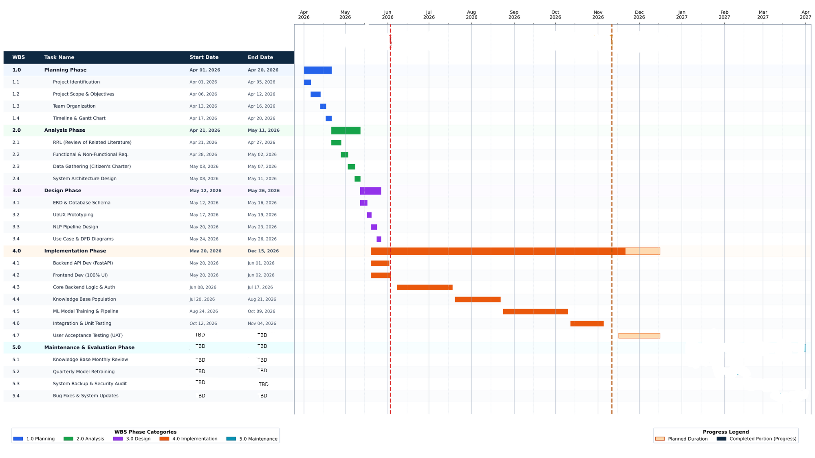
Figure 1. illustrates the updated Work Breakdown Structure (WBS) and project execution timeline across the five system engineering phases: Planning, Analysis and Design, Implementation, Testing and Evaluation, and Maintenance.

Project Status
VISTA is a working prototype in the Implementation and Integration stages, with the major system revisions implemented. These include a hybrid NLP feature extraction pipeline combining word- and character-level TF-IDF with semantic word vectors, an automated LSA text summarization module for verbose Citizen’s Charter entries, dynamic query disambiguation for multi-path administrative transactions, a calibrated confidence threshold with departmental fallback routing, and trilingual language normalization supporting English, Tagalog, and Bisaya. The citizen conversational interface, administrative metrics dashboard, and database schema have also been completed and integrated. User Acceptance Testing (UAT) and final field evaluation remain pending, scheduled to proceed following the Defense on November 11, 2026.
Recent Accomplishments

Since the previous adviser/panel consultation during the Outline Defense, the team implemented the mandated semantic NLP enhancements, summarization algorithms, and interface optimizations. The working dataset was augmented to eliminate class imbalances across specialized local government transactions. The system can accurately classify citizen inquiries phrased in diverse dialects, generate concise 3-sentence procedural summaries, disambiguate broad requests, and direct unhandled concerns to specific municipal offices, although formal evaluation using external citizen respondents remains outstanding.
Challenges Encountered and Solutions Implemented
- Morphological and dialectal variation in citizen queries. Citizens frequently submit inquiries using colloquial expressions, non-standard spelling, and regional dialect mixtures (Taglish and Bislish), causing pure word-level TF-IDF models to fail on out-of-vocabulary terms. The team integrated character-level n-gram vectorization (char_wb, ngram range 3–5) alongside word-level TF-IDF within a scikit-learn FeatureUnion, enabling the model to capture morphological roots even with typographical errors or regional prefixes (e.g., mag-, nag-, mokuha).

- Excessive length in Citizen's Charter responses. Procedural guidelines and statutory requirements from the municipal Citizen's Charter frequently exceed 1,000 characters, overwhelming chat bubbles and degrading user experience. The team integrated the sumy library utilizing Latent Semantic Analysis (LsaSummarizer), which automatically intercepts responses exceeding 400 characters and condenses them into concise, 3-sentence actionable summaries.
- Intent ambiguity in multi-path transactions. Broad queries such as "business permit" lack sufficient context to distinguish between New Application and Renewal procedures, which require entirely different statutory requirements. The team implemented dynamic backend disambiguation rules that detect ambiguous roots and present users with a simple numbered selection list, maintaining a simple interface without confusing navigation.
- Risk of false-positive answers on unhandled inquiries. Inquiries outside the scope of the Citizen's Charter risked generating inaccurate automated responses. The team established a calibrated confidence evaluation filter (threshold = $0.80$) with a fallback mechanism that identifies the responsible municipal department, provides official office contact numbers, and logs the unresolved query for administrative review.
- Class imbalance during dataset stratification. Certain specialized administrative intents had fewer than two sample phrases in raw data, causing matrix split exceptions during train/test partitioning. The team developed an automated dataset validation guard and phrase augmentation script in train.py to ensure all intent classes satisfy stratified sampling requirements.
Comparison of Actual Progress to the Planned Timeline

The following comparison uses the April–December 2026 revision schedule. The periods describe planned work windows rather than verified historical completion dates.

Phase | Planned Period in the Revised Chart | Current Progress
Planning | April 2026 | Problem scope, objectives, team organization, and Work Breakdown Structure (WBS) have been established.
Analysis | April–May 2026 | Review of Related Literature (RRL) compiled; Citizen's Charter documents gathered; Software Requirements Specifications (SRS) and system architecture finalized.
Design | May 2026 | Database schema (ERD), NLP query processing flow, and interactive UI/UX prototypes have been realized.
Implementation | May–November 2026 | Reported feature and architectural revisions are implemented. Core FastAPI backend, hybrid FeatureUnion pipeline, LSA text summarization, trilingual normalization, and Citizen's Charter database ingestion are operational. Prototype operates at ~90% functionality.
Testing | October–December 2026 and ongoing | Unit and internal system integration testing have been completed. User Acceptance Testing (UAT) with real citizen respondents and LGU personnel is scheduled for mid-November to December 2026.
Maintenance | January–March 2027 and ongoing | Scheduled post-defense activities including periodic model retraining, monthly knowledge base reviews, database backups, and system refinement remain planned.

The main difference from the planned timeline concerns the expansion of the NLP pipeline. The earlier plan relied on standalone keyword matching, but following panel recommendations from Chairman Rosebud C. Padios and Member Aldrheila Lonzaga, development in August–October was expanded to incorporate sub-word n-grams, semantic word vectors, and LSA summarization. System integration was completed in early November, placing the prototype on schedule for the November 11, 2026
Work Completed
- Hybrid feature extraction pipeline integration. Implemented a multi-tiered FeatureUnion architecture in train.py combining word-level TF-IDF and character-level n-grams with spaCy semantic embeddings. Deliverables include the trained model artifacts (best_model.pkl, label_encoder.pkl) and the feature extraction pipeline.
- automatic summarizer using the sumy engine that intercepts regulatory text over 400 characters and extracts a 3-sentence summary. Deliverable is the functioning summarize_text function in services/nlp.py.
- Dynamic query disambiguation system. Created an interactive disambiguation mechanism that identifies general transaction roots (e.g., Business Permits, Civil Registry) and prompts the citizen with numbered options. Deliverables include the disambiguation rule engine in routers/chat.py.
- Trilingual language normalization. Implemented rule-based heuristic language markers recognizing lexical roots in English, Tagalog, and Bisaya. Deliverable is the trilingual preprocessing module in services/nlp.py.
- Calibrated fallback and department routing. Established a confidence threshold filter ($0.80$) that redirects unhandled inquiries to the designated municipal office and logs unresolved queries to the database. Deliverables include the fallback routing module and inquiry logging service.
- Citizen's Charter knowledge base population. Parsed, cleaned, and ingested municipal regulatory guidelines (charter_p5_30.txt) into structured database tables linking requirements, fees, processing times, and responsible offices.
- Conversational citizen chat interface. Developed a responsive, user-friendly web interface (index.html) featuring real-time conversational messaging, card-based guidance, and interactive selection chips.
- Administrative monitoring and retraining dashboard. Built an administrative dashboard (admin.html) displaying training classification metrics, intent sample distributions, and logged fallback inquiries.
Evidence Of Work, Such As Code Snippets, Data Analysis, Or Prototypes
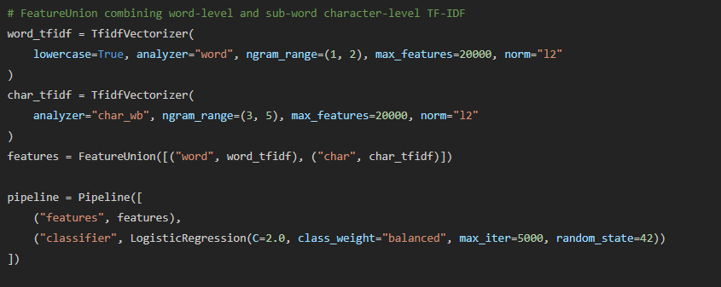
- Hybrid Feature Extraction Pipeline (train.py)
Figure 2. Hybrid feature extraction pipeline in train.py combining word-level and character-level n-grams.
- LSA Text Summarization Module (services/nlp.py)
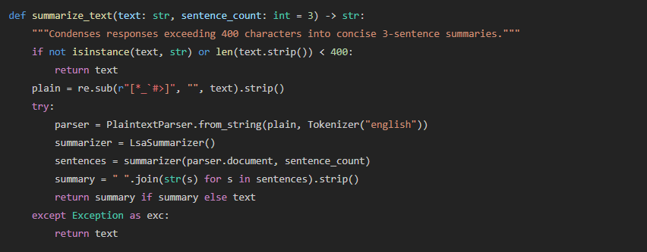
Figure 3. LSA summarization implementation in services/nlp.py.
- Citizen Conversational Chatbot Interface
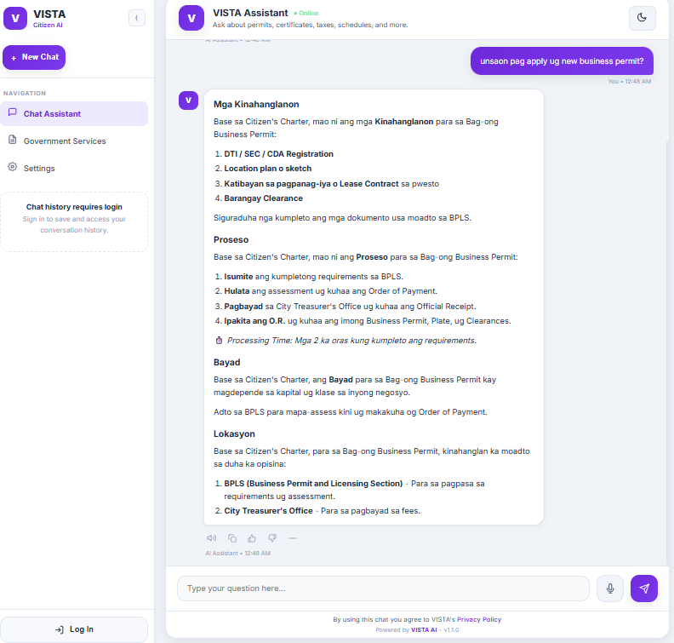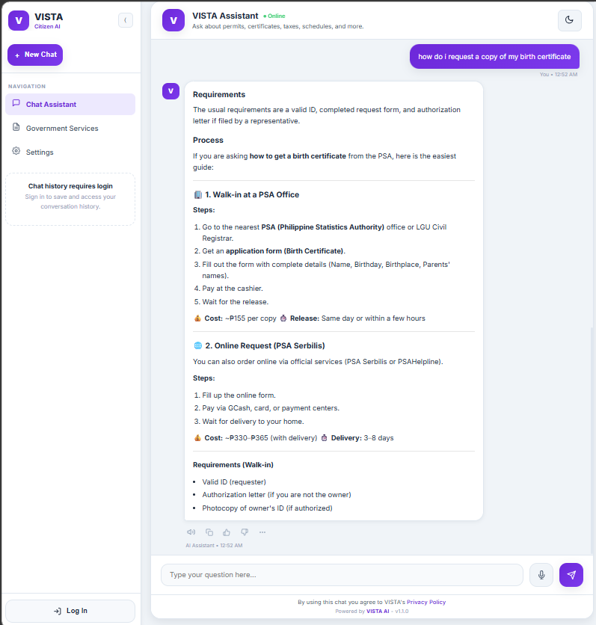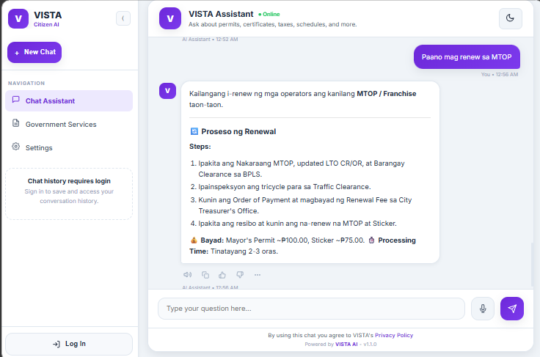
Figure 4. VISTA conversational web interface demonstrating trilingual inquiry processing and procedural responses.
- Dynamic Disambiguation Prompt
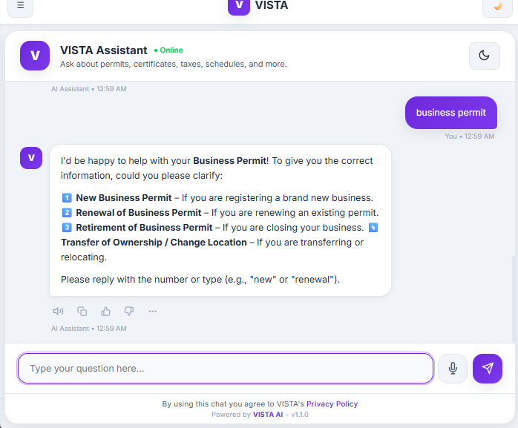

Figure 5. Disambiguation selection prompt presenting numbered choices for multi-path transactions.
- Administrative Monitoring Dashboard
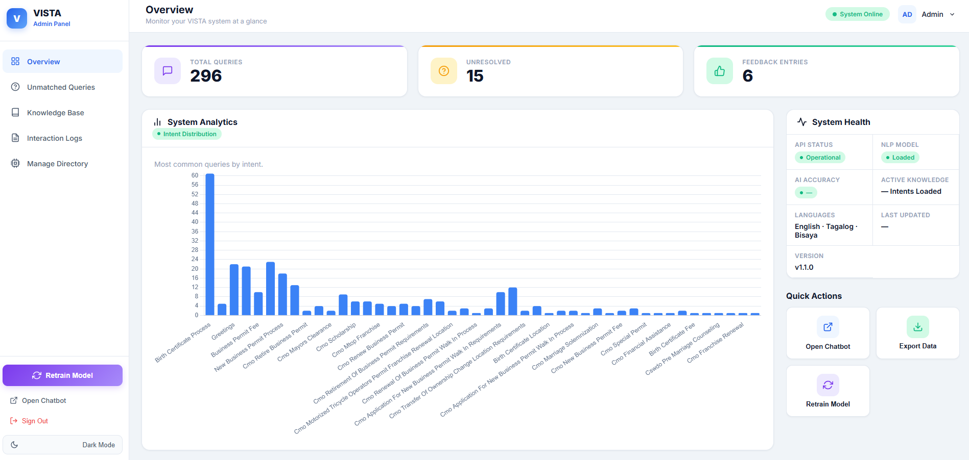
Figure 6. Administrative control dashboard

Work in Progress
The team is completing the data preparation and validation requirements for final NLP model calibration and pre-defense integration. The current working dataset incorporates core administrative transactions from the municipal Citizen’s Charter, and additional colloquial phrasing variations across English, Tagalog, and Bisaya are being compiled into the augmented dataset (training_phrases_augmented.csv) to improve classification coverage for non-standard dialect queries. The classification confidence evaluation filter (threshold = 0.80) is also undergoing empirical calibration to ensure secondary municipal transactions are accurately categorized without triggering false-positive matches or premature fallback prompts.

After these calibration tasks are finalized, the team will execute end-to-end integration dry runs between the FastAPI backend and the conversational interface, verify the semantic consistency of the 3-sentence LSA summaries, and rehearse system demonstrations in preparation for the Defense on November 11, 2026. User Acceptance Testing (UAT) and field usability evaluations will proceed immediately following panel approval.

Anticipated Completion Dates
Task | Anticipated Completion
Finalize the augmented trilingual training dataset (English, Tagalog, Bisaya) | Last week of October–first week of November 2026; completed / active
Calibrate confidence thresholding (0.80) and departmental fallback routing | Early November 2026, prior to defense
Conduct full system integration testing and demonstration dry runs | November 05–09, 2026 target
Conduct Defense | November 11, 2026
Review and incorporate panel comments and recommendations | Late November 2026, following receipt of defense minutes
Execute User Acceptance Testing (UAT) using SUS and ISO/IEC 25010 instruments | Mid-November–mid-December 2026 target, subject to respondent availability
Perform statistical analysis of evaluation results and accuracy metrics | January 2027, following survey collection
Continue periodic model retraining, security audits, and final defense preparation | January–March 2027 and ongoing
Early November remains a targeted timeline for final model calibration and rehearsal. Because the core system revisions—including the hybrid feature extraction pipeline, LSA summarization, dynamic disambiguation, and user interface—are already operational within the working prototype, the project is positioned for demonstration during the November 11, 2026 defense, while formal respondent evaluation (UAT) is scheduled as an immediate post-defense activity.

Conclusion

Key Findings and Achievements
VISTA now incorporates the major functional and architectural revisions identified during the Outline Defense. The working prototype supports hybrid feature extraction combining word-level TF-IDF and character-level n-grams with semantic word vectors, automated LSA text summarization for verbose Citizen’s Charter entries, dynamic query disambiguation for multi-path transactions, trilingual query normalization across English, Tagalog, and Bisaya, and departmental fallback routing with automated inquiry logging. The citizen conversational interface and administrative analytics dashboard have also been refined. The working dataset has been expanded to support localized dialect queries, while formal user evaluation using external respondents remains scheduled for the post-defense period.

Assessment Of Project Progress Against Goals
The project has substantially achieved its feature-development, architectural, and interface goals as directed by Panel Chairman Rosebud C. Padios, Member Jerson M. Viagedor, and Member Aldrheila Lonzaga. The transition from a basic keyword-matching model to a multi-tiered hybrid machine learning pipeline has been realized in the working prototype. The system operates at approximately 90% functional readiness, providing a platform for live demonstration, while the system’s real-world usability and empirical accuracy will be established through the scheduled User Acceptance Testing (UAT) following the Defense.

Outline of Plans and Next Steps
- Late October–early November 2026: Finalize augmented phrase validation, calibrate confidence boundaries, and verify response consistency across all supported municipal services.
- November 05–10, 2026: Conduct end-to-end system dry runs, finalize demonstration query scripts, and complete the defense slide deck.
- November 11, 2026: Present and demonstrate the working prototype to the panel during the next Defense.
- Late November–December 2026: Implement the panel's recommendations and conduct User Acceptance Testing (UAT) with citizen respondents and local government personnel using the System Usability Scale (SUS) and ISO/IEC 25010 quality standards.
- January–March 2027 and beyond: Compile survey evaluation data into Chapter 4, perform scheduled model maintenance and security audits, and prepare the final manuscript for the Final Defense and institutional deployment.

