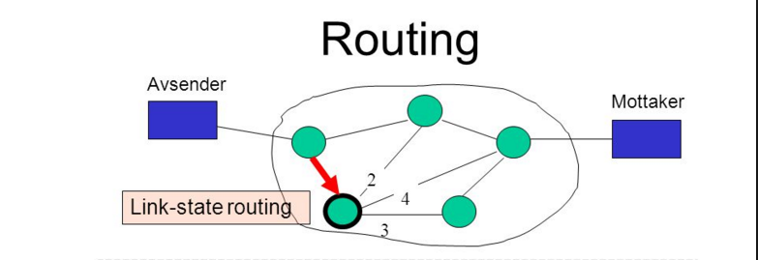

Chethan Kumar Appaji | Computer Networks_Section 02| 11-21-2015

CS 542 LINK-STATE ROUTING

INDEX

Page No.

1. Introduction 2

2. Dijkstra’s shortest path Algorithm 3

3. Application Design 4

4. Variables Used 5

5. Implementation &Instructions to run the code 6

6. Source code with comments 10

7. References 27

**Introduction**

**Routing:**

Routing is the process of selecting best paths in a network. Routing is performed for many kinds of networks, including the telephone network (circuit switching), electronic data networks and transportation networks.

In packet switching networks, routing directs packet forwarding (the transit of logically addressed network packets from their source toward their ultimate destination) through intermediate nodes. Intermediate nodes are typically network hardware devices such as routers, bridges, gateways, firewalls, or switches. General-purpose computers can also forward packets and perform routing, though they are not specialized hardware and may suffer from limited performance. The routing process usually directs forwarding on the basis of routing tables which maintain a record of the routes to various network destinations. Thus, constructing routing tables, which are held in the router's memory, is very important for efficient routing. Most routing algorithms use only one network path at a time. Multipath routing techniques enable the use of multiple alternative paths.

Routing, in a more narrow sense of the term, is often contrasted with bridging in its assumption that network addresses are structured and that similar addresses imply proximity within the network. Structured addresses allow a single routing table entry to represent the route to a group of devices. In large networks, structured addressing (routing, in the narrow sense) outperforms unstructured addressing (bridging).

**Link State Routing Protocol:**

Link State is a routing protocol which is used in packet switching networks for computer communication. In the network that uses link state, every node will perform link - state; they construct a map of the connection between nodes in network by showing which nodes connected with which other nodes. After that each nodes can independently calculate the best path from it to other nodes in network.

The link-state protocol is performed by every switching node in the network (i.e., nodes that are prepared to forward packets; in the Internet, these are called routers). The basic concept of link-state routing is that every node constructs a map of the connectivity to the network, in the form of a graph, showing which nodes are connected to which other nodes. Each node then independently calculates the next best logical path from it to every possible destination in the network. The collection of best paths will then form the node's routing table.

This contrasts with distance-vector routing protocols, which work by having each node share its routing table with its neighbors. In a link-state protocol the only information passed between nodes is connectivity related.

**Dijkstra’s Shortest Path Algorithm**

**Dijkstra's algorithm**, is a graph search algorithm that solves the single-source shortest path problem for a graph with non-negative edge path costs, producing a shortest path tree. This algorithm is often used in routing and as a subroutine in other graph algorithms.

It can also be used for finding costs of shortest paths from a single vertex to a single destination vertex by stopping the algorithm once the shortest path to the destination vertex has been determined. For example, if the vertices of the graph represent cities and edge path costs represent driving distances between pairs of cities connected by a direct road, Dijkstra's algorithm can be used to find the shortest route between one city and all other cities.

1 **function** Dijkstra(*Graph*, *source*):

2

3 create vertex set Q

4

5 **for each** vertex *v* in *Graph*: *// Initialization*

6 dist[*v*] ← INFINITY *// Unknown distance from source to v*

7 prev[*v*] ← UNDEFINED *// Previous node in optimal path from source*

8 add *v* to *Q* *// All nodes initially in Q (unvisited nodes)*

9

10 dist[*source*] ← 0 *// Distance from source to source*

11

12 **while** *Q* is not empty:

13 *u* ← vertex in *Q* with min dist[u] *// Source node will be selected first*

14 remove *u* from *Q*

15

16 **for each** neighbor *v* of *u*: *// where v is still in Q.*

17 *alt* ← dist[*u*] + length(*u*, *v*)

18 **if** *alt* < dist[*v*]: *// A shorter path to v has been found*

19 dist[*v*] ← *alt*

20 prev[*v*] ← *u*

21

22 **return** dist[], prev[]

If we are only interested in a shortest path between vertices *source* and *target*, we can terminate the search after line 13 if *u* = *target*. Now we can read the shortest path from *source* to *target* by reverse iteration:

1 *S* ← empty sequence

2 *u* ← *target*

3 **while** prev[*u*] is defined: *// Construct the shortest path with a stack S*

4 insert *u* at the beginning of *S* *// Push the vertex onto the stack*

5 *u* ← prev[*u*] *// Traverse from target to source*

6 insert *u* at the beginning of *S* *// Push the source onto the stack*

**Application Design**

In this project we develop a program to implement Link - State routing protocol. The program should simulate the process of generating routing tables for each router in a given network and compute optimal path with least cost between any two particular given routers. Dijkstra’s algorithm will be used to calculate the direction as well as the shortest path between two routers.

The objective of the application is to performs the following tasks

* To simulate the process of generating connection table for each router in a given network.
* To compute the optimal path with least cost between any two specific routers.

The application is designed in Java.

The application provides the following options to the user

**1**. **Create a Network Topology**

**2**. **Build a Connection Table**

**3**. **Shortest Path to Destination Router**

**4**. **Modify a topology**

**5**. **Exit**

We will use Java to implement the Dijkstra’s algorithm. In the code, we use several two - dimensional arrays to store original routing table, the distance between routers, values of distance during shortest path calculation, final table after calculation. Some integer valuable are used for routers counting. The program interface display a menu to user who can choose to load matrix of routing table from file, the program also help users calculate the shortest path between any couple of routers and display it to on the screen.

**Variables Used**

**static** **int** *choice*, *row*, *column*;

// To take input from the command prompt

**static** Scanner *scan* = **new** Scanner(System.***in***);

**static** **int**[][] *fileData*=**null**;

// Variables to store intermediate values

**static** **int**[] *temp*;

**static** String *fName*;

**static** **int** *gotResult*;

**static** **int** *nextMinvalue*;

**static** **int** *nextMinvaluePosition*;

**static** **int** *sourceNode*;

**static** **int** *destNode*;

**static** **int** *nodeToInsert*;

**static** **int**[] *inArray*;

**static** **int** *nodeToDelete*;

**static** **int** *conn* = 0;

**static** **int** *shpth* =0;

**static** **boolean** *breakWhileLoop* = **false**;

**static** **boolean** *sourceflag* = **false**;

**static** **boolean** *topologyflag* = **false**;

// "nodesVisited" keep track of the nodes that are visited

**static** ArrayList<Integer> *nodesVisited* = **new** ArrayList<Integer>();

// "listOfMinEdge" keep track of minimum value edges between nodes to find shortest path

**static** ArrayList<Integer> *listOfMinEdge* = **new** ArrayList<Integer>();

// "listofAdjNodes" keep track of adjacent neighbors of the node

**static** ArrayList<Integer> *listofAdjNodes* = **new** ArrayList<Integer>();

// "listofParentNodes" that keep track of parents of the node

**static** ArrayList<Integer> *listofParentNodes* = **new** ArrayList<Integer>();

// calculating the next node

**static** ArrayList<Integer> *listOfNextNode* = **new** ArrayList<Integer>();

**Implementation & Instructions to run the code**

**Interface:**

**Main Menu:**

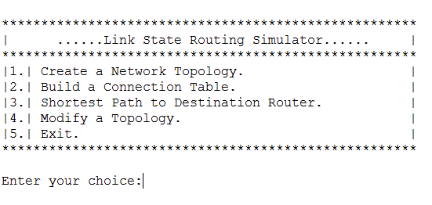

**Step 1: On selecting Option 1, to load the distance matrix from a text file**

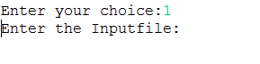

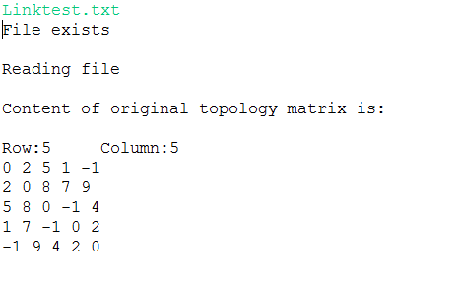

**Step 2: On selecting Option 2, to enter the source node and Display Connection table**

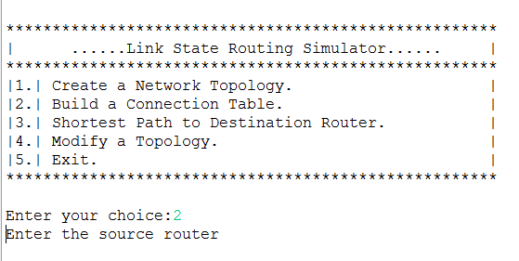

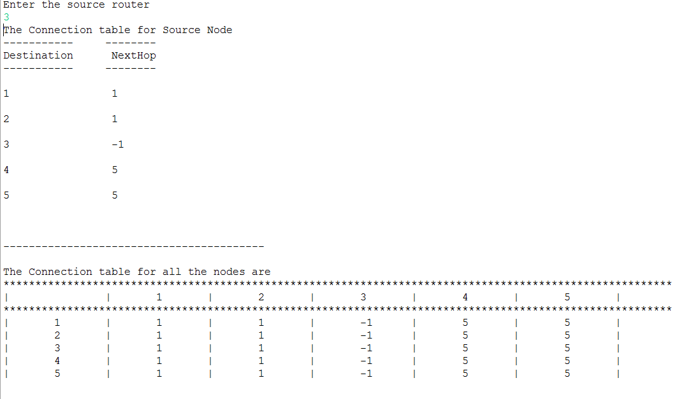

**Step 3: On selecting Option 3, to enter the destination node and Display shortest Path and Cost**

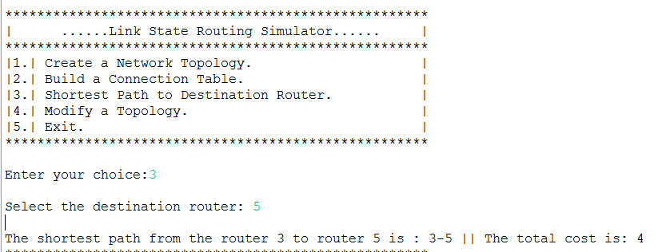

**Step 4: On selecting Option 4, Modify a topology. Display options to Add and delete a node**

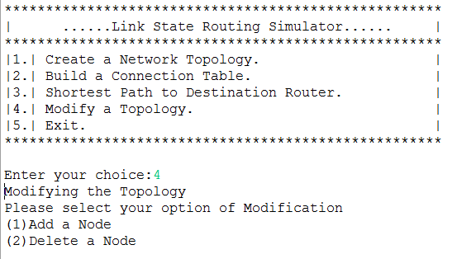

**Step 5: On selecting sub-option 1, Add a node. Enter the node to be added and its values and display new matrix.**

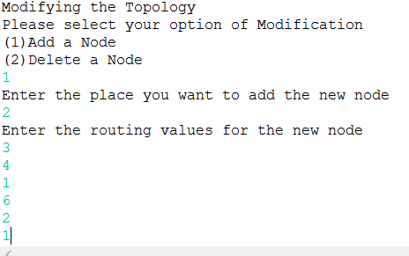

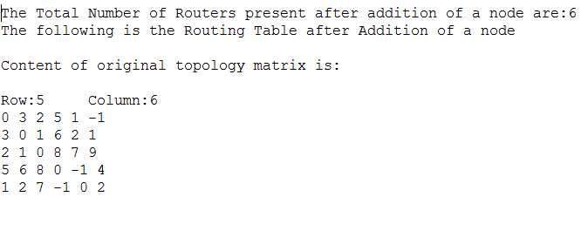

**Step 6: On selecting sub-option 2, Delete a node. Enter the node to be deleted and display new matrix.**

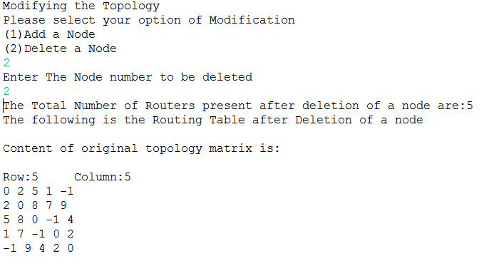

**Step 7: On selecting Option 5, Exit from Main Menu**

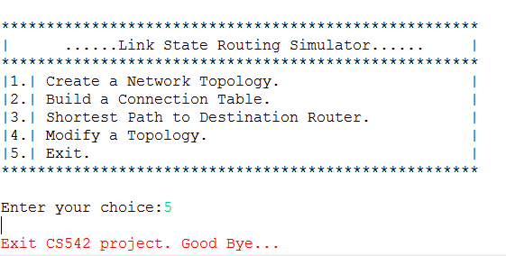

**Source code with comments**

**public** **static** **void** main(String[] args) **throws** IOException{

**while**(**true**){

System.***out***.println();

System.***out***.println("*****************************************************");

System.***out***.println("| ......Link State Routing Simulator...... |");

System.***out***.println("*****************************************************");

System.***out***.println("|1.| Create a Network Topology. |");

System.***out***.println("|2.| Build a Connection Table. |");

System.***out***.println("|3.| Shortest Path to Destination Router. |");

System.***out***.println("|4.| Modify a Topology. |");

System.***out***.println("|5.| Exit. |");

System.***out***.println("*****************************************************");

System.***out***.printf("\nEnter your choice:",*choice*);

*scan* = **new** Scanner(System.***in***);

**try** {

*choice* = *scan*.nextInt();

**if**((*choice*<=0 || *choice*>5))

{

System.***err***.println("Incorrect choice : Please select options 1 to 5");

System.***out***.println();

}

} **catch** (Exception e) {

System.***err***.println("Incorrect choice : Please select options 1 to 5");

System.***out***.println();

}

**switch**(*choice*){

**case** 1:

**try** {

*fName*= *readFile*();

File file = **new** File(*fName*);

file = **new** File(*fName*);

**if** (file.exists()){

System.***out***.println("File exists");

}

**else**{

System.***err***.print("Specified file doesn exists\n");

**break**;

}

} **catch** (Exception e) {

e.getStackTrace();

}

**try**{

*fileData* = *readFileContent*(*fName*);

}

**catch** (Exception e) {

e.getStackTrace();

}

*topologyflag* = **true**;

*dispTopology*(*fileData*);

**break**;

**case** 2:

**if**(*topologyflag*==**false**){

System.***out***.println();

System.***err***.println("Network topology input required before displaying Connection table");

}

**else**{

System.***out***.println("Enter the source router");

**try** {

*sourceNode* = *scan*.nextInt();

} **catch** (Exception e) {

System.***out***.println("Row:"+*row*+" "+"Column:"+*column*);

System.***err***.println("\n Incorrect Node : Source Node must be between 1 and "+*column*);

**break**;

}

**if** (*sourceNode* <= 0 || *sourceNode* > *column*) {

System.***out***.print("Row:"+*row*+" "+"Column:"+*column*);

System.***out***.print("\nIncorrect Node : Source Node must be between 1 and "+*column*);

System.***out***.println();

**break**;

}

*sourceflag* = **true**;

*buildConnectionTable*();

}

**break**;

**case** 3:

**if** (*sourceflag* == **false**) {

System.***err***.print("Source router must be entered in choice 2 before Destination router\n");

**break**;

}

System.***out***.print("\nSelect the destination router: ");

**try** {

*destNode* = *scan*.nextInt();

} **catch** (Exception e) {

System.***err***.print("\n Incorrect Node : Destination router number is between 1 and "+*column*);

**break**;

}

**if** (*destNode* <= 0 || *destNode* > *column*) {

System.***err***

.print("\n Incorrect Node : Destination Router number is between 1 and "+*column*);

**break**;

}

// finding shortest path and cost

*dispShortestPathandCost*();

**break**;

**case** 4:

**if**(*topologyflag*==**false**){

System.***out***.println();

System.***err***.println("Initial network topology input required before modifying topology");

}

*modifytopology*();

**break**;

**case** 5:

System.***err***.print("\nExit CS542 project. Good Bye... ");

*breakWhileLoop* = **true**;

**break**;

}

**if** (*breakWhileLoop* == **true**)

**break**;

}

}

**public** **static** String readFile(){

**try**{

System.***out***.println("Enter the Inputfile:");

*fName* = *scan*.next();

}

**catch**(Exception e){

System.***err***.println("File reading Exception");

}

**return** *fName*;

}

**public** **static** **int**[][] readFileContent(String fileName) **throws** IOException {

System.***out***.println();

System.***out***.println("Reading file");

String line = "";

BufferedReader bf = **new** BufferedReader(**new** FileReader (fileName));

line = bf.readLine();

String[] matrixDataSize = line.split(" ");

**for** (**int** i = 0; i < matrixDataSize.length; i++) {

*column*++;

}

bf.close();

// declaring the size of matrix

**int**[][] matrixData = **new** **int**[*column*][*column*];

String lineData = "";

BufferedReader bfData = **new** BufferedReader(**new** FileReader (fileName));

**int** lineCount = 0;

String[] numbers;

**while** ((lineData = bfData.readLine()) != **null**)

{

numbers= lineData.split(" ");

*row*=0;

**for** (**int** i = 0; i < numbers.length; i++)

{

**try**{

matrixData[lineCount][i] = Integer.*parseInt*(numbers[i]);

}

**catch**(NumberFormatException nfe)

{

System.***out***.println("It was an invalid number");

System.*exit*(1);

}

*row*++;

}

*column* = *row*;

lineCount++;

}

bfData.close();

**return** matrixData;

}

**public** **static** **void** dispTopology(**int**[][] fileData) {

System.***out***.println("\nContent of original topology matrix is:\n");

System.***out***.println("Row:"+*row*+" "+"Column:"+*column*);

**for** (**int** i = 0; i < *row*; i++) {

**for** (**int** j = 0; j < *column*; j++) {

System.***out***.print(fileData[i][j] + " ");

}

System.***out***.println();

}

System.***out***.println();

}

**public** **static** **void** buildConnectionTable(){

// routers index starts with 0,1,2.., rather than 1,2,3

*sourceNode* = *sourceNode* - 1;

// clearing all values for successive iteration.

*nextMinvaluePosition* = 0;

*nextMinvalue* = 0;

*listOfMinEdge*.clear();

*listofParentNodes*.clear();

*nodesVisited*.clear();

*listOfNextNode*.clear();

// initializing current list array

*initCurrRow*(*sourceNode*);

// make source node as visited

*nodesVisited*.add(*sourceNode*);

// initialize the parent list

*initParentList*(*sourceNode*);

// print the Connection table

*dispConnectionTable*(*sourceNode*);

}

// update listOfMinEdge ,used in calculating shortest path

**public** **static** **void** initCurrRow(**int** sourceNode) {

**int** j=0;

**while**(j<*column*){

**if**(j != sourceNode){

*listOfMinEdge*.add(1000);

}

**else**{

*listOfMinEdge*.add(0);

}

j++;

}

}

**public** **static** **void** initParentList(**int** sourceNode) {

**int** j=0;

**while**(j<*column*){

*listofParentNodes*.add(-1);

j++;

}

}

// Finding next node to reach from curr node.

**public** **static** **void** dispConnectionTable(**int** sourceNode) {

// storing initial source

*nextMinvaluePosition* = sourceNode;

**while** (*nodesVisited*.size() != *column*) {

// System.out.println("\n----------------------------------------- \n");

*findNeighborNode*(*nextMinvaluePosition*);

*findAndUpdateParList*(*nextMinvaluePosition*);

Integer i = 0;

**int** min = 1000;

**for** (Integer x : *listOfMinEdge*) {

**if** ((x != -1) && (x > 0)) {

**if** (x <= min && !(*nodesVisited*.contains(i))) {

*nextMinvalue* = x;

*nextMinvaluePosition* = i;

min = x;

}

}

i++;

}

*nodesVisited*.add(*nextMinvaluePosition*);

// System.out.println("\n----------------------------------------- \n");

}

*connectionTableArray*(sourceNode);

*gotResult* = 0;

**while** (*gotResult* != 1) {

*findTableContent*();

**if** (*listOfNextNode*.contains(0)) {

*gotResult* = 0;

} **else** {

*gotResult* = 1;

}

}

*dispTableContent*();

}

**public** **static** **void** dispTableContent(){

System.***out***.println("The Connection table for Source Node ");

System.***out***.println("-----------" + "\t" + "--------");

System.***out***.println("Destination" + "\t" + " NextHop");

System.***out***.println("-----------" + "\t" + "--------");

**for** (**int** k = 0; k < *column*; k++) {

System.***out***.println("\n" + (k + 1) + "\t\t" + " "+*listOfNextNode*.get(k));

}

System.***out***.println("\n");

System.***out***.println("\n----------------------------------------- \n");

System.***out***.println("The Connection table for all the nodes are ");

**for**(**int** k=0;k<*column*;k++){

System.***out***.print("*********************");

}

System.***out***.println();

System.***out***.print("|\t \t|");

**for**(**int** k=0;k<*column*;k++){

System.***out***.print("\t"+ (k+1) +"\t|");

}

System.***out***.print("\n");

**for**(**int** k=0;k<*column*;k++){

System.***out***.print("*********************");

}

System.***out***.print("\n");

**for**(**int** i=0;i<*column*;i++){

*allNodeRotingTable*(i);

System.***out***.print("|\t"+ (i+1) +"\t|");

**for**(**int** j=0;j<*column*;j++){

System.***out***.print("\t"+*temp*[j]+"\t|");

}

System.***out***.print("\n");

}

System.***out***.print("\n");

System.***out***.print("\n");

}

**public** **static** **void** allNodeRotingTable(**int** c)

{

*nextMinvaluePosition* = 0;

*nextMinvalue* = 0;

*listOfMinEdge*.clear();

*listofParentNodes*.clear();

*nodesVisited*.clear();

*listOfNextNode*.clear();

// initializing current list array

*initCurrRow*(*sourceNode*);

// make source node as visited

*nodesVisited*.add(*sourceNode*);

// initialize the parent list

*initParentList*(*sourceNode*);

*nextMinvaluePosition* = *sourceNode*;

**while** (*nodesVisited*.size() != *column*) {

// System.out.println("\n----------------------------------------- \n");

*findNeighborNode*(*nextMinvaluePosition*);

*findAndUpdateParList*(*nextMinvaluePosition*);

Integer i = 0;

**int** min = 1000;

**for** (Integer x : *listOfMinEdge*) {

**if** ((x != -1) && (x > 0)) {

**if** (x <= min && !(*nodesVisited*.contains(i))) {

*nextMinvalue* = x;

*nextMinvaluePosition* = i;

min = x;

}

}

i++;

}

*nodesVisited*.add(*nextMinvaluePosition*);

}

*connectionTableArray*(*sourceNode*);

*gotResult* = 0;

**while** (*gotResult* != 1) {

*findTableContent*();

**if** (*listOfNextNode*.contains(0)) {

*gotResult* = 0;

} **else** {

*gotResult* = 1;

}

}

*temp*=**new** **int**[*column*];

**for**(**int** i=0; i<*column*;i++){

*temp*[i]=0;

}

// printing the connection table for the node

**for** (**int** k = 0; k < *column*; k++) {

*temp*[k]=*listOfNextNode*.get(k);

}

}

// finding next node from parentlist to identify the table content

**public** **static** **void** findTableContent() {

**int** num = 0;

**int** i = 0;

**for** (**int** m = 0; m < *column*; m++) {

**if** (*listOfNextNode*.get(m) == 0) {

num = *listofParentNodes*.get(m);

i = 0;

**while** (i != 1) {

**if** (*listOfNextNode*.get(num) == (num + 1)) {

*listOfNextNode*.remove(m);

*listOfNextNode*.add(m, num + 1);

i = 1;

} **else** {

num = *listOfNextNode*.get(num);

**if** (num == 0) {

*listOfNextNode*.remove(m);

*listOfNextNode*.add(m, 0);

i = 1;

} **else** {

num--;

}

}

}

}

}

}

// used in finding next node from the parent list

**public** **static** **void** connectionTableArray(**int** sourceNode) {

**for** (**int** k = 0; k < *column*; k++) {

**if** (sourceNode == *listofParentNodes*.get(k)) {

*listOfNextNode*.add(k + 1);

} **else** {

**if** (-1 == *listofParentNodes*.get(k))

*listOfNextNode*.add(-1);

**else**

*listOfNextNode*.add(0);

}

}

}

// Finding final parent list for source node.

**public** **static** **void** findAndUpdateParList(**int** nextMinvaluePosition) {

**int** y = 0;

**int** nextMin = 0;

**for** (**int** j = 0; j < *listofAdjNodes*.size(); j++) {

y = *listofAdjNodes*.get(j);

nextMin = *fileData*[nextMinvaluePosition][y] + *nextMinvalue*;

**if** (nextMin < *listOfMinEdge*.get(y)) {

*listOfMinEdge*.add(y, nextMin);

*listOfMinEdge*.remove(y + 1);

*listofParentNodes*.add(y, nextMinvaluePosition);

*listofParentNodes*.remove(y + 1);

}

}

}

// finding neighbors of current node

**public** **static** **void** findNeighborNode(**int** nextMinvaluePosition) {

**int** x;

*listofAdjNodes*.clear();

**for** (**int** j = 0; j < *column*; j++) {

x = *fileData*[nextMinvaluePosition][j];

**if** (*nodesVisited*.contains(j)) {

// nothing , don't add the visited node;

} **else** {

**if** ((x != -1) && (x > 0)) {

*listofAdjNodes*.add(j);

}

}//else

}//for

}

// finding shorest path and cost

**public** **static** **void** dispShortestPathandCost() {

// coding is based on assumption destinationRouter index

// 0,1,2.., not 1,2,3

*destNode* = *destNode* - 1;

**int** leastCost = 0;

**int** currNode = *sourceNode*;

**int** findNode = 0;

Stack<Integer> lifo = **new** Stack<Integer>();

**if** (*listofParentNodes*.get(*destNode*) == currNode) {

leastCost = leastCost + *fileData*[currNode][*destNode*];

lifo.push(*destNode*);

} **else** {

**if** (*listofParentNodes*.get(*destNode*) == -1) {

// skip

} **else** {

**int** i = 0;

findNode = *destNode*;

**int** currSource;

**while** (i != 1) {

lifo.push(findNode);

currSource = *listofParentNodes*.get(findNode);

leastCost = leastCost + *fileData*[currSource][findNode];

**if** (*listofParentNodes*.get(currSource) == currNode) {

leastCost = leastCost + *fileData*[currNode][currSource];

lifo.push(currSource);

i = 1;

} **else** {

findNode = currSource;

}

}//while

}//inner-else

}//outer-else

lifo.push(currNode);

System.***out***.print("\nThe shortest path from the router "

+ (*sourceNode* + 1) + " to router " + (*destNode* + 1)

+ " is : ");

**if** (lifo.size() == 1) {

System.***out***.print(" NO PATH ");

} **else** {

**while** (!lifo.empty()) {

**int** x = lifo.pop();

x++;

System.***out***.print(x);

**if** (!lifo.empty())

System.***out***.print('-');

}//while

}//else

System.***out***.print(" || The total cost is: " + leastCost);

}

**public** **static** **void** modifytopology(){

*scan* = **new** Scanner(System.***in***);

**int** option;

System.***out***.println("Modifying the Topology");

System.***out***.println("Please select your option of Modification");

System.***out***.println("(1)Add a Node");

System.***out***.println("(2)Delete a Node");

option=*scan*.nextInt();

**switch**(option){

**case** 1:

//Adding a node

System.***out***.println("Enter the place you want to add the new node");

**try** {

*nodeToInsert*=*scan*.nextInt();

**if**(*nodeToInsert* > *column*+1 || *nodeToInsert*<1)

{

System.***out***.println("Out of Range");

**break**;

}

*nodeToInsert*=*nodeToInsert*-1;

*inArray*=**new** **int**[*column*+1];

System.***out***.println("Enter the routing values for the new node");

**for**(**int** i=0;i<*column*+1;i++){

*inArray*[i]=*scan*.nextInt();

}

*Insertnode*();

} **catch** (Exception e) {

System.***err***.print("Out of Range\n");

System.***out***.println();

}

**break**;

**case** 2:

//Deleting a node

System.***out***.println("Enter The Node number to be deleted");

**try**{

*nodeToDelete*=*scan*.nextInt();

**if**(*nodeToDelete* > *column* || *nodeToDelete*<1)

{

System.***out***.println("Wrong Router Number");

**break**;

}

*nodeToDelete*=*nodeToDelete*-1;

*Deletenode*();

}**catch** (Exception e) {

System.***err***.print("Wrong Router Number\n");

System.***out***.println();

}

**break**;

**default**:

System.***out***.println("Enter the Right Choice");

**break**;

}

}

//Inserting a node

**public** **static** **void** Insertnode(){

**int** OldNodevalue;

OldNodevalue=*column*;

*column*=*column*+1;

**int**[][]tempNodeValue=**new** **int**[*column*][*column*];

**for**(**int** i=0;i<*column*;i++){

**for**(**int** j=0;j<*column*;j++){

tempNodeValue[i][j]=0;

}

}

**for**(**int** i=0;i<OldNodevalue;i++){

**for**(**int** j=0;j<OldNodevalue;j++){

tempNodeValue[i][j]=*fileData*[i][j];

}

}

**if**(*nodeToInsert*>0){

**for**(**int** i=0;i<*nodeToInsert*;i++){

**for**(**int** j=*column*-1;j>*nodeToInsert*;j--){

tempNodeValue[i][j]=tempNodeValue[i][j-1];

tempNodeValue[j][i]=tempNodeValue[i][j];

}

}

}

**for**(**int** i=*column*-2;i>*nodeToInsert*;i--){

**for**(**int** j=*column*-1;j>i;j--){

tempNodeValue[i][j]=tempNodeValue[i-1][j-1];

tempNodeValue[j][i]=tempNodeValue[i][j];

}

}

**for**(**int** i=0;i<*column*;i++){

tempNodeValue[*nodeToInsert*][i]=*inArray*[i];

tempNodeValue[i][*nodeToInsert*]=*inArray*[i];

}

tempNodeValue[*nodeToInsert*][*nodeToInsert*]=0;

*fileData*=**new** **int**[*column*][*column*];

**for**(**int** i=0;i<*column*;i++){

**for**(**int** j=0;j<*column*;j++){

*fileData*[i][j]=tempNodeValue[i][j];

}

}

System.***out***.println("The Total Number of Routers present after addition of a node are:"+*column*);

//Printing the modified

System.***out***.println("The following is the Routing Table after Addition of a node");

*dispTopology*(*fileData*);

System.***out***.print("\n");

System.***out***.print("\n");

System.***out***.print("\n");

System.***out***.print("\n");

}

//Deleting a node

**public** **static** **void** Deletenode(){

**int** OldNodevalue;

OldNodevalue=*column*;

**int**[][]tempNodeValue=**new** **int**[*column*][*column*];

**for**(**int** i=0;i<*column*;i++){

**for**(**int** j=0;j<*column*;j++)

{

tempNodeValue[i][j]=*fileData*[i][j];

}

}

*column*=*column*-1;

**for**(**int** i=*nodeToDelete*;i<OldNodevalue-1;i++){

tempNodeValue[i][i]=tempNodeValue[i+1][i+1];

}

**if**(*nodeToDelete*>0){

**for**(**int** i=0;i<*nodeToDelete*;i++){

**for**(**int** j=*nodeToDelete*;j<OldNodevalue-1;j++){

tempNodeValue[i][j]=tempNodeValue[i][j+1];

tempNodeValue[j][i]=tempNodeValue[i][j];

}

}

}

**for**(**int** i=*nodeToDelete*;i<OldNodevalue-2;i++){

**for**(**int** j=i+1;j<OldNodevalue-1;j++){

tempNodeValue[i][j]=tempNodeValue[i+1][j+1];

tempNodeValue[j][i]=tempNodeValue[i][j];

}

}

**for**(**int** i=0;i<*column*;i++){

**for**(**int** j=0;j<*column*;j++){

*fileData*[i][j]=tempNodeValue[i][j];

}

}

System.***out***.println("The Total Number of Routers present after deletion of a node are:"+*column*);

//Printing the modified

System.***out***.println("The following is the Routing Table after Deletion of a node");

*dispTopology*(*fileData*);

System.***out***.print("\n");

System.***out***.print("\n");

System.***out***.print("\n");

}

**References**

*http://en.wikipedia.org/wiki/RoutingMasterOpt/MyL09.pdf*

[*http://en.wikipedia.org/wiki/Link-state_routing_protocol*](http://en.wikipedia.org/wiki/Link-state_routing_protocol)

[*http://en.wikipedia.org/wiki/Dijkstra%27s_algorithm*](http://en.wikipedia.org/wiki/Dijkstra%27s_algorithm)