



User Guide

SSH tunneling through GeoCloud Bastion Host for Windows, MacOS and VNC Servers

Page 1 of 10



Contents

I. Why this Guide? 3

1. SSH tunneling through bastion host for MacOS 3
2. SSH tunneling through bastion host for Windows 6
3. SSH tunneling through bastion host for VNC server 5

1. Why this Guide?

1. This guide is designed to show how you would use SSH to tunnel through to the bastion host if you are using either a Windows, MacOS or VNC server

# SSH tunneling through bastion host for MacOS

* 1. Provide PIV certs to the VTL team to configure the bastion host access by following these steps
  2. Run the following in the terminal and provide the cert to the VTL network team:



-Output looks like the following:

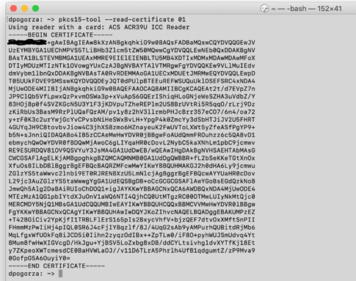

* 1. The VTL network team will attach the provided cert to your profile
  2. Once complete, connect to the bastion host using the following command and your credentials:

–ssh -YI /Library/OpenSC/lib/opensc-pkcs11.so

[david.pogorzala@10.58.150.20](mailto:david.pogorzala@10.58.150.20)

* 1. 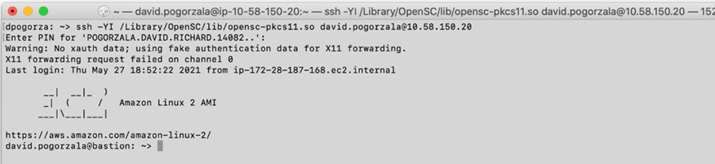Enter your PIN when prompted and you should connect like the following graphic:

1. Using a MAC book (MacOS) to connect to the Bastion host]

-Option 1 to Install command line OpenSC

-Option 2 to install via Github: (<https://github.com/OpenSC/OpenSC/wiki/macOS-Quick-Start>).

-Install the package: Opening the DMG-file loads the OpenSC bundle into Finder. Open the contextual menu of the installation package (e.g. use a two-finger tap on trackpad) and choose Open. Skip the warning about the package's origin and follow the installation guide. Since we aren't currently signing the installation package, double clicking cannot be used to install OpenSC.

1. Test the installation: Upon successful installation, OpenSC is installed in

/Library/OpenSC, the tokend module was registered and links to the OpenSC tools have been created in /usr/local/bin.

1. The PKCS#11 modules have been installed as

/Library/OpenSC/lib/opensc-pkcs11.so and

/Library/OpenSC/lib/onepin-opensc-pkcs11.so (copies of the libraries are available in /usr/local/lib).

1. You may test tokend support of you card with Keychain Access. The app should list your smart card in the Keychains pane on the upper left side. Click the lock to verify the smart card PIN and to allow access to the card's keys.
2. You may test the PKCS#11 support of your card with

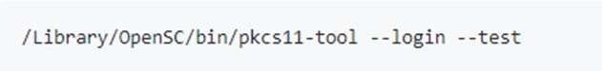

1. Customize the config: Change the default configuration file

/Library/OpenSC/etc/opensc.conf to your needs. The configuration options are explained within this file.

1. Uninstall OpenSC: From the OpenSC bundle double click the OpenSC Uninstaller. Alternatively, run the following from the command line:



1. With OpenSC installed, open terminal and run the following command to list all the certs on the card:

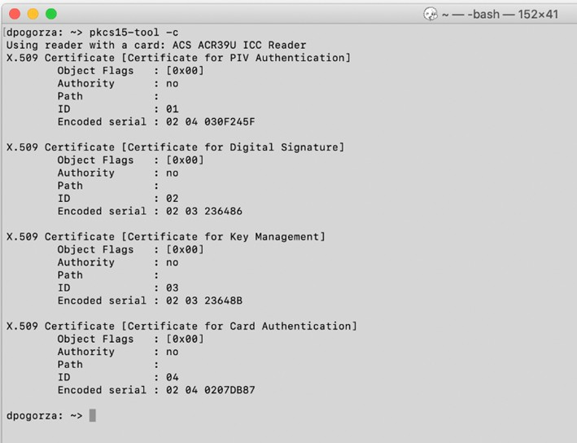-Output would look like the following:

8. For problems or concerns please contac[t admin.geocloud@noaa.gov](mailto:admin.geocloud@noaa.gov)

# SSH tunneling through bastion host for Windows

* 1. You will need to know the GeoCloud Bastion Host IPaddress (<GeoCloudBastionIP>) and the destination GeoCloud Windows serverIP address (<WindowsServerIP>).
  2. In Putty-CAC, Create an ssh Session with the GeoCloud Bastion Host IP Address as the destination

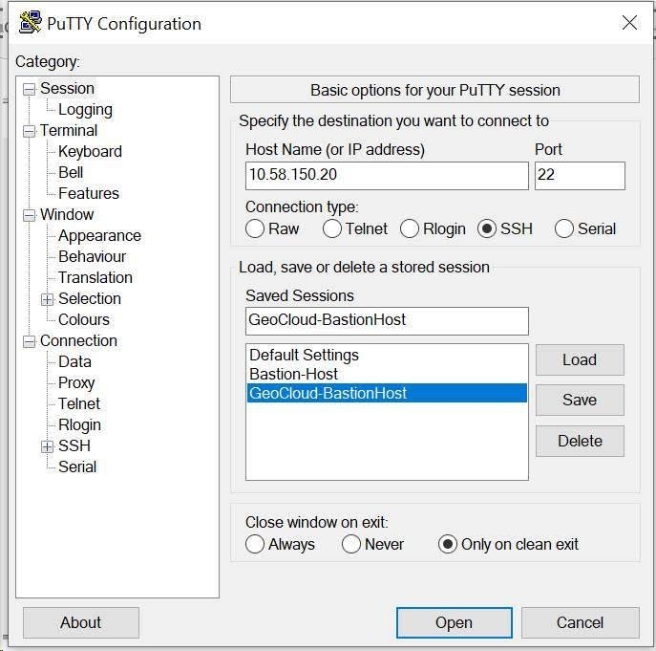

* 1. Under Connection -> SSH -> Tunnels, configure an RDP tunnel, e.g., mapping local port 33389 to port 3389 on <WindowsServerIP>, and press “Add”

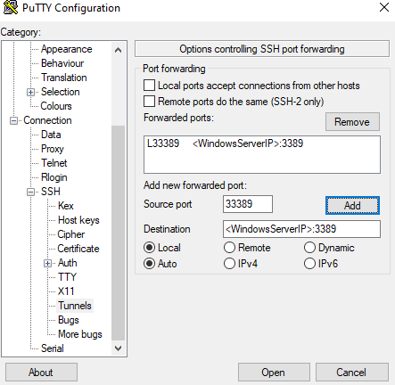

* 1. 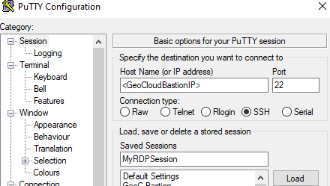Select Session, Enter a name for the Session (e.g., “MyRDPSession”), and press “Save”
  2. To initiate the RDP session, connect to the VPN, open Putty-CAC, and from the list of sessions, select “MyRDPSession”, and “Load” and then “Open” (or just double click on “MyRDPSession”). If successful, a terminal window will be opened on the bastion host.

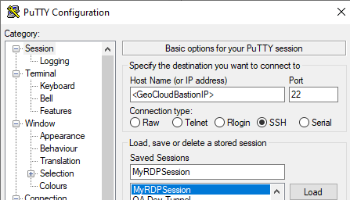

A terminal window will appear, and you will be prompted to enter your CAC PIN. If successful, you will be logged in on the bastion host.

* 1. 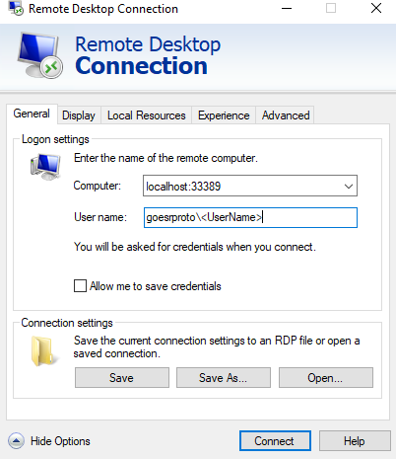Open your RDP Client (e.g., Windows Remote Desktop Connection) the tunnel information from step 3 (localhost:33389) as the remote computer, and your GeoCloud domain username (goesrproto\Username>) and press “Connect”
  2. Enter your GeoCloud Domain password and you will be logged into the remote server.

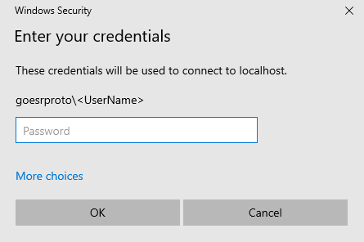

* 1. For problems or concerns please contac[t admin.geocloud@noaa.gov](mailto:admin.geocloud@noaa.gov)

# SSH tunneling through bastion host for VNC server

* 1. 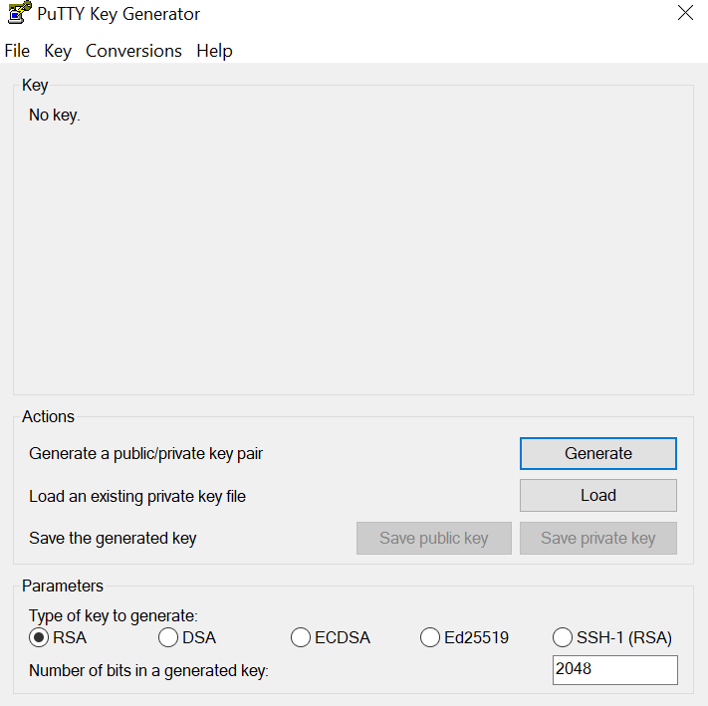Create one password-less SSH key to access the bastion host from your computer, then another one to access Jenkins server from the bastion host, if you don’t have a SSH key yet. You can do this by using putty key generator or by using the Ssh-keygen command.
  2. Have a SSH and a VNC client installed on your computer. MobaXterm is an effective VNC client; they also have a portable version. https://mobaxterm.mobatek.net/download.html
  3. On the Jenkins server (10.201.20.173), start the VNC server:

## $ vncserver :5

* 1. While connected to the ERAV VPN, open a terminal/cmd on your computer and run the following command to open a VNC tunnel:

## $ ssh -L 5905:localhost:5905 <bastion host username>@<bastion host IP> -L 5905:localhost:5905 -N -f <AD username>@10.201.20.173

If successful, this command should hang.

* 1. 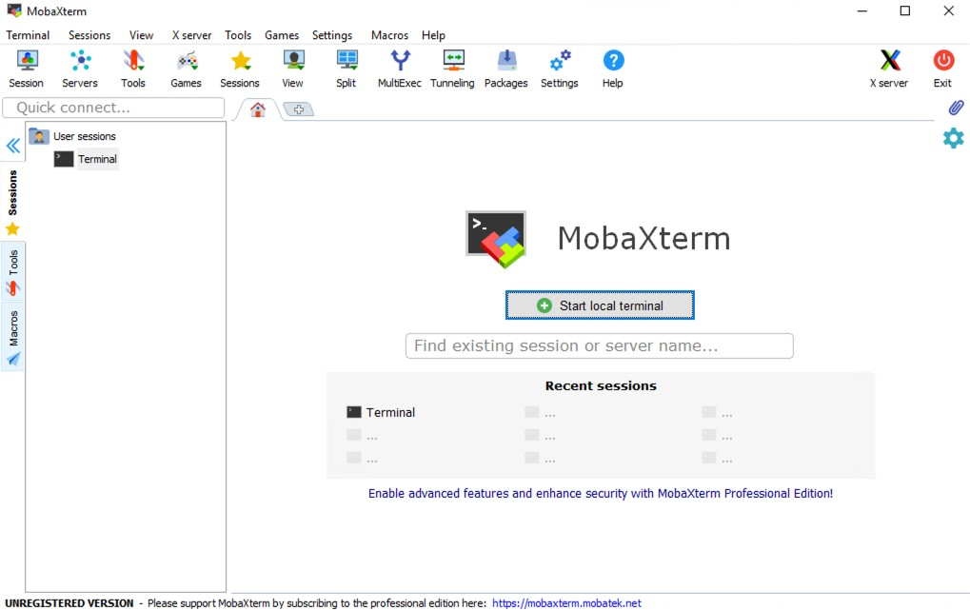Open the VNC client on your computer, e.g. MobaXterm, and open a VNC session on localhost:5905
  2. Navigate to Applications -> Internet -> Chromium Web Browser
  3. Navigate to geocloud-jenkins in the browser. You should get the Jenkins login page.
  4. Login using AD credentials.
  5. For problems or concerns please contac[t admin.geocloud@noaa.gov](mailto:admin.geocloud@noaa.gov)